AP BIOLOGY 2021-22 November 9, 2021

Today’s Agenda (Day 53)

- Housekeeping Items

- Homework Check:
READING GUIDE: Ch 9
- Class Activity:
TEST: Chapter 9
*Go to www.socrative.com enter room “MSBAPBIO” enter ID #

WEDNESDAY: Ch 10 PPT Review
- Section 10.2 – The light reactions convert solar energy to the chemical energy of ATP and NADPH
- Section 10.3 – The Calvin cycle uses the chemical energy of ATP and NADPH to reduce CO₂ to sugar
- Section 10.4 – Alternative mechanisms of carbon fixation have evolved to hot, arid climates
WEEK of Nov. 8: LAB: Osmosis and Diffusion (Part 2)

HOMEWORK:
- READ: Chapters 9 – 13
- COMPLETE: Chapter 10 Reading Guide
- STUDY: Ch 10 Test AND Ch 10_11 Vocabulary Quiz
Chapter 10 - Photosynthesis
Absorption spectrum | Action spectrum | Bundle-sheath cells | C3 plant | C4 plant | Calvin cycle
CAM plant | Carbon fixation | Carotenoids | Chlorophyll | Crassulacean acid metabolism (CAM) | Cyclic electron flow
Electromagnetic spectrum | Glyceraldehyde 3-phospate (G3P) | Light reactions | Light-harvesting complex | Linear electron flow | Mesophyll
Photons | Photophosphorylation | Photorespiration | Photosystem | Photosystem I | Photosystem II
PEP carboxylase | Primary electron acceptor | Reaction-center complex | Rubisco | Spectrophotometer | Stomata
Stroma | Thylakoids | Visible light | wavelength

REMINDERS:
- TEST: Chapter 9 Nov. 10
- Ch 10 Reading Guide – Nov. 13
- TEST: Chapter 10 Nov. 18
- QUIZ: Chapter 10 & 11 Vocabulary Nov. 24
- TEST: Chapter 11 Nov. 30
- TEST: Chapter 12 Dec. 9
- MIDTERM: Covers Ch 1 – 13
Chapter 11 – Cell communication
Adenylyl cyclase | Apoptosis | Biofilm | Chemical messengers | Cyclic AMP | Diacylglycerol (DAG)
Endocrine signaling | Growth factors | Hormones | Inositol triphosphate (IP3) | Ligand | Paracrine signaling
Phosphorylation cascade | Plant growth regulators | Protein kinase | Protein phosphatases | Scaffolding proteins | Second messengers
Signal transduction pathway | Synaptic signaling

AP BIOLOGY 2021-22 READING GUIDE

Chapter 10: Photosynthesis

This chapter is as challenging as the one you just finished on cellular respiration. However, conceptually it will be a little easier because the concepts learned in Chapter 9—namely, chemiosmosis and an electron transport system—will play a central role in photosynthesis.

1. As a review, define the terms autotroph and heterotroph. Keep in mind that plants have mitochondria and chloroplasts and do both cellular respiration and photosynthesis!

Concept 10.1 Photosynthesis converts light energy to the chemical energy of food

- Take a moment to place the chloroplast in the leaf by working through Figure 10.3. Draw a picture of the chloroplast and label the stroma, thylakoid, thylakoid space, inner membrane and outer membrane.

- Use both chemical symbols and words to write out the formula for photosynthesis (use the one that indicates only the net consumption of water). The formula is the opposite of cellular respiration. You should know both formulas from memory.

- Using ¹⁸O as the basis of your discussion, explain how we know that the oxygen released in photosynthesis comes from water.

- Photosynthesis is not a single process, but two processes, each with multiple steps.

  - Explain what occurs in the light reactions stage of photosynthesis. Be sure to use NADP⁺ and photophosphorylation in your discussion.

  - Explain the Calvin cycle, utilizing the term carbon fixation in your discussion.

- The details of photosynthesis will be easier to organize if you can visualize the overall process. Label Figure 10.5, below. As you work on this, underline the items that are cycled between the light reactions and the Calvin cycle.

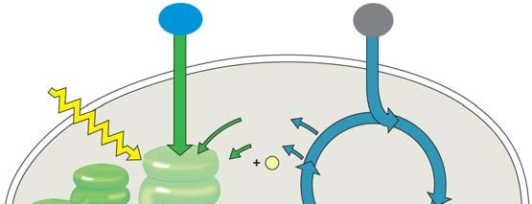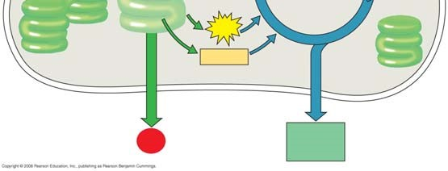

Concept 10.2 The light reactions convert solar energy to the chemical energy of ATP and NADPH
This is a long and challenging concept. Take your time, work through the questions, and realize that this is the key concept for photosynthesis.

- Some of the types of energy in the electromagnetic spectrum will be familiar, such as X-rays, microwaves, and radio waves. The most important part of the spectrum in photosynthesis is visible light. What are the colors of the visible spectrum?

Notice the colors and corresponding wavelengths and then explain the relationship between wavelength and energy.

- Read Figure 10.9 carefully; then explain the correlation between an absorption spectrum and an action spectrum.

- Describe how Englemann was able to form an action spectrum long before the invention of a spectrophotometer.

- A photosystem is composed of a protein complex called a ___________-__________ complex surrounded by several __________-____________ complexes.

- Within the photosystems, the critical conversion of solar energy to chemical energy occurs. This process is the essence of being a producer! Using Figure 10.12 as a guide, label the diagram and then explain the role of the terms in the photosystem.

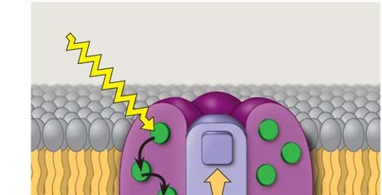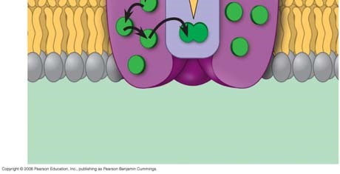

  - Reaction center complex—

  - Light-harvesting complex—

  - Primary electron acceptor—

- Photosystem I is referred to by the wavelength at which its reaction center best absorbs light, or
P__________; photosystem II is also known by this characteristic, or P__________.

- Linear electron flow is, fortunately, easier than it looks. It is an electron transport chain, somewhat like the one we worked through in cellular respiration. While reading the section “Linear Electron Flow,” label the diagram number by number as you read.

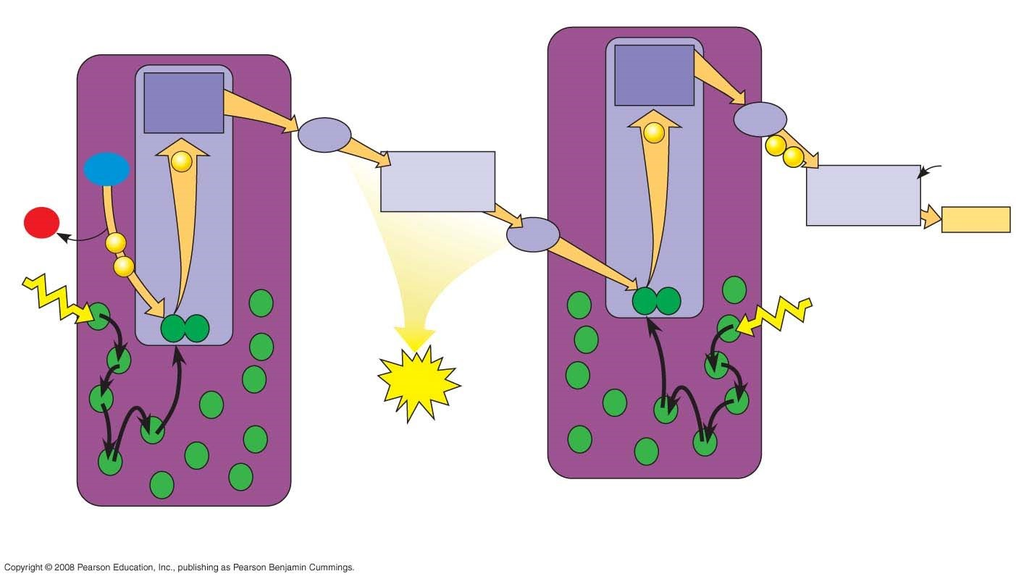

- The following set of questions deal with linear electron flow:

    - What is the source of energy that requires the electron in photosystem II?

    - What compound is the source of electrons for linear electron flow? This compound is also the source of ___________ in the atmosphere.
    - As electrons fall between photosystem I and II, the cytochrome complex uses the energy to pump ________ ions. This builds a proton gradient that is used in chemiosmosis to produce
what?

    - In photosystem II, the excited electron is eventually used by NADP⁺ reductase to join
NADP⁺ and a H⁺ to form ___________.

* Notice that two high-energy compounds have been produced by the light reactions: ATP and NADPH. Both compounds will be used in the Calvin cycle.

- Cyclic electron flow can be visualized in Figure 10.15. Cyclic electron flow is thought to be similar to the first forms of photosynthesis to evolve. In cyclic electron flow no water is split, there is no production of __________, and there is no release of __________.

- The last idea in this challenging concept is how chemiosmosis works in photosynthesis. Use four examples to compare how chemiosmosis is similar in photosynthesis and cellular respiration.

- Use two key differences to explain how chemiosmosis is different in photosynthesis and cellular respiration. (These two questions are another example of compare and contrast.)

- Label all the locations in the diagram first. Next, follow the steps in linear electron flow to label the components of the light reactions in chemiosmosis.
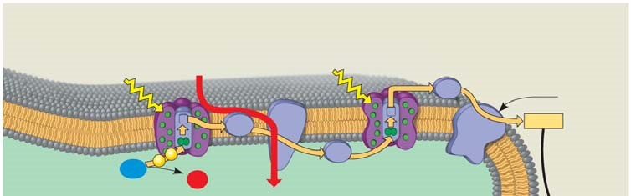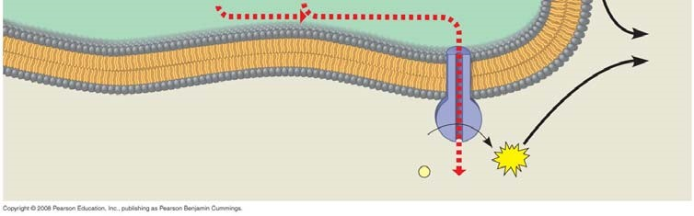

- List the three places in the light reactions where a proton-motive force is generated.

- As a review, note that the light reactions store chemical energy in __________ and __________, which shuttle the energy to the carbohydrate-producing __________ cycle.

Concept 10.3 The Calvin cycle uses ATP and NADPH to convert CO₂ to sugar
The Calvin cycle is a metabolic pathway in which each step is governed by an enzyme, much like the citric acid cycle from cellular respiration. However, keep in mind that the Calvin cycle uses energy (in the form of ATP and NADPH) and is therefore anabolic; in contrast, cellular respiration is catabolic and releases energy that is used to generate ATP and NADH.

- The carbohydrate produced directly from the Calvin cycle is not glucose, but the three-carbon compound __________________________. Each turn of the Calvin cycle fixes one molecule of CO₂; therefore, it will take ___________ turns of the Calvin cycle to net one G3P.

- Explain the important events that occur in the carbon fixation stage of the Calvin cycle.

- The enzyme responsible for carbon fixation in the Calvin cycle, and possibly the most abundant protein on Earth, is __________________.

- In phase two, the reduction stage, the reducing power of _________________ will donate electrons to the low-energy acid 1,3-bisphosphoglycerate to form the three-carbon sugar
_________________________.

- Examine Figure 10.18 while we tally carbons. This figure is designed to show the production of one net G3P. That means the Calvin cycle must be turned three times. Each turn will require a starting molecule of ribulose bisphosphate, a five-carbon compound. This means we start with __________ carbons distributed in three RuBPs. After fixing three carbon dioxides using the enzyme _______________, the Calvin cycle forms six G3Ps with a total of _________ carbons. At this point the net gain of carbons is _________, or one net G3P molecule.

- Three turns of the Calvin cycle net one G3P because the other five must be recycled to RuBP. Explain how the regeneration of RuBP is accomplished.

- The net production of one G3P requires __________ molecules of ATP and __________ molecules of NADPH.

Concept 10.4 Alternative mechanisms of carbon fixation have evolved in hot, arid climates
- Explain what is meant by a C₃ plant.

- What happens when a plant undergoes photorespiration?

- Explain how photorespiration can be a problem in agriculture.

- Explain what is meant by a C₄ plant.

- Explain the role of PEP carboxylase in C₄ plants, including key differences between it and rubisco.

- Conceptually, it is important to know that the C₄ pathway does not replace the Calvin cycle but works as a CO₂ pump that prefaces the Calvin cycle. Explain how changes in leaf architecture help isolate rubisco in high CO₂ areas but low O₂ areas.

- Using Figure 10.19 as a guide, explain the three key events—indicated by the arrows below— in the C₄ pathway.

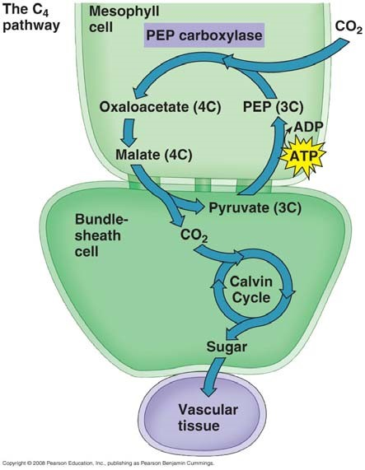

- Compare and contrast C₄ plants with CAM plants. In your explanation, give two key similarities and two key differences.

- Explain the statement that only the green cells of a plant are the autotroph while the rest of the plant is a heterotroph.

- Now that you have worked through the entire chapter, study Figure 10.21. Go back to the figure used in question 6. On the left side of that figure, list additional information for the light reactions; on the right side, summarize additional information for the Calvin cycle reactions. Finally, label this entire figure without looking back in your book! If you can do this, you understand the “big picture.”
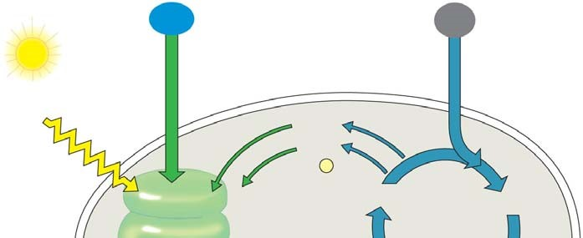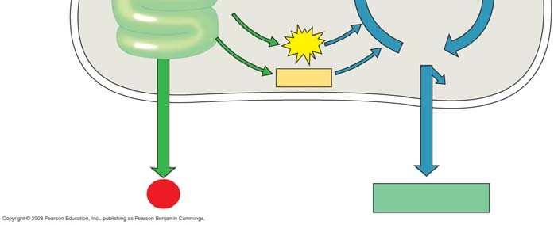
Testing Your Knowledge: Self-Quiz Answers
Now you should be ready to test your knowledge. Place your answers here:

AP BIOLOGY 2021-22 LAB ACTIVITY 2

