AP BIOLOGY 2021-22 November 8, 2021

Today’s Agenda (Day 52)

- Housekeeping Items

- Homework Check:
READING GUIDE: Ch 9

- Class Activity:
CLICKER QUESTIONS: Chapter 9 Review
BEGIN: Ch 10 PPT Review
- Section 10.1 – Photosynthesis converts light energy to the chemical energy of food
- Section 10.2 – The light reactions convert solar energy to the chemical energy of ATP and NADPH
- Section 10.3 – The Calvin cycle uses the chemical energy of ATP and NADPH to reduce CO₂ to sugar
- Section 10.4 – Alternative mechanisms of carbon fixation have evolved to hot, arid climates

WEEK of Nov. 8: LAB: Osmosis and Diffusion (Part 2)

HOMEWORK:
- READ: Chapters 9 – 13
- COMPLETE: Chapter 10 Reading Guide
- STUDY: Ch 9 Test
Chapter 10 - Photosynthesis
Absorption spectrum | Action spectrum | Bundle-sheath cells | C3 plant | C4 plant | Calvin cycle
CAM plant | Carbon fixation | Carotenoids | Chlorophyll | Crassulacean acid metabolism (CAM) | Cyclic electron flow
Electromagnetic spectrum | Glyceraldehyde 3-phospate (G3P) | Light reactions | Light-harvesting complex | Linear electron flow | Mesophyll
Photons | Photophosphorylation | Photorespiration | Photosystem | Photosystem I | Photosystem II
PEP carboxylase | Primary electron acceptor | Reaction-center complex | Rubisco | Spectrophotometer | Stomata
Stroma | Thylakoids | Visible light | wavelength

REMINDERS:
- READING GUIDE: Ch 9 – Nov. 8
- TEST: Chapter 9 Nov. 10
- Ch 10 Reading Guide – Nov. 13
- TEST: Chapter 10 Nov. 18
- QUIZ: Chapter 10 & 11 Nov. 24
- TEST: Chapter 11 Nov. 30
- TEST: Chapter 12 Dec. 9
- MIDTERM: Covers Ch 1 – 13
Chapter 11 – Cell communication
Adenylyl cyclase | Apoptosis | Biofilm | Chemical messengers | Cyclic AMP | Diacylglycerol (DAG)
Endocrine signaling | Growth factors | Hormones | Inositol triphosphate (IP3) | Ligand | Paracrine signaling
Phosphorylation cascade | Plant growth regulators | Protein kinase | Protein phosphatases | Scaffolding proteins | Second messengers
Signal transduction pathway | Synaptic signaling

AP BIOLOGY 2021-22 READING GUIDE

Chapter 9: Cellular Respiration: Harvesting Chemical Energy

Overview: Before getting involved with the details of cellular respiration and photosynthesis, take a second to look at the big picture. Photosynthesis and cellular respiration are key ecological concepts involved with energy flow. Use Figure 9.2 to label the missing parts below.

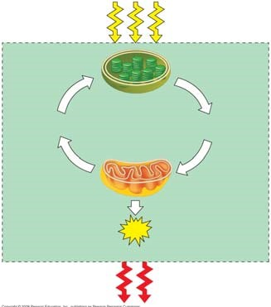

Concept 9.1 Catabolic pathways yield energy by oxidizing organic fuels

- Explain the difference between fermentation and cellular respiration.

- Give the formula (with names) for the catabolic degradation of glucose by cellular respiration.

- Both cellular respiration and photosynthesis are redox reactions. In redox, reactions pay attention to the flow of electrons. What is the difference between oxidation and reduction?

- The following is a generalized formula for a redox reaction:

Xe– + Y Æ X + Ye–
Draw an arrow showing which part of the reaction is oxidized and which part is reduced.
___________ is the reducing agent in this reaction, and __________ is the oxidizing agent.
- When compounds lose electrons, they _________ energy; when compounds gain electrons, they _________ energy.
- In cellular respiration, electrons are not transferred directly from glucose to oxygen. Each electron is coupled with a proton to form a hydrogen atom. Following the movement of hydrogens allows you to follow the flow of electrons. The hydrogens are held in the cell temporarily by what electron carrier?

What is a coenzyme? (If you have forgotten, look back to a few pages in Chapter 8.)

- What is the function of the electron transport chain in cellular respiration?

- Show the normal, downhill route most electrons follow in cellular respiration:

Glucose ______________________ ____________________ oxygen

- Understanding the overall map of how cellular respiration works will make the details easier to learn. Use Figure 9.2 to label the missing information in the figure below.

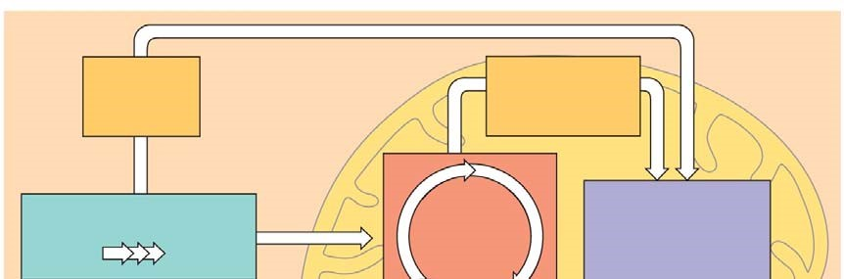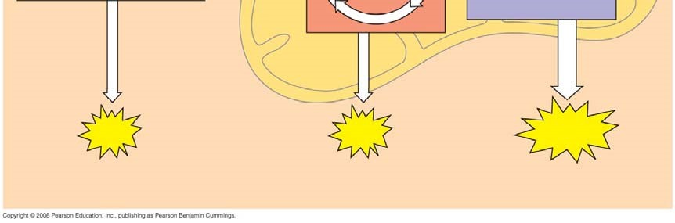

- Three types of phosphorylation (adding a phosphate) are covered in the text, and two of these occur in cellular respiration. Explain how the electron transport chain is utilized in oxidative phosphorylation.

- The second form of phosphorylation is substrate level. Label the figure below to show the direct transfer of a phosphate from a substrate to ADP to form ATP.
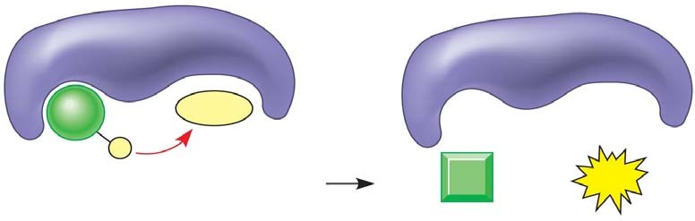

Concept 9.2 Glycolysis harvests chemical energy by oxidizing glucose to pyruvate
- Why is glycolysis an appropriate term for this step of cellular respiration?

- The starting product of glycolysis is the six-carbon sugar ________________, and the ending product is two ____________ carbon compounds termed ____________________.
- The ten individual steps of glycolysis can be divided into two stages: energy investment and energy payoff. Label the energy investment stage below; then use Figure 9.9 to find the two specific stages where ATP is used.
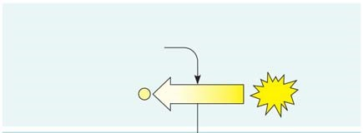

- The second step in glycolysis is the energy payoff phase. Label this stage. Note that it provides both ATP and NADH. Look at Figure 9.9 to locate the two stages where ATP is formed and the one stage where NADH is formed.
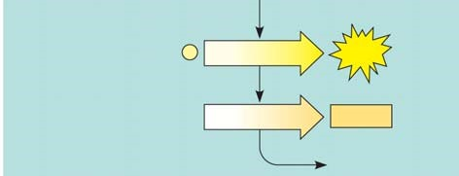

- This final figure shows the net gain of energy for the cell after glycolysis. Most of the energy is still present in the two molecules of pyruvate. Fill in the chart below and show the net energy gains.

- Notice that glycolysis occurs in the ____________________ of the cell. What is the relationship concerning glycolysis and oxygen?

Concept 9.3 The citric acid cycle completes the energy-yielding oxidation of organic molecules
- To enter the citric acid cycle, pyruvate must enter the mitochondria by active transport. Three things are necessary to convert pyruvate to acetyl CoA. Complete the missing parts of the chart below and then explain the three steps in the conversion process.

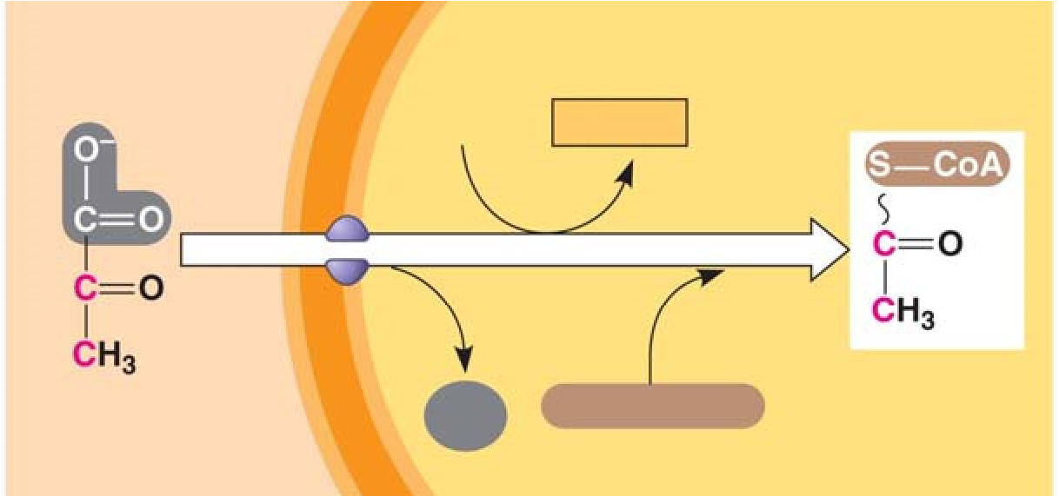

(1)
(2)
(3)
- How many times does the citric acid cycle occur for each molecule of glucose?

- Use Figure 9.11 to help you answer the following summary questions about the citric acid cycle:

  - How many NADHs are formed?

  - How many total carbons are lost as pyruvate is oxidized?

  - The carbons have been lost in the molecule __________ __________ .

  - How many FADH₂ have been formed?

  - How many ATPs are formed?

- The diagram covers only one pyruvate, although two pyruvates are formed from a single glucose. How many molecules of the following are formed from the breakdown of glucose?

  - NADH = __________

  - FADH₂ = __________

  - ATP = __________

- The step that converts pyruvate to acetyl CoA at the top of the diagram also occurs twice per glucose. This step accounts for two additional reduced ____________ molecules and two carbon dioxide molecules.
- Explain what has happened to the six-carbon molecules found in the original glucose molecule.

Concept 9.4 During oxidative phosphorylation, chemiosmosis couples electron transport to ATP synthesis

- Oxidative phosphorylation involves two components: the electron transport chain and ATP synthesis.
Referring to Figure 9.13, notice that each member of the electron transport chain is lower in free __________ than the preceding member of the chain, but higher in _______________. The molecule at zero free energy, which is __________, is lowest of all the molecules in free energy and highest in electronegativity.
- Explain why oxygen is the ultimate electron acceptor. Oxygen stabilizes the electrons by combining with two hydrogen ions to form what compound?

- The two electron carrier molecules that feed electrons into the electron transport system are
________________ and __________________.
- Using Figure 9.14, explain the overall concept of how ATP synthase uses the flow of hydrogen ions to produce ATP.

- What is the role of the electron transport chain in forming the H⁺ gradient across the inner mitochondrial membrane?

- Two key terms are chemiosmosis and proton-motive force. Relate both of these terms to the process of oxidative phosphorylation.

- Figure 9.16 is a key to understanding the production of ATP in the mitochondria. In the figure below, label all locations and molecules. Then use one color to trace the flow of electrons and another color to show the flow of protons.
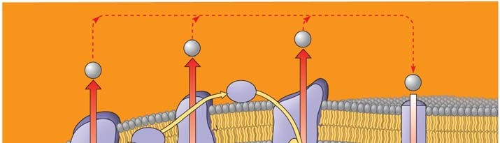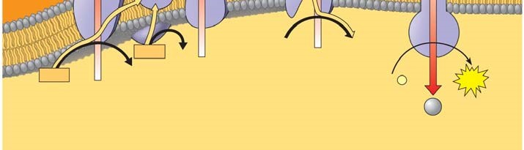

- At this point, you should be able to account for the total number of ATPs that could be formed from a glucose molecule. To accomplish this, we have to add the substrate-level ATPs from glycolysis and the citric acid cycle to the ATPs formed by chemiosmosis. Each NADH can form a maximum of ________ ATP molecules. Each FADH₂, which donates electrons that activate only two proton pumps, makes _____ ATP molecules.
- Use the figure to account for all the ATP molecules formed during cellular respiration. Use the text to be sure you understand how each subtotal on the bar below the figure is reached.

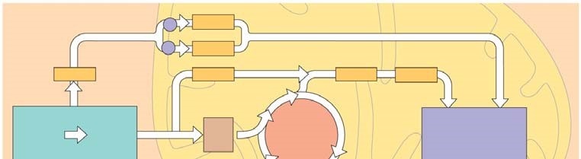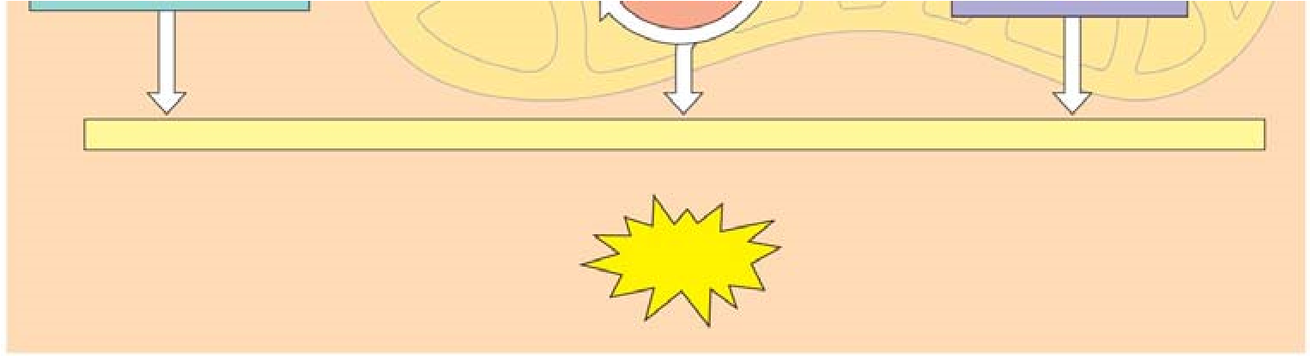

- Why is the total count about 36 or 38 ATP molecules rather than a specific number?

Concept 9.5 Fermentation enables some cells to produce ATP without the use of oxygen
- Fermentation allows for the production of ATP without using either __________ or any ___________
______________________________.

- For aerobic respiration to continue, the cell must be supplied with oxygen—the ultimate electron acceptor. What is the electron acceptor in fermentation?

- Explain how alcohol fermentation starts with glucose and yields ethanol. Be sure to stress how NAD⁺ is recycled.

- Explain how lactic acid fermentation starts with glucose and yields lactate. Be sure to stress how NAD⁺ is recycled.

- Using Figure 9.19 as a guide, draw and explain why pyruvate is a key juncture in metabolism.

Concept 9.6 Glycolysis and the citric acid cycle connect to many other metabolic pathways
- What three organic macromolecules are often utilized to make ATP by cellular respiration?

- Explain the difference in energy usage between the catabolic reactions of cellular respiration and anabolic pathways of biosynthesis.

- Explain how AMP stimulates cellular respiration while citrate and ATP inhibit it.

Testing Your Knowledge: Self-Quiz Answers
Now you should be ready to test your knowledge. Place your answers here:

1.______ 2.______ 3._______ 4.______ 5._______ 6._______ 7._______ 8.______ 9._______

AP BIOLOGY 2021-22 READING GUIDE

Chapter 10: Photosynthesis

This chapter is as challenging as the one you just finished on cellular respiration. However, conceptually it will be a little easier because the concepts learned in Chapter 9—namely, chemiosmosis and an electron transport system—will play a central role in photosynthesis.

1. As a review, define the terms autotroph and heterotroph. Keep in mind that plants have mitochondria and chloroplasts and do both cellular respiration and photosynthesis!

Concept 10.1 Photosynthesis converts light energy to the chemical energy of food

- Take a moment to place the chloroplast in the leaf by working through Figure 10.3. Draw a picture of the chloroplast and label the stroma, thylakoid, thylakoid space, inner membrane and outer membrane.

- Use both chemical symbols and words to write out the formula for photosynthesis (use the one that indicates only the net consumption of water). The formula is the opposite of cellular respiration. You should know both formulas from memory.

- Using ¹⁸O as the basis of your discussion, explain how we know that the oxygen released in photosynthesis comes from water.

- Photosynthesis is not a single process, but two processes, each with multiple steps.

  - Explain what occurs in the light reactions stage of photosynthesis. Be sure to use NADP⁺ and photophosphorylation in your discussion.

  - Explain the Calvin cycle, utilizing the term carbon fixation in your discussion.

- The details of photosynthesis will be easier to organize if you can visualize the overall process. Label Figure 10.5, below. As you work on this, underline the items that are cycled between the light reactions and the Calvin cycle.

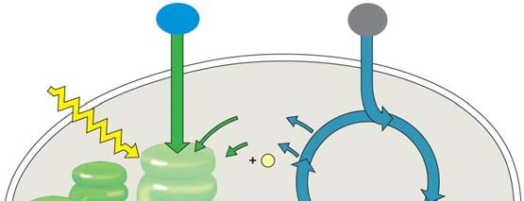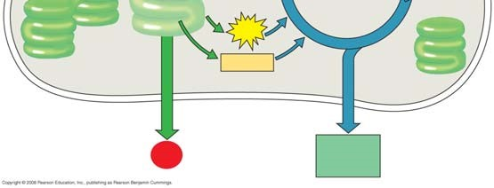

Concept 10.2 The light reactions convert solar energy to the chemical energy of ATP and NADPH
This is a long and challenging concept. Take your time, work through the questions, and realize that this is the key concept for photosynthesis.

- Some of the types of energy in the electromagnetic spectrum will be familiar, such as X-rays, microwaves, and radio waves. The most important part of the spectrum in photosynthesis is visible light. What are the colors of the visible spectrum?

Notice the colors and corresponding wavelengths and then explain the relationship between wavelength and energy.

- Read Figure 10.9 carefully; then explain the correlation between an absorption spectrum and an action spectrum.

- Describe how Englemann was able to form an action spectrum long before the invention of a spectrophotometer.

- A photosystem is composed of a protein complex called a ___________-__________ complex surrounded by several __________-____________ complexes.

- Within the photosystems, the critical conversion of solar energy to chemical energy occurs. This process is the essence of being a producer! Using Figure 10.12 as a guide, label the diagram and then explain the role of the terms in the photosystem.

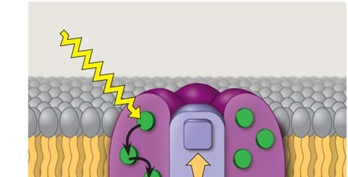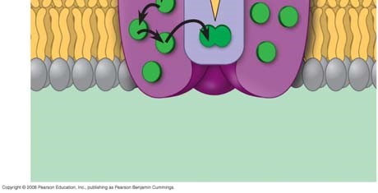

  - Reaction center complex—

  - Light-harvesting complex—

  - Primary electron acceptor—

- Photosystem I is referred to by the wavelength at which its reaction center best absorbs light, or
P__________; photosystem II is also known by this characteristic, or P__________.

- Linear electron flow is, fortunately, easier than it looks. It is an electron transport chain, somewhat like the one we worked through in cellular respiration. While reading the section “Linear Electron Flow,” label the diagram number by number as you read.

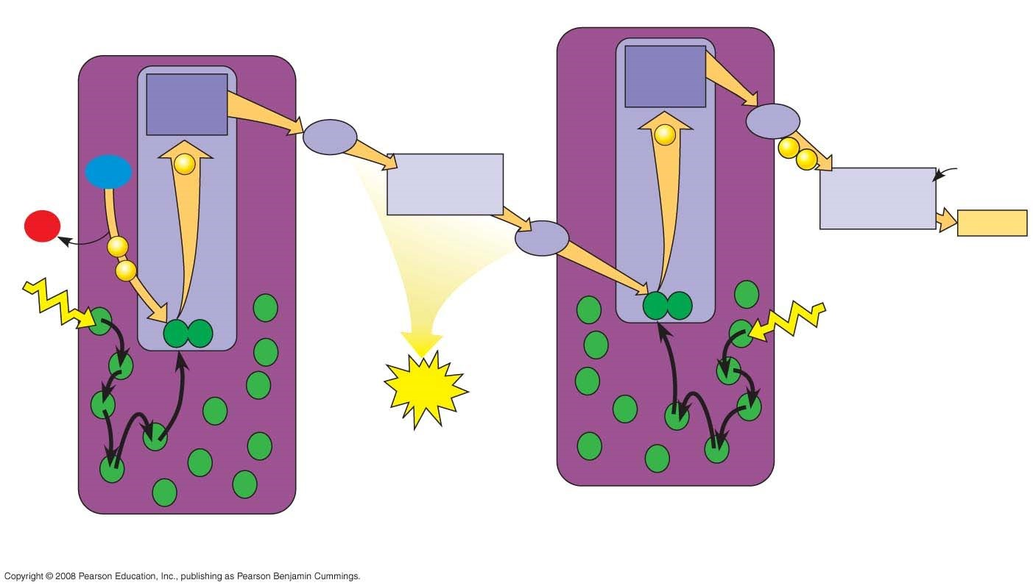

- The following set of questions deal with linear electron flow:

    - What is the source of energy that requires the electron in photosystem II?

    - What compound is the source of electrons for linear electron flow? This compound is also the source of ___________ in the atmosphere.
    - As electrons fall between photosystem I and II, the cytochrome complex uses the energy to pump ________ ions. This builds a proton gradient that is used in chemiosmosis to produce
what?

    - In photosystem II, the excited electron is eventually used by NADP⁺ reductase to join
NADP⁺ and a H⁺ to form ___________.

* Notice that two high-energy compounds have been produced by the light reactions: ATP and NADPH. Both compounds will be used in the Calvin cycle.

- Cyclic electron flow can be visualized in Figure 10.15. Cyclic electron flow is thought to be similar to the first forms of photosynthesis to evolve. In cyclic electron flow no water is split, there is no production of __________, and there is no release of __________.

- The last idea in this challenging concept is how chemiosmosis works in photosynthesis. Use four examples to compare how chemiosmosis is similar in photosynthesis and cellular respiration.

- Use two key differences to explain how chemiosmosis is different in photosynthesis and cellular respiration. (These two questions are another example of compare and contrast.)

- Label all the locations in the diagram first. Next, follow the steps in linear electron flow to label the components of the light reactions in chemiosmosis.
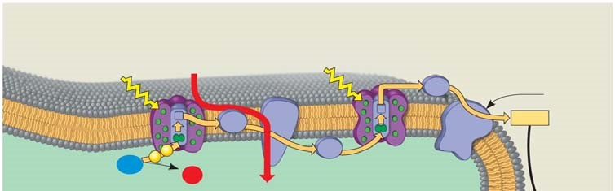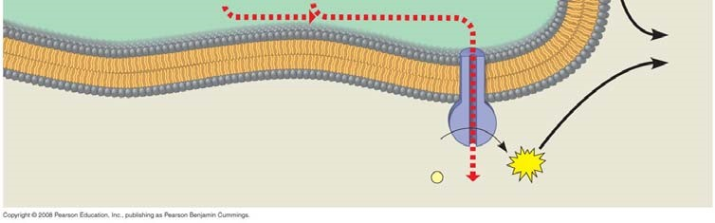

- List the three places in the light reactions where a proton-motive force is generated.

- As a review, note that the light reactions store chemical energy in __________ and __________, which shuttle the energy to the carbohydrate-producing __________ cycle.

Concept 10.3 The Calvin cycle uses ATP and NADPH to convert CO₂ to sugar
The Calvin cycle is a metabolic pathway in which each step is governed by an enzyme, much like the citric acid cycle from cellular respiration. However, keep in mind that the Calvin cycle uses energy (in the form of ATP and NADPH) and is therefore anabolic; in contrast, cellular respiration is catabolic and releases energy that is used to generate ATP and NADH.

- The carbohydrate produced directly from the Calvin cycle is not glucose, but the three-carbon compound __________________________. Each turn of the Calvin cycle fixes one molecule of CO₂; therefore, it will take ___________ turns of the Calvin cycle to net one G3P.

- Explain the important events that occur in the carbon fixation stage of the Calvin cycle.

- The enzyme responsible for carbon fixation in the Calvin cycle, and possibly the most abundant protein on Earth, is __________________.

- In phase two, the reduction stage, the reducing power of _________________ will donate electrons to the low-energy acid 1,3-bisphosphoglycerate to form the three-carbon sugar
_________________________.

- Examine Figure 10.18 while we tally carbons. This figure is designed to show the production of one net G3P. That means the Calvin cycle must be turned three times. Each turn will require a starting molecule of ribulose bisphosphate, a five-carbon compound. This means we start with __________ carbons distributed in three RuBPs. After fixing three carbon dioxides using the enzyme _______________, the Calvin cycle forms six G3Ps with a total of _________ carbons. At this point the net gain of carbons is _________, or one net G3P molecule.

- Three turns of the Calvin cycle net one G3P because the other five must be recycled to RuBP. Explain how the regeneration of RuBP is accomplished.

- The net production of one G3P requires __________ molecules of ATP and __________ molecules of NADPH.

Concept 10.4 Alternative mechanisms of carbon fixation have evolved in hot, arid climates
- Explain what is meant by a C₃ plant.

- What happens when a plant undergoes photorespiration?

- Explain how photorespiration can be a problem in agriculture.

- Explain what is meant by a C₄ plant.

- Explain the role of PEP carboxylase in C₄ plants, including key differences between it and rubisco.

- Conceptually, it is important to know that the C₄ pathway does not replace the Calvin cycle but works as a CO₂ pump that prefaces the Calvin cycle. Explain how changes in leaf architecture help isolate rubisco in high CO₂ areas but low O₂ areas.

- Using Figure 10.19 as a guide, explain the three key events—indicated by the arrows below— in the C₄ pathway.

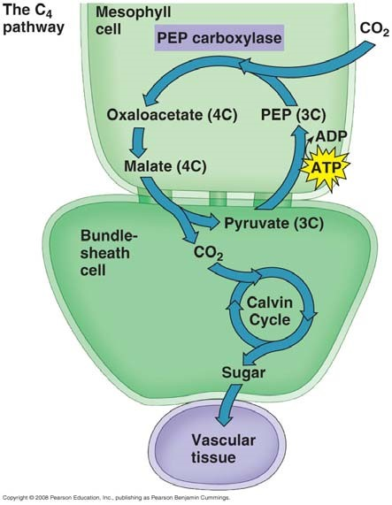

- Compare and contrast C₄ plants with CAM plants. In your explanation, give two key similarities and two key differences.

- Explain the statement that only the green cells of a plant are the autotroph while the rest of the plant is a heterotroph.

- Now that you have worked through the entire chapter, study Figure 10.21. Go back to the figure used in question 6. On the left side of that figure, list additional information for the light reactions; on the right side, summarize additional information for the Calvin cycle reactions. Finally, label this entire figure without looking back in your book! If you can do this, you understand the “big picture.”
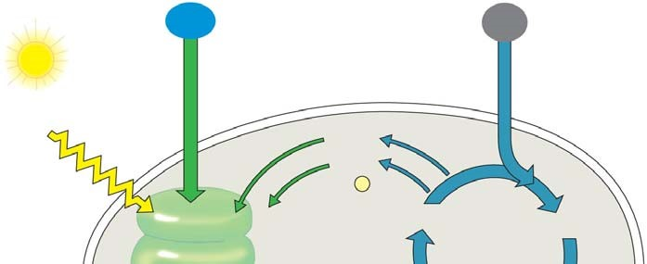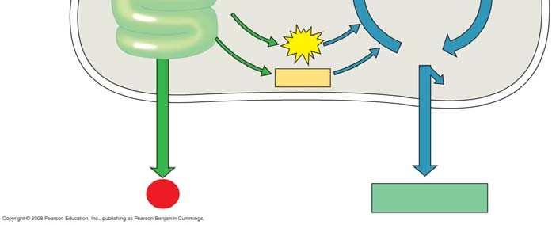
Testing Your Knowledge: Self-Quiz Answers
Now you should be ready to test your knowledge. Place your answers here:

AP BIOLOGY 2021-22 LAB ACTIVITY 2

