AP BIOLOGY 2021-22 August 24, 2021

Today’s Agenda (Day 5)

- Housekeeping Items
REQUEST FOR ITEMS: a) balloons
- Homework Check:

- Class Activity:
DISCUSS: Marshmallow Challenge
BEGIN: Chapter 1 PPT Review

HOMEWORK:
- READ: Chapters 1 – 3
- COMPLETE: Chapter 1 Reading Guide – see p. 8 of document
- COMPLETE: Lung Capacity Lab – use Lab Report Template

Chapter 1 Vocabulary
Adaptive radiation | Archaea | Bacteria | Bioinformatics | Biology | Biosphere
Community | Consumer | Controlled experiment | Deductive reasoning | Dependent variable | DNA
Domains | Ecosystem | Emergent property | Eukarya | Eukaryotic cell | Evolution
Experiment | Feedback regulation | Gene expression | Genes | Genome | Genomics
Hypothesis | Independent variables | Inductive reasoning | Inquiry | Model organism | Natural selection organisms
Population | Producer | Prokaryotic cell | Proteome | Proteomics | Qualitative data
Quantitative data | Systems biology | Technology | theory

Chapter 2 Vocabulary
Anion | Atom | Atomic mass | Atomic nucleus | Atomic number | Balance
Cation | Chemical bonds | Chemical equilibrium | Compound | Dalton | Double bond
Electron shells | Electronegativity | Electrons | Element | Energy | Essential elements
Half-life | Hydrogen bond | Ionic compound/salts | Ionic bond | Ion | Isotope
Mass number | Matter molecule | Neutron | Nonpolar covalent bond | Covalent bond | Orbital
Polar covalent bond | Potential energy | Product | Proton | Radioactive isotope | Radiometric dating
Reactant | Single bond | Trace elements | Valence electrons | Valance shell | Van der Waals interactions

REMINDERS:
- Chapter 1 Reading Guide – Tuesday, Aug. 24
- Lab Report: Lung Capacity – Wed, Aug. 25
- Chapter 2 Reading Guide – Tuesday, Aug. 30
- QUIZ: Ch 1 & 2 Vocabulary August 31
- TEST: Ch 1 & 2 Sept. 1

AP BIOLOGY 2021-22 ACTIVITY

Marshmallow Challenge- Analysis
After completing the challenge, reflect on what your group accomplished, watch the video (http://marshmallowchallenge.com/TED_Talk.html) and answer the questions below:

- In your own words, describe what you think was the purpose of this activity. Elaborate on your answer.

- Create a timeline of 18 minutes showcasing what you spent your time doing. Ex. orient, plan, build, ta-da!.

- Was your group more like the recent business school graduates or the kindergarten school graduates? Explain.

- What was your tower’s height? _____ cm. The average height for this experiment is 20inches. How many cm’s is that? _____. How does your height compare to the average height?

- During the presentation, the speaker goes over different skill sets, which skill set is your group most like?

- Why do you think incentives initially decreased the amount of groups who were able to complete the challenge?

- What did your group do really well? Elaborate.

- If you could do this challenge over again, what would you do differently? Elaborate.

- What did you learn about your group members AND yourself?

- When thinking about how you approached and completed this project, compare and contrast it to the standard scientific method.

AP BIOLOGY 2021-22 LAB ACTIVITY

Lung Capacity Lab

The amount of air that you move in and out of your lungs while breathing normally is called TIDAL VOLUME. This amount of air provides enough oxygen for a person who is resting. It is possible to inhale and exhale more forcefully - the maximum amount of air moved in and out of the lungs is called the VITAL CAPACITY. In this activity, you will be measuring the vital capacity and the tidal volume of your own lungs, this actual number can then be compared with a number derived from an equation that measures vital capacity. In effect, you are measuring an actual number, based on laboratory measurements, to a theoretical number, based on an equation. If you have any breathing difficulties (asthma or other condition), you should not participate in this activity, instead only take the data on your lab partner or group.

Procedure:
1. Measuring Tidal Volume -- Stretch a round balloon several times to stretch it out. Inhale normally and then exhale normally into the balloon. Do not force your breathing. Pinch the end of the balloon and measure its diameter (in cm). Repeat this so that you have 3 total measurements and can take the average and record in the data table.
2. Measuring Vital Capacity - Repeat the procedure, only this time inhale as much air as you can and exhale forcefully. Record the measurements in the data table.
3. Convert the diameters to a volume using the graph and record this in your table.
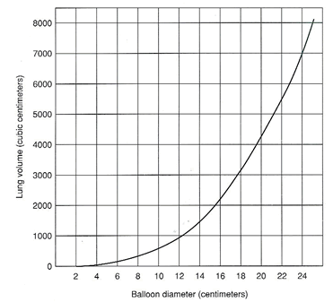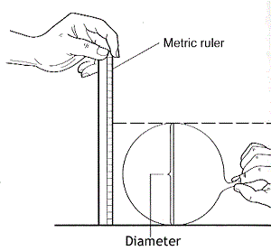
4. Estimated Vital Capacity
Research has shown that the capacity of a person's lungs is proportional to the surface area of his or her body. To find the surface area, you will need to know your height and weight. There are a couple of different ways to calculate your body surface area mathematically. Use the equation provided below.
BSA=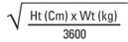 Show Calculations:
** 1lb = .453592kg**
Height (cm)
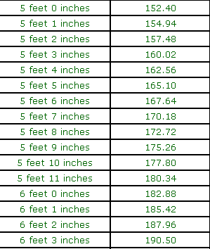

Once you have calculated your surface area, a second equation will calculate your estimated vital capacity.
Males: SA x 2500 Females SA x 2000

Show Calculations:

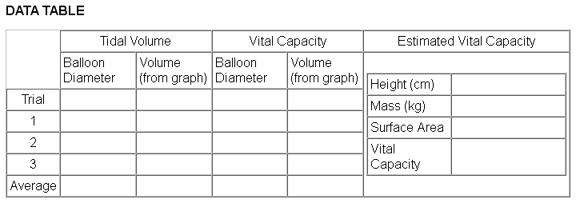
ANALYSIS
1. Why is it important to measure tidal volume and vital capacity three times and then get an average?
2. Compare your data to other members of the class. How can you account for differences? List at least 3.

3. How does your measured vital capacity compare to the vital capacity you estimated using the formula? Which do you think is more accurate and why?

4. How might an athlete's vital capacity compare to a non-athlete? Explain your reasoning.
5. Is this a valid experiment? Why or Why not.

APPLICATION
1. Examine the data table of a person who entered into a training program. This person's vital capacity was measured over a 60 day period. Use the data to construct a graph. Make sure you label your graph correctly.
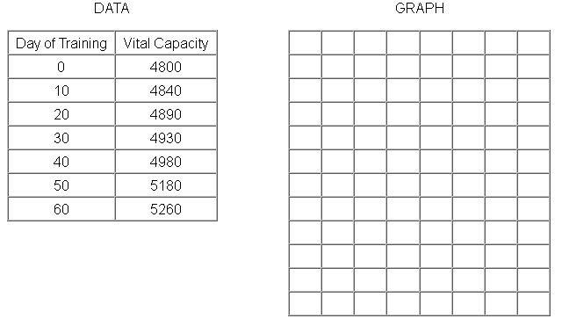

2. What happened to the person's vital capacity over the course of the training period?

3. What probably caused the change?

4. How might vital capacity be important to a musician?

LAB WRITE-UP TEMPLATE

I. Title: Lab Report Procedure

II. Purpose or Question: to inform students of the appropriate format for writing lab
Reports. How is a lab report written?

III. Materials:
notebook paper graph paper
metric ruler pencils (for most work)
calculator colored pens (optional)

IV. Procedure: written in outline to summarize steps actually conducted:
A. All labs are assigned in advance and are expected to be read and prepared before class.

B. The first sections of the lab reports are written in class to document the observations of experiments during class.

C. All data are to be recorded at the time of observation. Scratch paper or recopied data tables are not acceptable.

D. Lab reports are due within one week of completing the lab. Lab reports that are more than one week late will NOT receive credit.

V. Data: an objective record of what is observed directly, usually in the form of a data table or diagram. The data may be expanded by analysis with calculations or a graph, but it should be noted as an extension, not an observation.

IV. Discussion: This section includes the interpretation of what was observed and recorded in section V, the data. It should include a thorough explanation of the data, not just a restatement of it. Why did you see what you saw? It also includes any questions that are a part of the procedure in the experiment, as well as the application of what was observed to any other type of experiment or to the information in your text. Does anything that you observed make you curious about another type of experiment? What is your next question? Have you collaborated with your colleagues on any of the ideas? Have you cited evidence for your ideas from any of your colleagues? The discussion is usually the longest part of the lab report. It is written in complete sentences and proper paragraph structure.

VII. Conclusion: the conclusion is usually one sentence to summarize the report and to answer any question posed in the purpose:

**Students now have the information to write lab reports in an acceptable format.**

AP BIOLOGY 2021-22 READING GUIDE

Chapter 1: Introduction: Themes in the Study of Life

Begin your study of biology this year by reading Chapter 1. It will serve as a reminder about biological concepts that you may have learned in an earlier course and give you an overview of what you will study this year.

1. In the overview, Figure 1.3 recalls many of the properties of life. Label the seven properties illustrated here and give a different example of each.
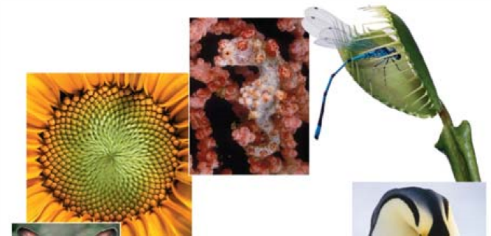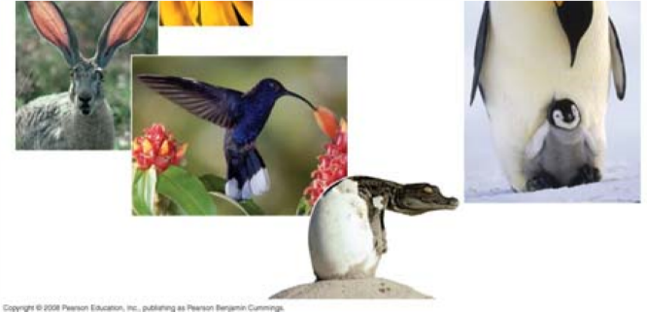

Concept 1.1 Themes connect the concepts of biology

- What are emergent properties? Give two examples.

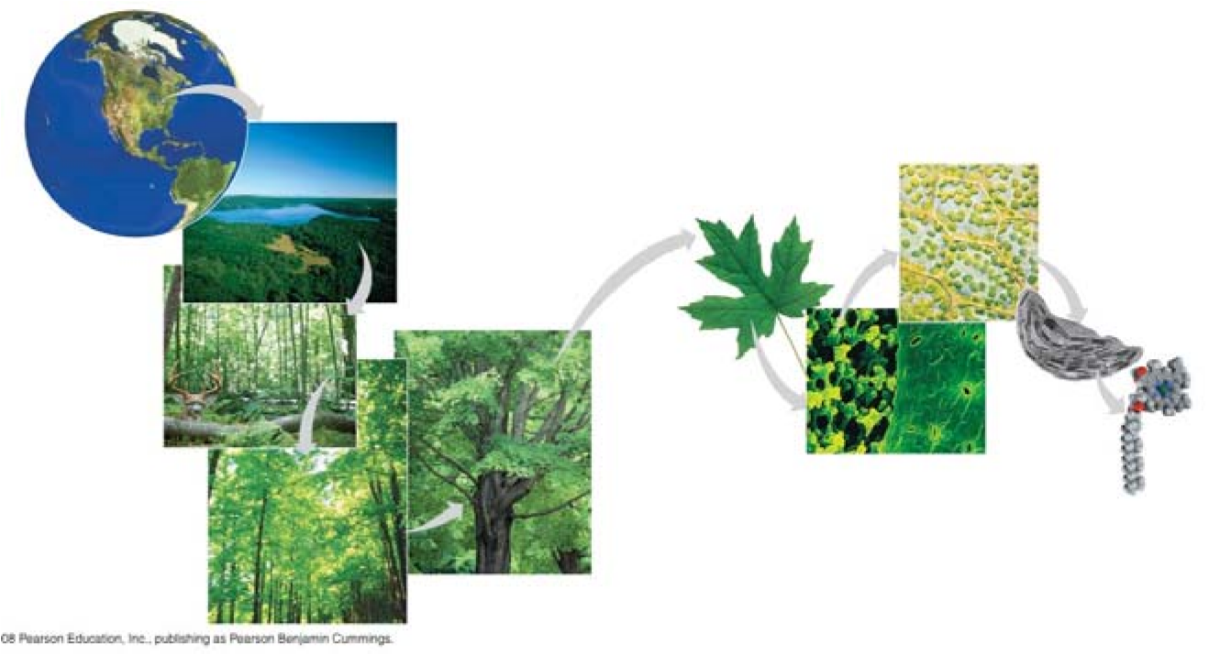

- Life is organized on many scales. Figure 1.4 (see above) zooms you in from viewing Earth from space all the way to the level of molecules. As you study this figure, write in a brief definition of each level.

biosphere ecosystem community population organism organs organ systems tissues cells organelles molecules

- Our study of biology will be organized around recurring themes. Make a list here of the themes that are presented and give an example that illustrates each theme. Watch for these themes throughout your study this entire year. This will help you see the big picture and organize your thinking. (Go to the Summary of Key Concepts at the end of the chapter for a concise look at the themes.)

Theme 1 | Example
Theme 2:
Theme 3:
Theme 4:
Theme 5:
Theme 6:
Theme 7: (Find it in 1.2.)

- As you read this section, you will be reminded of things you may have studied in an earlier course. Since this material will be presented in detail in future chapters, you will come back to these ideas, so don’t fret if some of the concepts presented are unfamiliar. However, to guide your study, define each of the terms in bold as you come to them.

eukaryotic cell prokaryotic cell
DNA
genes genome negative feedback/positive feedback

Concept 1.2 The Core Theme: Evolution accounts for the unity and diversity of life
6. Life is organized into groups. Study Figure 1.14.

- Which level contains the greatest diversity of organism?

- The least?

- Write out the levels of organization in order.
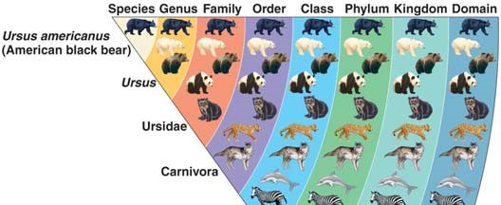
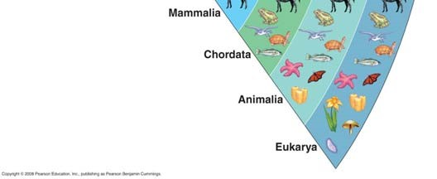

- Most people use a mnemonic device to remember these levels. If you have one, write it here.

- Taxonomy is the branch of biology that names and classifies organisms. Because of new molecular information, there have been many changes in placement of certain groups in recent years. Notice that all life is now organized in your text into 3 domains rather than the 5 kingdoms you may have learned earlier. Put the kingdoms mentioned in the text in the space above the proper domain names shown here.

Bacteria Archaea Eukarya

- What two main points were articulated in Darwin’s The Origin of Species?

- What did Darwin propose as the mechanism of evolution? Summarize this mechanism.

- Study Figure 1.22, which shows an evolutionary “tree.” What is indicated by each twig? What do the branch points represent? Where did the “common ancestor” of the Galápagos finches originate?
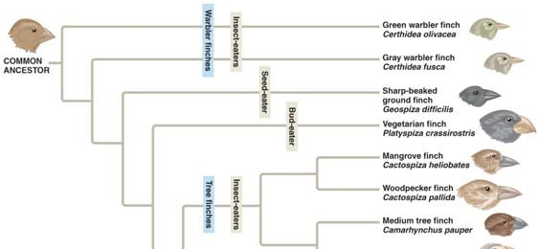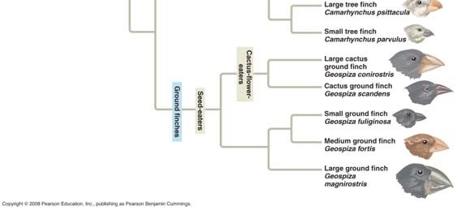

Concept 1.3 Scientists use two main forms of inquiry in their study of nature

- What are the two main types of scientific inquiry? Give an example of each.

- What is data?

- Distinguish between quantitative and qualitative data. Which type would be presented in a data chart and could be graphed? Which type is found in the field sketches made by Jane Goodall?

- In science, how do we define hypothesis?

- A scientific hypothesis has two important qualities. The first is that it is testable. What is the second?

- Are scientific hypotheses proved? Explain your answer!

- Look at Figure 1.24. Use it to write a hypothesis using the “If . . . then . . .” format.

- What is a controlled experiment?

- The text points out a common misconception about the term “controlled experiment”. In the snake mimicry experiment, what factors were held constant?

- Why are supernatural explanations outside the bounds of science?

- Explain what is meant by a scientific theory by giving the three ways your text separates a theory from a hypothesis or mere speculation.

1.

2.

3.

Testing Your Knowledge: Self-Quiz Answers
Now you should be ready to test your knowledge. Place your answers here:

AP BIOLOGY 2021-22 READING GUIDE

Chapter 2: The Chemical Context of Life

This chapter covers the basics that you may have learned in your chemistry class. Whether your teacher goes over this chapter or assigns it for you do review on your own, the questions that follow should help you focus on the most important points.

Concept 2.1 Matter consists of chemical elements in pure form and in combinations called compounds

1. Define and give an example of the following terms:

Define Example

matter

element

compound
- What four elements make up 96% of all living matter?

- What is the difference between an essential element and a trace element?
essential element

trace element

Concept 2.2 An element’s properties depend on the structure of its atoms

- Sketch a model of an atom of helium, showing the: electrons, protons, neutrons, and atomic nucleus.

- What is the atomic number of helium? _________ Its atomic mass? ________

- Here are some more terms that you should firmly grasp. Define each term: neutron, proton, electron, atomic number, atomic mass, isotope, electron shells , energy

- Consider this entry in the periodic table for carbon: C⁶ ₁₂

What is the atomic mass? ______ atomic number? _______

How many electrons does carbon have? _______ neutrons? _______

- Which is the only subatomic particle that is directly involved in the chemical reactions between atoms?

- What is potential energy?

- Explain which has more potential energy in each pair:

  - boy at the top of a slide/boy at the bottom

  - electron in the first energy shell/electron in the third energy shell

  - water/glucose

- What determines the chemical behavior of an atom?

- Here is an electron distribution diagram for sodium:

  - How many valence electrons does it have? ______ Circle the valence electron(s).

  - How many protons does it have? ______
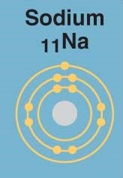

Concept 2.3 The formation and function of molecules depend on chemical bonding between atoms
- Define molecule.

- Now, refer back to your definition of a compound and fill in the following chart:

 | Molecule? (y/n) | Compound? (y/n) | Molecular Formula | Structural Formula
Water
Carbon dioxide
Methane
O₂ |  |  | O₂

- What type of bond is seen in O₂? Explain what this means.

- What is meant by electronegativity?

- Explain the difference between a nonpolar covalent bond and a polar covalent bond.

- Make an electron distribution diagram of water. Which element is most electronegative? Why is water considered a polar molecule? Label the regions that are more positive or more negative. (This is a very important concept. Spend some time with this one!)

- Another bond type is the ionic bond. Explain what is happening in the figure below (2.14):
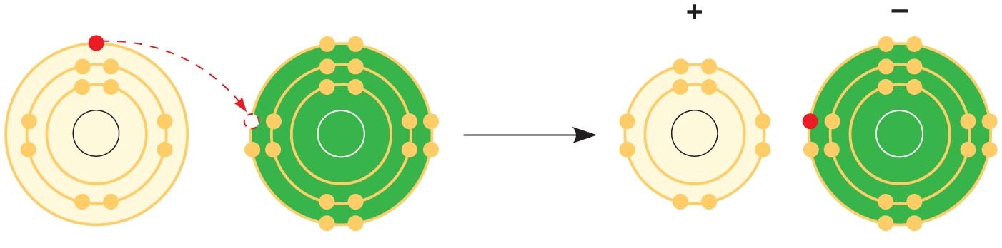
- What two elements are involved above?

- Define anion and cation. In the preceding example, which is the anion?

- What is a hydrogen bond? Indicate where the hydrogen bond occurs in this figure.
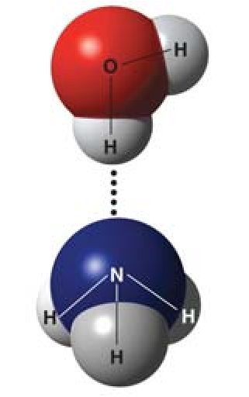

- Explain van der Waals interactions. Though they represent very weak attractions, when these interactions are numerous they can stick a gecko to the ceiling!

- Here is a list of the types of bonds and interactions discussed in this section. Place them in order from the strongest to the weakest: hydrogen bonds, van der Waals interactions, covalent bonds, ionic bonds.

STRONG

WEAK

25. Use morphine and endorphins as examples to explain why molecular shape is crucial in biology.

Concept 2.4 Chemical reactions make and break chemical bonds
- Write the chemical shorthand equation for photosynthesis. Label the reactants and the products.

- For the equation you just wrote, how many molecules of carbon dioxide are there? _____

How many molecules of glucose? _________ How many elements in glucose? _________

- What is meant by dynamic equilibrium? Does this imply equal concentrations of each reactant and product?

Testing Your Knowledge: Self-Quiz Answers
Now you should be ready to test your knowledge. Place your answers here:

