AP BIOLOGY 2021-22 November 3, 2021

Today’s Agenda (Day 49)

- Housekeeping Items

- Homework Check:
Daily Videos 3.1 – 3.7
LAB REPORT: Osmosis & Diffusion 1

- Class Activity:
CONT’D: Chapter 9 PPT Review
- Section 9.2 – Glycolysis harvests chemical energy
- Section 9.3 – Citric acid cycle
- Section 9.4 – Oxidative phosphorylation & chemiosmosis
- Section 9.5 – Fermentation & anaerobic respiration
- Section 9.6 – Connecting to other metabolic pathways

WEEK of Nov. 8: LAB: Osmosis and Diffusion (Part 2)

HOMEWORK:
- READ: Chapters 6 – 10
- STUDY: Ch 9 Test

REMINDERS:
- LAB REPORT: Osmosis & Diffusion 1 – Nov. 3
- READING GUIDE: Ch 9 – Nov. 5
- TEST: Chapter 9 Nov. 9

AP BIOLOGY 2021-22 READING GUIDE

Chapter 9: Cellular Respiration: Harvesting Chemical Energy

Overview: Before getting involved with the details of cellular respiration and photosynthesis, take a second to look at the big picture. Photosynthesis and cellular respiration are key ecological concepts involved with energy flow. Use Figure 9.2 to label the missing parts below.

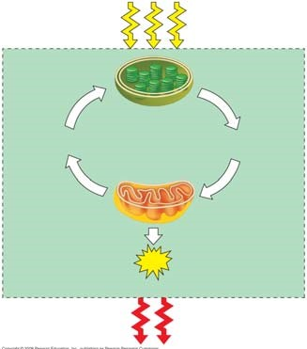

Concept 9.1 Catabolic pathways yield energy by oxidizing organic fuels

- Explain the difference between fermentation and cellular respiration.

- Give the formula (with names) for the catabolic degradation of glucose by cellular respiration.

- Both cellular respiration and photosynthesis are redox reactions. In redox, reactions pay attention to the flow of electrons. What is the difference between oxidation and reduction?

- The following is a generalized formula for a redox reaction:

Xe– + Y Æ X + Ye–
Draw an arrow showing which part of the reaction is oxidized and which part is reduced.
___________ is the reducing agent in this reaction, and __________ is the oxidizing agent.
- When compounds lose electrons, they _________ energy; when compounds gain electrons, they _________ energy.
- In cellular respiration, electrons are not transferred directly from glucose to oxygen. Each electron is coupled with a proton to form a hydrogen atom. Following the movement of hydrogens allows you to follow the flow of electrons. The hydrogens are held in the cell temporarily by what electron carrier?

What is a coenzyme? (If you have forgotten, look back to a few pages in Chapter 8.)

- What is the function of the electron transport chain in cellular respiration?

- Show the normal, downhill route most electrons follow in cellular respiration:

Glucose ______________________ ____________________ oxygen

- Understanding the overall map of how cellular respiration works will make the details easier to learn. Use Figure 9.2 to label the missing information in the figure below.

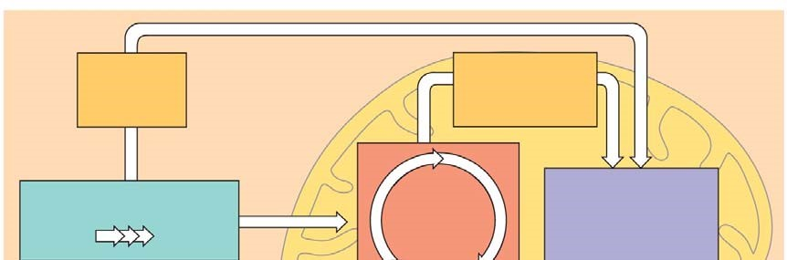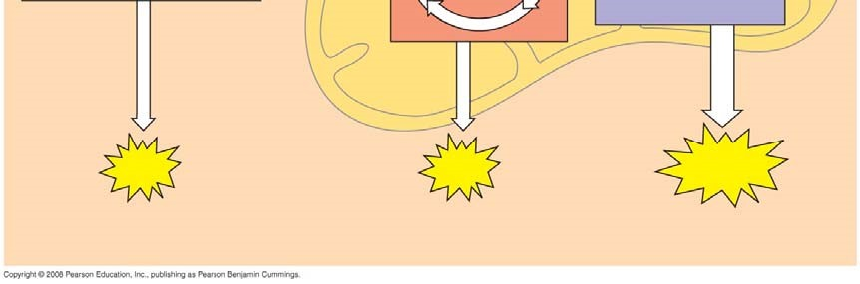

- Three types of phosphorylation (adding a phosphate) are covered in the text, and two of these occur in cellular respiration. Explain how the electron transport chain is utilized in oxidative phosphorylation.

- The second form of phosphorylation is substrate level. Label the figure below to show the direct transfer of a phosphate from a substrate to ADP to form ATP.
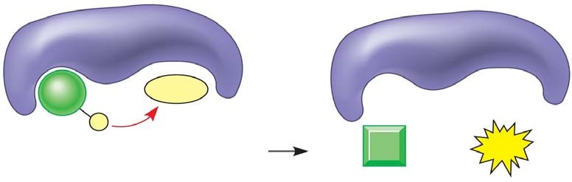

Concept 9.2 Glycolysis harvests chemical energy by oxidizing glucose to pyruvate
- Why is glycolysis an appropriate term for this step of cellular respiration?

- The starting product of glycolysis is the six-carbon sugar ________________, and the ending product is two ____________ carbon compounds termed ____________________.
- The ten individual steps of glycolysis can be divided into two stages: energy investment and energy payoff. Label the energy investment stage below; then use Figure 9.9 to find the two specific stages where ATP is used.
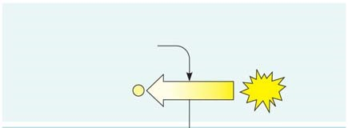

- The second step in glycolysis is the energy payoff phase. Label this stage. Note that it provides both ATP and NADH. Look at Figure 9.9 to locate the two stages where ATP is formed and the one stage where NADH is formed.
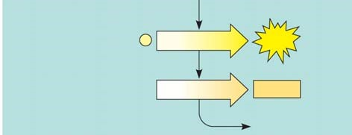

- This final figure shows the net gain of energy for the cell after glycolysis. Most of the energy is still present in the two molecules of pyruvate. Fill in the chart below and show the net energy gains.

- Notice that glycolysis occurs in the ____________________ of the cell. What is the relationship concerning glycolysis and oxygen?

Concept 9.3 The citric acid cycle completes the energy-yielding oxidation of organic molecules
- To enter the citric acid cycle, pyruvate must enter the mitochondria by active transport. Three things are necessary to convert pyruvate to acetyl CoA. Complete the missing parts of the chart below and then explain the three steps in the conversion process.

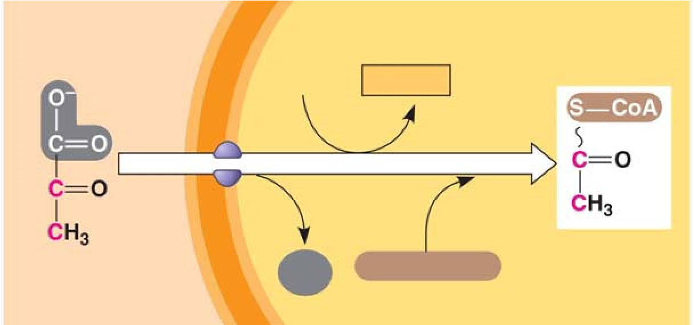

(1)
(2)
(3)
- How many times does the citric acid cycle occur for each molecule of glucose?

- Use Figure 9.11 to help you answer the following summary questions about the citric acid cycle:

  - How many NADHs are formed?

  - How many total carbons are lost as pyruvate is oxidized?

  - The carbons have been lost in the molecule __________ __________ .

  - How many FADH₂ have been formed?

  - How many ATPs are formed?

- The diagram covers only one pyruvate, although two pyruvates are formed from a single glucose. How many molecules of the following are formed from the breakdown of glucose?

  - NADH = __________

  - FADH₂ = __________

  - ATP = __________

- The step that converts pyruvate to acetyl CoA at the top of the diagram also occurs twice per glucose. This step accounts for two additional reduced ____________ molecules and two carbon dioxide molecules.
- Explain what has happened to the six-carbon molecules found in the original glucose molecule.

Concept 9.4 During oxidative phosphorylation, chemiosmosis couples electron transport to ATP synthesis

- Oxidative phosphorylation involves two components: the electron transport chain and ATP synthesis.
Referring to Figure 9.13, notice that each member of the electron transport chain is lower in free __________ than the preceding member of the chain, but higher in _______________. The molecule at zero free energy, which is __________, is lowest of all the molecules in free energy and highest in electronegativity.
- Explain why oxygen is the ultimate electron acceptor. Oxygen stabilizes the electrons by combining with two hydrogen ions to form what compound?

- The two electron carrier molecules that feed electrons into the electron transport system are
________________ and __________________.
- Using Figure 9.14, explain the overall concept of how ATP synthase uses the flow of hydrogen ions to produce ATP.

- What is the role of the electron transport chain in forming the H⁺ gradient across the inner mitochondrial membrane?

- Two key terms are chemiosmosis and proton-motive force. Relate both of these terms to the process of oxidative phosphorylation.

- Figure 9.16 is a key to understanding the production of ATP in the mitochondria. In the figure below, label all locations and molecules. Then use one color to trace the flow of electrons and another color to show the flow of protons.
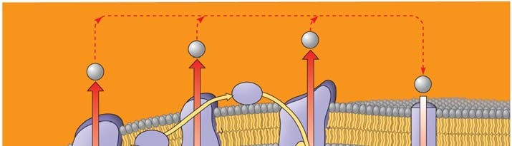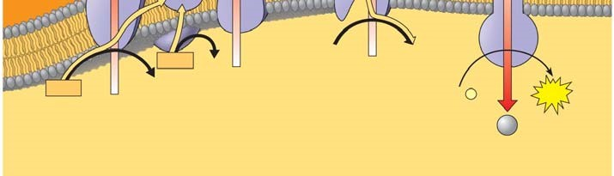

- At this point, you should be able to account for the total number of ATPs that could be formed from a glucose molecule. To accomplish this, we have to add the substrate-level ATPs from glycolysis and the citric acid cycle to the ATPs formed by chemiosmosis. Each NADH can form a maximum of ________ ATP molecules. Each FADH₂, which donates electrons that activate only two proton pumps, makes _____ ATP molecules.
- Use the figure to account for all the ATP molecules formed during cellular respiration. Use the text to be sure you understand how each subtotal on the bar below the figure is reached.

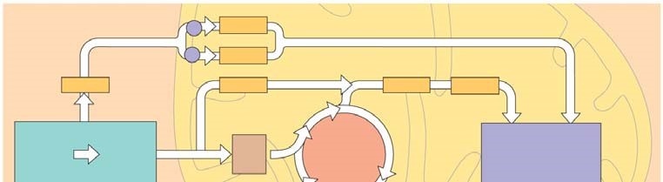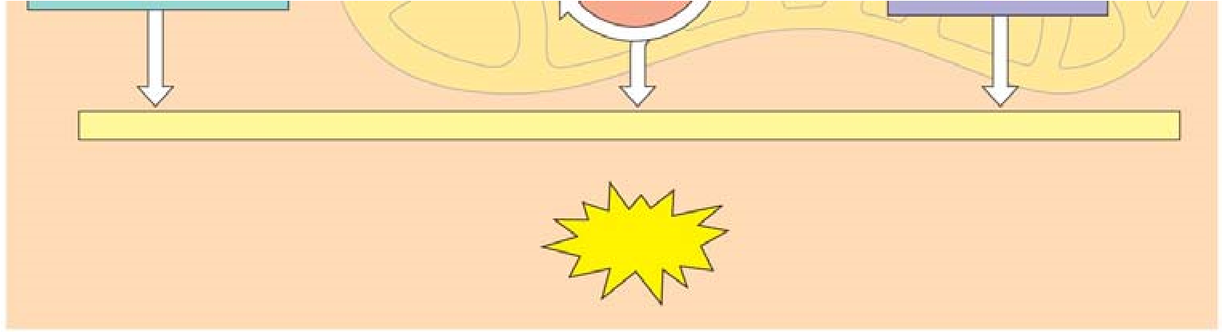

- Why is the total count about 36 or 38 ATP molecules rather than a specific number?

Concept 9.5 Fermentation enables some cells to produce ATP without the use of oxygen
- Fermentation allows for the production of ATP without using either __________ or any ___________
______________________________.

- For aerobic respiration to continue, the cell must be supplied with oxygen—the ultimate electron acceptor. What is the electron acceptor in fermentation?

- Explain how alcohol fermentation starts with glucose and yields ethanol. Be sure to stress how NAD⁺ is recycled.

- Explain how lactic acid fermentation starts with glucose and yields lactate. Be sure to stress how NAD⁺ is recycled.

- Using Figure 9.19 as a guide, draw and explain why pyruvate is a key juncture in metabolism.

Concept 9.6 Glycolysis and the citric acid cycle connect to many other metabolic pathways
- What three organic macromolecules are often utilized to make ATP by cellular respiration?

- Explain the difference in energy usage between the catabolic reactions of cellular respiration and anabolic pathways of biosynthesis.

- Explain how AMP stimulates cellular respiration while citrate and ATP inhibit it.

Testing Your Knowledge: Self-Quiz Answers
Now you should be ready to test your knowledge. Place your answers here:

1.______ 2.______ 3._______ 4.______ 5._______ 6._______ 7._______ 8.______ 9._______

AP BIOLOGY 2021-22 LAB ACTIVITY 1

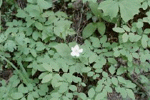

Biology

Biology Lab: AP Lab #4 - Osmosis

Biology Lab: Osmosis and Diffusion
Concept: Diffusion is the net movement of particles from a region where they are more concentrated to a region where they are less concentrated. You can demonstrate diffusion of molecules evaporating from a container of liquid through a gas by opening a bottle of perfume and moving to the other side of the room. After some time, you will smell the perfume.
Osmosis is the diffusion of water across a membrane which allows water molecules to pass but does not allow other particles to pass through. The solutions on either side of the membrane must have different concentrations. Then water will flow through the membrane to the side with the more concentrated solution to dilute it, so that both sides will eventually be in equilibrium.

Goal: To measure or observe diffusion and osmosis across different membranes by performing one of the following experiments.

Part A: Diffusion of cornstarch through a membrane

Materials
Iodine turns purple in the presence of starch. Lugol's solution (used in the AP version of this lab) is an iodine compound (IKI) which is very changes color in the presence of starches. In the absence of Lugol's solution, however, we can use a simple iodine formula -- but be sure that you obtain brown iodine, not clear, for this experiment. We need to use this color change to observe diffusion of starch and sugar through a membrane.
- Two jars for mixing solutions
- Two jars, bowls, or beakers large enough to hold a test tube or smaller jar upside down
- Two small jars or test tubes
- Eyedropper
- Iodine (brown, not clear!) IODINE IS POISONOUS. DO NOT TASTE IT. BROWN IODINE WILL STAIN, so take whatever precautions are necessary to avoid staining your clothes, your hands, or your work area.
- Cornstarch
- Distilled water
- A membrane: balloons, cellophane, dialysis tubing, sausage casings are all possibilities. Saran wrap is not permeable and won't work. If you can get dialysis tubing, cut it in 10cm strips and tie off the ends; you can use the tubing sections in place of the test tubes in the instructions below.
- Rubber bands

Procedure
- Soak your membrane in distilled water until it is soft and pliable.
- Prepare a dilute solution of iodine by mixing drops of iodine with one cup of water until the water is noticeably colored brown.
- Prepare a cornstarch solution by mixing 1/2 teaspoon cornstarch with a cup of water.
- Fill one of the test tubes (or dialysis tubing sections) with some of the iodine solution and use a rubber band to fasten your membrane over the end of the test tube. Fill one of the larger jars or beakers half-way with cornstarch solution and place your iodine-filled tube or jar upside down (so the membrane is in the cornstarch solution) in the larger jar.
- Fill the other small jar/tube with cornstarch solution, fasten the membrane over the end with the rubber band, and place it upside down in the larger jar/beaker. Fill the large jar with enough iodine solution to cover the membrane.
- Check your solutions after 1 minute, 5 minutes and 30 minutes. What do you observe?
- Try repeating the experiment with a different type of membrane.

Part B: Osmosis through a membrane

Materials
- Six membranes (see list in part A), softened by soaking in water for at least 30 minutes.
- If you are not using dialysis tubing, you will also need six test tubes capable of holding 25ml of solution.
- Sugar
- Large glass cup or beaker
- Six cups or beakers
- Kitchen scale accurate to .5 gm differences
- Rubber bands

Procedure
- Prepare the sugar solutions:
  - In the large glass cup or beaker, make 75 ml of 1.0M sucrose solution by adding 25.7g (.90 oz) of sugar to 75ml of distilled water.
  - Put 25 ml of this solution in the first test tube (or dialysis tubing section); label it 1.0M
  - Put 5ml of the sugar solution in the second test tube; add water to 25ml and label it .2M
  - Put 10ml of the sugar solution in the third test tube; add water to 25ml and label it .4M.
  - Put 15ml of the sugar solution in the fourth test tube; add water to 25ml and label it .6M
  - Put 20ml in the fifth test tube; add water to 25ml and label it .8M.
  - Put 25ml plain distilled water in the final test tube.
- If you are not using tubing, cover each test tube with a piece of membrane and tie off with a rubber band.
- Carefully blot (dry off) the tube or tubing as much as possible, weigh, and record the mass of the tube.
- Fill the six cups or beakers with distilled water.
- Immerse each tube or tubing section in a beaker. Label the beakers with the molarity of the sucrose solution.
- Let stand for half an hour, then remove, blot, and weigh the tube or tubing section, and record your data in a table, using columns for molarity of solute, initial mass, and final mass. In a fourth column, calculate the percent change in mass as amount of change / initial mass.

Analysis
- Using spreadsheet software, graph the percent change in mass vertically against molarity of the solution along the horizontal axis.
- Predict what would happen if you placed all the bags in a 0.4M solution instead of distilled water.

Part C: Osmosis through a vegetable cell wall

Materials
- Raw potato
- Six jars or cups
- Sugar
- Distilled water
- Knife (be careful not to cut yourself!)
- Thermometer cable of recording temperatures in centigrade to the nearest half-degree.
- Kitchen scale accurate to .5gm.

Procedure
- Prepare a set of sugar solutions as in part B above, so that you have 6 beakers of clear distilled water, and 0.2M, 0.4M, 0.6M, 0.8M, and 1.0M sucrose solutions. Mark the jars so you can identify the solutions later!
- Cut the potato into 24 strips 3cm long and 10-15mm thick. Dry off the slices and group them in bunches of four. Try not to get any skin on your strips.
- Weigh each bunch.
- Place each bunch in one of the solutions. Be sure they are completely submerged. Mark the solution jar with the original mass of the group.
- Check the slices after 24 hrs. Dry and weigh them.

Analysis
- Plot the change in percentage mass against sucrose molarity on a graph. Remember to put your "zero" change line across the middle of the graph, since you could have both increases and decreases in mass, depending on the sucrose concentration.
- Determine the osmotic pressure using the formula
Ψ _{π} =-iCRT
i is the ionization constant. For sugar, its value is 1, since sugar doesn't ionize.
C is the molar concentration (the 0.2M, 0.4M or whatever your solution was).
R is the pressure constant: use 0.0831-liter bars/mole °K
T is temperature = temperature in °C + 273 to get K
This value is equal to the water potential of the potato cells.
- What will happen to the water potential of potato cells that are allowed to dehydrate in the open air?
- Is a cell hypertonic or hypotonic when it has a lower water potential than its surrounding environment?

Report
Complete the observations, analysis, and summary for each of the lab activities. Prepare a lab report template.
Write up a general description of your procedures.
Organize all your data into tables for comparison with the work of your fellow students.
What conclusions can you draw about the behavior of solutions and solutes of different concentrations on either side of a membrane?
Post your lab summaries for this lab.

AP BIOLOGY 2021-22 LAB ACTIVITY 2

