AP BIOLOGY 2021-22 October 25, 2021

Today’s Agenda (Day 43)

- Housekeeping Items

- Homework Check:

Daily Videos 2.4 – 2.11

- Class Activity:
LAB: Osmosis and Diffusion (Part 1) - see p. 2 of document

HOMEWORK:
- READ: Chapters 6 – 10

- STUDY: Ch 8Test

REMINDERS:
- READING GUIDE: Ch 8 – Oct. 27
- TEST: Chapter 8 Oct. 28

AP BIOLOGY 2021-22 LAB ACTIVITY 1

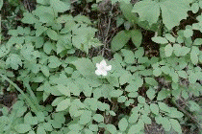

Biology

Biology Lab: AP Lab #4 - Osmosis

Biology Lab: Osmosis and Diffusion
Concept: Diffusion is the net movement of particles from a region where they are more concentrated to a region where they are less concentrated. You can demonstrate diffusion of molecules evaporating from a container of liquid through a gas by opening a bottle of perfume and moving to the other side of the room. After some time, you will smell the perfume.
Osmosis is the diffusion of water across a membrane which allows water molecules to pass but does not allow other particles to pass through. The solutions on either side of the membrane must have different concentrations. Then water will flow through the membrane to the side with the more concentrated solution to dilute it, so that both sides will eventually be in equilibrium.

Goal: To measure or observe diffusion and osmosis across different membranes by performing one of the following experiments.

Part A: Diffusion of cornstarch through a membrane

Materials
Iodine turns purple in the presence of starch. Lugol's solution (used in the AP version of this lab) is an iodine compound (IKI) which is very changes color in the presence of starches. In the absence of Lugol's solution, however, we can use a simple iodine formula -- but be sure that you obtain brown iodine, not clear, for this experiment. We need to use this color change to observe diffusion of starch and sugar through a membrane.
- Two jars for mixing solutions
- Two jars, bowls, or beakers large enough to hold a test tube or smaller jar upside down
- Two small jars or test tubes
- Eyedropper
- Iodine (brown, not clear!) IODINE IS POISONOUS. DO NOT TASTE IT. BROWN IODINE WILL STAIN, so take whatever precautions are necessary to avoid staining your clothes, your hands, or your work area.
- Cornstarch
- Distilled water
- A membrane: balloons, cellophane, dialysis tubing, sausage casings are all possibilities. Saran wrap is not permeable and won't work. If you can get dialysis tubing, cut it in 10cm strips and tie off the ends; you can use the tubing sections in place of the test tubes in the instructions below.
- Rubber bands

Procedure
- Soak your membrane in distilled water until it is soft and pliable.
- Prepare a dilute solution of iodine by mixing drops of iodine with one cup of water until the water is noticeably colored brown.
- Prepare a cornstarch solution by mixing 1/2 teaspoon cornstarch with a cup of water.
- Fill one of the test tubes (or dialysis tubing sections) with some of the iodine solution and use a rubber band to fasten your membrane over the end of the test tube. Fill one of the larger jars or beakers half-way with cornstarch solution and place your iodine-filled tube or jar upside down (so the membrane is in the cornstarch solution) in the larger jar.
- Fill the other small jar/tube with cornstarch solution, fasten the membrane over the end with the rubber band, and place it upside down in the larger jar/beaker. Fill the large jar with enough iodine solution to cover the membrane.
- Check your solutions after 1 minute, 5 minutes and 30 minutes. What do you observe?
- Try repeating the experiment with a different type of membrane.

Part B: Osmosis through a membrane

Materials
- Six membranes (see list in part A), softened by soaking in water for at least 30 minutes.
- If you are not using dialysis tubing, you will also need six test tubes capable of holding 25ml of solution.
- Sugar
- Large glass cup or beaker
- Six cups or beakers
- Kitchen scale accurate to .5 gm differences
- Rubber bands

Procedure
- Prepare the sugar solutions:
  - In the large glass cup or beaker, make 75 ml of 1.0M sucrose solution by adding 25.7g (.90 oz) of sugar to 75ml of distilled water.
  - Put 25 ml of this solution in the first test tube (or dialysis tubing section); label it 1.0M
  - Put 5ml of the sugar solution in the second test tube; add water to 25ml and label it .2M
  - Put 10ml of the sugar solution in the third test tube; add water to 25ml and label it .4M.
  - Put 15ml of the sugar solution in the fourth test tube; add water to 25ml and label it .6M
  - Put 20ml in the fifth test tube; add water to 25ml and label it .8M.
  - Put 25ml plain distilled water in the final test tube.
- If you are not using tubing, cover each test tube with a piece of membrane and tie off with a rubber band.
- Carefully blot (dry off) the tube or tubing as much as possible, weigh, and record the mass of the tube.
- Fill the six cups or beakers with distilled water.
- Immerse each tube or tubing section in a beaker. Label the beakers with the molarity of the sucrose solution.
- Let stand for half an hour, then remove, blot, and weigh the tube or tubing section, and record your data in a table, using columns for molarity of solute, initial mass, and final mass. In a fourth column, calculate the percent change in mass as amount of change / initial mass.

Analysis
- Using spreadsheet software, graph the percent change in mass vertically against molarity of the solution along the horizontal axis.
- Predict what would happen if you placed all the bags in a 0.4M solution instead of distilled water.

Part C: Osmosis through a vegetable cell wall

Materials
- Raw potato
- Six jars or cups
- Sugar
- Distilled water
- Knife (be careful not to cut yourself!)
- Thermometer cable of recording temperatures in centigrade to the nearest half-degree.
- Kitchen scale accurate to .5gm.

Procedure
- Prepare a set of sugar solutions as in part B above, so that you have 6 beakers of clear distilled water, and 0.2M, 0.4M, 0.6M, 0.8M, and 1.0M sucrose solutions. Mark the jars so you can identify the solutions later!
- Cut the potato into 24 strips 3cm long and 10-15mm thick. Dry off the slices and group them in bunches of four. Try not to get any skin on your strips.
- Weigh each bunch.
- Place each bunch in one of the solutions. Be sure they are completely submerged. Mark the solution jar with the original mass of the group.
- Check the slices after 24 hrs. Dry and weigh them.

Analysis
- Plot the change in percentage mass against sucrose molarity on a graph. Remember to put your "zero" change line across the middle of the graph, since you could have both increases and decreases in mass, depending on the sucrose concentration.
- Determine the osmotic pressure using the formula
Ψ _{π} =-iCRT
i is the ionization constant. For sugar, its value is 1, since sugar doesn't ionize.
C is the molar concentration (the 0.2M, 0.4M or whatever your solution was).
R is the pressure constant: use 0.0831-liter bars/mole °K
T is temperature = temperature in °C + 273 to get K
This value is equal to the water potential of the potato cells.
- What will happen to the water potential of potato cells that are allowed to dehydrate in the open air?
- Is a cell hypertonic or hypotonic when it has a lower water potential than its surrounding environment?

Report
Complete the observations, analysis, and summary for each of the lab activities. Prepare a lab report template.
Write up a general description of your procedures.
Organize all your data into tables for comparison with the work of your fellow students.
What conclusions can you draw about the behavior of solutions and solutes of different concentrations on either side of a membrane?
Post your lab summaries for this lab.

AP BIOLOGY 2021-22 LAB ACTIVITY 2

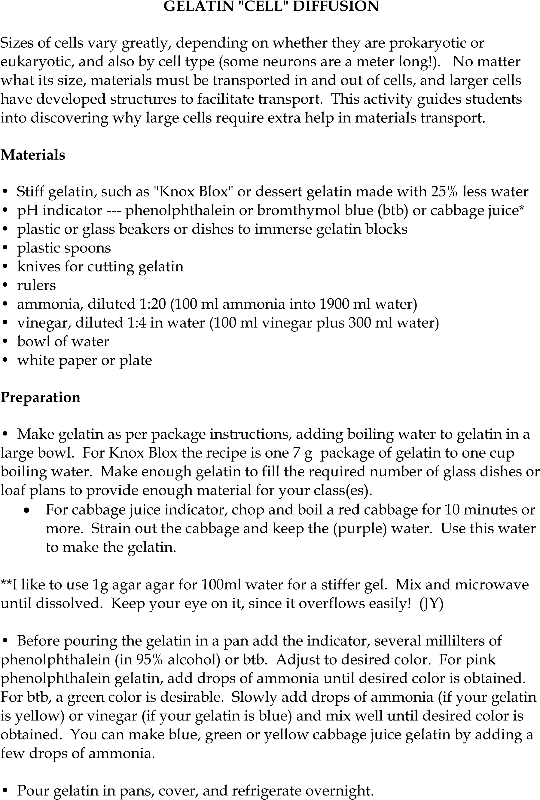
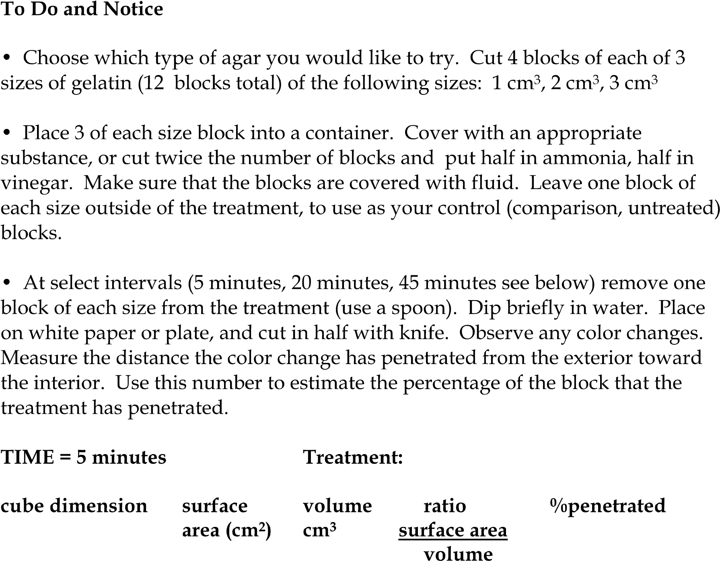

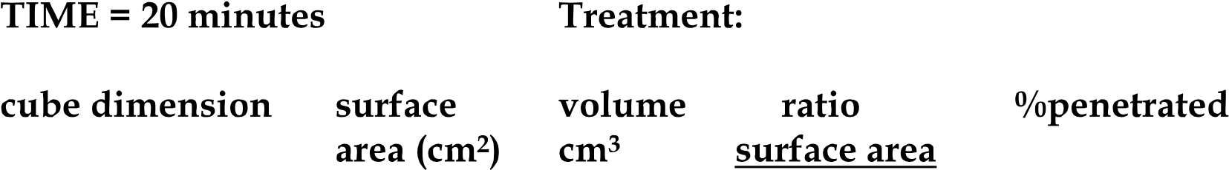

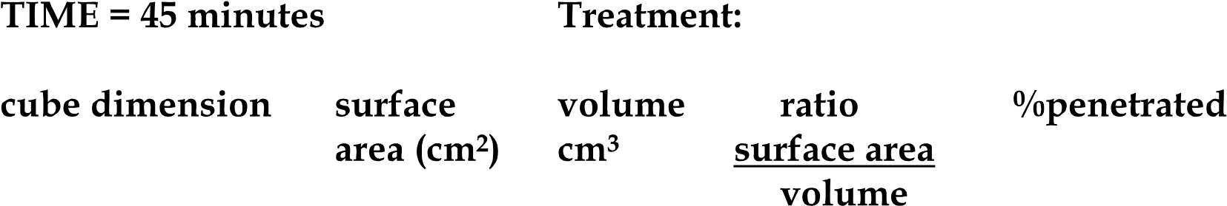

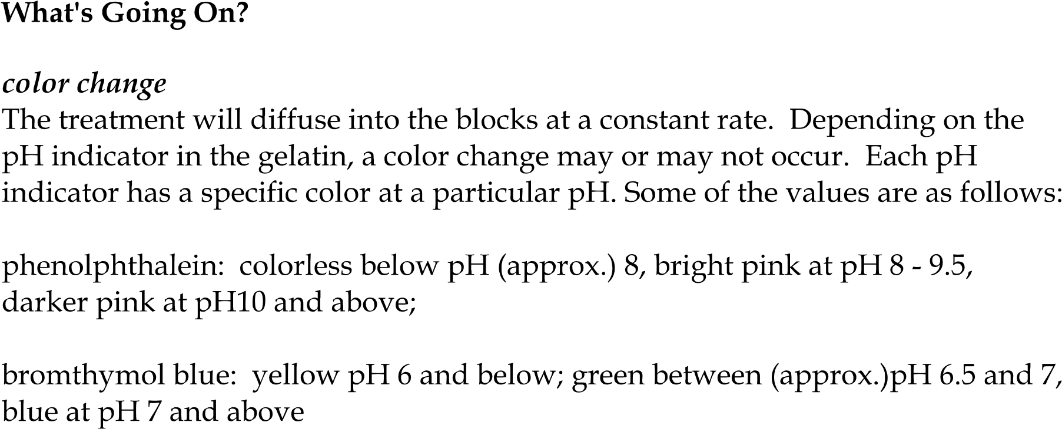
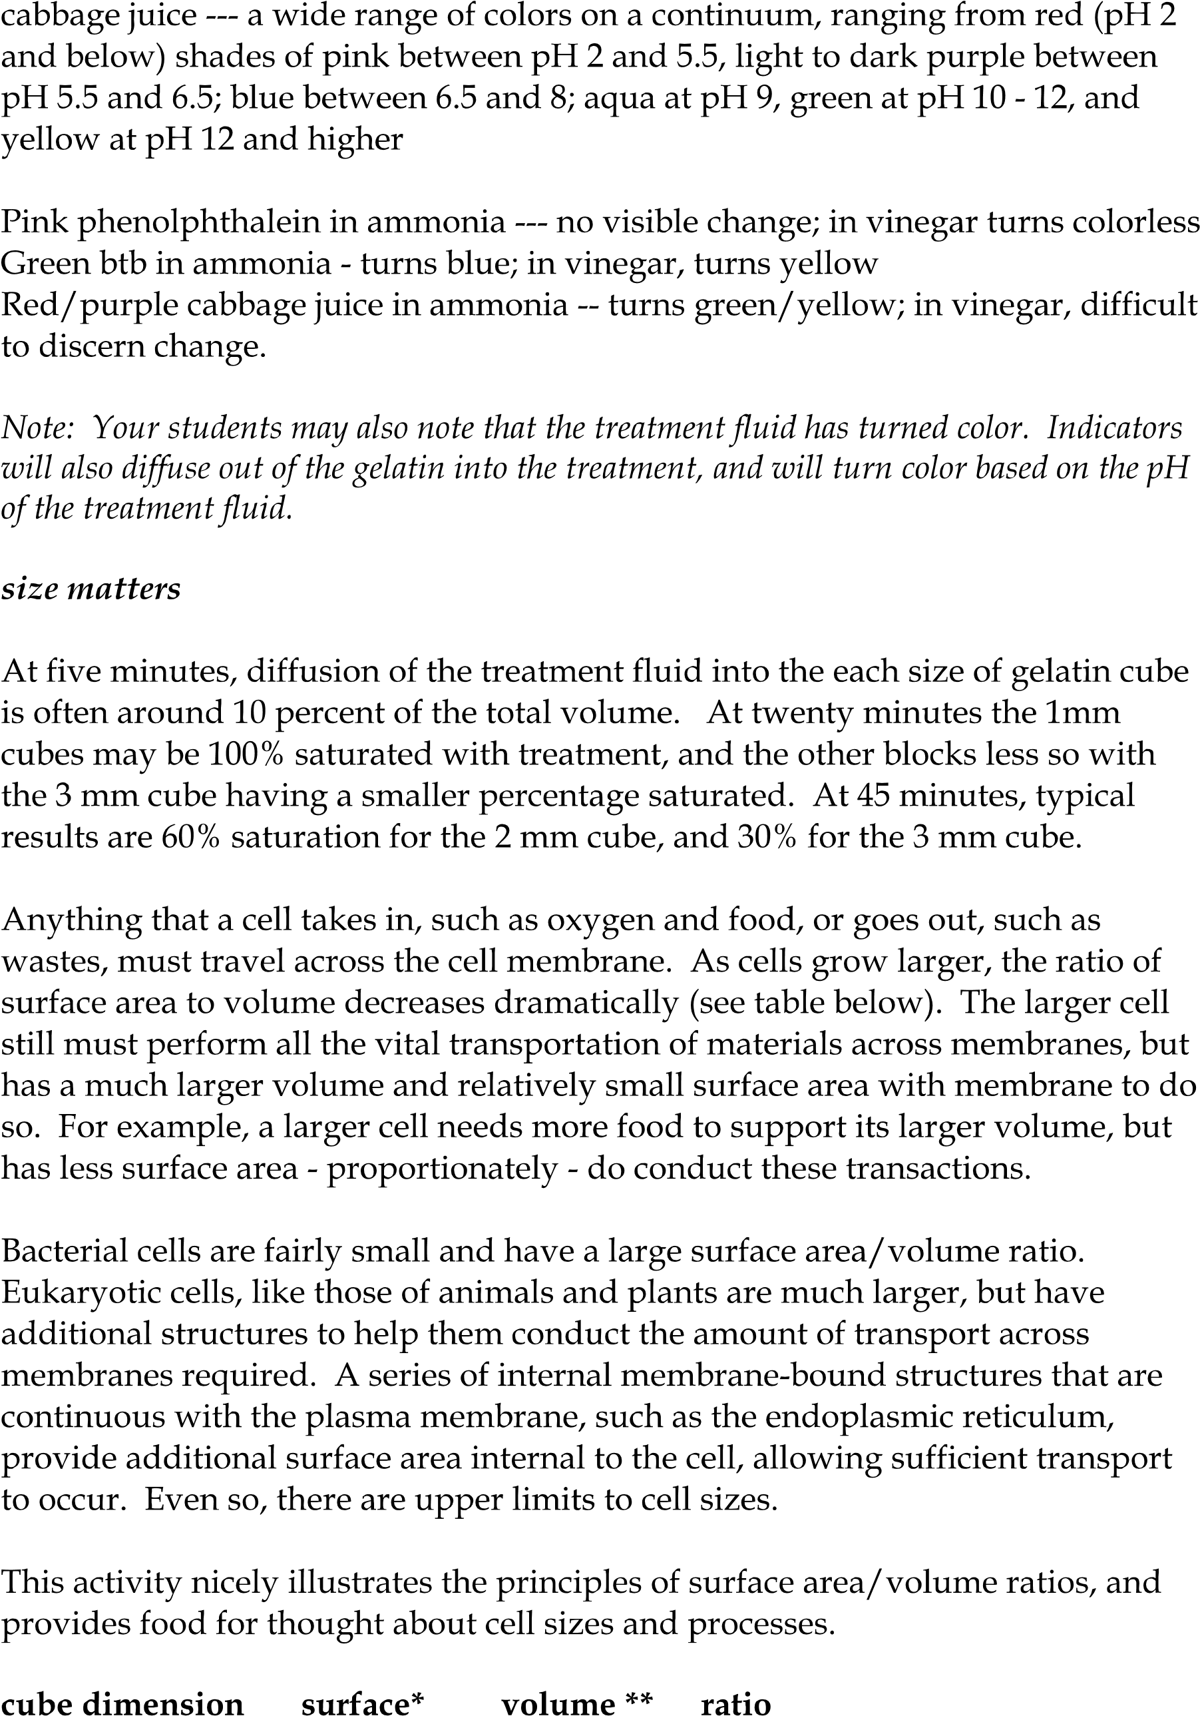

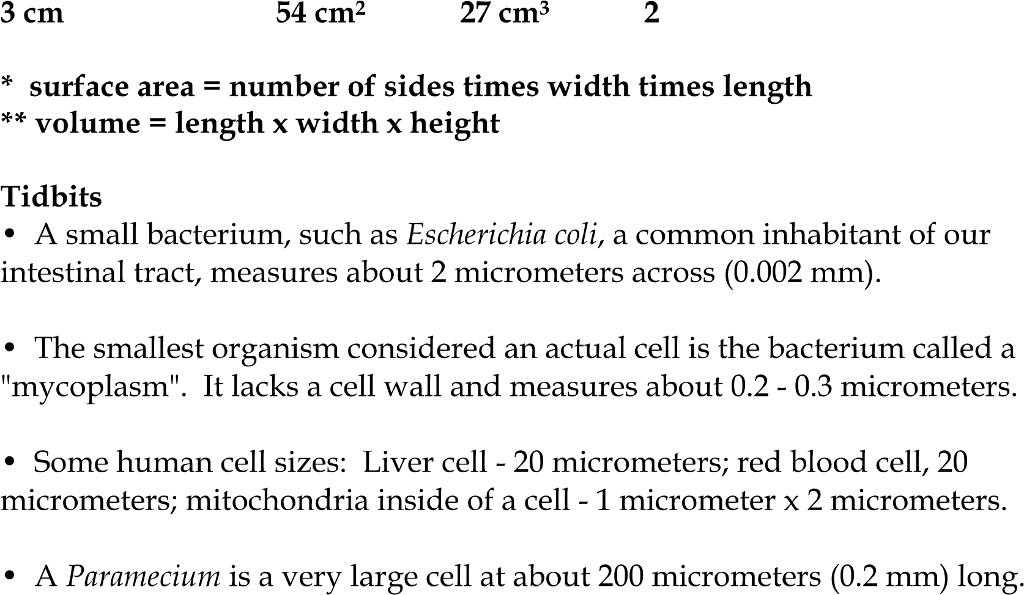

AP BIOLOGY 2021-22 READING GUIDE

Chapter 8: An Introduction to Metabolism

Concept 8.1 An organism’s metabolism transforms matter and energy, subject to the laws of thermodynamics

- Define metabolism.

- There are two types of reactions in metabolic pathways: anabolic and catabolic.

  - Which reactions release energy?

  - Which reactions consume energy?

  - Which reactions build up larger molecules?

  - Which reactions break down molecules?

  - Which reactions are considered “uphill”?

  - What type of reaction is photosynthesis?

  - What type of reaction is cellular respiration?

  - Which reactions require enzymes to catalyze reactions?

- Contrast kinetic energy with potential energy.

- Which type of energy does water behind a dam have? A mole of glucose?

Concept 8.2 The free-energy change of a reaction tells us whether the reaction occurs spontaneously

- What is free energy? What is its symbol?

- For an exergonic reaction, is ∆G negative or positive?

- Is cellular respiration an endergonic or an exergonic reaction? What is ∆G for this reaction?

- Is photosynthesis endergonic or exergonic? What is the energy source that drives it?

- To summarize, if energy is released, ∆G must be what?

Concept 8.3 ATP powers cellular work by coupling exergonic reactions to endergonic reactions

- List the three main kinds of work that a cell does. Give an example of each.
(1)
(2)
(3)

- Here is a molecule of ATP. Label it. Use an arrow to show which bond is likely to break.

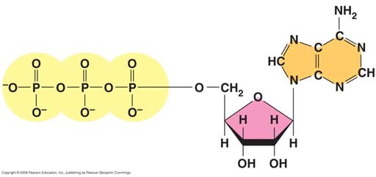

  - By what process will that bond break?

  - Explain the name ATP by listing all the molecules that make it up.

- When the terminal phosphate bond is broken, a molecule of inorganic phosphate P _{i} is formed, and energy is ___________________?

For this reaction: ATP Æ ADP + P_{i}, ∆G = __________________________

Is this reaction endergonic or exergonic?

FYI: An essay question on the 2009 AP Biology exam asked students to identify the molecules that make up ATP. What are they again?

- What is energy coupling?

In many cellular reactions, a phosphate group is transferred from ATP to some other molecule in order to make the second molecule less stable. The second molecule is said to be _______________.
- Look for this amazing bit of trivia: If you could not regenerate ATP by phosphorylating ADP, how much ATP would you need to consume each day?

Concept 8.4 Enzymes speed up metabolic reactions by lowering energy barriers

- What is a catalyst?

- What is activation energy (E_{A})?

On the graph, label the x-axis “Progress of the reaction” and the y-axis “Free Energy.” Label E_{A} on this sketch, both with and without enzyme.

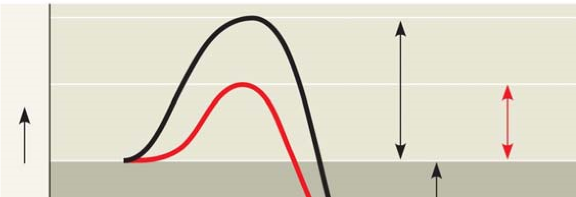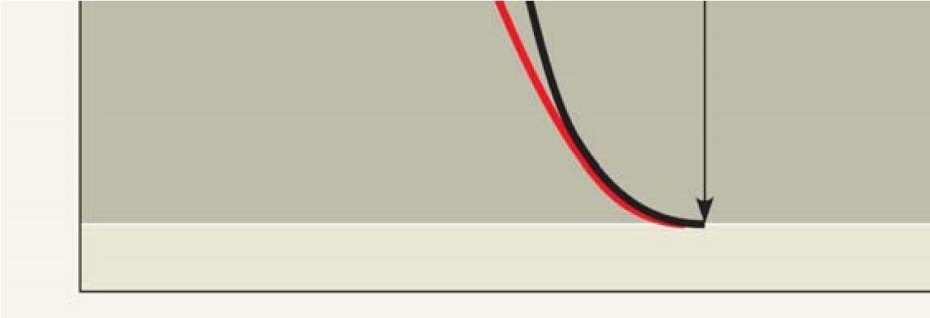

  - What effect does an enzyme have on E_{A}?

  - Label ∆G. Is it positive or negative?

  - How is ∆G affected by the enzyme?

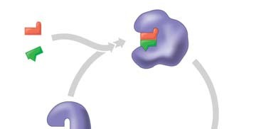
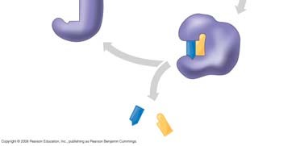
- Label this figure while you define each of the following terms:

enzyme
substrate
active site

products

- What is meant by induced fit? How is it shown in this figure?

- Explain how protein structure is involved in enzyme specificity.

- Enzymes use a variety of mechanisms to lower activation energy. Describe four of these mechanisms.

(1)

(2)

(3)

(4)

- Many factors can affect the rate of enzyme action. Explain each factor listed here.
  - initial concentration of substrate
  - pH
  - temperature
- Recall that enzymes are globular proteins. Why can extremes of pH or very high temperatures affect enzyme activity?

- Name a human enzyme that functions well in pH 2. Where is it found?

- Distinguish between cofactors and coenzymes. Give examples of each.

- Compare and contrast competitive inhibitors and noncompetitive inhibitors. Label each type of inhibitor in this figure.

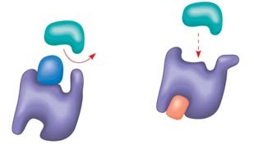

Concept 8.5 Regulation of enzyme activity helps control metabolism

- What is allosteric regulation?

- How is it somewhat like noncompetitive inhibition? How might it be different?

- Explain the difference between an allosteric activator and an allosteric inhibitor.

- Although it is not an enzyme, hemoglobin shows cooperativity in binding O₂. Explain how hemoglobin works at the gills of a fish.

- Study this figure from your book (Figure 8.22).

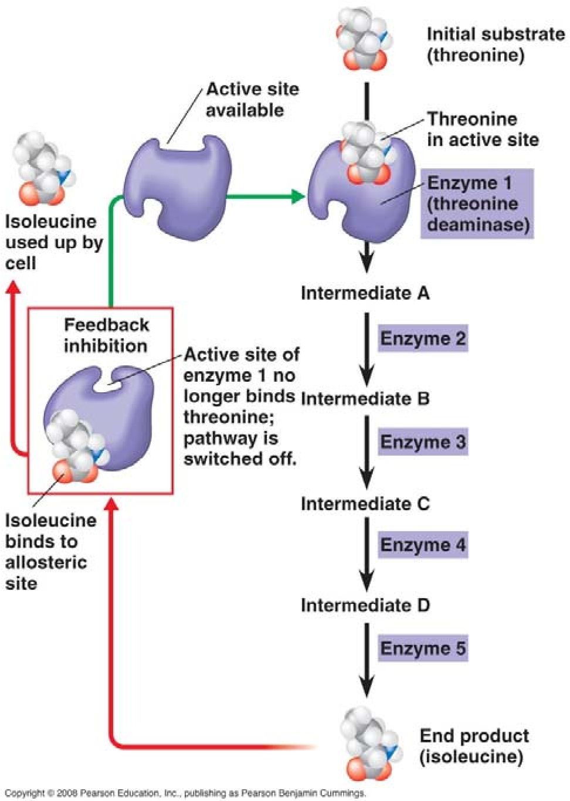

  - What is the substrate molecule to initiate this metabolic pathway?

  - What is the inhibitor molecule?

  - What type of inhibitor is it?

  - When does it have the most significant regulatory effect?

  - What is this type of metabolic control called?

Testing Your Knowledge: Self-Quiz Answers Now you should be ready to test your knowledge. Place your answers here:

1.______ 2.______ 3._______ 4.______ 5._______ 6._______

