AP BIOLOGY 2021-22 October 21, 2021

Today’s Agenda (Day 41)

- Housekeeping Items

- Homework Check:
Chapter 7 Vocabulary
Daily Videos 2.1, 2.2, 2.3.1, 2.3.2

- Class Activity:
TEST: Chapter 6 & 7
*Go to www.socrative.com enter room “MSBAPBIO” enter ID #

HOMEWORK:
- READ: Chapters 6 – 10
- VIEW: AP Daily Videos
Daily Video 2.4 – Plasma membrane
https://apclassroom.collegeboard.org/d/j8a9edp546?sui=6,2
Daily Video 2.5 – Membrane Permeability
https://apclassroom.collegeboard.org/d/2qa7jfm8fv?sui=6,2
Daily Video 2.6 – Membrane Transport
https://apclassroom.collegeboard.org/d/lu2yy32s3n?sui=6,2
Daily Video 2.7 – Facilitated diffusion
https://apclassroom.collegeboard.org/d/0r7imqshk0?sui=6,2
Daily Video 2.8 – Tonicity and Osmoregulation
https://apclassroom.collegeboard.org/d/vnamkvzu30?sui=6,2
https://apclassroom.collegeboard.org/d/ly7evl8s7q?sui=6,2
https://apclassroom.collegeboard.org/d/mtoi6igmsq?sui=6,2
Daily Video 2.9 – Mechanisms of Transport
https://apclassroom.collegeboard.org/d/a9iggb5rjy?sui=6,2
Daily Video 2.10 – Cell Compartmentalization
https://apclassroom.collegeboard.org/d/2aadsubqjq?sui=6,2
Daily Video 2.11 – Origins of Cell Compartmentalization
https://apclassroom.collegeboard.org/d/fvgckpq21n?sui=6,2

- STUDY: Ch 6 & 7 Test

REMINDERS:
- AP Videos – Oct. 22, 9:30 AM
- READING GUIDE: Ch 8 – Oct. 27
- TEST: Chapter 8 Oct. 28

AP BIOLOGY 2021-22 READING GUIDE

Chapter 8: An Introduction to Metabolism

Concept 8.1 An organism’s metabolism transforms matter and energy, subject to the laws of thermodynamics

- Define metabolism.

- There are two types of reactions in metabolic pathways: anabolic and catabolic.

  - Which reactions release energy?

  - Which reactions consume energy?

  - Which reactions build up larger molecules?

  - Which reactions break down molecules?

  - Which reactions are considered “uphill”?

  - What type of reaction is photosynthesis?

  - What type of reaction is cellular respiration?

  - Which reactions require enzymes to catalyze reactions?

- Contrast kinetic energy with potential energy.

- Which type of energy does water behind a dam have? A mole of glucose?

Concept 8.2 The free-energy change of a reaction tells us whether the reaction occurs spontaneously

- What is free energy? What is its symbol?

- For an exergonic reaction, is ∆G negative or positive?

- Is cellular respiration an endergonic or an exergonic reaction? What is ∆G for this reaction?

- Is photosynthesis endergonic or exergonic? What is the energy source that drives it?

- To summarize, if energy is released, ∆G must be what?

Concept 8.3 ATP powers cellular work by coupling exergonic reactions to endergonic reactions

- List the three main kinds of work that a cell does. Give an example of each.
(1)
(2)
(3)

- Here is a molecule of ATP. Label it. Use an arrow to show which bond is likely to break.

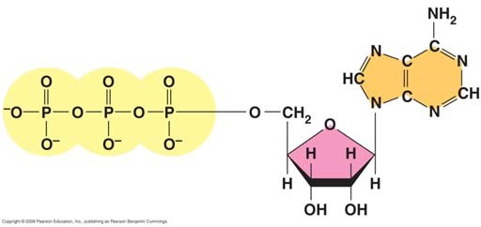

  - By what process will that bond break?

  - Explain the name ATP by listing all the molecules that make it up.

- When the terminal phosphate bond is broken, a molecule of inorganic phosphate P _{i} is formed, and energy is ___________________?

For this reaction: ATP Æ ADP + P_{i}, ∆G = __________________________

Is this reaction endergonic or exergonic?

FYI: An essay question on the 2009 AP Biology exam asked students to identify the molecules that make up ATP. What are they again?

- What is energy coupling?

In many cellular reactions, a phosphate group is transferred from ATP to some other molecule in order to make the second molecule less stable. The second molecule is said to be _______________.
- Look for this amazing bit of trivia: If you could not regenerate ATP by phosphorylating ADP, how much ATP would you need to consume each day?

Concept 8.4 Enzymes speed up metabolic reactions by lowering energy barriers

- What is a catalyst?

- What is activation energy (E_{A})?

On the graph, label the x-axis “Progress of the reaction” and the y-axis “Free Energy.” Label E_{A} on this sketch, both with and without enzyme.

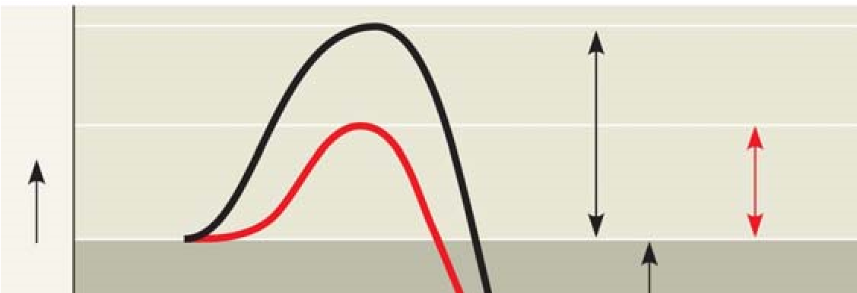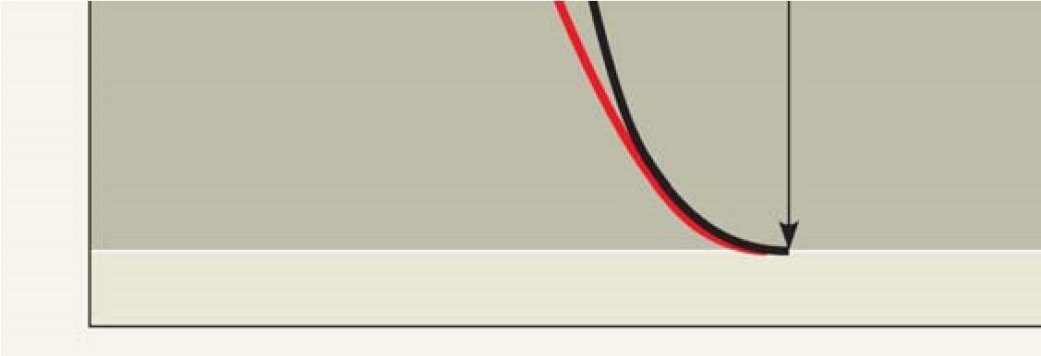

  - What effect does an enzyme have on E_{A}?

  - Label ∆G. Is it positive or negative?

  - How is ∆G affected by the enzyme?

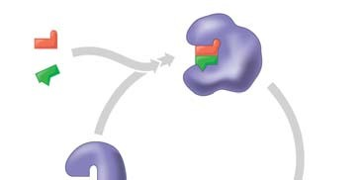
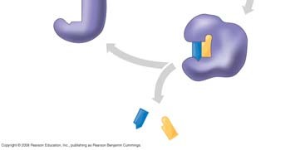
- Label this figure while you define each of the following terms:

enzyme
substrate
active site

products

- What is meant by induced fit? How is it shown in this figure?

- Explain how protein structure is involved in enzyme specificity.

- Enzymes use a variety of mechanisms to lower activation energy. Describe four of these mechanisms.

(1)

(2)

(3)

(4)

- Many factors can affect the rate of enzyme action. Explain each factor listed here.
  - initial concentration of substrate
  - pH
  - temperature
- Recall that enzymes are globular proteins. Why can extremes of pH or very high temperatures affect enzyme activity?

- Name a human enzyme that functions well in pH 2. Where is it found?

- Distinguish between cofactors and coenzymes. Give examples of each.

- Compare and contrast competitive inhibitors and noncompetitive inhibitors. Label each type of inhibitor in this figure.

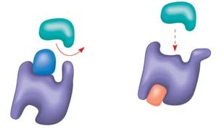

Concept 8.5 Regulation of enzyme activity helps control metabolism

- What is allosteric regulation?

- How is it somewhat like noncompetitive inhibition? How might it be different?

- Explain the difference between an allosteric activator and an allosteric inhibitor.

- Although it is not an enzyme, hemoglobin shows cooperativity in binding O₂. Explain how hemoglobin works at the gills of a fish.

- Study this figure from your book (Figure 8.22).

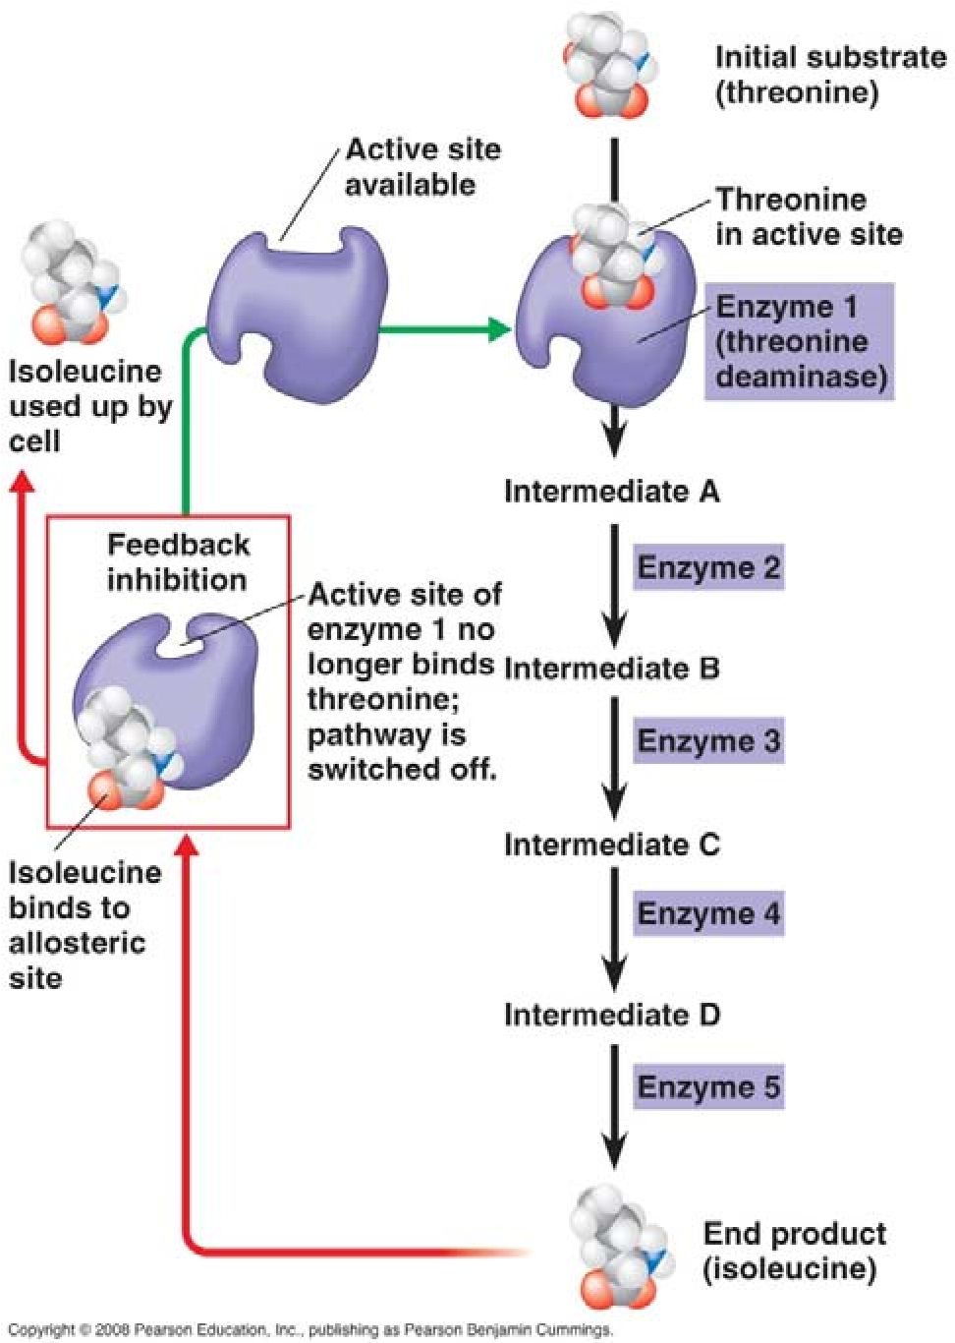

  - What is the substrate molecule to initiate this metabolic pathway?

  - What is the inhibitor molecule?

  - What type of inhibitor is it?

  - When does it have the most significant regulatory effect?

  - What is this type of metabolic control called?

Testing Your Knowledge: Self-Quiz Answers Now you should be ready to test your knowledge. Place your answers here:

1.______ 2.______ 3._______ 4.______ 5._______ 6._______

