AP BIOLOGY 2021-22 October 18, 2021

Today’s Agenda (Day 38)

- Housekeeping Items

- Homework Check:
Chapter 7 Vocabulary
Daily Videos 2.1, 2.2, 2.3.1, 2.3.2
- Class Activity:
BEGIN: Chapter 7 PPT Review
- Section 7.3 – Passive transport is diffusion across membrane with no energy investment
- Section 7.4 – Active transport uses energy to move solutes against their gradient
- Section 7.5 – Bulk transport across plasma membrane

HOMEWORK:
- READ: Chapters 6 – 10
- STUDY: Ch 6 & 7 Test
Chapter 7 Vocabulary
Active transport | Amphipathic | Aquaporins | Carrier proteins | Channel proteins
Concentration gradient | Cotransport | Diffusion | Electrochemical gradient | Electrogenic pump
Endocytosis | Exocytosis | Facilitated diffusion | Flaccid | Fluid mosaic model
Gated channels | Glycolipids | Glycoproteins | Hypertonic solution | Hypotonic solution
Integral proteins | Integrins | Ion channels | Isotonic solution | Ligands
Membrane potential | Osmoregulation | Osmosis | Passive transport | Peripheral proteins
Plasmolysis | Proton pump | Selective permeability | Sodium-potassium pump | Tonicity
Transmembrane proteins | Transport proteins | Turgid

REMINDERS:
- QUIZ: Chapter 6 & 7 Vocabulary Oct. 19
- TEST: Chapter 6 & 7 Oct. 20
Chapter 6 Vocabulary
Actin | Basal body | Cell fractionation | Cell wall | Central vacuole
Centrioles | Centrosome | Chloroplasts | Chromatin | Chromosomes
Cilia | Collagen | Communicating junctions | Contractile vacuoles | Cortex
Cristae | Cytoplasm | Cytoplasmic streaming | Cytoskeleton | Cytosol
Desmosomes | Dynein | Electron microscope | Electrons | Endomembrane system
Endoplasmic reticulum | Endosymbiont theory | Eukaryotic cell | Extracellular matrix | Fibronectin
Flagella | Glycoproteins | Golgi apparatus | Granum | Integrins
Intermediate filaments | Light microscope | Lysosome | Microfilaments | Microtubules
Middle lamella | Mitochondria | Mitochondrial matrix | Motor proteins | Myosin
Nuclear envelope | Nuclear lamina | Nucleolus | Nucleus | Peroxisome
Phagocytosis | Plasma membrane | Plasmodesmata | Plastids | Primary cell wall
Prokaryotic cell | Proteoglycans | Pseudopodia | Ribosomes | Rough ER
Scanning electron microscope | Secondary cell wall | Smooth ER | Stroma | Thylakoids
Tight junctions | Transmission electron microscope | Transport vesicles | vacuoles

Chapter 7 Vocabulary
Active transport | Amphipathic | Aquaporins | Carrier proteins | Channel proteins
Concentration gradient | Cotransport | Diffusion | Electrochemical gradient | Electrogenic pump
Endocytosis | Exocytosis | Facilitated diffusion | Flaccid | Fluid mosaic model
Gated channels | Glycolipids | Glycoproteins | Hypertonic solution | Hypotonic solution
Integral proteins | Integrins | Ion channels | Isotonic solution | Ligands
Membrane potential | Osmoregulation | Osmosis | Passive transport | Peripheral proteins
Plasmolysis | Proton pump | Selective permeability | Sodium-potassium pump | Tonicity
Transmembrane proteins | Transport proteins | Turgid

AP BIOLOGY 2021-22 READING GUIDE

Chapter 7: Membrane Structure and Function

Concept 7.1 Cellular membranes are fluid mosaics of lipids and proteins

- The large molecules of all living things fall into just four main classes. Name them.

- Explain what is meant when we say a molecule is amphipathic.

- In the 1960s, the Davson-Danielli model of membrane structure was widely accepted. Describe this model and then cite two lines of evidence that were inconsistent with it.

- Who proposed the fluid mosaic model of membrane structure? When? Describe this model.

- What is meant by membrane fluidity? Describe the movements seen in the fluid membrane.

- Describe how each of the following can affect membrane fluidity:

  - decreasing temperature

  - phospholipids with unsaturated hydrocarbon chains

  - cholesterol

- Membrane proteins are the mosaic part of the model. Describe each of the two main categories:

integral proteins

peripheral proteins

- Use Figure 7.9 to briefly describe major functions of membrane proteins.

Function | Description
Transport
Enzymatic activity
Signal transduction
Cell-cell recognition
Intercellular joining
Attachment to cytoskeleton and ECM

- Membrane carbohydrates are important in cell-cell recognition. What are two examples of this?

- Distinguish between glycolipids and glycoproteins.

- Label the following structures:

glycolipid glycoprotein integral protein
peripheral protein cholesterol phospholipid
ECM fibers cytoskeleton microfilaments

integrins

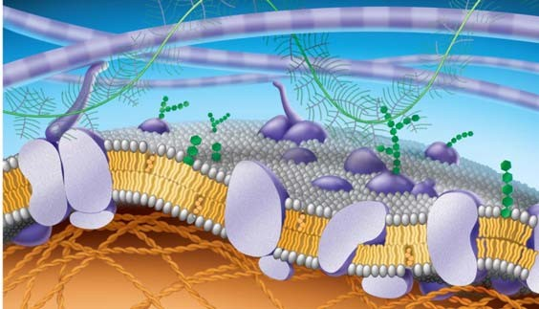

Concept 7.2 Membrane structure results in selective permeability

- Distinguish between channel proteins and carrier proteins.

- Are transport proteins specific? Cite an example that supports your response.

- Peter Agre received the Nobel Prize in 2003 for the discovery of aquaporins. What are they?

- Consider the following materials that must cross the membrane. For each, tell how it is accomplished.

Material | Method
CO₂
glucose
H+
O₂
H₂O

Concept 7.3 Passive transport is diffusion of a substance across a membrane with no energy investment

- Define the following terms:
diffusion concentration gradient passive transport osmosis isotonic hypertonic hypotonic turgid flaccid plasmolysis
- Use as many words from the list above to describe why a carrot left on the counter overnight would become limp. Underline each word you use.

- What is facilitated diffusion? Is it active or passive? Cite two examples.

- Label the hypotonic solution, isotonic solution, and hypertonic solution. What is indicated by the blue arrows? Label them. Which cell is lysed? Turgid? Flaccid? Plasmolyzed? Apply all these labels.

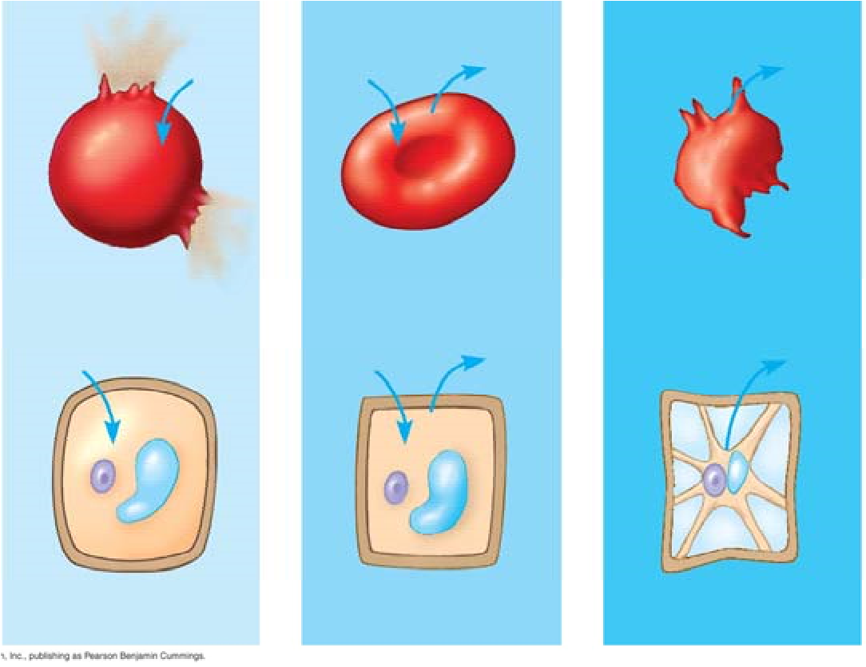
- Why doesn’t the plant cell burst?

Concept 7.4 Active transport uses energy to move solutes against their gradients

- Describe active transport. What type of transport proteins are involved, and what is the role of ATP in the process?

- The sodium-potassium pump is an important system for you to know. Use the following diagram to understand how it works. Use the following terms to label these figures, and briefly summarize what is occurring in each figure:
extracellular fluid, cytoplasm, Na+, K+, ATP, ADP, P, transport protein.

Summary
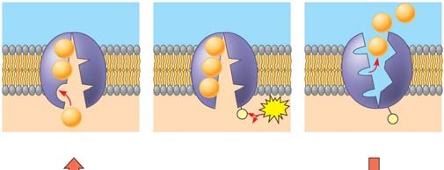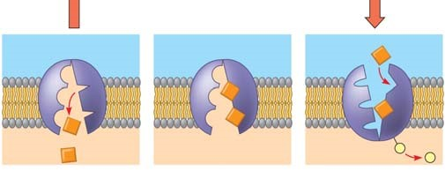
1.

2
.

3
.

4
.

5
.

6
.

- On the diagram below, add these labels: facilitated diffusion with a carrier protein, facilitated diffusion with a channel protein, active transport with a carrier protein, simple diffusion. For each type of transport, give an example of a material that is moved in this manner.

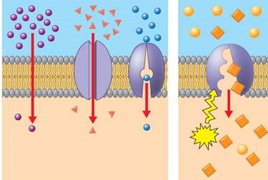

- What is membrane potential? Which side of the membrane is positive?

- What are the two forces that drive the diffusion of ions across the membrane? What is the combination of these forces called?

- What is cotransport? Explain how understanding it is used in our treatment of diarrhea.

Concept 7.5 Bulk transport across the plasma membrane occurs by exocytosis and endocytosis

- Define each of the following and give a specific cellular example.

endocytosis

phagocytosis

pinocytosis

exocytosis

receptor-mediated endocytosis

- What is a ligand? What do ligands have to do with receptor-mediated endocytosis?

- Are the processes you described in question 23 active or passive transport?
Explain your response.

Testing Your Knowledge: Self-Quiz Answers
Now you should be ready to test your knowledge. Place your answers here:

1._______ 2._______ 3._______ 4._______ 5._______

Reproduce the diagram for question 6, and draw arrows as instructed.

