AP BIOLOGY 2021-22 September 28, 2021

Today’s Agenda (Day 30)

- Housekeeping Items
Request for Item: Pond Algae

- Homework Check:
Chapter 6 Reading Guide

- Class Activity:
CONT’D: Chapter 6 PPT Review
- Section 6.3 – The eukaryotic cell’s genetic instructions are housed in the nucleus
- Section 6.4 – The endomembrane system regulates protein traffic
- Section 6.5 – Mitochondria and chloroplasts change energy from one form to another
- Section 6.6 – The cytoskeleton is a network of fibers that organizes structures and activities in the cell

TENTATIVELY: Microscope Activity

HOMEWORK:
- READ: Chapters 6 – 10
- COMPLETE: Chapter 7 Reading Guide
- STUDY: Ch 6 & 7 Test
Chapter 6 Vocabulary
Actin | Basal body | Cell fractionation | Cell wall | Central vacuole
Centrioles | Centrosome | Chloroplasts | Chromatin | Chromosomes
Cilia | Collagen | Communicating junctions | Contractile vacuoles | Cortex
Cristae | Cytoplasm | Cytoplasmic streaming | Cytoskeleton | Cytosol
Desmosomes | Dynein | Electron microscope | Electrons | Endomembrane system
Endoplasmic reticulum | Endosymbiont theory | Eukaryotic cell | Extracellular matrix | Fibronectin
Flagella | Glycoproteins | Golgi apparatus | Granum | Integrins
Intermediate filaments | Light microscope | Lysosome | Microfilaments | Microtubules
Middle lamella | Mitochondria | Mitochondrial matrix | Motor proteins | Myosin
Nuclear envelope | Nuclear lamina | Nucleolus | Nucleus | Peroxisome
Phagocytosis | Plasma membrane | Plasmodesmata | Plastids | Primary cell wall
Prokaryotic cell | Proteoglycans | Pseudopodia | Ribosomes | Rough ER
Scanning electron microscope | Secondary cell wall | Smooth ER | Stroma | Thylakoids
Tight junctions | Transmission electron microscope | Transport vesicles | vacuoles

REMINDERS:
- Chapter 7 Reading Guide – Oct. 12
- TEST: Chapter 6 & 7 Oct. 14
AP BIOLOGY 2021-22 ACTIVITY

Microscopes!
Introduction The microscope was invented in the 1500’s and has been a major tool of biology ever since. By means of lenses, the microscope can magnify things too small to be seen by the naked eye. One type of microscope we have in the lab is a compound microscope. You are to learn the structures and functions of the parts of this microscope. See the diagram and descriptions below.
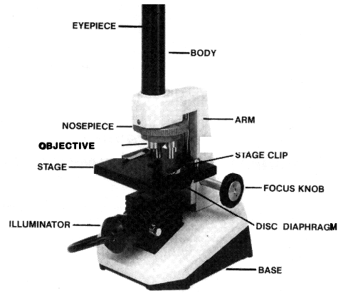
Parts of a Microscope
• Eyepiece magnifies the image ten times (10x). Do NOT remove it from the microscope because it will allow dirt into the body tube or you could drop and break it.
• Body tube keeps the eyepiece and objective lenses at standard distances.
• Low power objectives magnify the specimen 4x and 10x. ALWAYS START YOUR FOCUSING ON LOW POWER. Start with the 4x objective to scan the slide and then switch to the 10x objective. High power objective magnifies the object 20x on your microscopes. THE MICROSCOPE SHOULD ALWAYS BE LEFT ON LOW POWER WHEN PUTTING IT AWAY.
• Stage is the structure on which you place the slide. There are stage clips to hold the slide in place. The stage should be dry so you can easily move the slide to find whatever you are looking for.
• Focus knob is used to focus the specimen.
• Diaphragm is below the stage, is round and has holes. Some have more complicated structures. It allows you to adjust the amount of light coming up from the mirror. It works like the iris of your eye that controls the amount of light entering the pupil.
• Illuminators are built into these microscopes. The light is found under the stage to shine the light up through the specimen you are looking at
Learn These Terms
- Magnification is the ability to enlarge an image (what you see looking through the eyepiece). The total magnification for the microscope is obtained by multiplying the magnification of the eyepiece times the magnification of the objective lens. The eyepiece on the microscope is 10x and the three objective lenses are 4x, 10x and 20x.
What is the total magnification using each of the objective lenses? 4x=________ 10x=_________ 20x=_________
2. The Field of view is what is observed looking through the microscope. It is circular. The field of view on low power is larger than the field of view on high power.
3. Transmitted light is what goes through a thin specimen and is used in the compound microscope. Your specimen, therefore, has to be thin enough to allow light to go through it.
4. Reflected light is used in the stereo microscopes to observe large specimens. Light reflects off the surface so you can see the surface of the object, such as a flower.
Materials
• Slides • Plastic coverslips • Eyedroppers • Tweezers • Compound microscopes • letters from newsprint paper
Procedure
Part I. Compound Microscope:
1. Go to the table or desk where your teacher has placed the microscopes. The microscope should have been left with the low power lens in use.
2. Obtain a clean slide and coverslip. If the slide is not clean, use a paper towel and water to clean it.
3. Place a piece of newspaper under the objective lens and find a letter “e” in a word. You do not need to use a slide for this. Do not use the capital “E.” Make sure the “e” is in a normal position to your naked eye.
4. With a pencil, sketch the letter as you see it while looking through the microscope.
5. Compare how the “e” looks under the microscope to how it looks with the naked eye.
6. Switch to high power.
7. Now how does the “e” look?
8. Get a piece of colored paper. Put it on the stage without a slide and look through the microscope. Describe what you see under the microscope compared to what you see with your naked eye:
Observe a couple of strands of pond algae, or a drop from a hay infusion.
Take the algae from the container with a tweezers and place the strands on the slide. TAKE ONLY A COUPLE OF STRANDS or t. will look like a pile of junk under the microscope.
• Add a drop of pond water and a coverslip. You might also need to use Protoslo, if you are using hay infusion, to slow down the creatures in the drop.
• Wipe any water from under the slide with a piece of paper towel.
• Place the slide on the stage and observe under LOW POWER (4x and then 10x)
• Sketch what you see under LOW POWER
9. Switch the microscope to HIGH POWER (20X) and observe the algae very carefully. Make another sketch of what you see under HIGH POWER.

AP BIOLOGY 2021-22 ACTIVITY

Microscopes: Human Cheek Cell
1. To view cheek cells, gently scrape the inside lining of your cheek with a toothpick. DO NOT GOUGE THE INSIDE OF YOUR CHEEK!
2. Gently roll & tap the toothpick onto the center of a glass slide with a single drop of water. Some of the cheek cells will fall onto the slide.
3. Cover with a cover slip using proper procedure.
4. Observe the cheek cells under scanning, low and high power of your microscope.
5. Add a drop of methylene blue stain or iodine. This is done by placing a drop on the side of the cover slip and placing a paper towel on the opposite edge of the coverslip. This should draw the stain through and color the cells.
6. Observe the cheek cells under low and high power of your microscope (at the minimum you should observe the cell membrane, nucleus, and cytoplasm).
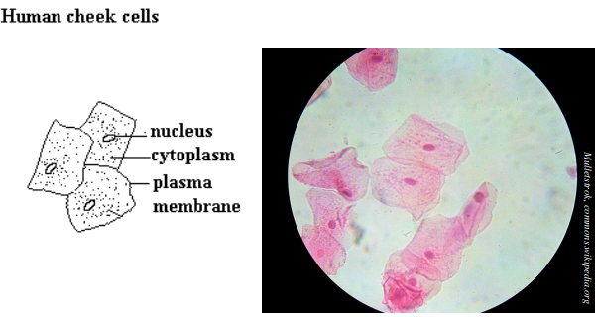

AP BIOLOGY 2021-22 READING GUIDE

Chapter 7: Membrane Structure and Function

Concept 7.1 Cellular membranes are fluid mosaics of lipids and proteins

- The large molecules of all living things fall into just four main classes. Name them.

- Explain what is meant when we say a molecule is amphipathic.

- In the 1960s, the Davson-Danielli model of membrane structure was widely accepted. Describe this model and then cite two lines of evidence that were inconsistent with it.

- Who proposed the fluid mosaic model of membrane structure? When? Describe this model.

- What is meant by membrane fluidity? Describe the movements seen in the fluid membrane.

- Describe how each of the following can affect membrane fluidity:

  - decreasing temperature

  - phospholipids with unsaturated hydrocarbon chains

  - cholesterol

- Membrane proteins are the mosaic part of the model. Describe each of the two main categories:

integral proteins

peripheral proteins

- Use Figure 7.9 to briefly describe major functions of membrane proteins.

Function | Description
Transport
Enzymatic activity
Signal transduction
Cell-cell recognition
Intercellular joining
Attachment to cytoskeleton and ECM

- Membrane carbohydrates are important in cell-cell recognition. What are two examples of this?

- Distinguish between glycolipids and glycoproteins.

- Label the following structures:

glycolipid glycoprotein integral protein
peripheral protein cholesterol phospholipid
ECM fibers cytoskeleton microfilaments

integrins

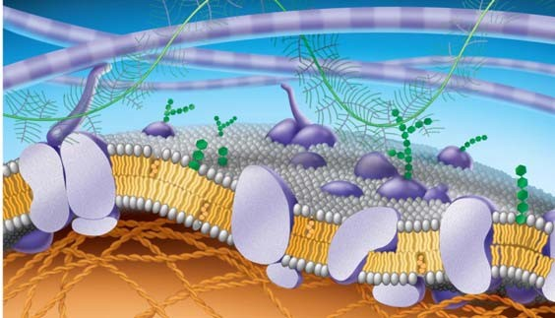

Concept 7.2 Membrane structure results in selective permeability

- Distinguish between channel proteins and carrier proteins.

- Are transport proteins specific? Cite an example that supports your response.

- Peter Agre received the Nobel Prize in 2003 for the discovery of aquaporins. What are they?

- Consider the following materials that must cross the membrane. For each, tell how it is accomplished.

Material | Method
CO₂
glucose
H+
O₂
H₂O

Concept 7.3 Passive transport is diffusion of a substance across a membrane with no energy investment

- Define the following terms:
diffusion concentration gradient passive transport osmosis isotonic hypertonic hypotonic turgid flaccid plasmolysis
- Use as many words from the list above to describe why a carrot left on the counter overnight would become limp. Underline each word you use.

- What is facilitated diffusion? Is it active or passive? Cite two examples.

- Label the hypotonic solution, isotonic solution, and hypertonic solution. What is indicated by the blue arrows? Label them. Which cell is lysed? Turgid? Flaccid? Plasmolyzed? Apply all these labels.

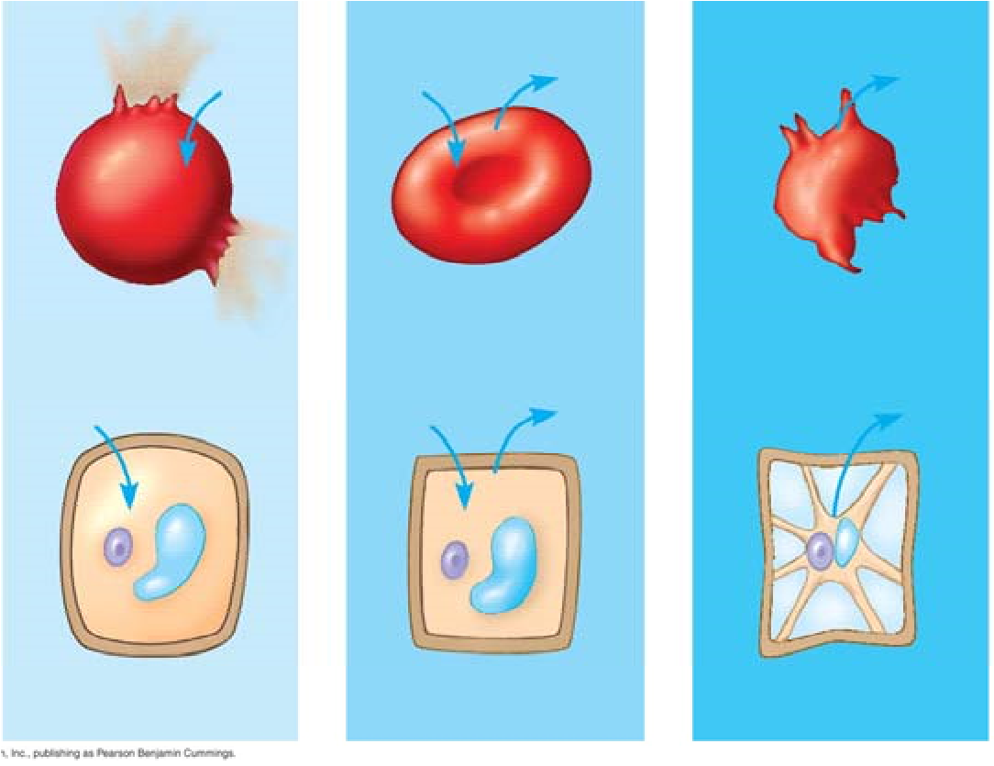
- Why doesn’t the plant cell burst?

Concept 7.4 Active transport uses energy to move solutes against their gradients

- Describe active transport. What type of transport proteins are involved, and what is the role of ATP in the process?

- The sodium-potassium pump is an important system for you to know. Use the following diagram to understand how it works. Use the following terms to label these figures, and briefly summarize what is occurring in each figure:
extracellular fluid, cytoplasm, Na+, K+, ATP, ADP, P, transport protein.

Summary
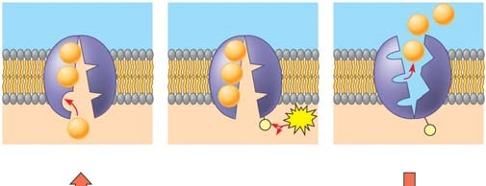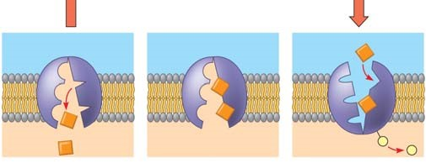
1.

2
.

3
.

4
.

5
.

6
.

- On the diagram below, add these labels: facilitated diffusion with a carrier protein, facilitated diffusion with a channel protein, active transport with a carrier protein, simple diffusion. For each type of transport, give an example of a material that is moved in this manner.

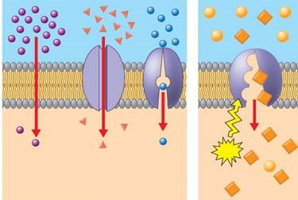

- What is membrane potential? Which side of the membrane is positive?

- What are the two forces that drive the diffusion of ions across the membrane? What is the combination of these forces called?

- What is cotransport? Explain how understanding it is used in our treatment of diarrhea.

Concept 7.5 Bulk transport across the plasma membrane occurs by exocytosis and endocytosis

- Define each of the following and give a specific cellular example.

endocytosis

phagocytosis

pinocytosis

exocytosis

receptor-mediated endocytosis

- What is a ligand? What do ligands have to do with receptor-mediated endocytosis?

- Are the processes you described in question 23 active or passive transport?
Explain your response.

Testing Your Knowledge: Self-Quiz Answers
Now you should be ready to test your knowledge. Place your answers here:

1._______ 2._______ 3._______ 4._______ 5._______

Reproduce the diagram for question 6, and draw arrows as instructed.

