AP BIOLOGY 2021-22 September 21, 2021

Today’s Agenda (Day 25)

- Housekeeping Items

- Homework Check:
Chapter 5 Reading Guide
- Class Activity:
REVIEW: Chapter 5Clicker Questions
QUIZ: Chapter 5 Vocabulary
*Go to www.socrative.com enter room “MSBAPBIO” enter ID #

HOMEWORK:
- READ: Chapters 4 – 6
- COMPLETE: Chapter 6 Reading Guide
- STUDY: Ch 5 Test
Chapter 5 Vocabulary
Aldose | amino acid | Antiparallel | Carbohydrates | Catalysts
Cellulose | Chaperonins | Chitin | Cholesterol | dehydration reaction
Denaturation | deoxyribonucleic acid | Deoxyribose | Disaccharide | double helix
Enzymes | Fat | fatty acid | Gene | gene expression
Genomics | Glycogen | glycosidic linkage | Hexose | Hydrolysis
Ketose | Lipids | Macromolecules | Monomers | Monosaccharides
nucleic acids | Nucleoside | Nucleotides | Pentose | peptide bond
Phospholipid | Polymer | Polynucleotides | Polypeptide | Polysaccharides
Protein | Proteomics | Purine | Pyrimidine | ribonucleic acid
Ribose | saturated fatty acid | sickle cell disease | Starch | Steroids
trans fats | Triacylglycerol | unsaturated fatty acid | x-ray crystallography

Chapter 6 Vocabulary
Actin | Basal body | Cell fractionation | Cell wall | Central vacuole
Centrioles | Centrosome | Chloroplasts | Chromatin | Chromosomes
Cilia | Collagen | Communicating junctions | Contractile vacuoles | Cortex
Cristae | Cytoplasm | Cytoplasmic streaming | Cytoskeleton | Cytosol
Desmosomes | Dynein | Electron microscope | Electrons | Endomembrane system
Endoplasmic reticulum | Endosymbiont theory | Eukaryotic cell | Extracellular matrix | Fibronectin
Flagella | Glycoproteins | Golgi apparatus | Granum | Integrins
Intermediate filaments | Light microscope | Lysosome | Microfilaments | Microtubules
Middle lamella | Mitochondria | Mitochondrial matrix | Motor proteins | Myosin
Nuclear envelope | Nuclear lamina | Nucleolus | Nucleus | Peroxisome
Phagocytosis | Plasma membrane | Plasmodesmata | Plastids | Primary cell wall
Prokaryotic cell | Proteoglycans | Pseudopodia | Ribosomes | Rough ER
Scanning electron microscope | Secondary cell wall | Smooth ER | Stroma | Thylakoids
Tight junctions | Transmission electron microscope | Transport vesicles | vacuoles

REMINDERS:
- TEST: Chapter 5 Sept. 22
- Chapter 6 Reading Guide – Sept. 27
- TEST: Chapter 6 & 7 Oct. 14
AP BIOLOGY 2021-22 READING GUIDE

Chapter 6: A Tour of the Cell

Concept 6.1 To study cells, biologists use microscopes and the tools of biochemistry

- The study of cells has been limited by their small size, and so they were not seen and described until 1665, when Robert Hooke first looked at dead cells from an oak tree. His contemporary, Anton van Leeuwenhoek, crafted lenses; and with the improvements in optical aids, a new world was opened. Magnification and resolving power limit what can be seen. Explain the difference.

- The development of electron microscopes has further opened our window on the cell and its organelles. What is considered a major disadvantage of the electron microscopes?

- Study the electron micrographs in your text. Describe the different types of images obtained from:

scanning electron microscopy (SEM)

transmission electron microscopy (TEM)

4. In cell fractionation, whole cells are broken up in a blender, and this slurry is centrifuged several times. Each time, smaller and smaller cell parts are isolated. This will isolate different organelles and allow study of their biochemical activities. Which organelles are the smallest ones isolated in this procedure?

Concept 6.2 Eukaryotic cells have internal membranes that compartmentalize their functions

- Which two domains consist of prokaryotic cells?

- A major difference between prokaryotic and eukaryotic cells is the location of their DNA. Describe this difference.

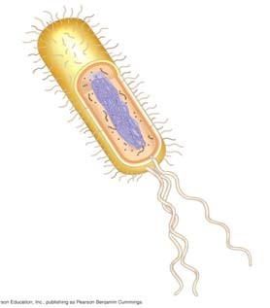
- On the sketch of a prokaryotic cell, label each of these features and give its function or description.
cell wall plasma membrane bacterial chromosome nucleoid cytoplasm flagella

- Why are cells so small? Explain the relationship of surface area to volume.

- Describe how many neurons and intestinal cells each have greatly increased surface area.

Concept 6.3 The eukaryotic cell’s genetic instructions are housed in the nucleus and carried out by the ribosomes

- In the figure below, label the nuclear envelope, nuclear pores, and pore complex.

- Describe the nuclear envelope. How many layers is it? What connects the layers?

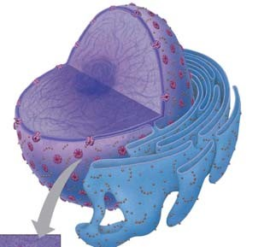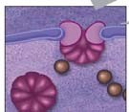
- What is the nuclear lamina? Nuclear matrix?

- Found within the nucleus are the chromosomes. They are made of chromatin. What are the two components of chromatin? When do the thin chromatin fibers condense to become distinct chromosomes?

- When are the nucleoli visible? What are assembled here?

- What is the function of ribosomes? What are their two components?

- Ribosomes in any type of organism are all the same, but we distinguish between two types of ribosomes based on where they are found, and the destination of the protein product made. Complete this chart to demonstrate this concept.

Type of Ribosome | Location | Product
Free ribosomes
Bound ribosomes

Concept 6.4 The endomembrane system regulates protein traffic and performs metabolic functions in the cell

- List all the structures of the endomembrane system.

- The endoplasmic reticulum (ER) makes up more than half the total membrane system in many eukaryotic cells. Use this sketch to explain the lumen, transport vesicles, and the difference between smooth and rough ER.
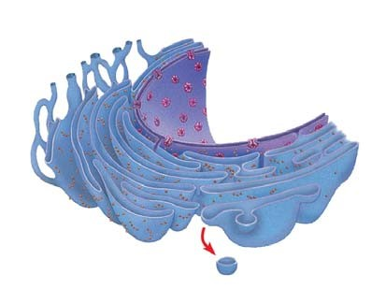

- List and describe three major functions of the smooth ER.

- Why does alcohol abuse increase tolerance to other drugs such as barbiturates?

- The rough ER is studded with ribosomes. As proteins are synthesized, they are threaded into the lumen of the rough ER. Some of these proteins have carbohydrates attached to them in the ER to form glycoproteins. What does the ER then do with these secretory proteins?

- Besides packaging secretory proteins into transport vesicles, what is another major function of the rough ER?

- The transport vesicles formed from the rough ER fuse with the Golgi apparatus.
Use this sketch to label the cisterna of the Golgi apparatus, and its cis and trans faces.
Describe what happens to a transport vesicle and its contents when it arrives at the Golgi.
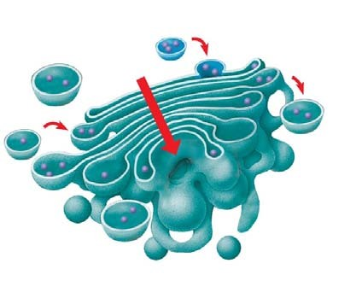

- What is a lysosome? What do they contain? What is their pH?

- One function of lysosomes is intracellular digestion of particles engulfed by phagocytosis.
Describe this process of digestion. What human cells carry out phagocytosis?

- A second function of lysosomes is to recycle cellular components in a process called autophagy. Describe this process.

- What happens in Tay-Sachs disease? Explain the role of the lysosomes in Tay-Sachs.

- There are many types of vacuoles. Briefly describe:
food vacuoles
contractile vacuoles

central vacuoles in plants
(give at least three functions/materials stored here)
29. Use this figure to explain how the elements of the endomembrane system function together to secrete a protein and to digest a cellular component. Label as you explain.
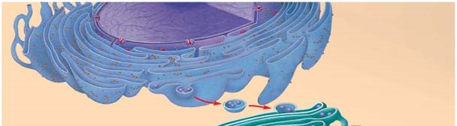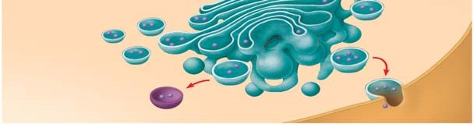

Concept 6.5 Mitochondria and chloroplasts change energy from one form to another

- Mitochondria and chloroplasts are not considered part of the endomembrane system, although they are enclosed by membranes. Sketch a mitochondrion here and label its outer membrane, inner membrane, inner membrane space, cristae, matrix, and ribosomes.

- Now sketch a chloroplast and label its outer membrane, inner membrane, inner membrane space, thylakoids, granum, and stroma. Notice that the mitochondrion had two membrane compartments, while the chloroplast has three compartments.

- What is the function of the mitochondria?

- What is the function of the chloroplasts?

- Recall the relationship of structure to function. Why is the inner membrane of the mitochondria highly folded? What role do all the individual thylakoid membranes serve? (Same answer for both questions.) Chloroplasts and mitochondria both have ribosomes and their own DNA. You will learn later about their evolution, but for now hold onto these facts. They are semiautonomous organelles that grow and reproduce within the cell. And you’re lucky today— there is not a question here!

- Explain the important role played by peroxisomes.

SUMMARY

On these diagrams of plant and animal cells, label each organelle and give a brief statement of its function.
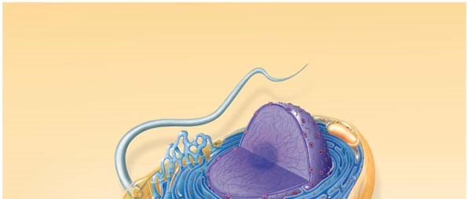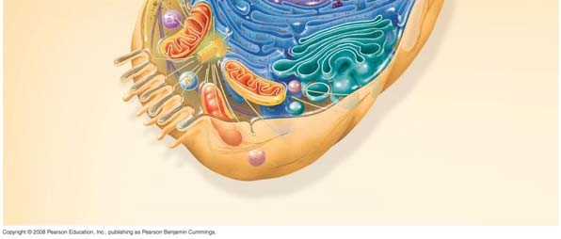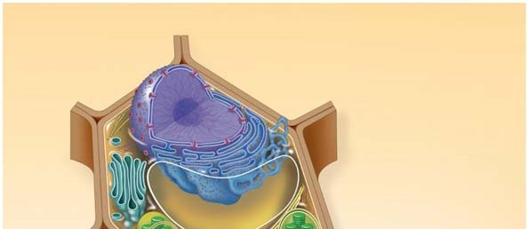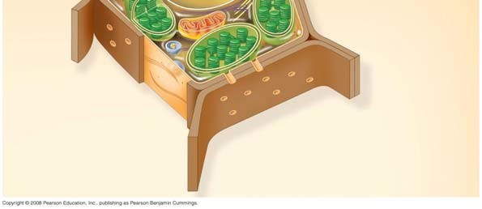

Concept 6.6 The cytoskeleton is a network of fibers that organizes structures and activities in the cell

- What is the cytoskeleton?

- What are the three roles of the cytoskeleton?

- There are three main types of fibers that make up the cytoskeleton. Name them.

- Microtubules are hollow rods made of a globular protein called tubulin. Each tubulin protein is a dimer made of two subunits. These are easily assembled and disassembled. What are four functions of microtubules?

- Animal cells have a centrosome that contains a pair of centrioles. Plant cells do not have centrioles. What is another name for centrosomes? What is believed to be the role of centrioles?

- Describe the organization of microtubules in a centriole. Make a sketch here that shows this arrangement in cross section.

- Cilia and flagella are also composed of microtubules. The arrangement of microtubules is said to be “9 + 2.” Make a sketch of a cross section here.

- Compare and contrast cilia and flagella. (This is a specific instruction that means you are to tell how they are alike—compare—and tell how they are different—contrast. Remember this hint when you see a similar phrase on an exam.)

- How do motor proteins called dyneins cause movement of cilia? What is the role of ATP in this movement? This figure might help you explain.
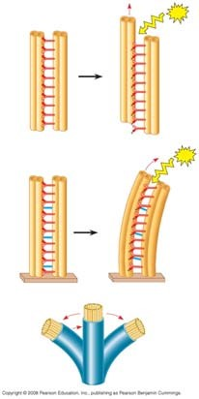

- Microfilaments are solid, and they are built from a double chain of actin. What are four functions of microfilaments? What are the motor proteins that move the microfilaments?

- Intermediate filaments are bigger than microfilaments but smaller than microtubules. They are more permanent fixtures of cells. Give two functions of intermediate filaments.

Concept 6.7 Extracellular components and connections between cells help coordinate cellular activities

47 What are three functions of the cell wall?

- What is the composition of the cell wall?

- What is the relatively thin and flexible wall secreted first by a plant cell?

- What is the middle lamella? Where is it found? What material is it made of?

- Explain the deposition of a secondary cell wall.

- On the sketch, label the primary cell wall, secondary cell wall, middle lamella, cytosol, plasma membrane, central vacuole, and plasmodesmata.

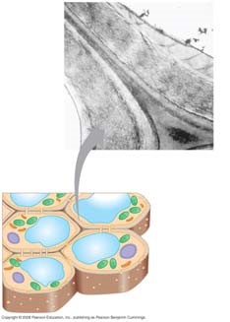

- Animal cells do not have cell walls, but they do have an extracellular matrix (ECM). On this figure, label the elements indicated, and give the role of each.
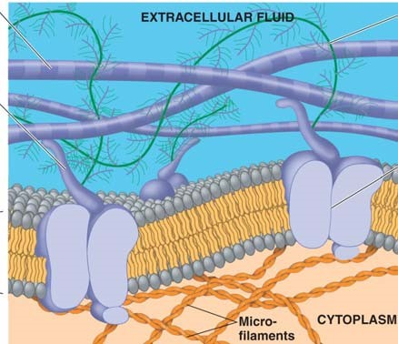

- What are the intercellular junctions between plant cells? What can pass through them?

- Animals cells do not have plasmodesmata. This figure shows the three types of intercellular junctions seen in animal cells. Label each type and summarize its role.

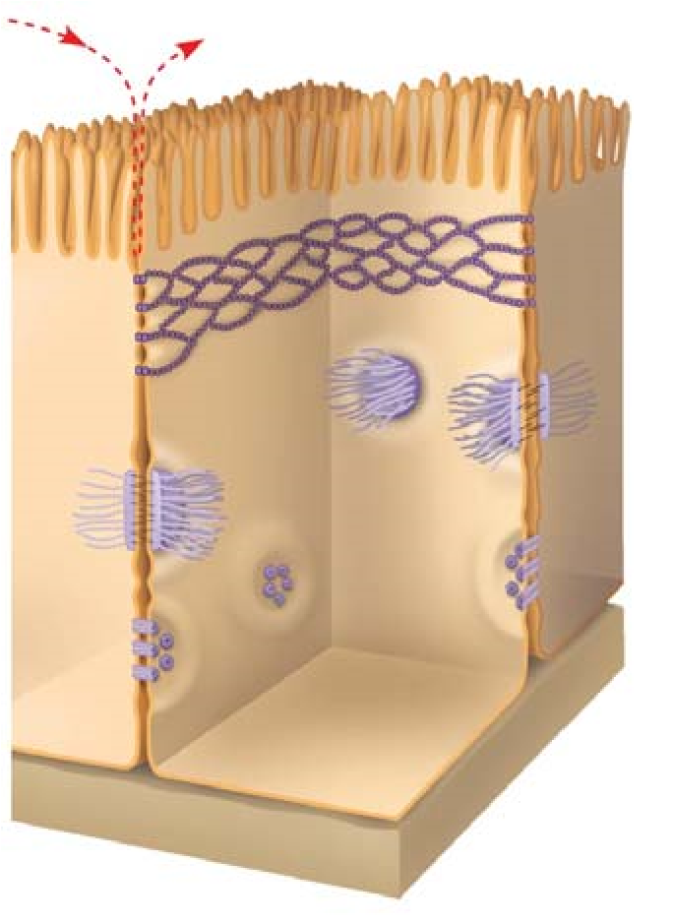

Here’s a great chart to summarize three concepts—study it!

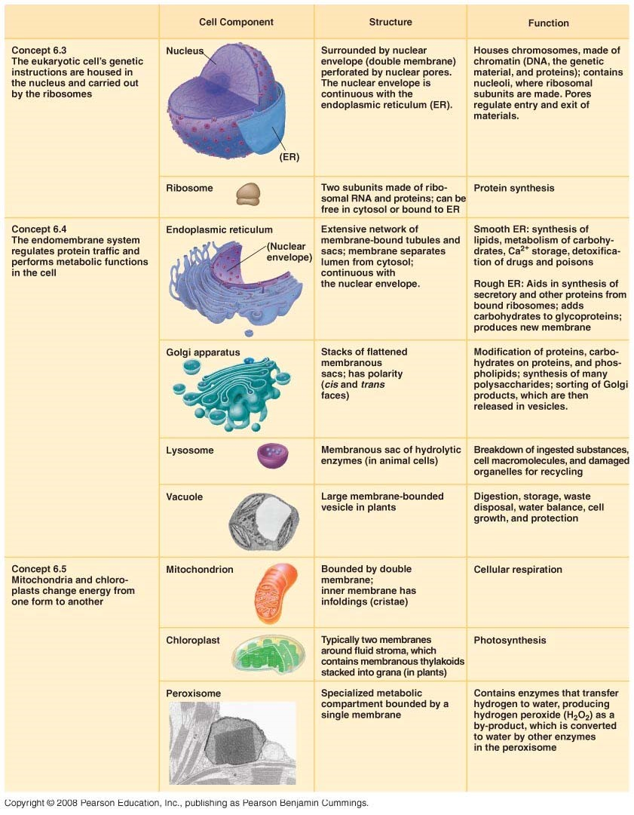

Testing Your Knowledge: Self-Quiz Answers
Now you should be ready to test your knowledge. Place your answers here:

