AP BIOLOGY 2021-22 September 14, 2021

Today’s Agenda (Day 20)

- Housekeeping Items

- Homework Check:
Chapter 4 Reading Guide

- Class Activity:
TEST: Chapter 4
*Go to www.socrative.com enter room “MSBAPBIO” enter ID #

THURSDAY: Chapter 5 PPT Review - CONT’D
- Section 5.1 - Macromolecules are polymers
- Section 5.2 – Carbohydrates as fuel and building material
- Section 5.3 - Lipids as a diverse group of hydrophobic molecules
- Section 5.4 – Proteins include diversity of structures and functions
- Section 5.5 – Nucleic acids store, transmit and help express hereditary information
- Section 5.6 – Genomics & proteomics transformed biological inquiry

HOMEWORK:
- READ: Chapters 4 - 6
- COMPLETE: Chapter 5 Reading Guide
- STUDY: Ch 5 Vocabulary

Chapter 5 Vocabulary
Aldose | amino acid | Antiparallel | Carbohydrates | Catalysts
Cellulose | Chaperonins | Chitin | Cholesterol | dehydration reaction
Denaturation | deoxyribonucleic acid | Deoxyribose | Disaccharide | double helix
Enzymes | Fat | fatty acid | Gene | gene expression
Genomics | Glycogen | glycosidic linkage | Hexose | Hydrolysis
Ketose | Lipids | Macromolecules | Monomers | Monosaccharides
nucleic acids | Nucleoside | Nucleotides | Pentose | peptide bond
Phospholipid | Polymer | Polynucleotides | Polypeptide | Polysaccharides
Protein | Proteomics | Purine | Pyrimidine | ribonucleic acid
Ribose | saturated fatty acid | sickle cell disease | Starch | Steroids
trans fats | Triacylglycerol | unsaturated fatty acid | x-ray crystallography

REMINDERS:
- QUIZ: Chapter 5 Vocabulary Sept. 21
- TEST: Chapter 5 Sept. 22

AP BIOLOGY 2021-22 READING GUIDE

Chapter 5: The Structure and Function of Large Biological Molecules

Concept 5.1 Macromolecules are polymers, built from monomers

- The large molecules of all living things fall into just four main classes. Name them.

- Circle the three classes that are called macromolecules. Define macromolecule.

- What is a polymer? A monomer?

- Monomers are connected in what type of reaction? What occurs in this reaction?

- Large molecules (polymers) are converted to monomers in what type of reaction?

- The root words of hydrolysis will be used many times to form other words you will learn this year. What does each root word mean?
hydro–

-lysis

- Consider the following reaction:
C₆H₁₂O₆ + C₆H12O6 C₁₂H₂₂O₁₁
  - The equation is not balanced; it is missing a molecule of water. Write it in on the correct side of the equation.

  - So, what kind of reaction is this?

  - Is C₆H₁₂O₆ (glucose) a monomer, or a polymer?

  - To summarize, when two monomers are joined, a molecule of __________ is always removed.

Concept 5.2 Carbohydrates serve as fuel and building material

- Let’s look at carbohydrates, which include sugars and starches. First, what are the monomers of all carbohydrates?
- Most monosaccharides are some multiple of (CH₂O). For example, ribose is a 5-carbon sugar with the formula C₅H₁₀O₅. It is a pentose sugar. (From the root penta–, meaning 5.) What is the formula of a hexose sugar?

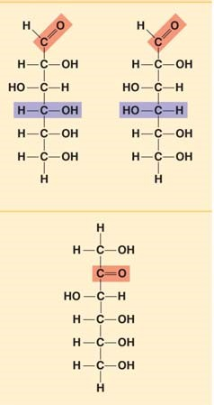
- Here are the three hexose sugars. Label each of them. Notice that all sugars have the same two functional groups. Name them:

C=O ___________________
—OH ___________________

- What is the difference between an aldehyde sugar and a ketone sugar?

- So, as a quick review, all these sugars have the same chemical formula: C₆H₁₂O₆. What term did you learn in Chapter 3 for compounds that have the same molecular formulas but different structural formulas?

- Here is the abbreviated ring structure of glucose. Where are all the carbons?

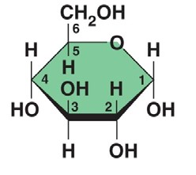

Pay attention to the numbering system. This will be important as we progress in our study. Circle the number 3 carbon. Put a square around the number 5 carbon.

- Let’s look at our reaction in question 7 again: C₆H₁₂O₆ + C₆H₁₂O₆ C₁₂H₂₂O₁₁ + H₂O

Notice that two monomers are joined to make a polymer. Since the monomers are monosaccharides, the polymer is a disaccharide. Three disaccharides are important to us with the formula C₁₂H₂₂O₁₁. Name them below and fill out the chart.

Disaccharide | Formed from which two monosaccharides? | Found where?

- Have you noticed that all the sugars end in –ose? This root word means ____________.

- What is a glycosidic linkage?

- Here is a molecule of starch, which shows 1–4 glycosidic linkages. Translate and explain this terminology in terms of carbon numbering.
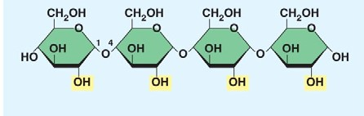

- There are two categories of polysaccharides. Name them and give examples.

Type of Polysaccharide | Examples

- Why can you not digest cellulose? What organisms can?

- Each prompt below describes a unique carbohydrate. Name the correct carbohydrate for each.
  - Has 1–4 B glucose linkages
  - Is a storage polysaccharide produced by vertebrates; stored in your liver
  - Two monomers of this form maltose
  - Glucose +________ form sucrose
  - Monosaccharide commonly called “fruit sugar”
  - “Milk sugar”
  - Structural polysaccharide that gives cockroaches their crunch
  - Malt sugar; used to brew beer
  - Structural polysaccharide that comprises plant cell walls

Concept 5.3 Lipids are a diverse group of hydrophobic molecules

- Lipids include fats, waxes, oils, phospholipids, and steroids. What characteristic do all lipids share?

- What are the building blocks of fats? Label them on this figure.
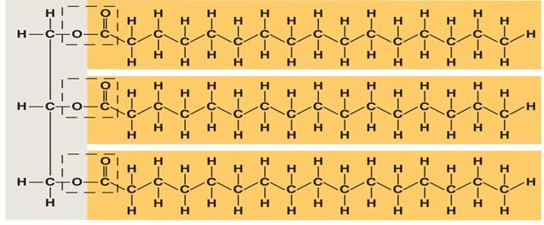

- If a fat is composed of 3 fatty acids and 1 glycerol molecule, how many water molecules will be removed to form it? Again, what is this process called?

- On the figure with question 22, label the ester linkages.

- Draw a fatty acid chain that is 8 carbons long and is unsaturated. Circle the element in your chain that makes it unsaturated and explain what this means.

- Name two saturated fats.

- Name two unsaturated fats.

- Why are many unsaturated fats liquid at room temperature?

- What is a trans-fat? Why should you limit them in your diet?

- List four important functions of fats.

- Here is a figure that shows the structure of a phospholipid. Label the sketch to show the phosphate group, the glycerol, and the fatty acid chains. Also indicate the region that is hydrophobic and the region that is hydrophilic.
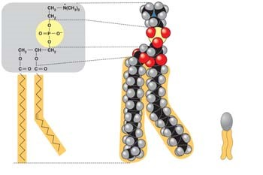

- Why is the “tail” hydrophobic?

- Which of the two fatty acid chains in the figure with question 31 is unsaturated? Label it. How do you know it is unsaturated?

- To summarize, a phospholipid has a glycerol attached to a phosphate group and two fatty acid chains. The head is hydrophilic, and the tail is hydrophobic. Now, sketch the phospholipid bilayer structure of a plasma membrane. Label the hydrophilic heads, hydrophobic tails, and location of water.

- Study your sketch. Why are the tails all located in the interior?

- Some people refer to this structure as three hexagons and a doghouse. What is it?

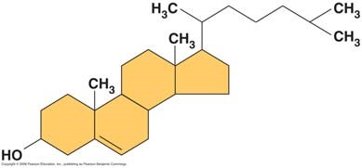

- What are other examples of steroids?

Concept 5.4 Proteins have many structures, resulting in a wide range of functions

- Table 5.1 is loaded with important information. Select any five types of proteins and summarize each type here.

Type of Protein | Function | Example

- Enzymes are an important type of protein. They will be studied in Chapter 8. For now, use this sketch to review what you know about enzymes. Label the active site, the substrate, and the products. Show what happens to water.
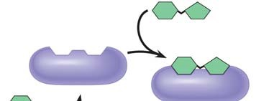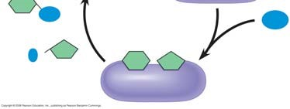

- Is this reaction dehydration synthesis or hydrolysis?

- The monomers of proteins are amino acids. Sketch an amino acid here. Label the alpha or central carbon, amino group, carboxyl group, and R group.

- What is represented by R? How many are there?

- Study the figure. See if you can understand why some R groups are nonpolar, some polar, and others electrically charged (acidic or basic). If you were given an R group, could you place it in the correct group? Work on the R groups until you can see common elements in each category.
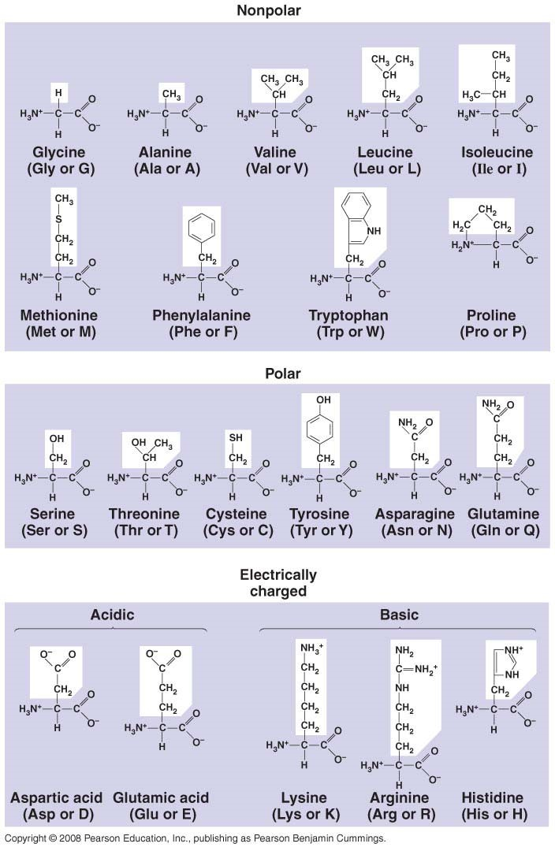

- Define these terms:
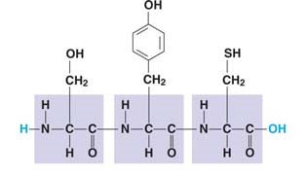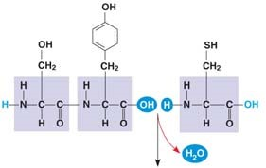

dipeptide

polypeptide

peptide bond
Label each of these terms on the diagrams.

- There are four levels of protein structure. Refer to Figure 5.21 and summarize each level in the following table.
Level of Protein Structure | Explanation | Example
Primary (Iº)

Secondary (IIº)

Alpha helix
Beta pleated sheet
Tertiary (IIIº)

Quaternary (IVº)

- Label each of the levels of protein structure on this figure.
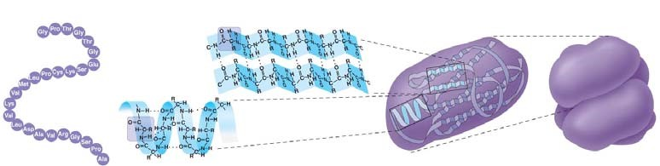

- Enzymes are globular proteins that exhibit at least tertiary structure. On this figure, identify and explain each interaction that folds this portion.
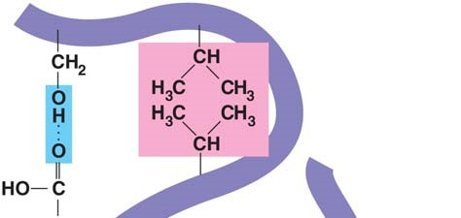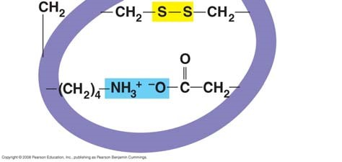

- Do you remember when, in Chapter 4, we said, “Change the structure, change the function”? Explain how that principle applies to sickle-cell disease. Why is the structure changed?

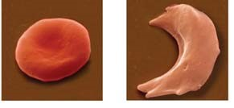
- Besides mutation, which changes the primary structure of a protein, protein structure can be changed by denaturation. Define denaturation and give at least three ways a protein may become denatured.

- Chaperone proteins or chaperonins assist in the proper folding of proteins. Annotate this figure to explain the process.

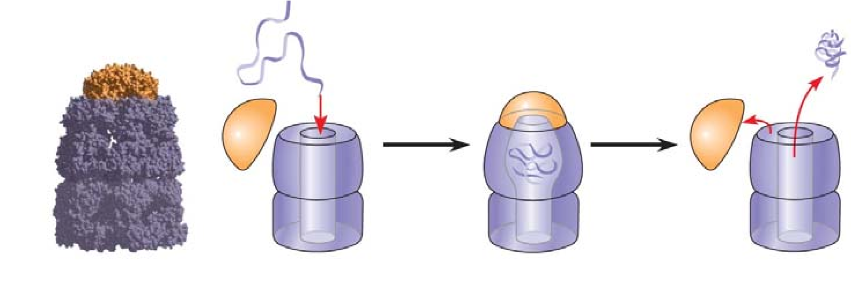

Concept 5.5 Nucleic acids store and transmit hereditary information

DNA and RNA will be the core topics of Chapter 17. For now, you should just review the general functions and know the components.
- The flow of genetic information is from DNA RNA protein. Use this figure to explain the process. Label the nucleus, DNA, mRNA, ribosome, and amino acids.
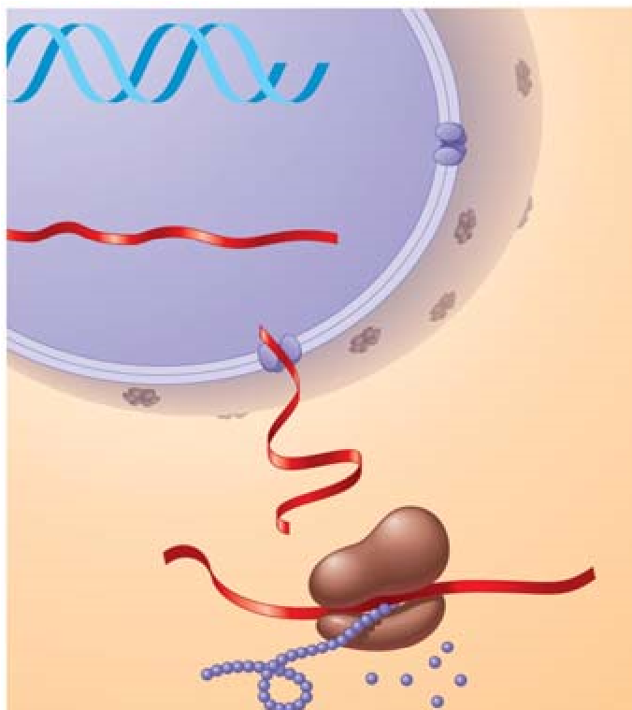
- The components of a nucleic acid are a sugar, a nitrogenous base, and a phosphate group. Label each on the figure below.

- You may recall that early in this chapter we looked at the numbering system for the carbons of a sugar. Label the end of the strand on the left side of the figure below that has the number 5 sugar 5' and the other end of the chain 3'.
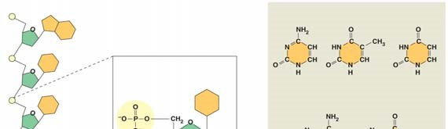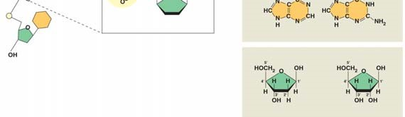

- Notice that there are five nitrogen bases. Which four are found in DNA?

- Which four are found in RNA?

- How do ribose and deoxyribose sugars differ?

- To summarize, what are the three components of a nucleotide?

- Here is a model of DNA, which was proposed by James Watson and Francis Crick. What is this
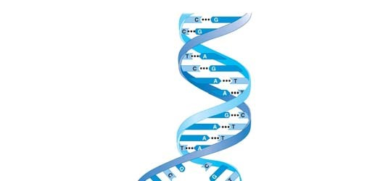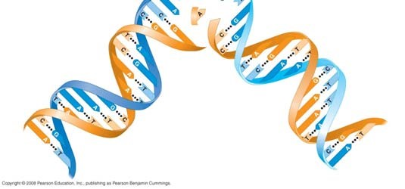
shape called?

- Why are the strands said to be antiparallel?

- What two molecules make up the “uprights”?

- What molecules make up the rungs?

- For the two nucleotides of DNA below, provide the complementary base.
A —
C —
- In a DNA double helix, a region along one DNA strand has this sequence of nitrogenous bases:
5'-T A G G C C T-3'

Write the complementary strand. Indicate the 5' and 3' ends of the new strand.

Testing Your Knowledge: Self-Quiz Answers
Now you should be ready to test your knowledge. Place your answers here:

This summary table from the Chapter 5 Review is an excellent study tool. Use it to organize material from this chapter in your mind.

