AP BIOLOGY 2021-22 May 11, 2022

Today’s Agenda (Day 154)

- Housekeeping Items

- Homework Check:

- Class Activity:
REVIEW: Final Exam !TODAY!

HOMEWORK:

REMINDERS:
- AP BIOLOGY FINAL EXAM May 11

AP BIOLOGY 2021-22 PRACTICE

WATER POTENTIAL – Problem Set #1

- If a cell’s Ψ_{P} = 3 bars and its Ψ_{S} = -4.5 bars, what is the resulting Ψ?

- The cell from question #1 is placed in a beaker of sugar water with Ψ_{S} = - 4.0 bars. In which direction will the net flow of water be?

- The original cell from question # 1 is placed in a beaker of sugar water with Ψ_{S} = - 0.15 MPa (megapascals). We know that 1 MPa = 10 bars. In which direction will the net flow of water be?

- The value for Ψ in root tissue was found to be - 3.3 bars. If you take the root tissue and place it in a 0.1 M solution of sucrose at 20°C in an open beaker, what is the Ψ of the solution, and in which direction would the net flow of water be?

- NaCl dissociates into 2 particles in water: Na⁺ and Cl⁻. If the solution in question 4 contained 0.1M NaCl instead of 0.1M sucrose, what is the Ψ of the solution, and in which direction would the net flow of water be?

- A plant cell with a Ψ_{s} of -7.5 bars keeps a constant volume when immersed in an open-beaker solution that has a Ψ_{s} of -4 bars. What is the cell’s Ψ_{P}?

- At 20°C, a cell containing 0.6M glucose is in equilibrium with its surrounding solution containing 0.5M glucose in an open container. What is the cell’s Ψ_{P}?

- A plant cell has a solute potential of –4.0 and a pressure potential of 1.0. It is then placed in a solution with a water potential of –5.0. What will happen to this plant cell?

- At 20°C, a cell with Ψ_{P} of 3 bars is in equilibrium with the surrounding 0.4M solution of sucrose in an open beaker. What is the molar concentration of sucrose in the cell?
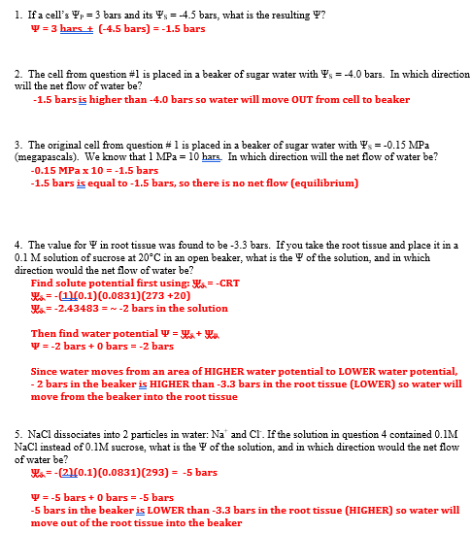
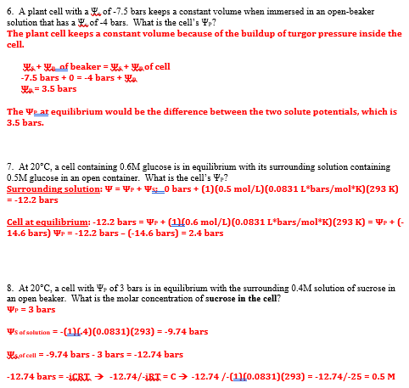

WATER POTENTIAL – Problem Set #2
1. A solution in a beaker has NaCl dissolved in water with a solute potential of
-0.5 bars. A flaccid cell is placed in the above beaker with a solute potential of -0.9 bars.

a) What is the pressure potential of the flaccid cell before it was placed in the beaker?

b) What is the water potential of the cell before it was placed in the beaker?

c) What is the water potential in the beaker containing the sodium chloride?

d) How will the water move?

e) What is the pressure potential of the plant cell when it is in equilibrium with the NaCl solution outside?

f) What is the cells final water potential when it is in equilibrium?

g) Is the cell now turgid/flaccid/plasmolyzed?

h) Is the cell hypotonic or hypertonic with respect to the outside?

i) If it is hypo/hyper (choose one) tonic – this means that its water potential is higher/lower (choose one) than the outside.

2. A solution in a beaker has sucrose dissolved in water with a solute potential of
-0.9 bars. A flaccid cell is placed in the above beaker with a solute potential of -0.3 bars.

a) What is the pressure potential of the flaccid cell before it was placed in the beaker?

b) What is the water potential of the cell before it was placed in the beaker?

c) What is the water potential in the beaker containing the sucrose?

d) How will the water move?

e) What is the pressure potential of the plant cell when it is in equilibrium with the sucrose solution outside? Think carefully – does the plant cell wall change shape?

f) Also, what is the cell’s final water potential when it is in equilibrium?

g) What is the cell’s solute potential when it is in equilibrium?

h) Is the cell hypotonic or hypertonic with respect to the outside?

i) If it is hypo/hyper (choose one) tonic – this means that its water potential is higher/lower (choose one) than the outside.

3. Calculate the water potential of a solution of 0.15 M sucrose. The solution is at standard temperature.

4. If a flaccid cell having a solute potential of -0.69 bars is placed in the above solution, what will be its pressure potential at equilibrium?

5. If the cell above is removed from that solution of 0.15 M sucrose and placed in a solution of 0.35 M sucrose, will the pressure potential of the cell increase or decrease? What will be the new value?

6. You measure the total water potential of a cell and find it to be -0.24 bars. If the pressure potential of the same cell is 0.46 bars, what is the solute potential of that cell?

7. If a cell having a molar concentration of glucose at 0.22 M is placed in a solution of pure 20 °C water, what will be its pressure potential at equilibrium?

8. If you added 0.1 M glucose to the solution what would happen to the cell? Justify your answer mathematically.

9. What must be the molar concentration of sugar inside a cell for it not to change volume when placed in a beaker of 0.35M NaCl solution at 37°C? The Ψp of the cell is 4.7 bars.

10. A cell is in equilibrium with an outside solution where Ψw = -1.0 bars. Water is added to the outside solution such that Ψw = -0.2 bars and the cell volume increases 1.5 times. What Pressure potential is required to stop the movement of water into the cell?

11. A hypertonic environment has a High/Low (circle one) water potential compared to the cell? Why?

12. Then, water will move which way according to water potential rules?

