AP BIOLOGY 2021-22 September 6, 2021

Today’s Agenda (Day 14)

- Housekeeping Items

- Homework Check:
Chapter 3 Reading Guide
Element Chart – ionic charges

- Class Activity:
BEGIN: Chapter 3 PPT Review

HOMEWORK:
- READ: Chapters 4 - 6
- COMPLETE: Chapter 4 Reading Guide
- STUDY: Chapter 3 Test & Polyatomic Ions/Elements Tables

Chapter 4Vocabulary
adenosine triphosphate | amino group | asymmetric carbon | carbonyl group | carboxyl group
cis isomers | enantiomers | ethane | ethene | functional groups
hydrocarbons | hydroxyl group | isomers | methane | methyl group
organic chemistry | phosphate group | structural isomers | sulfhydryl group | trans isomer

REMINDERS:
- Element Chart – ionic charges – Sept. 6
- Chapter 3 Reading Guide – Sept. 4, 11:59:59 pm
- TEST: Ch 3 & Chemical Symbols Sept. 8
- Chapter 4 Reading Guide – Sept. 11, 11:59:59 pm
- TEST: Chapter 4 Sept. 15

AP BIOLOGY 2021-22 CHEMISTRY REVIEW
POLYATOMIC IONS TO MEMORIZE
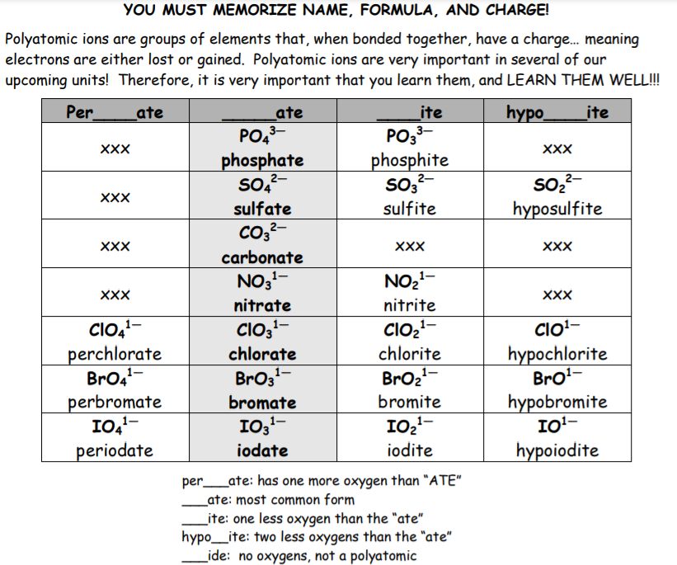
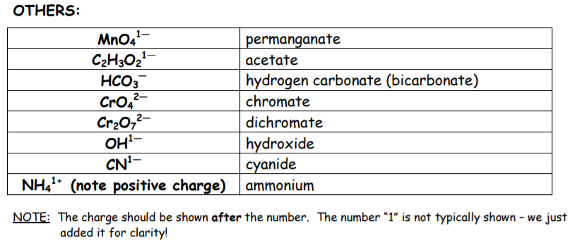
AP BIOLOGY 2021-22 CHEMISTRY REVIEW

Important elements
DIRECTIONS: Find the ionic charge for each of the elements listed below. Then memorize the element name, chemical symbol and ionic charge.

Symbol | Name | Ionic Charge | Symbol | Name | Ionic Charge | Symbol | Name | Ionic Charge
Al | Aluminum |  | F | Fluorine |  | O | Oxygen
As | Arsenic |  | Au | Gold |  | P | Phosphorus
Ba | Barium |  | He | Helium |  | Pt | Platinum
Be | Beryllium |  | H | Hydrogen |  | K | Potassium
B | Boron |  | Fe | Iron |  | Si | Silicon
Cd | Cadmium |  | Pb | Lead |  | Ag | Silver
Ca | Calcium |  | Mg | Magnesium |  | Na | Sodium
C | Carbon |  | Mn | Manganese |  | Sr | Strontium
Cl | Chlorine |  | Mo | Molybdenum |  | S | Sulfur
Cr | Chromium |  | Ne | Neon |  | Ti | Titanium
Co | Cobalt |  | Ni | Nickel |  | U | Uranium
Cu | Copper |  | N | Nitrogen |  | Zn | Zinc

AP BIOLOGY 2021-22 READING GUIDE

Chapter 4: Carbon and the Molecular Diversity of Life

Concept 4.1 Organic chemistry is the study of carbon compounds
- Study this figure of Stanley Miller’s experiment to simulate conditions thought to have existed on the early Earth. Explain the elements of this experiment, using arrows to indicate what occurs in various parts of the apparatus.

- What was collected in the sample for chemical analysis? What was concluded from the results of this experiment?

Concept 4.2 Carbon atoms can form diverse molecules by bonding to four other atoms

- Make an electron distribution diagram of carbon. It is essential that you know the answers to these questions:
- How many valence electrons does carbon have?
- How many bonds can carbon form?
- What type of bonds does it form with other elements?

- Carbon chains form skeletons. List here the types of skeletons that can be formed.

- What is a hydrocarbon? Name two. Are hydrocarbons hydrophobic or hydrophilic?

- In Chapter 2 you learned what an isotope is. Since students often confuse this word with isomer, please define each term here and give an example.

 | Definition | Example
isotope
isomer

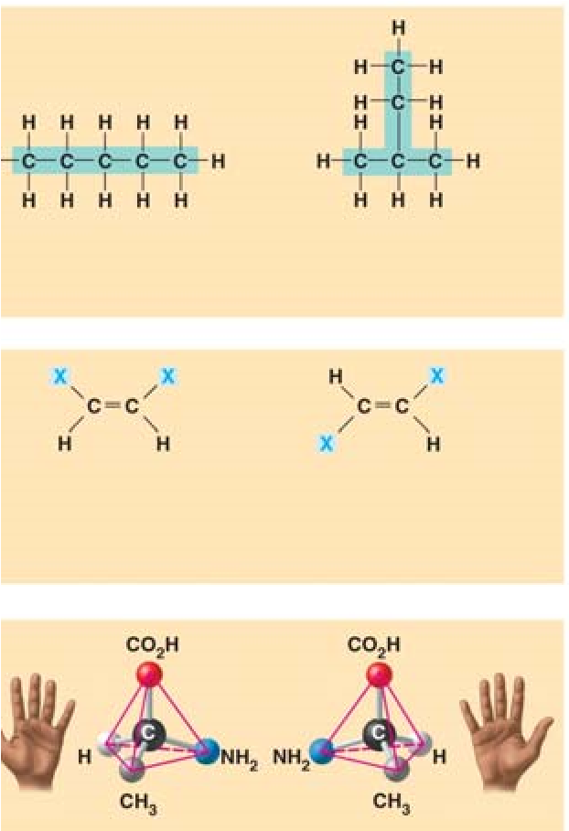
- Use this figure to identify the three types of isomers. For each type, give a key character and an example.

- Give one example of enantiomers that vary in their pharmacological effect.

Concept 4.3 A small number of chemical groups are key to the functioning of biological molecules
- Here is an idea that will recur throughout your study of the function of molecules: Change the structure, change the function. You see this in enantiomers, you will see it in proteins and enzymes, and now we are going to look at testosterone and estradiol. Notice how similar these two molecules are, and yet you know what a vastly different effect each has. Label each molecule in the sketch below and circle the differences.
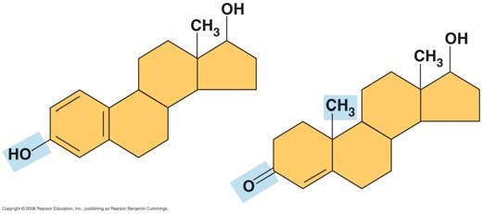

- Define functional group.

- There are seven functional groups. Complete the following chart.

 | Hydroxyl | Carbonyl | Carboxyl | Amino | Sulfhydryl | Phosphate | Methyl
Structure
Example
Functional Properties

- You will need to master the chart and the information in it. Using the functional groups above, see if you can answer the following prompts:

  - –NH₂
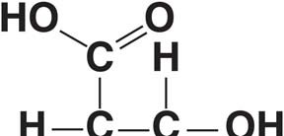
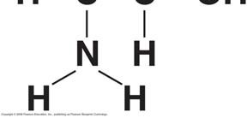
  - Can form cross-links that stabilize protein structure

  - Key component of ATP
  - Can affect gene expression
  - CH₃
  - Is always polar
  - Determines the two groups of sugars
  - Has acidic properties
  - –COOH
  - Acts as a base
  - Circle and identify three functional groups in the molecule shown above.

Testing Your Knowledge: Self-Quiz Answers
Now you should be ready to test your knowledge. Place your answers here:

