AP BIOLOGY 2021-22 March 31, 2022

Today’s Agenda (Day 134)

- Housekeeping Items

- Homework Check:

- Class Activity:
TEST: Ch 54 & 55
*Go to www.socrative.com enter room “MSBAPBIO” enter ID #

HOMEWORK:
- READ: Chapters 43, 45, 49, 50
- STUDY:

REMINDERS:
- TEST: Ch 54 & 55 March 31
AP BIOLOGY 2021-22 READING GUIDE

Chapter 43: The Immune System

Our students consider this chapter to be a particularly challenging and important one. Expect to work your way slowly through the first three concepts. Take particular care with Concepts 43.2 and 43.3. It is rewarding, however, in Concept 43.4 to put your new knowledge to work and truly understand the devastation caused by the destruction of helper T cells by HIV.

Overview: The immune responses of animals can be divided into innate immunity and acquired immunity. As an overview, complete this figure indicating the divisions of both innate and acquired immunity.
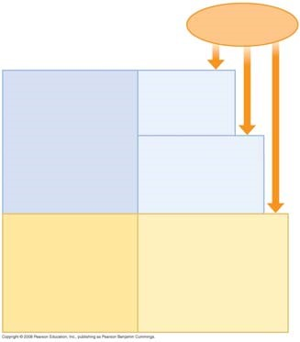

Concept 43.1 In innate immunity, recognition and response rely on shared traits of pathogens

- We first encountered phagocytosis in Concept 7.5, but it plays an important role in the immune systems of both invertebrates and vertebrates. Review the process by briefly explaining the six steps to ingestion and destruction of a microbe by a phagocytic cell.

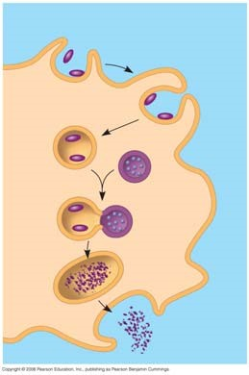

- Explain the role of the Toll receptor in producing antimicrobial peptides.

- List the three innate defenses vertebrates share with invertebrates and the two defenses unique to vertebrates.

- In the chart below, list five examples of barrier defenses and how they work.

Barrier Defense | How the Barrier Repels Pathogens

- Explain how Toll-like receptors are used in cellular innate defenses, using TLR3 and TLR4 as examples.

- In the chart below, explain the role of the four phagocytic cells.

Phagocytic Cell Type | Role in Innate Defense
Neutrophils
Macrophages
Eosinophils
Dendritic cells

- In the figure below, trace the flow of lymph in four stages. For each stage, explain the role of the lymphatic system in innate defense.

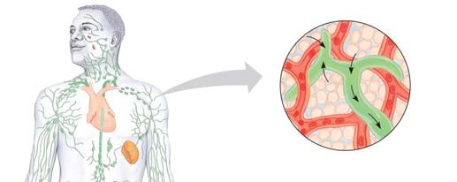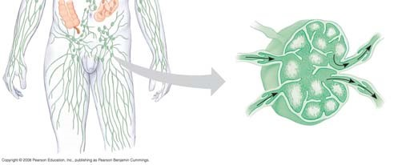

- Explain the role of the following two antimicrobial compounds.
Interferon

Complement

- Use the figure below to explain the three steps of an inflammatory response.
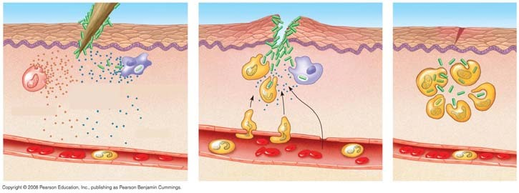

- What role do natural killer cells play in the immune system?

- It might seem like pathogens have little hope of mounting an infection, but do not forget that pathogens are constantly evolving ways to circumvent our immune system. As examples, how do the pathogens that cause pneumonia and tuberculosis avoid our immune responses?

Concept 43.2 In acquired immunity, lymphocyte receptors provide pathogen-specific recognition

- From the first four paragraphs of this concept, summarize where T cells and B cells develop, and give an overview of their functions. (Note that they are a type of white blood cell known as a lymphocyte.)

- What is immunological memory, and why is it important?

- Explain how cytokines help coordinate the innate and acquired immune responses.

- The following brief questions will serve as a primer for immune system recognition.
  - What is an antigen?
  - What is the relationship between an antigen receptor, an antibody, and an immunoglobin?
  - How is an epitope related to an antigen? (Look at Figure 43.10.)

- In the figure of a B cell below, label the antigen-binding sites, light and heavy chains, variable and constant regions, transmembrane region, and disulfide bridges.

- What forms the specific antigen-binding site? (Be sure to note that each B cell produces only one type of antigen receptor. For any one cell, all antigen receptors or antibodies produced are identical.)

- In the figure of a T cell below, label the antigen-binding site, alpha and beta chain, variable and constant regions, transmembrane region, and disulfide bridge.

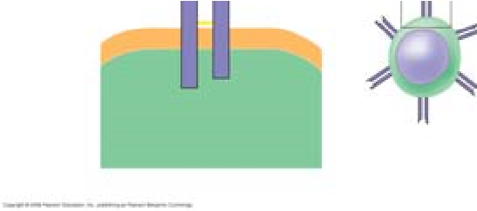

- T cells also display only one type of antigen receptor on the surface of the cell. Compare and contrast a T cell with a B cell.

- B-cell receptors recognize and bind to antigens whether they are free antigens (like a secreted toxin) or on the surface of a pathogen. Explain the role of the major histocompatibility complex (MHC) to T-cell receptor binding.

- Explain how an infected host cell uses the MHC molecule to display an antigen.

- Explain the differences between Class I and Class II MHC molecules, noting type of cells that display the molecule, types of diseases involved with each molecule, and what type of T cell recognizes the MHC molecules.

MHC Class | Displayed by? | Diseases associated with  (cancer, viral or bacterial)? | Recognized by which T cells?
Class I MHC
Class II MHC

- Using Figure 43.12 as a guide, label completely the figure below.

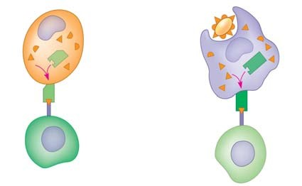
- List three properties of the acquired immune system.

- One of the early problems in immunology was trying to understand how an organism with a limited number of genes (for humans, about 20,500) could produce a million different B-cell protein receptors and 10 million different T-cell protein receptors! The answer resulted in a Nobel Prize and a startling exception to the notion that all cells have exactly the same DNA. Use the figure below to label and explain the four steps involved in producing genetically unique B-cell receptors.

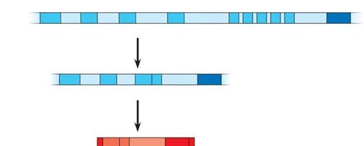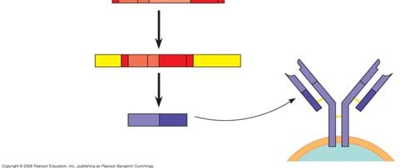

- Explain how the body develops self-tolerance in the immune system.

- Define the following terms.
Effector cells

Memory cells

Clonal selection

- Using the blue text in the margin of Figure 43.14, explain the four key events to clonal selection.

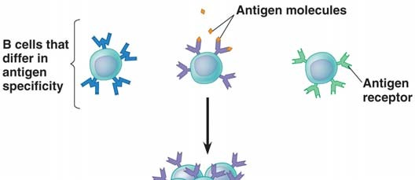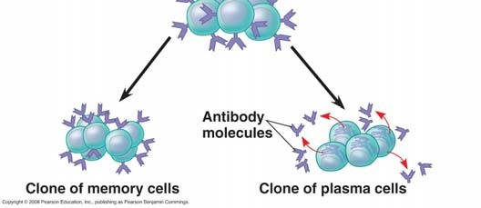

- Graphs similar to the one below have been seen on several AP Biology exams. It depicts the primary and secondary immune response. The first arrow shows exposure to antigen A. The second arrow shows exposure to antigen A again, and also antigen B. Label this graph and then use it to explain the difference between a primary and secondary immune response.

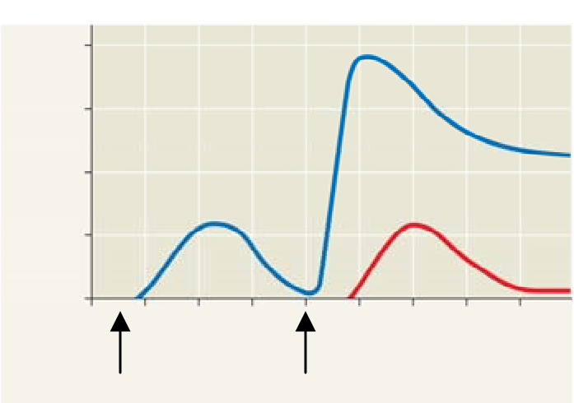

Concept 43.3 Acquired immunity defends against infection of body cells and fluids

- Explain fully the function of the two divisions of acquired immunity.
Humoral immune response

Cell-mediated immune response

- Helper T cells play a critical role in activation of both T cells and B cells. In full detail, label and explain the three steps involved using Figure 43.17. This is an important step!

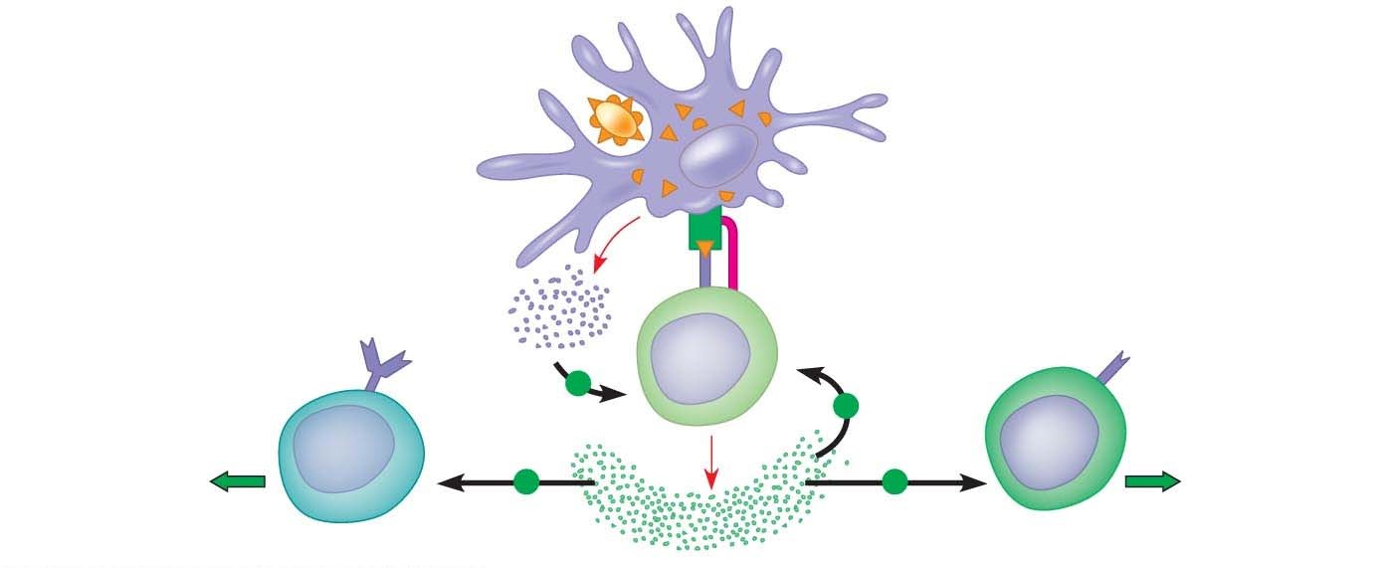
- Explain the role of dendritic cells and macrophages in starting a primary and secondary immune response.

- _________________________________________ are the effector cells in cell-mediated immunity.

- What must occur for a cytotoxic T cell to become activated?

- Completely label the diagram below. Then carefully explain the three primary steps that occur as a cytotoxic T cell destroys a target cell.

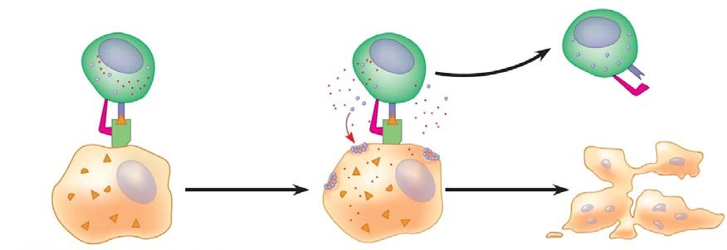
- How is B-cell antigen presentation unique?

- Completely label the diagram below. Then carefully explain the three primary steps that occur in B cell activation.

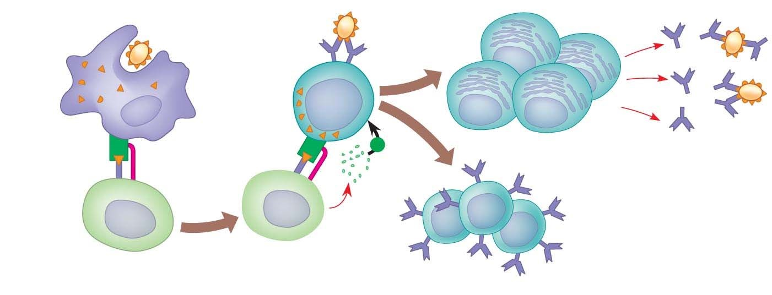
- What is the difference between plasma cells and memory cells produced from the activation of B cells?

- Explain how monoclonal antibodies are used in home pregnancy kits.

- Why is the antibody response to a microbial infection polyclonal?

- Explain these three ways antibodies can dispose of antigens.
Viral neutralization

Opsonization

Activation of complement

- Using examples, explain the difference between active and passive immunity.

- Describe how immunizations can serve as an example of active immunity.

- Why is immune rejection an example of a healthy immune system?

- Briefly describe the following features of immune rejection.
  - Explain how antibodies against blood types are present.

  - What is the role of MHC in tissue and organ transplants?

  - Why are bone marrow transplants medically unique?

Concept 43.4 Disruptions in immune system function can elicit or exacerbate disease

- What are allergies?

- Label Figure 43.23 and then use it to explain a typical allergic response.
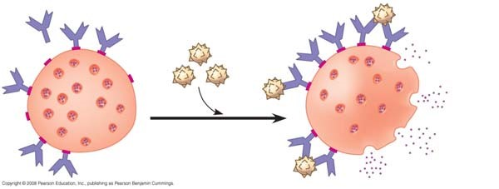
- Explain what happens if a person experiences anaphylactic shock.

- Autoimmune diseases occur when the immune system turns against particular molecules of the body. Describe the cause and symptoms of the following autoimmune diseases.
Lupus

Rheumatoid arthritis

Type 1 diabetes mellitus

Multiple sclerosis

- Explain how immunodeficiency diseases are different from autoimmune diseases.

- Just as our immune system has evolved to thwart pathogens, pathogens have evolved to thwart our immune system. Describe the following pathogen strategies.
Antigenic variation

Latency

Attack on the immune system: HIV

- Explain how the high mutation rate in surface antigen genes in HIV has hampered development of a vaccine for AIDS. (You might take note that HIV—human immunodeficiency virus—is the virus that causes the disease AIDS—acquired immunodeficiency syndrome. These acronyms are often used incorrectly.)

AP BIOLOGY 2021-22 READING GUIDE

Chapter 45: Hormones and the Endocrine System

Overview
- What is a hormone?

- Why does a hormone elicit a response only with target cells?

- The body has two long-distance regulating systems. Which involves chemical signals by hormones?

- What is the other major communication and control system?

Concept 45.1 Hormones and other signaling molecules bind to target receptors, triggering specific response pathways
- Explain the difference between an endocrine gland and an exocrine gland. Give an example of each.

- Several types of secreted signaling molecules are discussed in this chapter. Compare the action of each of the following, and give an example.
hormones
local regulators
neurotransmitters
pheromones
- These figures show five different types of signals. Label and explain each one.
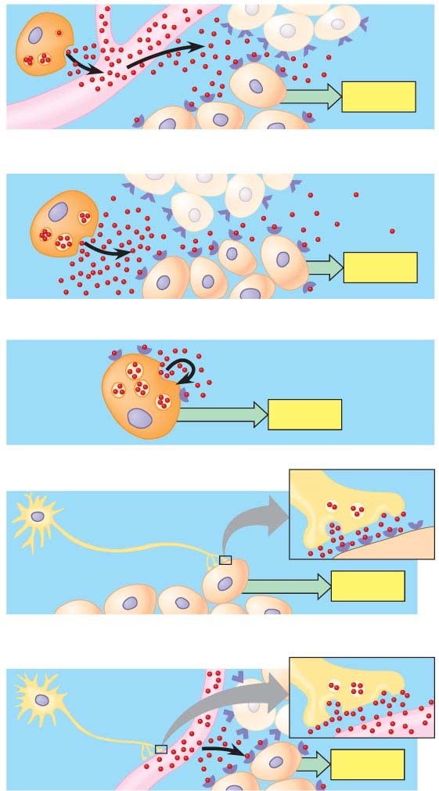
- Recall that target cells have receptors for specific hormones. Where are the receptors for lipid-soluble hormones found?

- Where are the receptors for the water-soluble proteins found? Explain this difference for the two types of hormones.

- Carefully read the section Cellular Response Pathways, and use that information to complete this table.

Hormone Type | Method of Secretion | Mode of Travel in Bloodstream | Location of Receptors | Examples
water-soluble
lipid-soluble

- What endocrine gland secretes epinephrine?

- What are the two intracellular responses in the liver to epinephrine? How do these help the body deal with short-term stress?

- Use the following figure to explain the signal transduction pathway for epinephrine. (You may need to review signal transduction in Chapter 11).
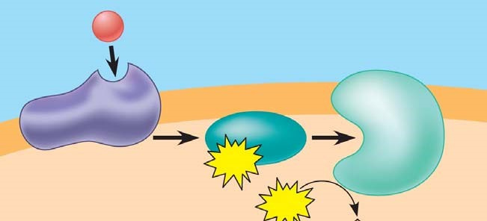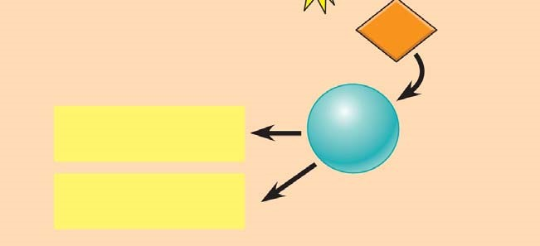
- Lipid-soluble hormones, such as estradiol, bind to intracellular receptors. Explain the action of this steroid in the following figure.

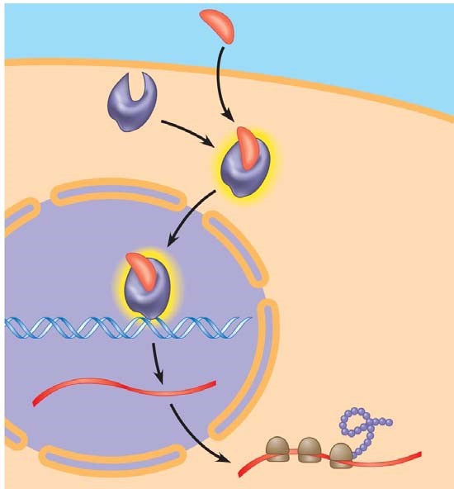
- One hormone can have several different effects. For example, epinephrine can cause the release of glucose from liver cells, dilate blood vessels to skeletal muscles, and constrict intestinal blood vessels. All these effects prepare the body for “fight or flight.” Explain how these multiple effects are possible.

- There are some interesting effects of a couple of local regulators discussed in your text. Explain how the local regulator nitric oxide (NOO) is affected by Viagra, a drug used to treat male erectile dysfunction.

- Now read about prostaglandins and explain why they contribute to menstrual cramps in females.

Concept 45.2 Negative feedback and antagonistic hormone pairs are common features of the endocrine system

- Throughout this course, we have emphasized feedback loops. What occurs in a negative feedback loop?

- Complete the following chart for this pair of antagonistic hormones.

Hormone | Secreted by | Action
insulin
glucagon

Make sure you specifically noted alpha cells or beta cells in the chart above.

- On the AP Biology exam, you will be expected to explain a feedback loop. Use this figure to explain the control of blood glucose by insulin and glucagon. This is a commonly used example, and one you should know.

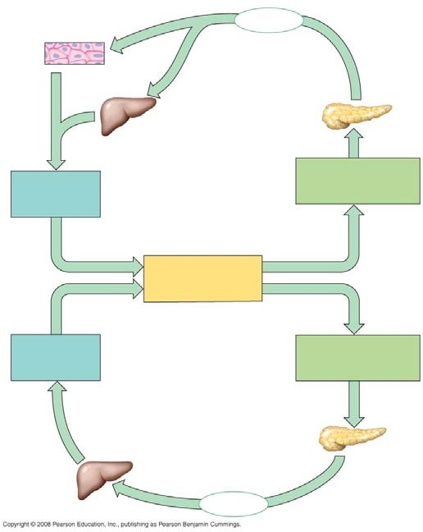

- What occurs in diabetes mellitus?
- Distinguish between type 1 diabetes and type 2 diabetes.

- Which type of diabetes is correlated with obesity?

Concept 45.3 The endocrine and nervous systems act individually and together in regulating animal physiology
- The hypothalamus directly secretes hormones that travel to the posterior pituitary and regulating hormones that affect secretions of hormones by the anterior pituitary. On this sketch, label hypothalamus, anterior pituitary, and posterior pituitary and the two hormones secreted from the posterior pituitary.
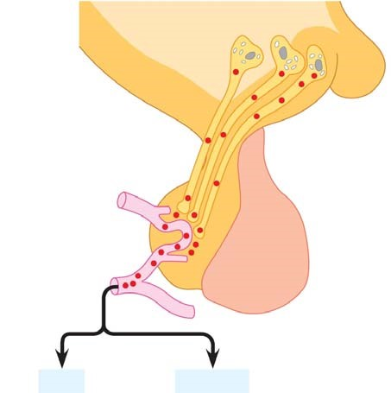

Anterior pituitary hormones
- Return to the figure above, and list the hormones secreted by the anterior pituitary.

- You will find it useful to be able to link hormones with the tissue that secretes them, and know their functions. Pull together the information from this chapter to complete the following chart.

Hormone | Secreted by | Action and/or Effect of Hypo- or Hypersecretion
growth hormone
FSH, LH
TRH
prolactin
 | thyroid
 | parathyroid
 | alpha cells of pancreas
insulin
testosterone
estradiol
cortisone
epinephrine
aldosterone
cortisol

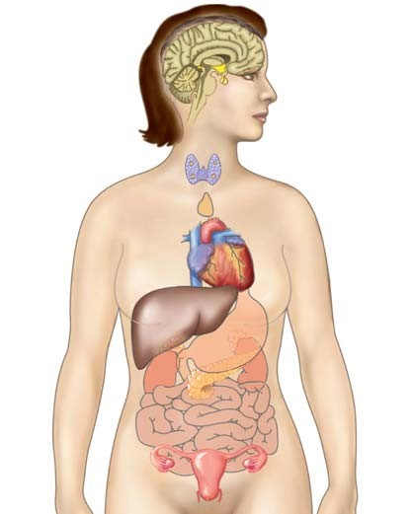

- Let’s pull out a few more details from this section. How is oxytocin an example of a hormone that is under positive regulation?

- What are tropic hormones? Give three examples and tell what each hormone regulates.

- What two hormones are antagonistic controllers of blood calcium levels?

- How does parathyroid hormone (PTH) raise blood calcium? (three ways)

- Why are glucocorticoids effective in treating arthritis? What is the problem with their long-term use?

- The chart you just completed does not cover all the hormones, but it will give you a good start in learning this complex system. To extend this exercise, label the endocrine organs on the figure below and then, next to each organ, list a hormone or hormones secreted by the organ.

