AP BIOLOGY 2021-22 March 16, 2022

Today’s Agenda (Day 123)

- Housekeeping Items

- Homework Check:
Ch 24 & 26 Reading Guides

- Class Activity:
CONT’D: Ch 26 PPT Review
- Section 26.4 – An organism’s evolutionary history is documented in its genome
- Section 26.5 – Molecular clocks help track evolutionary time
- Section 26.6 – Our understanding of the tree of life continues to change based on new data

HOMEWORK:
- READ: Chapters 22 – 26, 52 – 55, 43, 45, 49, 50
- STUDY: Chapter 24 & 26 Test

REMINDERS:

- Ch 24 & 26 Reading Guides [in PAIRS] – March 16
- TEST: Ch 24 & 26 March 17

AP BIOLOGY 2021-22 READING GUIDE

Chapter 24: The Origin of Species

Overview

- What was Darwin’s “mystery of mysteries”?

- Define speciation.

- Distinguish between microevolution and macroevolution.

Concept 24.1 The biological species concept emphasizes reproductive isolation

- Use the biological species concept to define species.

- What is required for the formation of new species?

- What are hybrids?

- Explain the two types of barriers that maintain reproductive isolation.

- The following charts summarize the various ways that reproductive isolation is maintained. Explain and give an example of each type of isolating mechanism.

Prezygotic Reproductive Barriers | Explanation | Example
Habitat isolation
Temporal isolation
Behavioral isolation
Mechanical isolation
Gametic isolation

Postzygotic  Reproductive Barriers | Explanation | Example
Reduced hybrid viability
Reduced hybrid fertility
Hybrid breakdown

- The concept of reproductive isolation is essential for an understanding of speciation, so we are going to have you look at it again. Refer to Figure 24.4 and label the sketch below. Name each type of isolating mechanism.

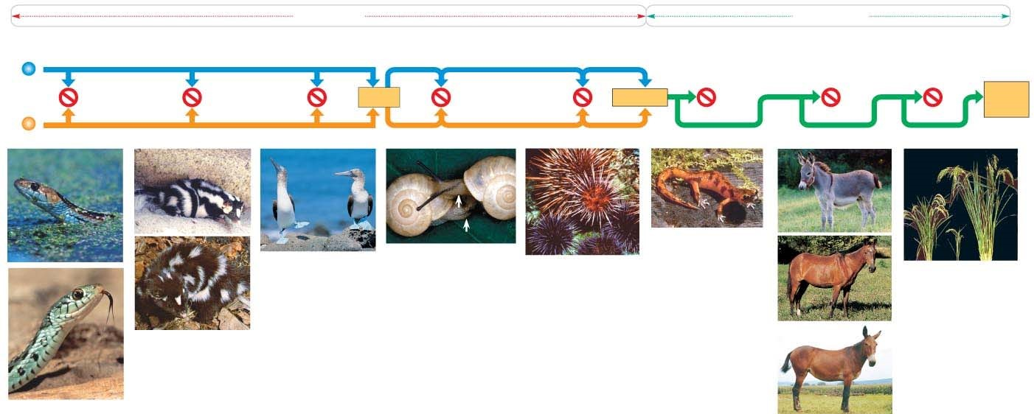

Concept 24.2 Speciation can take place with or without geographic separation

- Gene flow can be interrupted in two main ways. Explain and give an example of each by labeling and annotating this figure, which shows an ancestral species of fish and then the two modes of speciation.
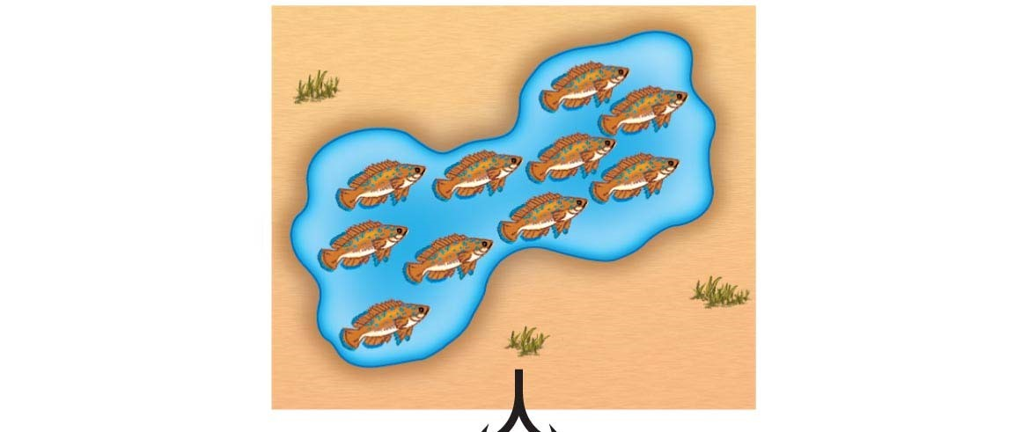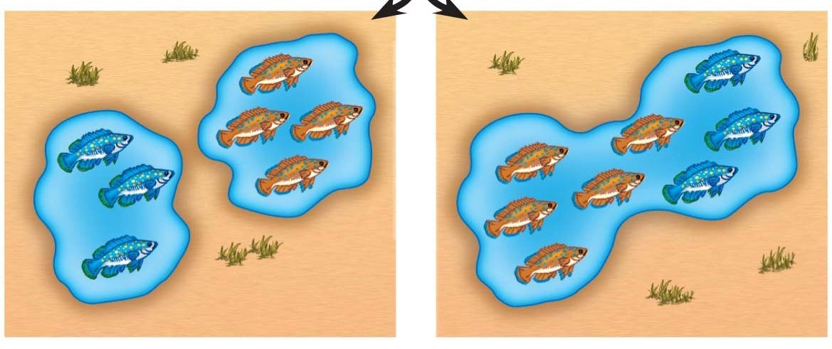

- What type of speciation is caused by a barrier such as the Grand Canyon?
____________________.
- Sympatric speciation occurs in populations that live in the same geographic area. How is this possible?

- Your response to question 13 should have listed polyploidy, habitat differentiation, and sexual selection. These are not easy concepts to understand, so let’s spend some time with each of them. To begin, use the following figure to explain autopolyploidy.

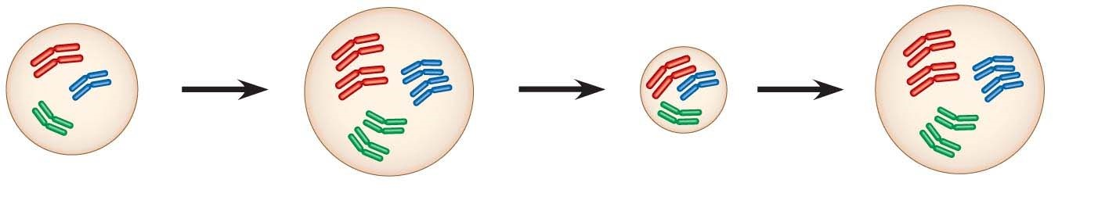

- Now, use this figure to explain allopolyploid speciation.

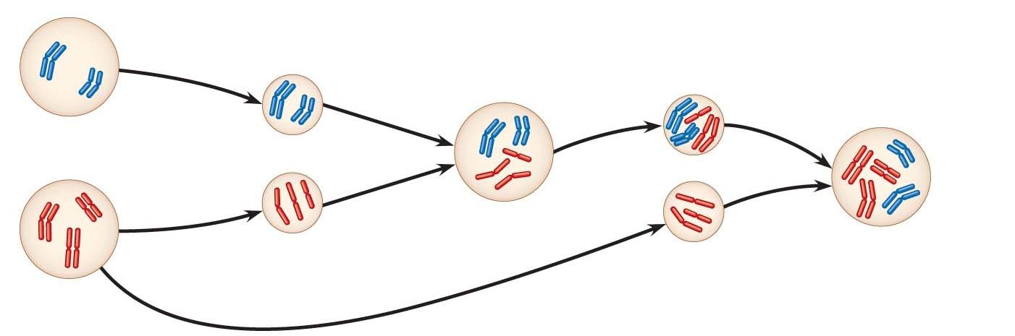

- Before we leave allopatric and sympatric speciation, explain what happens in sexual selection, and how this process can drive sympatric speciation.

Concept 24.3 Hybrid zones provide opportunities to study factors that cause reproductive isolation

- What are hybrid zones?

Concept 24.4 Speciation can occur rapidly or slowly, and it can result from changes in few or many genes

- Stephen Jay Gould and Niles Eldredge coined the term punctuated equilibria. What is meant by a punctuated pattern?

- This figure shows 2 different views of speciation. Label this figure, and explain how each of the pictures explains speciation.

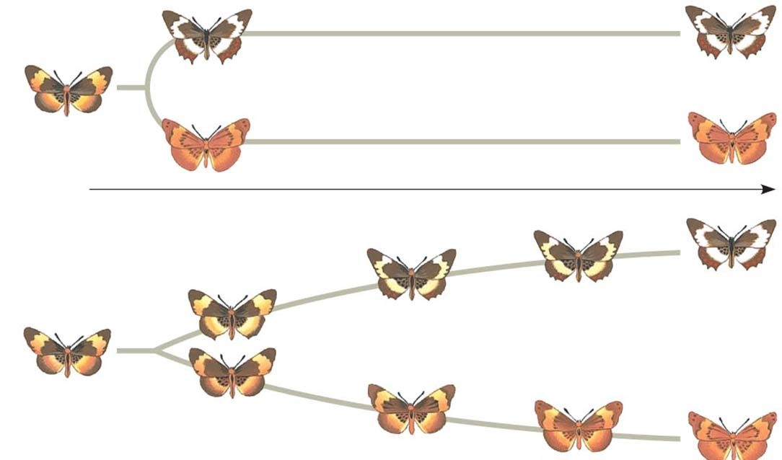

AP BIOLOGY 2021-22 READING GUIDE

Chapter 26: Phylogeny and the Tree of Life

Overview
1. What is systematics? How is it used to develop phylogenetic trees?

Concept 26.1 Phylogenies show evolutionary relationships
- What is taxonomy?

- Every organism on Earth may be referred to by a unique binomial, or a two-part name. These are in Latin, or Latinized. What is your binomial? What does it mean?

- What are the two components of every binomial?

- Taxonomy uses hierarchical categories that nest within each other, like Russian dolls. The figure below shows the categories, each called a taxon. Label each taxonomic category, in the boxes, and then give the one that applies exclusively to this panther to the side of each box.

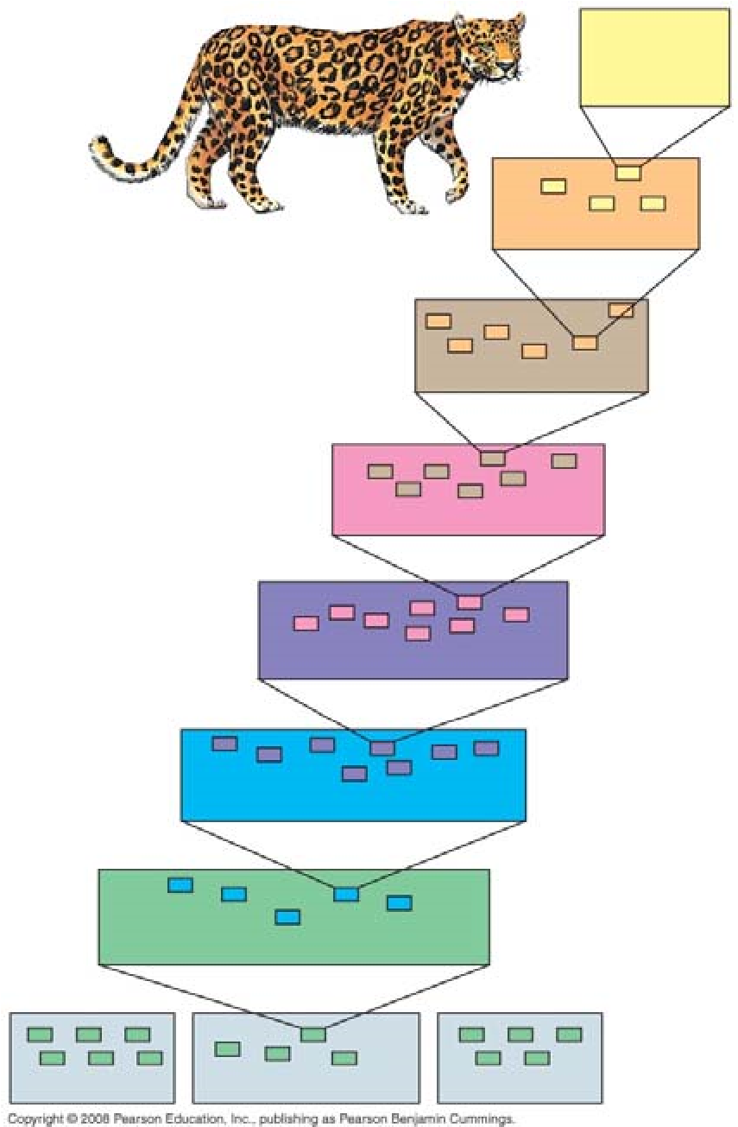

You will notice that the most general category, domain, the one that encompasses the most organisms, is shown at the bottom of the figure. As you move up in the figure, the organisms show greater and greater degrees of relatedness. You are expected to memorize these taxonomic categories in order! Most students use a mnemonic device linked to the first letter of each taxon to remember them. Make up your own, or try ours:

D K P C O F G S or Dear King Phillip Comes Over For Good Spaghetti

(You may choose to have King Philip come over for something else—whatever you can remember best!)

- So, which are more closely related, organisms in the same phylum, or those in the same order? _________

- Here is a phylogenetic tree. Recall that branch points represent common ancestors of the two lineages beyond the branch or node. Circle the common ancestor of badgers and otters, and label it as A. Circle the common ancestor of cats and dogs, and label it as B.

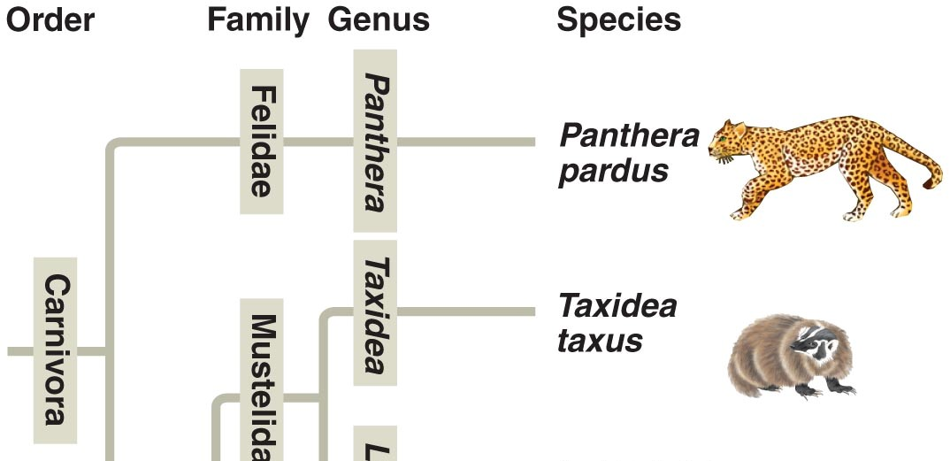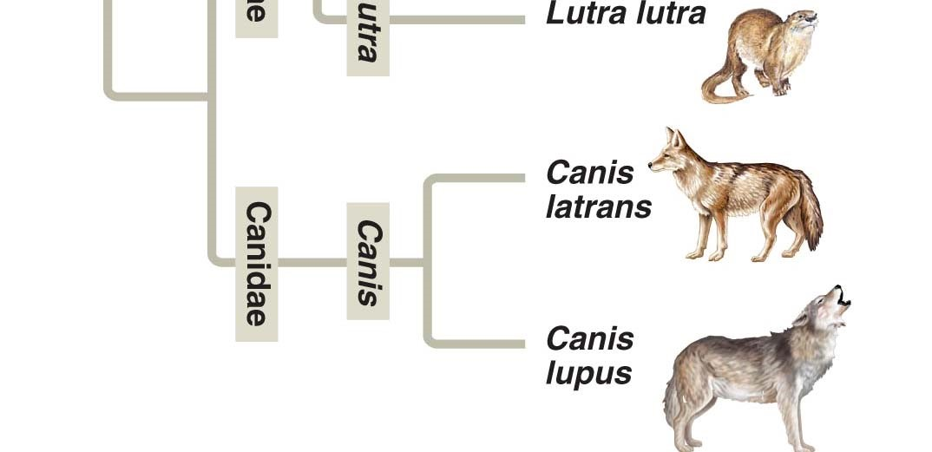

Concept 26.2 Phylogenies are inferred from morphological and molecular data

Let’s look back at a Study Tip from Chapter 22. This idea is repeated in our current chapter.
Study Tip
Homologous structures show evidence of relatedness. (whale fin, bat wing)
Analogous structures are similar solutions to similar problems but do not indicate close relatedness. (bird wing, butterfly wing)

8. Molecular systematics is a valuable tool used today to sort homology from analogy. What is it?

Concept 26.3 Shared characters are used to construct phylogenetic trees
- Below are three cladograms. What is a clade? Circle a clade that is not highlighted below.

- Why is Group I monophyletic?

- Explain why Group II is paraphyletic.

- What is a polyphyletic group?

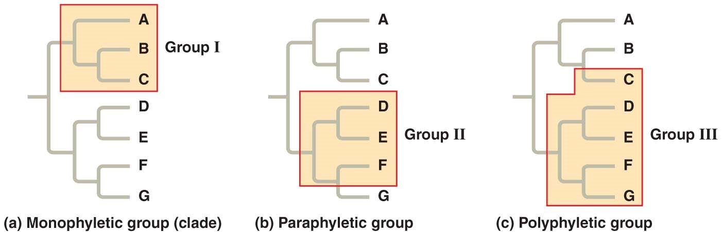

- Clades are derived by using shared derived characters. What are these?

- Explain why for mammals, hair is a shared derived character, but a backbone is not.

Concept 26.4 An organism’s evolutionary history is documented in its genome
Let’s summarize some important information from this section. The rate of evolution of DNA sequences varies from one part of the genome to another; therefore, comparing different sequences helps us to investigate relationships between groups of organisms that diverged a long time ago. For example, DNA that codes for ribosomal RNA (rRNA) changes relatively slowly and is useful for investigating relationships between taxa that diverged hundreds of millions of years ago. DNA that codes for mitochondrial DNA (mtDNA) evolves rapidly and can be used to explore recent evolutionary events.

- Which method reveals that fungi are more closely related to animals than to green plants?

- Which method reveals that the Pima of Arizona and Yanomami of Venezuela are descendants of the same Native Americans that crossed the Bering Land Bridge 13,000 years ago?

Concept 26.5 Molecular clocks help track evolutionary time
- What are molecular clocks?

- If we use a molecular clock, approximately when did HIV emerge?

Concept 26.6 New information continues to revise our understanding of the tree of life
Taxonomy is in flux! When your authors were in high school, we were taught there were two kingdoms: plants and animals. Then in our college courses, we were introduced to five kingdoms: Monera, Protista, Plantae, Fungi, and Animalia. Now biologists have adopted a three-domain system, which consists of the domains Bacteria, Archaea, and Eukarya. This system arose from the finding that there are two distinct lineages of prokaryotes.
EUKARYA
ARCHAEA

BACTERIA

- On the figure above, place an arrow at the point showing the common ancestor of all three domains.

- What two domains include all prokaryotes? Which two domains are most closely related?

- Which kingdom is made obsolete by the three-domain system? Why?

- Which kingdom crumbled because it is polyphyletic?

