AP BIOLOGY 2021-22 September 2, 2021

Today’s Agenda (Day 12)

- Housekeeping Items
REQUEST FOR ITEMS: a) Cake in a Mug this Friday
- Homework Check:
Chapter 2 Reading Guide
- Class Activity:
TEST: Chapter 1 & 2
*Go to www.socrative.com enter room “MSBAPBIO” enter ID #

FRIDAY: Cake in a Mug AND Ice Cream in a Bag please indicate who is bringing what!!

Base Ingredients
2 cups whole milk
1/2 cup granulated sugar
1 tablespoon vanilla extract
10 cups ice
8 tablespoons rock salt

*20 - Sandwich-size resealable plastic bag
*10 – Quart-size resealable plastic bag
*2 – 4-quart food storage container with lid (to facilitate the shaking process)
*1 – mixing bowl
*1 – spatula
*plastic spoons

Mint Chocolate Chip Ice Cream:
1 tablespoons mini semisweet chocolate chips
1/4 teaspoon peppermint extract

Chocolate Ice Cream:
1 tablespoon unsweetened cocoa powder

Strawberry Ice Cream:
1 tablespoons chopped strawberries (from about 2 strawberries)

HOMEWORK:
- READ: Chapters 4 - 6
- COMPLETE: Chapter 3 Reading Guide
- MEMORIZE: Chemical elements and polyatomic ions – see p. 2 -3 of document

Chapter 3Vocabulary
Acid | Adhesion | Aqueous solution | Base | Buffer | Calorie
Cohesion | Evaporative cooling | Heat | Heat of vaporization | Hydration shell | Hydrogen ion
Hydronium ion | Hydrophilic | Hydrophobic | Hydroxide ion | Joule | Kilocalorie
Kinetic energy | Molarity | Molecular mass | Ocean acidification | pH | Polar molecule
Solute | Solution | Solvent | Specific heat | Surface tension | Temperature
Thermal energy

Chapter 4Vocabulary
adenosine triphosphate | amino group | asymmetric carbon | carbonyl group | carboxyl group
cis isomers | enantiomers | ethane | ethene | functional groups
hydrocarbons | hydroxyl group | isomers | methane | methyl group
organic chemistry | phosphate group | structural isomers | sulfhydryl group | trans isomer

REMINDERS:
- TEST: Ch 1 & 2 Sept. 1
- Chapter 3 Reading Guide – Sept. 4, 11:59:59 pm
- TEST: Ch 3 & Chemical Symbols Sept. 8

AP BIOLOGY 2021-22 CHEMISTRY REVIEW
POLYATOMIC IONS TO MEMORIZE
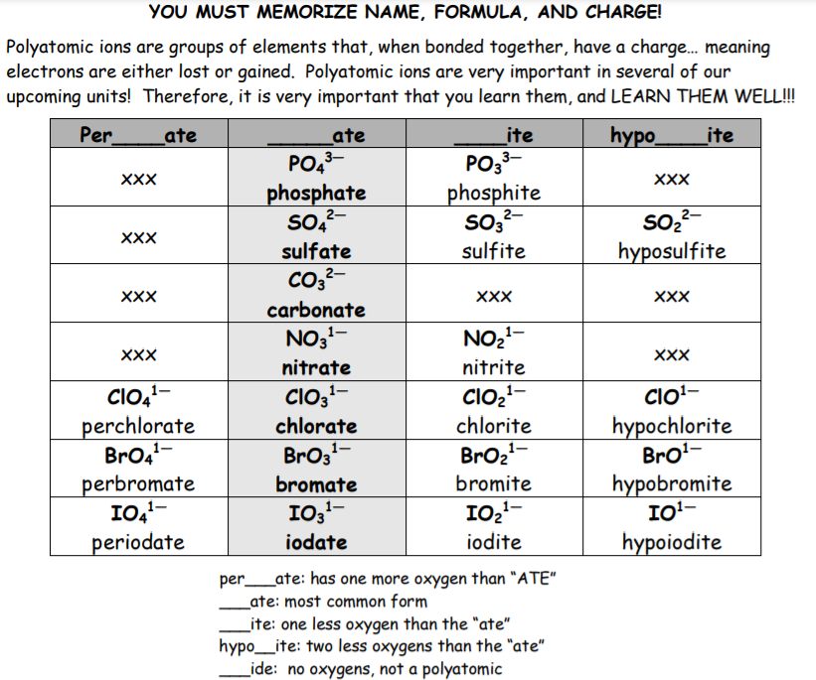
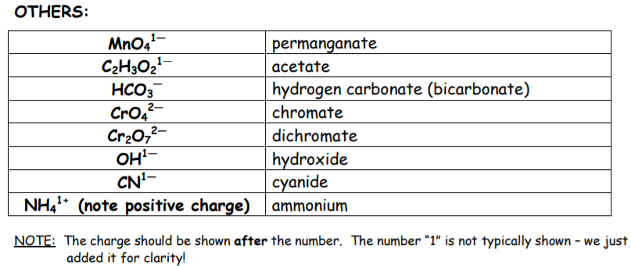
AP BIOLOGY 2021-22 CHEMISTRY REVIEW

Important elements
DIRECTIONS: Find the ionic charge for each of the elements listed below. Then memorize the element name, chemical symbol and ionic charge.

Symbol | Name | Ionic Charge | Symbol | Name | Ionic Charge | Symbol | Name | Ionic Charge
Al | Aluminum |  | F | Fluorine |  | O | Oxygen
As | Arsenic |  | Au | Gold |  | P | Phosphorus
Ba | Barium |  | He | Helium |  | Pt | Platinum
Be | Beryllium |  | H | Hydrogen |  | K | Potassium
B | Boron |  | Fe | Iron |  | Si | Silicon
Cd | Cadmium |  | Pb | Lead |  | Ag | Silver
Ca | Calcium |  | Mg | Magnesium |  | Na | Sodium
C | Carbon |  | Mn | Manganese |  | Sr | Strontium
Cl | Chlorine |  | Mo | Molybdenum |  | S | Sulfur
Cr | Chromium |  | Ne | Neon |  | Ti | Titanium
Co | Cobalt |  | Ni | Nickel |  | U | Uranium
Cu | Copper |  | N | Nitrogen |  | Zn | Zinc

AP BIOLOGY 2021-22 READING GUIDE

Chapter 3: Water and the Fitness of the Environment

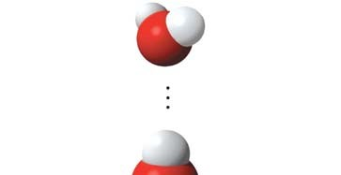
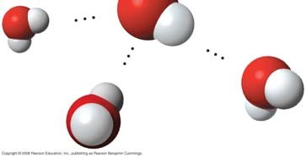
Concept 3.1 The polarity of water molecules results in hydrogen bonding

- Study the water molecules at the right. On the central molecule, label oxygen (O) and hydrogen (H).

- What is a polar molecule? Why is water considered polar?

- Now, add + and – signs to indicate the charged regions of each molecule. Then, indicate the hydrogen bonds.

- Explain hydrogen bonding. How many hydrogen bonds can a single water molecule form?

Concept 3.2 Four emergent properties of water contribute to Earth’s fitness for life

Hydrogen bonding accounts for the unique properties of water. Let’s look at several.

Cohesion

- Distinguish between cohesion and adhesion.

- What is demonstrated when you see beads of water on a waxed car hood?

- Which property explains the ability of a water strider to walk on water?

Moderation of Temperature

- The calorie is a unit of heat. Define calorie.

- Water has high specific heat. What does this mean? How does water’s specific heat compare to alcohol’s?

- Explain how hydrogen bonding contributes to water’s high specific heat.

- Summarize how water’s high specific heat contributes to the moderation of temperature. How is this property important to life?

- Define evaporation. What is heat of vaporization? Explain at least three effects of this property on living organisms.

Expansion upon Freezing

- Ice floats! So what? Consider what would happen if ponds and other bodies of water accumulated ice at the bottom. Describe why this property of water is important.

- Now, explain why ice floats. Why is 4ºC the critical temperature in this story?

Solvent of Life

- Review and define these terms: solvent solution solute
- Consider coffee to which you have added sugar. Which is the solvent? The solute?

- Explain why water is such a fine solvent.

- Define hydrophobic and hydrophilic.

- You already know that some materials, such as olive oil, will not dissolve in water. In fact, oil will float on top of water. Explain this property in terms of hydrogen bonding.

- Now, let’s do a little work that will enable you to prepare solutions. Read the section on solute concentrations carefully and show the calculations here for preparing a 1-molar solution of sucrose. Steps to help you do this follow. The first step is done for you. Fill in the rest.

Steps to prepare a solution:

  - Write the molecular formula. C₁₂H₂₂O₁₁

  - Use your periodic table to calculate the mass of each element. Multiply by the number of atoms of the element. (For example, O has a mass of 16. Therefore, one mole of O has a mass of 16 x 11 = 176 g/mole.)

  - Add the masses of each element in the molecule.

  - Add this mass of the compound to water to bring it to a volume of 1 liter. This makes 1 liter of a 1-M (1 molar) solution.

- Can you prepare 1 liter of a 0.5-molar glucose solution? Show your work here.

- Define molarity.

Concept 3.3 Acidic and basic conditions affect living organisms

- What two ions form when water dissociates?

You should have answered “hydronium (H₃O+) and hydroxide ions (OH–)” in the preceding question. However, by convention, we will represent the hydronium ion as H+.

- What is the concentration of each ion in pure water at 25ºC?

- Water has a pH of 7. pH is defined as the negative log of the hydrogen ion concentration [H+]. Can you now see how water is assigned a pH of 7?

- To go a step further, the product of H+ and OH– concentrations is constant at 10^{–14}.
[H+}[OH–} = 10^{–14.}
Water, which is neutral with a pH of 7, has an equal number of H+ and OH– ions. Now, define acid

base

- Because the pH scale is logarithmic, each numerical change represents a 10X change in ion concentration.

  - So, how many times more acidic is a pH of 3 compared to a pH of 5?

  - How many times more basic is a pH of 12 compared to a pH of 8?

  - Explain difference between a pH of 8 and a pH of 12 in terms of H+ concentration.

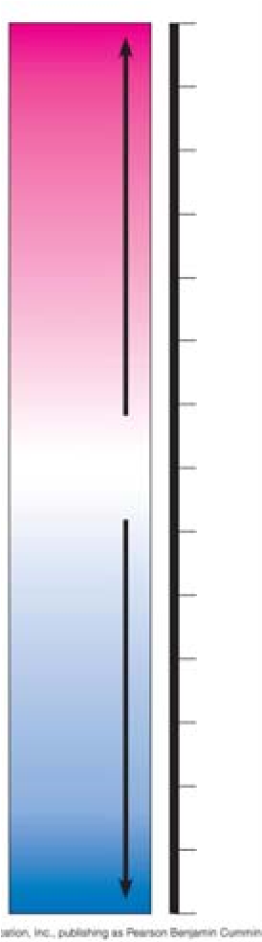
- On the pH chart, label pH 1–14. Label neutral, acid, base. Indicate the locations of pure water, urine, gastric juice, and bleach.

- Even a slight change in pH can be harmful! How do buffers moderate pH change?

- Exercise will result in the production of CO₂, which will acidify the blood. Explain the buffering system that minimizes blood pH changes.

- Acid precipitation is increasing. Explain its sources.

- Discuss how CO₂ emissions affect marine life and ecosystems.

Testing Your Knowledge: Self-Quiz Answers
Now you should be ready to test your knowledge. Place your answers here:

