AP BIOLOGY 2021-22 March 9, 2022

Today’s Agenda (Day 118)

- Housekeeping Items

- Homework Check:
Ch 22 & 23 Reading Guides [in PAIRS]

- Class Activity:
CONT’D: Ch 23 PPT REVIEW
- Section 23.1 – Genetic variation makes evolution possible
- Section 23.2 – The Hardy-Weinberg equation can be used to test whether a population is evolving
- Section 23.3 – Natural selection, genetic drift, and gene flow can alter allele frequencies in a population
- Section 23.4 – Natural selection is the only mechanism that consistently causes adaptive evolution

HOMEWORK:
- READ: Chapters 19-20, 22 - 26
- STUDY: Chapter 22 & 23 Test

REMINDERS:

- Ch 22 & 23 Reading Guides [in PAIRS] – March 9
- TEST: Ch 22 & 23 March 10
- Ch 24 & 26 Reading Guides [in PAIRS] – March 16
- TEST: Ch 24 & 26 March 17

AP BIOLOGY 2021-22 READING GUIDE

Chapter 22: Descent with Modification: A Darwinian View of Life

As you study this chapter, read several paragraphs at a time to catch the flow of ideas and understand the reasoning that is being described. In some places, the text describes a narrative or story of events that led to Darwin’s theory of evolution. Therefore, first read the narrative to absorb the big picture and then return to answer the few questions that accompany this material.

Overview

1. Define evolution broadly and then give a narrower definition, as discussed in the overview.

Concept 22.1 The Darwinian revolution challenged the traditional view of a young Earth inhabited by unchanging species

This section looks at the historical setting and influences on Darwin, and it sets the stage for our formal study of evolution.

2. How did each of the following sources view the origin of species?
Aristotle and Scala Naturae

The Old Testament

Carolus Linnaeus

Georges Cuvier

- Explain the role of fossils in rock strata as a window to life in earlier times.

- How would Georges Cuvier have explained the appearance of the record of life shown in the rock strata?

- James Hutton and Charles Lyell were geologists whose ideas strongly influenced Darwin’s thinking. What were the ideas each of them contributed?
James Hutton

Charles Lyell

- What is the importance of the principle of uniformitarianism?

- Jean-Baptiste de Lamarck proposed a mechanism for how life changes over time. Explain the two principles of his mechanism.
use and disuse

inheritance of acquired characteristics

- Although Lamarck’s mechanism of evolution does not explain the changes in species over time, his thinking has been influential. What is considered to be the great importance of his ideas?

Concept 22.2 Descent with modification by natural selection explains the adaptations of organisms and the unity and diversity of life

- Charles Darwin proposed that the mechanism of evolution is natural selection and that it explains how adaptations arise. What are adaptations? Give two examples of adaptations.

- Explain the process of natural selection.

- Let’s try to summarize Darwin’s observations that drive changes in species over time:

Observation | Cite an Example
1. Variations in traits exist.

2. These variations (traits) are heritable.

3. Species overproduce.
4. There is competition for resources; not all offspring survive.

- From these four observations, which two inferences did Darwin make?

- It is important to remember that differences in heritable traits can lead to differential reproductive success. This means that the individuals who have the necessary traits to promote survival in the current environment will leave the most offspring. What can this differential reproductive success lead to over time?

- To demonstrate your understanding of this section, complete the following sentences:

_____________________ do not evolve. ______________________ evolve.

Now, take out your highlighter and mark the information in the box above. Hold these ideas firmly in your brain! Finally, if you are ever asked to explain Darwin’s theory of evolution by natural selection (a common AP essay question), do not pull out the phrase “survival of the fittest.” Instead, cite the points made in question 11 and explain the inferences that are drawn from them.

Concept 22.3 Evolution is supported by an overwhelming amount of scientific evidence

- Use Figure 22.13 to explain how John Endler’s work with guppies demonstrated observable evolutionary change.
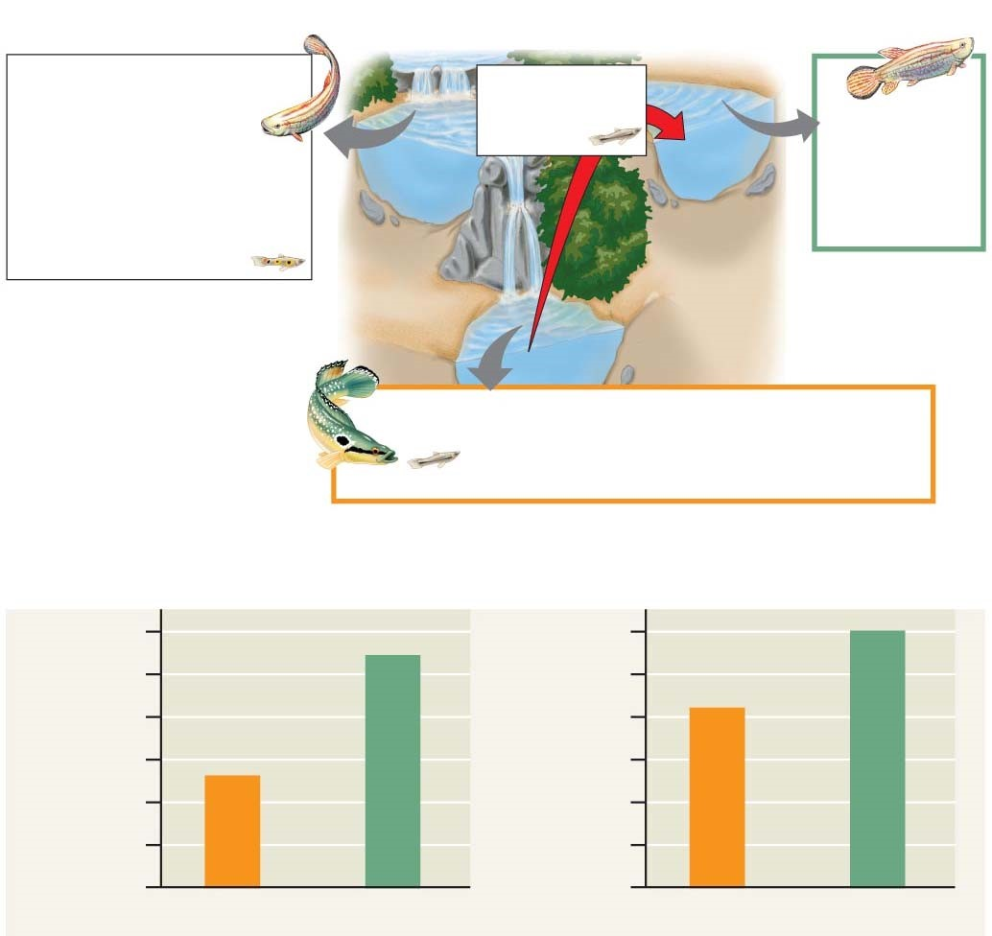

- What is the role of 3TC in inhibiting HIV reproduction?

- Explain the evolution of drug resistance to 3TC.

- Do antibiotics cause bacteria to become resistant? Explain your response.

- Let’s make a list of the four evidences for evolution that are described in this concept.

Evidence for Evolution

- How does the fossil record give evidence for evolution?

- What is meant by each of the following terms? Give an example of each.

Term | Example
Homologous structures
Vestigial structures
Analogous structures (see p. 465)

- How do homologous structures give evidence for evolution?

- What is summarized in an evolutionary tree?

- Figure 22.19 shows an evolutionary tree. What is indicated by each branch point? Mark each branch point.

- What is indicated by the hatch marks?

- Use the tree below to answer this question: Are crocodiles more closely related to lizards or to birds? Explain your response.

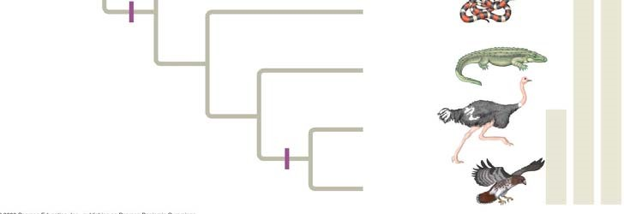

- On the evolutionary tree, label the vertical lines to the right, and annotate the key feature that marks each group.
- Organisms that are only distantly related can resemble each other. Explain convergent evolution and describe how analogous structures can arise.

- Convergent evolution might be summarized like this: Similar problem, similar solution. Can you give two examples of convergent evolution?

Study Tip
Homologous structures show evidence of relatedness. (whale fin, bat wing)
Analogous structures are similar solutions to similar problems but do not indicate close relatedness. (bird wing, butterfly wing)

- What is biogeography? How is it affected by continental drift and the presence of endemic species?

Let’s wrap up all of these ideas with a final summary.

ORGANIZE YOUR THOUGHTS

- Evolution is change in species over time.
- Heritable variations exist within a population.
- These variations can result in differential reproductive success.
- Over generations, this can result in changes in the genetic composition of the population.

And remember: Individuals do not evolve! Populations evolve.

AP BIOLOGY 2021-22 READING GUIDE

Chapter 23: The Evolution of Populations

This chapter begins with the idea that we focused on as we closed the last chapter: Individuals do not evolve! Populations evolve. The Overview looks at the work of Peter and Rosemary Grant with Galápagos finches to illustrate this point, and the rest of the chapter examines the change in populations over time. As in the last chapter, first read each concept to get the big picture and then go back to work on the details presented by our questions. Don’t lose sight of the conceptual understanding by getting lost in the details!

Overview

- What is microevolution?

- What are the three main mechanisms that can cause changes in allele frequency?

- Which is the only mechanism that is adaptive, or improves the match between organisms and their environment?

Concept 23.1 Mutation and sexual reproduction produce the genetic variation that makes evolution possible

- Because Darwin did not know about the work of Gregor Mendel, he could not explain how organisms pass heritable traits to their offspring. In looking at genetic variation, what are discrete characters, and what are quantitative characters?

- Using the techniques of molecular biology, what are the two ways of measuring genetic variation in a population?

- Geographic variation may be shown in a graded manner along a geographic axis known as a cline. What external factors might produce a cline? Why does the existence of a cline suggest natural selection?

- What is the ultimate source of new alleles?

- Mutations are any change in the nucleotide sequence of an organism’s DNA. These mutations provide the raw material from which new traits may arise and be selected. What occurs in a point mutation?

- What is translocation? How could it be beneficial?

- How does gene duplication occur? How might it play a role in evolution?

- Much of the genetic variation that makes evolution possible comes through sexual reproduction. What are the three mechanisms by which sexual reproduction shuffles existing alleles?

Concept 23.2 The Hardy-Weinberg equation can be used to test whether a population is evolving

- What is a population?

- What is a gene pool?

- The greater the number of fixed alleles, the lower the species’ diversity. What does it mean to say that an allele is fixed?

- The Hardy-Weinberg principle is used to describe a population that is not evolving. What does this principle state?

- If the frequency of alleles in a population remains constant, the population is at Hardy Weinberg equilibrium. There are five conditions for Hardy-Weinberg equilibrium. It is very important for you to know these conditions, so enter them neatly into the box below.

CONDITIONS FOR HARDY-WEINBERG EQUILIBRIUM
1.
2.
3.
4.
5.

It is not very likely that all five of these conditions will occur, is it? Allelic frequencies change. Populations evolve. This data can be tested by applying the Hardy Weinberg equation. Let’s look at how to do this.
Equation for Hardy-Weinberg Equilibrium
p² + 2pq + q² = 1
Where p² is equal to the frequency of the homozygous dominant in the population, 2pq is equal to the frequency of all the heterozygotes in the population, and q² is equal to the frequency of the homozygous recessive in the population.

Consider a gene locus that exists in two allelic forms, A and a, in a population.

Let p = the frequency of A, the dominant allele

and q = the frequency of a, the recessive allele.

So, p² = AA,
q² = aa,
2pq = Aa

If we know the frequency of one of the alleles, we can calculate the frequency of the other allele:
p + q = 1, so p = 1 – q q = 1 – p
- So, here is a problem to try. Suppose in a plant population that red flowers (R) are dominant to white flowers (r). In a population of 500 individuals, 25% show the recessive phenotype. How many individuals would you expect to be homozygous dominant and heterozygous for this trait? (A complete solution for this problem is at the end of this Reading Guide.)

- In a population of plants, 64% exhibit the dominant flower color (red), and 36% of the plants have white flowers. What is the frequency of the dominant allele? (There are a couple of twists in this problem, so read and think carefully. A complete solution for this problem is at the end of this Reading Guide.)

Concept 23.3 Natural selection, genetic drift, and gene flow can alter allele frequencies in a population

- First, let’s try to summarize the big idea from this section. Scan through the entire concept to pull out this information. Three major factors alter allelic frequency and bring about evolutionary change. List each factor and give an explanation.

Factor | Explanation

- Which of the factors above results in a random, nonadaptive change in allelic frequencies?

- Which of the factors above tends to reduce the genetic differences between populations and make populations more similar?

- Of the three factors you listed above, only one results in individuals that are better suited to their environment. Which is it?

- Explain what happens in each of these examples of genetic drift:

founder effect

bottleneck effect

Concept 23.4 Natural selection is the only mechanism that consistently causes adaptive evolution

- In evolutionary terms, fitness refers only to the ability to leave offspring and contribute to the gene pool of the next generation. It may have nothing to do with being big, or strong, or aggressive. Define relative fitness.

- What is the relative fitness of a sterile mule? _______________________________________

- Figure 23.13 is important because it helps explain the three modes of selection. Label each type of selection and fill in the chart to explain what is occurring.

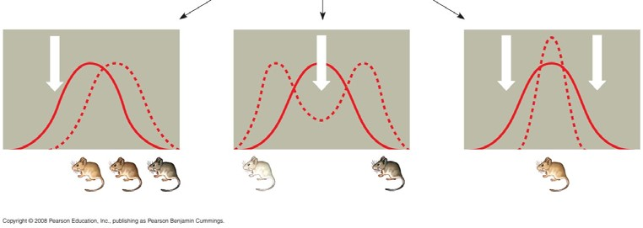
Type of Selection | How It Works
Stabilizing
Directional
Disruptive

- What is often the result of sexual selection?

- What is the difference between intrasexual selection and intersexual selection? Give an example of each type of selection.

- Explain two ways in which genetic variation is preserved in a population.

- Discuss what is meant by heterozygote advantage and use sickle-cell anemia as an example.

Finally, give four reasons why natural selection cannot produce perfect organisms.

AP BIOLOGY 2021-22 READING GUIDE

Chapter 24: The Origin of Species

Overview

- What was Darwin’s “mystery of mysteries”?

- Define speciation.

- Distinguish between microevolution and macroevolution.

Concept 24.1 The biological species concept emphasizes reproductive isolation

- Use the biological species concept to define species.

- What is required for the formation of new species?

- What are hybrids?

- Explain the two types of barriers that maintain reproductive isolation.

- The following charts summarize the various ways that reproductive isolation is maintained. Explain and give an example of each type of isolating mechanism.

Prezygotic Reproductive Barriers | Explanation | Example
Habitat isolation
Temporal isolation
Behavioral isolation
Mechanical isolation
Gametic isolation

Postzygotic  Reproductive Barriers | Explanation | Example
Reduced hybrid viability
Reduced hybrid fertility
Hybrid breakdown

- The concept of reproductive isolation is essential for an understanding of speciation, so we are going to have you look at it again. Refer to Figure 24.4 and label the sketch below. Name each type of isolating mechanism.

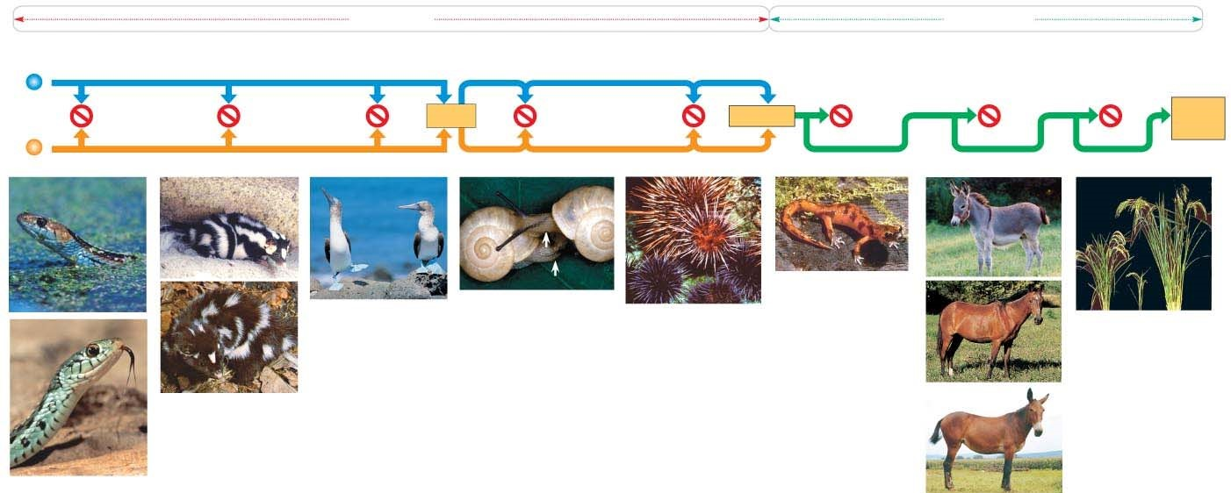

Concept 24.2 Speciation can take place with or without geographic separation

- Gene flow can be interrupted in two main ways. Explain and give an example of each by labeling and annotating this figure, which shows an ancestral species of fish and then the two modes of speciation.
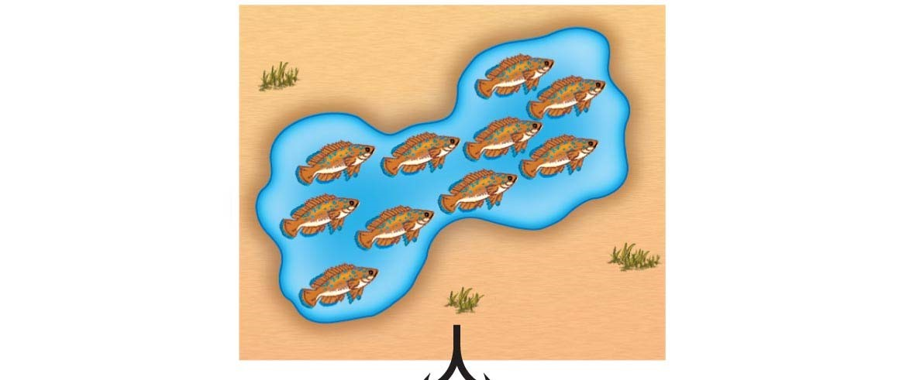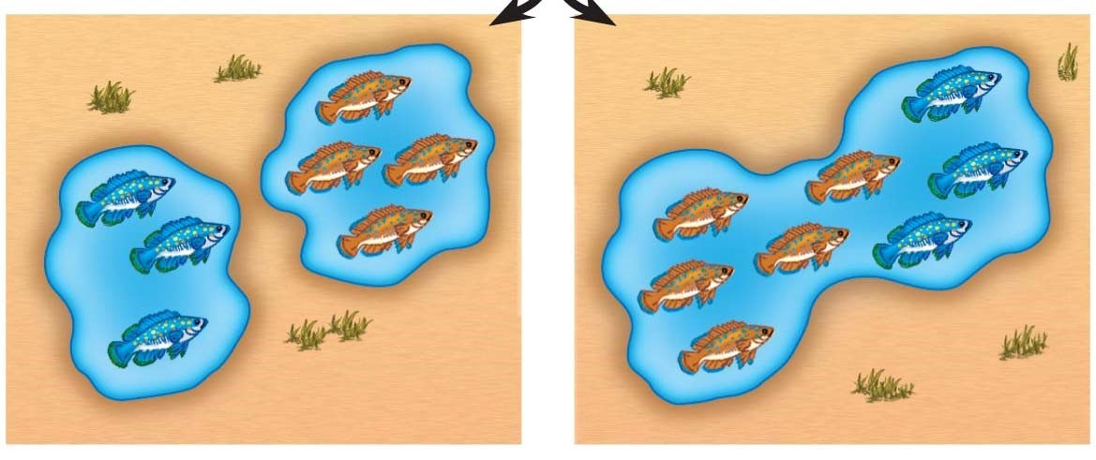

- What type of speciation is caused by a barrier such as the Grand Canyon?
____________________.
- Sympatric speciation occurs in populations that live in the same geographic area. How is this possible?

- Your response to question 13 should have listed polyploidy, habitat differentiation, and sexual selection. These are not easy concepts to understand, so let’s spend some time with each of them. To begin, use the following figure to explain autopolyploidy.

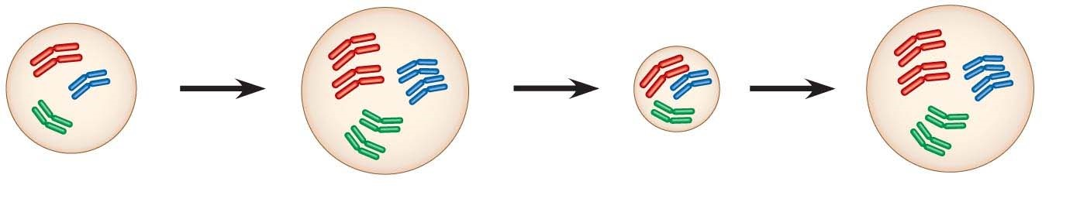

- Now, use this figure to explain allopolyploid speciation.

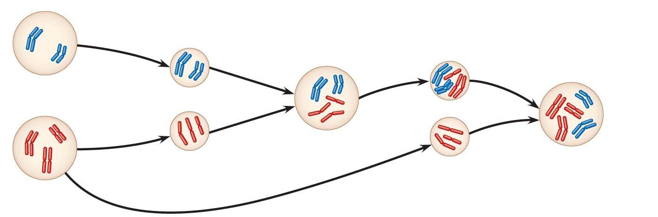

- Before we leave allopatric and sympatric speciation, explain what happens in sexual selection, and how this process can drive sympatric speciation.

Concept 24.3 Hybrid zones provide opportunities to study factors that cause reproductive isolation

- What are hybrid zones?

Concept 24.4 Speciation can occur rapidly or slowly, and it can result from changes in few or many genes

- Stephen Jay Gould and Niles Eldredge coined the term punctuated equilibria. What is meant by a punctuated pattern?

- This figure shows 2 different views of speciation. Label this figure, and explain how each of the pictures explains speciation.

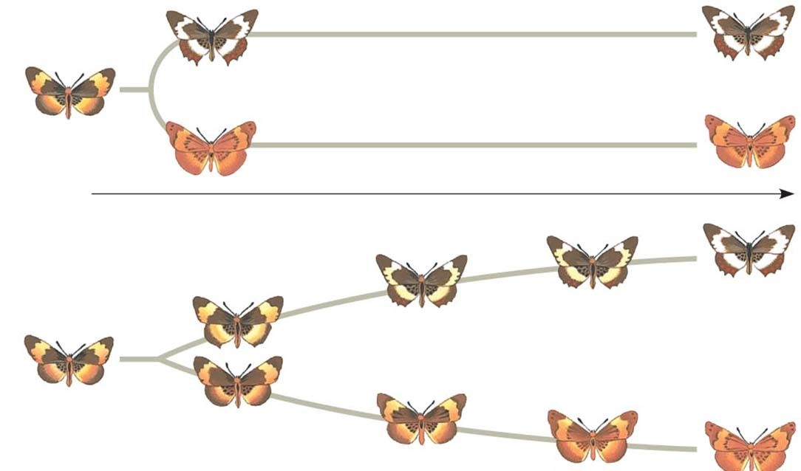

AP BIOLOGY 2021-22 READING GUIDE

Chapter 26: Phylogeny and the Tree of Life

Overview
1. What is systematics? How is it used to develop phylogenetic trees?

Concept 26.1 Phylogenies show evolutionary relationships
- What is taxonomy?

- Every organism on Earth may be referred to by a unique binomial, or a two-part name. These are in Latin, or Latinized. What is your binomial? What does it mean?

- What are the two components of every binomial?

- Taxonomy uses hierarchical categories that nest within each other, like Russian dolls. The figure below shows the categories, each called a taxon. Label each taxonomic category, in the boxes, and then give the one that applies exclusively to this panther to the side of each box.

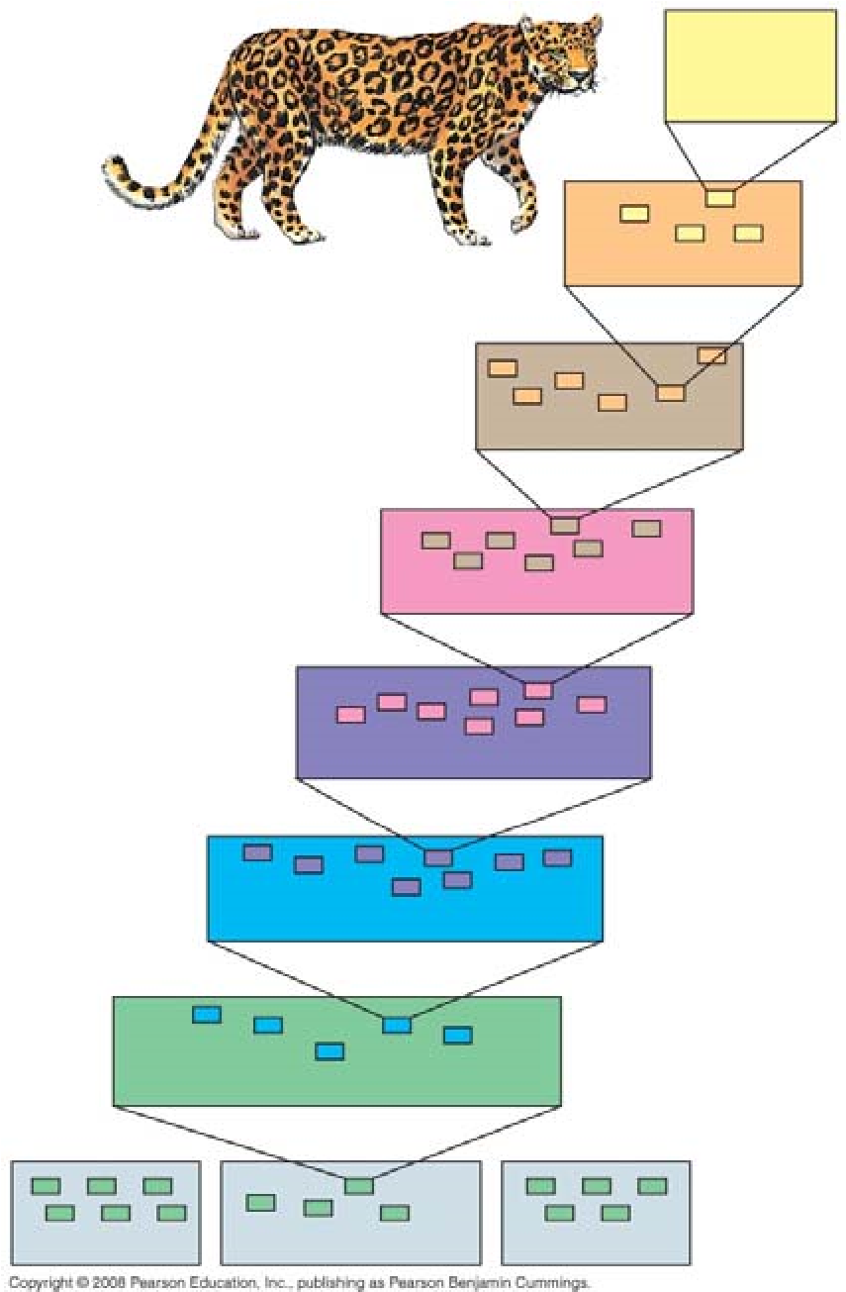

You will notice that the most general category, domain, the one that encompasses the most organisms, is shown at the bottom of the figure. As you move up in the figure, the organisms show greater and greater degrees of relatedness. You are expected to memorize these taxonomic categories in order! Most students use a mnemonic device linked to the first letter of each taxon to remember them. Make up your own, or try ours:

D K P C O F G S or Dear King Phillip Comes Over For Good Spaghetti

(You may choose to have King Philip come over for something else—whatever you can remember best!)

- So, which are more closely related, organisms in the same phylum, or those in the same order? _________

- Here is a phylogenetic tree. Recall that branch points represent common ancestors of the two lineages beyond the branch or node. Circle the common ancestor of badgers and otters, and label it as A. Circle the common ancestor of cats and dogs, and label it as B.

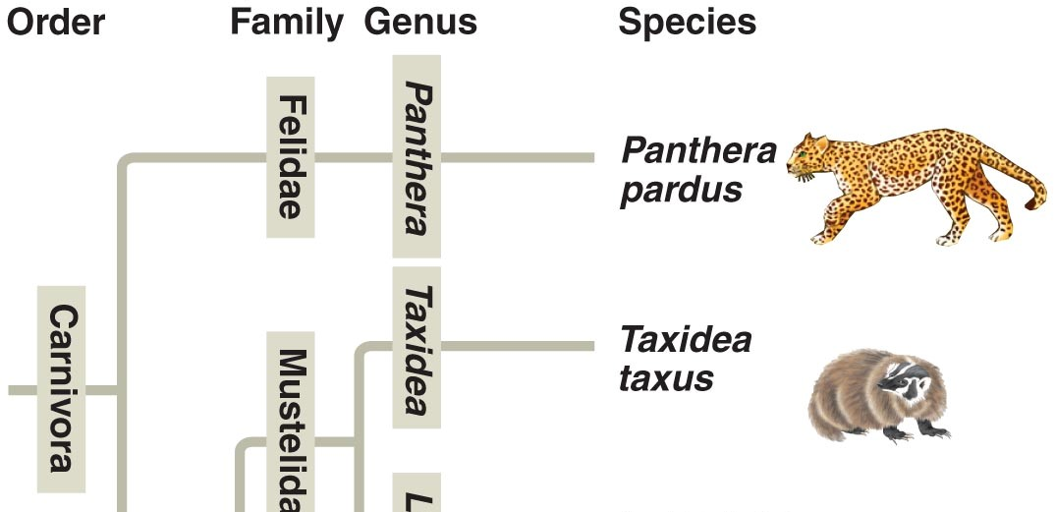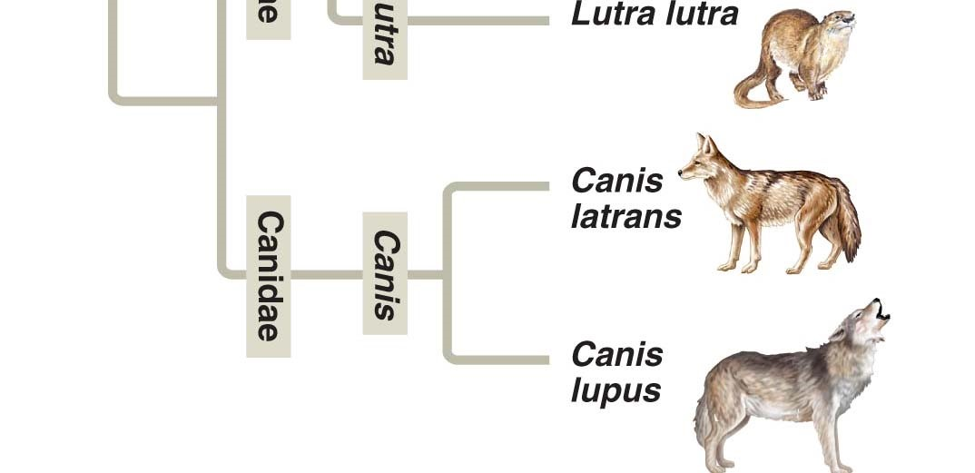

Concept 26.2 Phylogenies are inferred from morphological and molecular data

Let’s look back at a Study Tip from Chapter 22. This idea is repeated in our current chapter.
Study Tip
Homologous structures show evidence of relatedness. (whale fin, bat wing)
Analogous structures are similar solutions to similar problems but do not indicate close relatedness. (bird wing, butterfly wing)

8. Molecular systematics is a valuable tool used today to sort homology from analogy. What is it?

Concept 26.3 Shared characters are used to construct phylogenetic trees
- Below are three cladograms. What is a clade? Circle a clade that is not highlighted below.

- Why is Group I monophyletic?

- Explain why Group II is paraphyletic.

- What is a polyphyletic group?

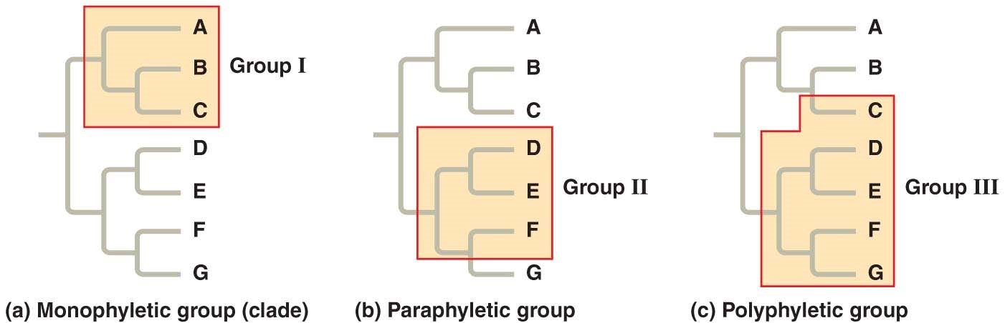

- Clades are derived by using shared derived characters. What are these?

- Explain why for mammals, hair is a shared derived character, but a backbone is not.

Concept 26.4 An organism’s evolutionary history is documented in its genome
Let’s summarize some important information from this section. The rate of evolution of DNA sequences varies from one part of the genome to another; therefore, comparing different sequences helps us to investigate relationships between groups of organisms that diverged a long time ago. For example, DNA that codes for ribosomal RNA (rRNA) changes relatively slowly and is useful for investigating relationships between taxa that diverged hundreds of millions of years ago. DNA that codes for mitochondrial DNA (mtDNA) evolves rapidly and can be used to explore recent evolutionary events.

- Which method reveals that fungi are more closely related to animals than to green plants?

- Which method reveals that the Pima of Arizona and Yanomami of Venezuela are descendants of the same Native Americans that crossed the Bering Land Bridge 13,000 years ago?

Concept 26.5 Molecular clocks help track evolutionary time
- What are molecular clocks?

- If we use a molecular clock, approximately when did HIV emerge?

Concept 26.6 New information continues to revise our understanding of the tree of life
Taxonomy is in flux! When your authors were in high school, we were taught there were two kingdoms: plants and animals. Then in our college courses, we were introduced to five kingdoms: Monera, Protista, Plantae, Fungi, and Animalia. Now biologists have adopted a three-domain system, which consists of the domains Bacteria, Archaea, and Eukarya. This system arose from the finding that there are two distinct lineages of prokaryotes.
EUKARYA
ARCHAEA

BACTERIA

- On the figure above, place an arrow at the point showing the common ancestor of all three domains.

- What two domains include all prokaryotes? Which two domains are most closely related?

- Which kingdom is made obsolete by the three-domain system? Why?

- Which kingdom crumbled because it is polyphyletic?

