AP BIOLOGY 2021-22 March 4, 2022

Today’s Agenda (Day 116)

- Housekeeping Items

- Homework Check:
Ch 19 Reading Guide

- Class Activity:
BEGIN: Ch 22 PPT REVIEW
- Section 22.1 – Darwinian revolution challenged traditional views
- Section 22.2 – Descent with modification by natural selection
- Section 22.3 – Evolution is supported by overwhelming scientific evidence

HOMEWORK:
- READ: Chapters 19-20, 22 - 26
- No test for Ch 20…reading guide only
- STUDY: Chapter 19 Test

Chapter 20 – DNA Tools & Biotechnology
Biotechnology | Cloning vector | Complementary DNA (cDNA) | DNA cloning | DNA ligase | DNA microarray assays
DNA sequencing | DNA technology | Electroporation | Expression vector | Gel electrophoresis | Gene cloning
Gene therapy | Genetic engineering | Genetic profile | Genetically modified (GM) organisms | Genome-wide association studies | In situ hybridization
In vitro mutagenesis | Nucleic acid hybridization | Nucleic acid probe | Plasmids | Pluripotent | Polymerase chain reaction (PCR)
Recombinant DNA | Restriction enzymes | Restriction fragments | Restriction site | Reverse transcriptase-polymerase chain reaction (RT-PCR) | RNA interference (RNAi)
Short tandem repeats (STRs) | Single nucleotide polymorphism (SNP) | Stem cell | Sticky end | Totipotent | transgenic

REMINDERS:

- Ch 20 Vocabulary – March 4
- Ch 20 Reading Guide [in PAIRS] – March 8
- Ch 22 & 23 Reading Guides [in PAIRS] – March 9
- TEST: Ch 22 & 23 March 10
- Ch 24 & 26 Reading Guides [in PAIRS] – March 16
- TEST: Ch 24 & 26 March 17

AP BIOLOGY 2021-22 READING GUIDE

Chapter 20: Biotechnology

The AP Biology exam has reached into this chapter for essay questions on a regular basis over the past 15 years. Student responses show that biotechnology is a difficult topic. This chapter requires a strong conceptual understanding of the technological processes and the underlying biology that guides the procedure. With a little careful work, this chapter will give you insights into the incredible advancements already made and a basis for understanding the new marvels yet to be discovered in biotechnology.

Overview
1. It is important to understand the meaning of the three terms in bold to start this chapter.
recombinant DNA

biotechnology

genetic engineering

Concept 20.1 DNA cloning yields multiple copies of a gene or other DNA segment
- Plasmids are important in biotechnology. Give a full and complete definition of plasmid.

- The production of multiple copies of a single gene is called ____________________________.
- Using Figure 20.2, label and explain the four steps in this preview of gene cloning.

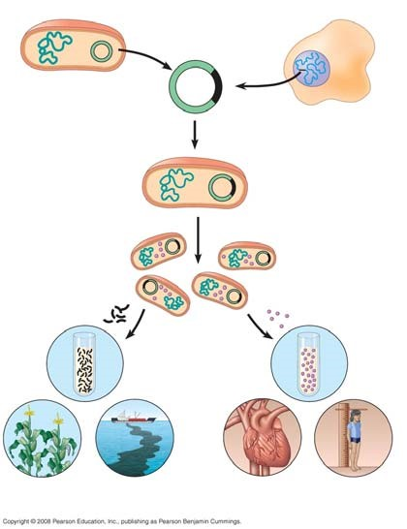

- Read the description of restriction enzymes on page 398 carefully. Then draw and explain each step of Figure 20.3. When you finish, you should have recreated Figure 20.3 in the space below.

- What is a cloning vector?
- Figure 20.4 is a more detailed discussion of the gene cloning procedure shown in Figure 20.2. Explain the following key points.

  - Explain why the plasmid is engineered with amp^{R} and lacZ.

  - After transformation has occurred, why are some colonies blue?

  - Why are some colonies white? Why is this important?

- The cloning procedure described in question 7 and Figure 20.4 will produce many different fragments of hummingbird DNA. These fragments may be stored in a genomic library.

    - What is the purpose of a genomic library?

    - Explain how a bacterial artificial library (BAC) and a cDNA library are formed.

- Once the hummingbird DNA is cloned, we have the problem of finding the piece of DNA that holds our gene of interest. Explain how nucleic acid hybridization will accomplish this task.

- Describe how a radioactively labeled nucleic acid probe can locate the gene of interest on a multiwell plate. (Use Figure 20.7 to guide your response.)

- What are two problems with bacterial gene expression systems?

- The polymerase chain reaction (PCR) is a Nobel Prize–winning idea that is used by scientists to amplify DNA, particularly when the quantity of DNA is very small or contaminated. Explain the three initial steps that occur in cycle 1 of PCR.

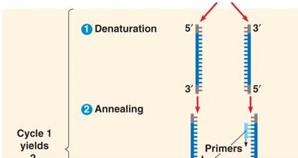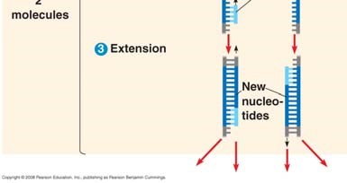
- How many molecules will be produced by four PCR cycles?

Concept 20.2 DNA technology allows us to study the sequence, expression, and function of a gene
This section begins with a discussion of gel electrophoresis, a technique covered in AP Biology Lab 6. It is important to understand the principles of gel electrophoresis.
- ____________________ is a technique used to separate nucleic acids or proteins that differ in size or electrical charge.
- Why is the DNA sample to be separated by gel electrophoresis always loaded at the cathode or negative end of the power source?

- Explain why shorter DNA molecules travel farther down the gel than larger molecules.

- To the right of the β-globin alleles, draw a gel showing the different pattern obtained from a normal patient and a sickle-cell patient. For help, examine Figure 20.10.

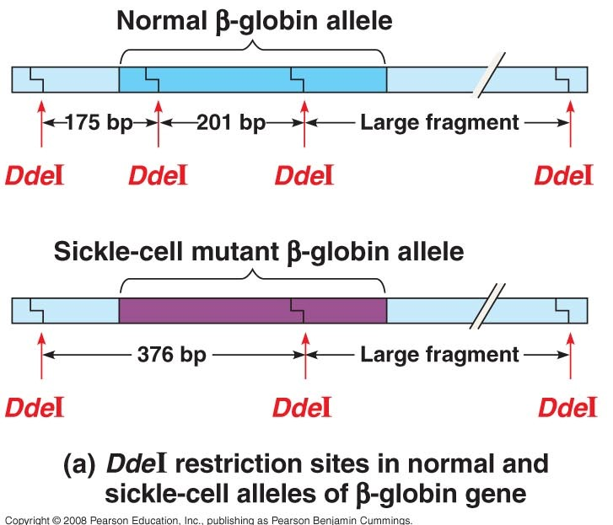
- A patient who is a carrier for sickle-cell anemia would have a gel electrophoresis pattern showing four bands. Add this pattern to your gel in number 17 and explain why the gel shows a four-band pattern.

- What is the purpose of a Southern blot?

- What two techniques discussed earlier in this chapter are used in performing a Southern blot?

- In working toward the general idea of how DNA sequencing was mechanized, look at Figure 20.12 to answer the following general questions about the dideoxy chain termination method for sequencing DNA.
  - Why does a dideoxyribonucleotide terminate a growing DNA strand? (You may need to refer to Figure 16.14, as suggested in the text, to answer this question).

  - Why are the four nucleotides in DNA each labeled with a different color of fluorescent tag?

Use unlabeled Figure 20.15 to explain the four steps of DNA microarray assays.
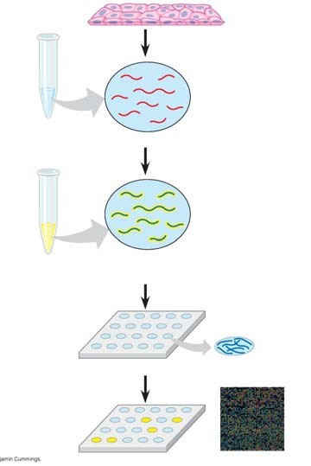

(1)

(2)

(3)

(4)

- Explain how microarrays are used in understanding patterns of gene expression in normal and cancerous tissue.

Concept 20.3 Cloning organisms may lead to production of stem cells for research and other applications

- What is a totipotent cell?

- How is nuclear transplantation performed in animals?

- Use unlabeled Figure 20.18 to explain the six steps in reproductive cloning for mammals.
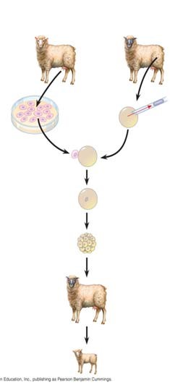

(1)

(2)

(3)

(4)

(5)

(6)

- What are stem cells?

- What is the major difference between embryonic stem cells (ES) and adult stem cells?

- How might induced pluripotent stem cells (iPS) resolve the debate about using stem cells for medical treatments?

Concept 20.4 The practical applications of DNA technology affect our lives in many ways

- In question 17, you used two ideas that are featured in the first part of this concept. Explain how single-nucleotide polymorphisms (SNPs) and restriction fragment length polymorphisms (RFLPs) were demonstrated in analyzing sickle-cell alleles.

- Explain the idea of gene therapy, and discuss the problems with this technique as demonstrated in the treatment of SCID.

- Explain how transgenic “pharm” animals might be able to produce human proteins.

- Describe how short tandem repeats can produce a sensitive genetic profile.

- How does the Ti plasmid make genetic engineering in plants a possibility?

- What are genetically modified organisms, and why are they controversial?

AP BIOLOGY 2021-22 READING GUIDE

Chapter 22: Descent with Modification: A Darwinian View of Life

As you study this chapter, read several paragraphs at a time to catch the flow of ideas and understand the reasoning that is being described. In some places, the text describes a narrative or story of events that led to Darwin’s theory of evolution. Therefore, first read the narrative to absorb the big picture and then return to answer the few questions that accompany this material.

Overview

1. Define evolution broadly and then give a narrower definition, as discussed in the overview.

Concept 22.1 The Darwinian revolution challenged the traditional view of a young Earth inhabited by unchanging species

This section looks at the historical setting and influences on Darwin, and it sets the stage for our formal study of evolution.

2. How did each of the following sources view the origin of species?
Aristotle and Scala Naturae

The Old Testament

Carolus Linnaeus

Georges Cuvier

- Explain the role of fossils in rock strata as a window to life in earlier times.

- How would Georges Cuvier have explained the appearance of the record of life shown in the rock strata?

- James Hutton and Charles Lyell were geologists whose ideas strongly influenced Darwin’s thinking. What were the ideas each of them contributed?
James Hutton

Charles Lyell

- What is the importance of the principle of uniformitarianism?

- Jean-Baptiste de Lamarck proposed a mechanism for how life changes over time. Explain the two principles of his mechanism.
use and disuse

inheritance of acquired characteristics

- Although Lamarck’s mechanism of evolution does not explain the changes in species over time, his thinking has been influential. What is considered to be the great importance of his ideas?

Concept 22.2 Descent with modification by natural selection explains the adaptations of organisms and the unity and diversity of life

- Charles Darwin proposed that the mechanism of evolution is natural selection and that it explains how adaptations arise. What are adaptations? Give two examples of adaptations.

- Explain the process of natural selection.

- Let’s try to summarize Darwin’s observations that drive changes in species over time:

Observation | Cite an Example
1. Variations in traits exist.

2. These variations (traits) are heritable.

3. Species overproduce.
4. There is competition for resources; not all offspring survive.

- From these four observations, which two inferences did Darwin make?

- It is important to remember that differences in heritable traits can lead to differential reproductive success. This means that the individuals who have the necessary traits to promote survival in the current environment will leave the most offspring. What can this differential reproductive success lead to over time?

- To demonstrate your understanding of this section, complete the following sentences:

_____________________ do not evolve. ______________________ evolve.

Now, take out your highlighter and mark the information in the box above. Hold these ideas firmly in your brain! Finally, if you are ever asked to explain Darwin’s theory of evolution by natural selection (a common AP essay question), do not pull out the phrase “survival of the fittest.” Instead, cite the points made in question 11 and explain the inferences that are drawn from them.

Concept 22.3 Evolution is supported by an overwhelming amount of scientific evidence

- Use Figure 22.13 to explain how John Endler’s work with guppies demonstrated observable evolutionary change.
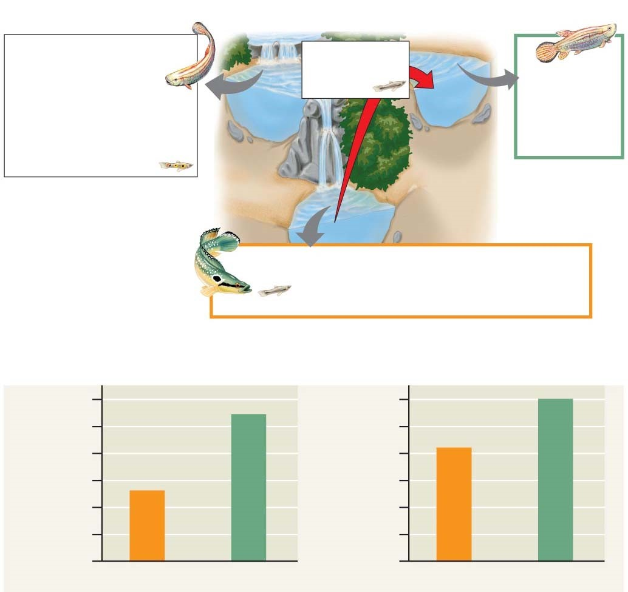

- What is the role of 3TC in inhibiting HIV reproduction?

- Explain the evolution of drug resistance to 3TC.

- Do antibiotics cause bacteria to become resistant? Explain your response.

- Let’s make a list of the four evidences for evolution that are described in this concept.

Evidence for Evolution

- How does the fossil record give evidence for evolution?

- What is meant by each of the following terms? Give an example of each.

Term | Example
Homologous structures
Vestigial structures
Analogous structures (see p. 465)

- How do homologous structures give evidence for evolution?

- What is summarized in an evolutionary tree?

- Figure 22.19 shows an evolutionary tree. What is indicated by each branch point? Mark each branch point.

- What is indicated by the hatch marks?

- Use the tree below to answer this question: Are crocodiles more closely related to lizards or to birds? Explain your response.

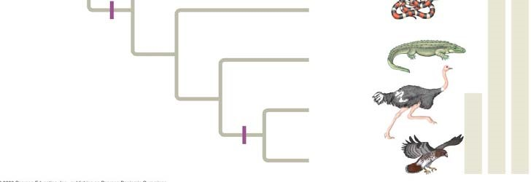

- On the evolutionary tree, label the vertical lines to the right, and annotate the key feature that marks each group.
- Organisms that are only distantly related can resemble each other. Explain convergent evolution and describe how analogous structures can arise.

- Convergent evolution might be summarized like this: Similar problem, similar solution. Can you give two examples of convergent evolution?

Study Tip
Homologous structures show evidence of relatedness. (whale fin, bat wing)
Analogous structures are similar solutions to similar problems but do not indicate close relatedness. (bird wing, butterfly wing)

- What is biogeography? How is it affected by continental drift and the presence of endemic species?

Let’s wrap up all of these ideas with a final summary.

ORGANIZE YOUR THOUGHTS

- Evolution is change in species over time.
- Heritable variations exist within a population.
- These variations can result in differential reproductive success.
- Over generations, this can result in changes in the genetic composition of the population.

And remember: Individuals do not evolve! Populations evolve.

AP BIOLOGY 2021-22 READING GUIDE

Chapter 23: The Evolution of Populations

This chapter begins with the idea that we focused on as we closed the last chapter: Individuals do not evolve! Populations evolve. The Overview looks at the work of Peter and Rosemary Grant with Galápagos finches to illustrate this point, and the rest of the chapter examines the change in populations over time. As in the last chapter, first read each concept to get the big picture and then go back to work on the details presented by our questions. Don’t lose sight of the conceptual understanding by getting lost in the details!

Overview

- What is microevolution?

- What are the three main mechanisms that can cause changes in allele frequency?

- Which is the only mechanism that is adaptive, or improves the match between organisms and their environment?

Concept 23.1 Mutation and sexual reproduction produce the genetic variation that makes evolution possible

- Because Darwin did not know about the work of Gregor Mendel, he could not explain how organisms pass heritable traits to their offspring. In looking at genetic variation, what are discrete characters, and what are quantitative characters?

- Using the techniques of molecular biology, what are the two ways of measuring genetic variation in a population?

- Geographic variation may be shown in a graded manner along a geographic axis known as a cline. What external factors might produce a cline? Why does the existence of a cline suggest natural selection?

- What is the ultimate source of new alleles?

- Mutations are any change in the nucleotide sequence of an organism’s DNA. These mutations provide the raw material from which new traits may arise and be selected. What occurs in a point mutation?

- What is translocation? How could it be beneficial?

- How does gene duplication occur? How might it play a role in evolution?

- Much of the genetic variation that makes evolution possible comes through sexual reproduction. What are the three mechanisms by which sexual reproduction shuffles existing alleles?

Concept 23.2 The Hardy-Weinberg equation can be used to test whether a population is evolving

- What is a population?

- What is a gene pool?

- The greater the number of fixed alleles, the lower the species’ diversity. What does it mean to say that an allele is fixed?

- The Hardy-Weinberg principle is used to describe a population that is not evolving. What does this principle state?

- If the frequency of alleles in a population remains constant, the population is at Hardy Weinberg equilibrium. There are five conditions for Hardy-Weinberg equilibrium. It is very important for you to know these conditions, so enter them neatly into the box below.

CONDITIONS FOR HARDY-WEINBERG EQUILIBRIUM
1.
2.
3.
4.
5.

It is not very likely that all five of these conditions will occur, is it? Allelic frequencies change. Populations evolve. This data can be tested by applying the Hardy Weinberg equation. Let’s look at how to do this.
Equation for Hardy-Weinberg Equilibrium
p² + 2pq + q² = 1
Where p² is equal to the frequency of the homozygous dominant in the population, 2pq is equal to the frequency of all the heterozygotes in the population, and q² is equal to the frequency of the homozygous recessive in the population.

Consider a gene locus that exists in two allelic forms, A and a, in a population.

Let p = the frequency of A, the dominant allele

and q = the frequency of a, the recessive allele.

So, p² = AA,
q² = aa,
2pq = Aa

If we know the frequency of one of the alleles, we can calculate the frequency of the other allele:
p + q = 1, so p = 1 – q q = 1 – p
- So, here is a problem to try. Suppose in a plant population that red flowers (R) are dominant to white flowers (r). In a population of 500 individuals, 25% show the recessive phenotype. How many individuals would you expect to be homozygous dominant and heterozygous for this trait? (A complete solution for this problem is at the end of this Reading Guide.)

- In a population of plants, 64% exhibit the dominant flower color (red), and 36% of the plants have white flowers. What is the frequency of the dominant allele? (There are a couple of twists in this problem, so read and think carefully. A complete solution for this problem is at the end of this Reading Guide.)

Concept 23.3 Natural selection, genetic drift, and gene flow can alter allele frequencies in a population

- First, let’s try to summarize the big idea from this section. Scan through the entire concept to pull out this information. Three major factors alter allelic frequency and bring about evolutionary change. List each factor and give an explanation.

Factor | Explanation

- Which of the factors above results in a random, nonadaptive change in allelic frequencies?

- Which of the factors above tends to reduce the genetic differences between populations and make populations more similar?

- Of the three factors you listed above, only one results in individuals that are better suited to their environment. Which is it?

- Explain what happens in each of these examples of genetic drift:

founder effect

bottleneck effect

Concept 23.4 Natural selection is the only mechanism that consistently causes adaptive evolution

- In evolutionary terms, fitness refers only to the ability to leave offspring and contribute to the gene pool of the next generation. It may have nothing to do with being big, or strong, or aggressive. Define relative fitness.

- What is the relative fitness of a sterile mule? _______________________________________

- Figure 23.13 is important because it helps explain the three modes of selection. Label each type of selection and fill in the chart to explain what is occurring.

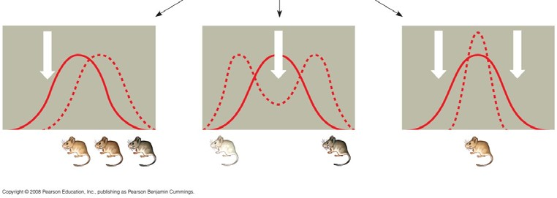
Type of Selection | How It Works
Stabilizing
Directional
Disruptive

- What is often the result of sexual selection?

- What is the difference between intrasexual selection and intersexual selection? Give an example of each type of selection.

- Explain two ways in which genetic variation is preserved in a population.

- Discuss what is meant by heterozygote advantage and use sickle-cell anemia as an example.

Finally, give four reasons why natural selection cannot produce perfect organisms.

