AP BIOLOGY 2021-22 March 2, 2022

Today’s Agenda (Day 114)

- Housekeeping Items

- Homework Check:

- Class Activity:
CONT’D: Ch 19 PPT Review
- Section 19.2 – Viruses replicate only in host cells
- Section 19.3 – Viruses, viroids, and prions are formidable pathogens in animals and plants

HOMEWORK:
- READ: Chapters 19-20, 22 - 26
- No test for Ch 20…reading guide only
- STUDY: Chapter 19 Test

Chapter 20 – DNA Tools & Biotechnology
Biotechnology | Cloning vector | Complementary DNA (cDNA) | DNA cloning | DNA ligase | DNA microarray assays
DNA sequencing | DNA technology | Electroporation | Expression vector | Gel electrophoresis | Gene cloning
Gene therapy | Genetic engineering | Genetic profile | Genetically modified (GM) organisms | Genome-wide association studies | In situ hybridization
In vitro mutagenesis | Nucleic acid hybridization | Nucleic acid probe | Plasmids | Pluripotent | Polymerase chain reaction (PCR)
Recombinant DNA | Restriction enzymes | Restriction fragments | Restriction site | Reverse transcriptase-polymerase chain reaction (RT-PCR) | RNA interference (RNAi)
Short tandem repeats (STRs) | Single nucleotide polymorphism (SNP) | Stem cell | Sticky end | Totipotent | transgenic

REMINDERS:

- Ch 19 Reading Guide – March 2
- TEST: Chapter 19 March 3
- Ch 20 Vocabulary – March 4
- Ch 20 Reading Guide [in PAIRS] – March 8
- Ch 22 & 23 Reading Guides [in PAIRS] – March 9
- TEST: Ch 22 & 23 March 10
- Ch 24 & 26 Reading Guides [in PAIRS] – March 16
- TEST: Ch 24 & 26 March 17

AP BIOLOGY 2021-22 READING GUIDE

Chapter 20: Biotechnology

The AP Biology exam has reached into this chapter for essay questions on a regular basis over the past 15 years. Student responses show that biotechnology is a difficult topic. This chapter requires a strong conceptual understanding of the technological processes and the underlying biology that guides the procedure. With a little careful work, this chapter will give you insights into the incredible advancements already made and a basis for understanding the new marvels yet to be discovered in biotechnology.

Overview
1. It is important to understand the meaning of the three terms in bold to start this chapter.
recombinant DNA

biotechnology

genetic engineering

Concept 20.1 DNA cloning yields multiple copies of a gene or other DNA segment
- Plasmids are important in biotechnology. Give a full and complete definition of plasmid.

- The production of multiple copies of a single gene is called ____________________________.
- Using Figure 20.2, label and explain the four steps in this preview of gene cloning.

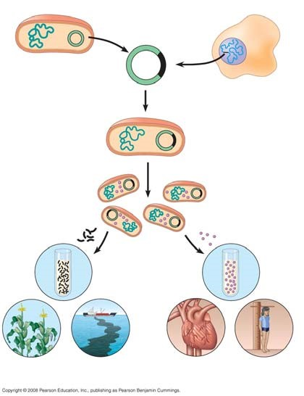

- Read the description of restriction enzymes on page 398 carefully. Then draw and explain each step of Figure 20.3. When you finish, you should have recreated Figure 20.3 in the space below.

- What is a cloning vector?
- Figure 20.4 is a more detailed discussion of the gene cloning procedure shown in Figure 20.2. Explain the following key points.

  - Explain why the plasmid is engineered with amp^{R} and lacZ.

  - After transformation has occurred, why are some colonies blue?

  - Why are some colonies white? Why is this important?

- The cloning procedure described in question 7 and Figure 20.4 will produce many different fragments of hummingbird DNA. These fragments may be stored in a genomic library.

    - What is the purpose of a genomic library?

    - Explain how a bacterial artificial library (BAC) and a cDNA library are formed.

- Once the hummingbird DNA is cloned, we have the problem of finding the piece of DNA that holds our gene of interest. Explain how nucleic acid hybridization will accomplish this task.

- Describe how a radioactively labeled nucleic acid probe can locate the gene of interest on a multiwell plate. (Use Figure 20.7 to guide your response.)

- What are two problems with bacterial gene expression systems?

- The polymerase chain reaction (PCR) is a Nobel Prize–winning idea that is used by scientists to amplify DNA, particularly when the quantity of DNA is very small or contaminated. Explain the three initial steps that occur in cycle 1 of PCR.

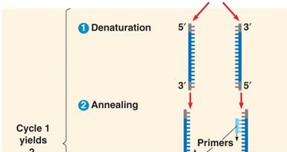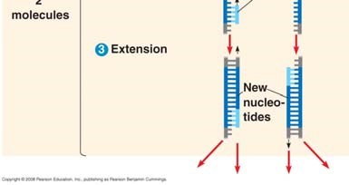
- How many molecules will be produced by four PCR cycles?

Concept 20.2 DNA technology allows us to study the sequence, expression, and function of a gene
This section begins with a discussion of gel electrophoresis, a technique covered in AP Biology Lab 6. It is important to understand the principles of gel electrophoresis.
- ____________________ is a technique used to separate nucleic acids or proteins that differ in size or electrical charge.
- Why is the DNA sample to be separated by gel electrophoresis always loaded at the cathode or negative end of the power source?

- Explain why shorter DNA molecules travel farther down the gel than larger molecules.

- To the right of the β-globin alleles, draw a gel showing the different pattern obtained from a normal patient and a sickle-cell patient. For help, examine Figure 20.10.

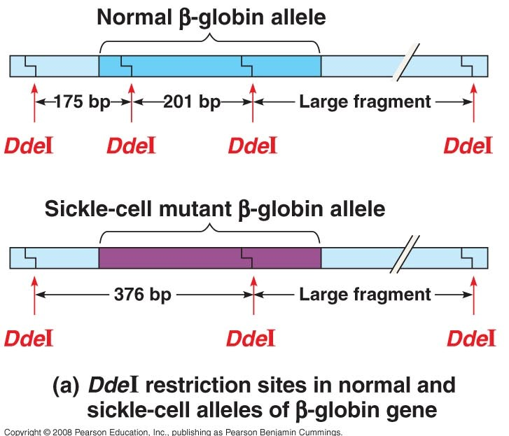
- A patient who is a carrier for sickle-cell anemia would have a gel electrophoresis pattern showing four bands. Add this pattern to your gel in number 17 and explain why the gel shows a four-band pattern.

- What is the purpose of a Southern blot?

- What two techniques discussed earlier in this chapter are used in performing a Southern blot?

- In working toward the general idea of how DNA sequencing was mechanized, look at Figure 20.12 to answer the following general questions about the dideoxy chain termination method for sequencing DNA.
  - Why does a dideoxyribonucleotide terminate a growing DNA strand? (You may need to refer to Figure 16.14, as suggested in the text, to answer this question).

  - Why are the four nucleotides in DNA each labeled with a different color of fluorescent tag?

Use unlabeled Figure 20.15 to explain the four steps of DNA microarray assays.
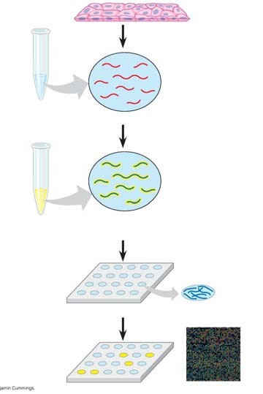

(1)

(2)

(3)

(4)

- Explain how microarrays are used in understanding patterns of gene expression in normal and cancerous tissue.

Concept 20.3 Cloning organisms may lead to production of stem cells for research and other applications

- What is a totipotent cell?

- How is nuclear transplantation performed in animals?

- Use unlabeled Figure 20.18 to explain the six steps in reproductive cloning for mammals.
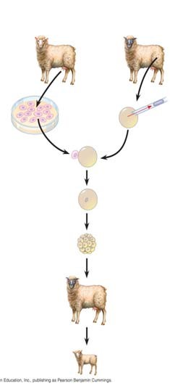

(1)

(2)

(3)

(4)

(5)

(6)

- What are stem cells?

- What is the major difference between embryonic stem cells (ES) and adult stem cells?

- How might induced pluripotent stem cells (iPS) resolve the debate about using stem cells for medical treatments?

Concept 20.4 The practical applications of DNA technology affect our lives in many ways

- In question 17, you used two ideas that are featured in the first part of this concept. Explain how single-nucleotide polymorphisms (SNPs) and restriction fragment length polymorphisms (RFLPs) were demonstrated in analyzing sickle-cell alleles.

- Explain the idea of gene therapy, and discuss the problems with this technique as demonstrated in the treatment of SCID.

- Explain how transgenic “pharm” animals might be able to produce human proteins.

- Describe how short tandem repeats can produce a sensitive genetic profile.

- How does the Ti plasmid make genetic engineering in plants a possibility?

- What are genetically modified organisms, and why are they controversial?

AP BIOLOGY 2021-22 READING GUIDE

Chapter 19: Viruses

Overview

Experimental work with viruses has provided important evidence that genes are made of nucleic acids.
Viruses were also important in working out the molecular mechanisms of DNA replication, transcription, and translation. Viruses have been important in the development of techniques of manipulating and transferring genes. As you learn about viruses in this chapter, you will build on the foundation necessary for an understanding of the molecular techniques of biotechnology.

Concept 19.1 A virus consists of a nucleic acid surrounded by a protein coat

- What was some early evidence of the existence of viruses? Why were they difficult to study?

- What was Wendell Stanley’s contribution to our knowledge of viruses?

- What are the four forms of viral genomes?

- What is a capsid? What are capsomeres? What different shapes may capsids have?

- As you see, all viruses consist of a nucleic acid enclosed in a protein coat. Some viruses also have a membranous envelope. What are the components of a viral envelope? Which component is derived from the host cell, and which is of viral origin?
Viral Component | Derived From

- What is the role of an envelope in animal viruses?

- For the virus shown below, label the protein capsid, tail fibers, head, tail sheath, and genome.
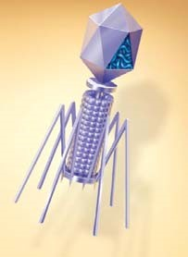
  - What type of virus is this?
  - What does its name mean?
  - What is its host?
  - Is the genome of this virus DNA, or RNA?

Concept 19.2 Viruses reproduce only in host cells
- What property of a virus determines its attachment to a host cell membrane?

- Viruses are obligate intracellular parasites. What does this mean?

- What is meant by host range? Distinguish between a virus with a broad host range and one with an extremely limited host range and give an example of each.

- Compare the host range for the rabies virus to that of the human cold virus.

- What components of the host cell does a virus use to reproduce itself?

- How does a DNA virus reproduce its genome?

- How do most RNA viruses replicate their genome?

- On this figure of a simplified viral reproductive cycle, label arrows to show these processes:
transcription, translation, infection, replication, and self-assembly. Annotate your labels to explain the process of viral reproduction.
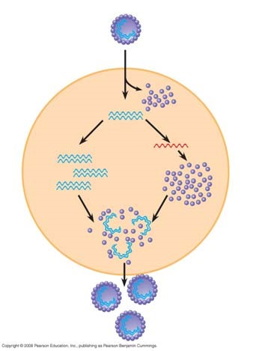
- What are bacteriophages? Distinguish between virulent and temperate phages.

- What portion of a phage enters the host cell? How does it do this?

- What are restriction enzymes? What is their role in bacteria?

- Why don’t restriction enzymes destroy the DNA of the bacterial cells that produce them?

- What are three ways bacteria may win the battle against the phages?

- What is a prophage?

- Since cells that have incorporated phage DNA into their genome may continue to divide and propagate the viral genome, this might be considered somewhat like the Trojan horse. What might trigger the switchover from lysogenic to lytic mode?

- Label the following elements of the figure below: lysogenic phage, lysogenic cycle, lytic cycle, prophage, phage DNA, bacterial chromosome, and self-assembly.

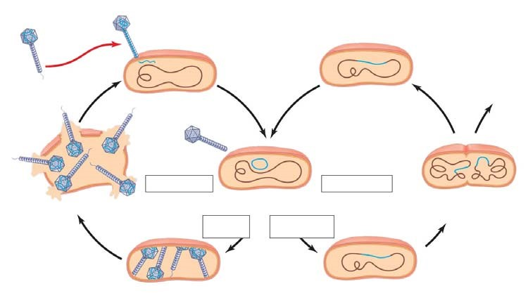

- Describe the lytic and lysogenic modes of bacteriophage reproduction.

- There are some general differences between bacteriophages and animal viruses. What are two elements that nearly all animal viruses have?

- What is a retrovirus? How do retroviruses, such as HIV, replicate their genome?

- Here is a sketch of HIV. Label these parts: envelope, reverse transcriptase, RNA, and capsid.

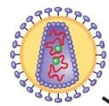

- Compare and contrast a prophage and a provirus. Which one are you likely to carry?

- This sketch shows the infection of a cell by HIV. Extend label lines to give a complete explanation of the process. Refer to your text Figure 19.8 for details.

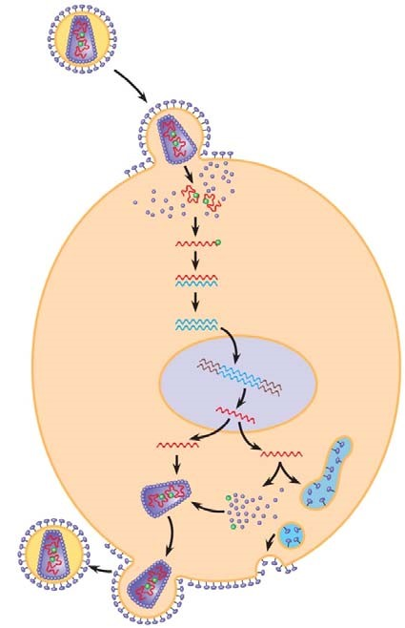

- The final section in this concept is titled “Evolution of Viruses.” From this part, describe the two possible sources of viral genomes. You will see each of these important mobile genetic elements again.
Description of the Mobile Genetic Element
Plasmids
Transposons

Concept 19.3 Viruses, viroids, and prions are formidable pathogens in animals and plants
- What are three ways that viruses make us ill? Why do we recover completely from a cold but not from polio?

- What tools are in the medical arsenal against human viral diseases?

- Emerging viruses such as HIV, Ebola, and SARS seem to burst upon the human scene. What are three processes that contribute to this sudden emergence?

- The current flu pandemic is H1N1. What does this name mean?

- Distinguish between horizontal transmission and vertical transmission in plants.

- How do viruses spread throughout plant bodies?

- What is a viroid? What important lesson do they teach? Name one viroid disease.

- Prions strike fear into carnivores everywhere. What are they? How are they transmitted? What do they do?

- Name four diseases caused by prions.

- What are two alarming characteristics of prions?

- Two Nobel Prizes have been awarded for the study of prions. One went to Carlton Gajdusek, who worked with the Fore people of Papua New Guinea in the 1960s to determine the cause of a kuru epidemic. Who got the second Nobel Prize in this area, and when?

