AP BIOLOGY 2021-22 February 28, 2022

Today’s Agenda (Day 112)

- Housekeeping Items

- Homework Check:

- Class Activity:
CONT’D: Ch 18 PPT Review
- Section 18.5 – Cancer results from genetic changes that affect cell cycle control
REVIEW: Ch 18 – Clicker Questions
BEGIN: Ch 19 PPT Review
- Section 19.1 – A virus consists of a nucleic acid surrounded by protein coat
- Section 19.2 – Viruses replicate only in host cells
- Section 19.3 – Viruses, viroids, and prions are formidable pathogens in animals and plants

HOMEWORK:
- READ: Chapters 19-20
- STUDY: Chapter 18 Test

Chapter 19 - Viruses
Bacteriophage (phage) | Capsid | Epidemic | HIV (human immunodeficiency virus) | Host range | Lysogenic cycle
Lytic cycle | Pandemic | Prions | Prophage | Provirus | Restriction enzymes
Retroviruses | Reverse transcriptase | Temperate phage | Vaccine | Viral envelope | Viroid
Virulent phage | virus

REMINDERS:

- TEST: Chapter 18 February 24 March 1
- Ch 19 Reading Guide – March 2
- TEST: Chapter 19 March 3

AP BIOLOGY 2021-22 READING GUIDE

Chapter 19: Viruses

Overview

Experimental work with viruses has provided important evidence that genes are made of nucleic acids.
Viruses were also important in working out the molecular mechanisms of DNA replication, transcription, and translation. Viruses have been important in the development of techniques of manipulating and transferring genes. As you learn about viruses in this chapter, you will build on the foundation necessary for an understanding of the molecular techniques of biotechnology.

Concept 19.1 A virus consists of a nucleic acid surrounded by a protein coat

- What was some early evidence of the existence of viruses? Why were they difficult to study?

- What was Wendell Stanley’s contribution to our knowledge of viruses?

- What are the four forms of viral genomes?

- What is a capsid? What are capsomeres? What different shapes may capsids have?

- As you see, all viruses consist of a nucleic acid enclosed in a protein coat. Some viruses also have a membranous envelope. What are the components of a viral envelope? Which component is derived from the host cell, and which is of viral origin?
Viral Component | Derived From

- What is the role of an envelope in animal viruses?

- For the virus shown below, label the protein capsid, tail fibers, head, tail sheath, and genome.
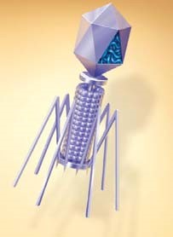
  - What type of virus is this?
  - What does its name mean?
  - What is its host?
  - Is the genome of this virus DNA, or RNA?

Concept 19.2 Viruses reproduce only in host cells
- What property of a virus determines its attachment to a host cell membrane?

- Viruses are obligate intracellular parasites. What does this mean?

- What is meant by host range? Distinguish between a virus with a broad host range and one with an extremely limited host range and give an example of each.

- Compare the host range for the rabies virus to that of the human cold virus.

- What components of the host cell does a virus use to reproduce itself?

- How does a DNA virus reproduce its genome?

- How do most RNA viruses replicate their genome?

- On this figure of a simplified viral reproductive cycle, label arrows to show these processes:
transcription, translation, infection, replication, and self-assembly. Annotate your labels to explain the process of viral reproduction.
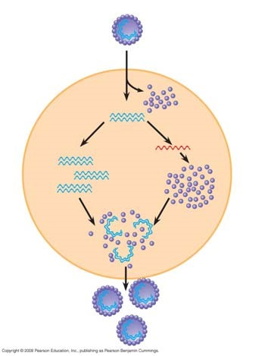
- What are bacteriophages? Distinguish between virulent and temperate phages.

- What portion of a phage enters the host cell? How does it do this?

- What are restriction enzymes? What is their role in bacteria?

- Why don’t restriction enzymes destroy the DNA of the bacterial cells that produce them?

- What are three ways bacteria may win the battle against the phages?

- What is a prophage?

- Since cells that have incorporated phage DNA into their genome may continue to divide and propagate the viral genome, this might be considered somewhat like the Trojan horse. What might trigger the switchover from lysogenic to lytic mode?

- Label the following elements of the figure below: lysogenic phage, lysogenic cycle, lytic cycle, prophage, phage DNA, bacterial chromosome, and self-assembly.

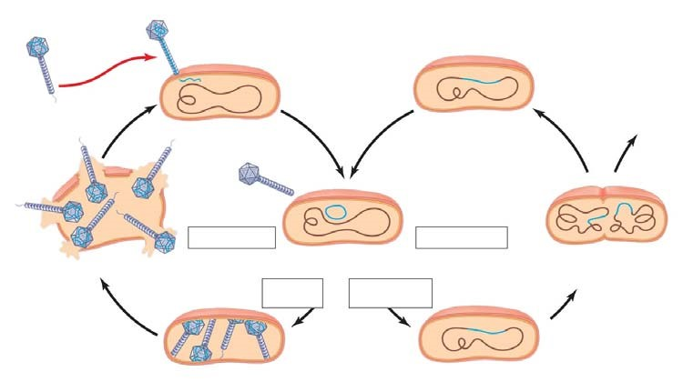

- Describe the lytic and lysogenic modes of bacteriophage reproduction.

- There are some general differences between bacteriophages and animal viruses. What are two elements that nearly all animal viruses have?

- What is a retrovirus? How do retroviruses, such as HIV, replicate their genome?

- Here is a sketch of HIV. Label these parts: envelope, reverse transcriptase, RNA, and capsid.

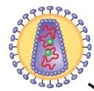

- Compare and contrast a prophage and a provirus. Which one are you likely to carry?

- This sketch shows the infection of a cell by HIV. Extend label lines to give a complete explanation of the process. Refer to your text Figure 19.8 for details.

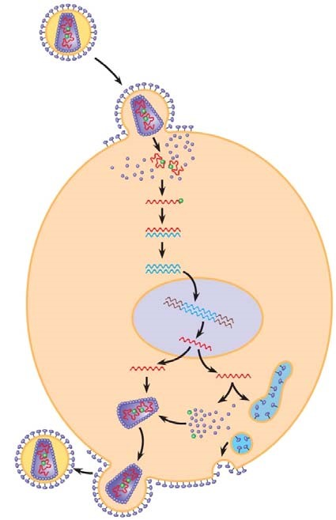

- The final section in this concept is titled “Evolution of Viruses.” From this part, describe the two possible sources of viral genomes. You will see each of these important mobile genetic elements again.
Description of the Mobile Genetic Element
Plasmids
Transposons

Concept 19.3 Viruses, viroids, and prions are formidable pathogens in animals and plants
- What are three ways that viruses make us ill? Why do we recover completely from a cold but not from polio?

- What tools are in the medical arsenal against human viral diseases?

- Emerging viruses such as HIV, Ebola, and SARS seem to burst upon the human scene. What are three processes that contribute to this sudden emergence?

- The current flu pandemic is H1N1. What does this name mean?

- Distinguish between horizontal transmission and vertical transmission in plants.

- How do viruses spread throughout plant bodies?

- What is a viroid? What important lesson do they teach? Name one viroid disease.

- Prions strike fear into carnivores everywhere. What are they? How are they transmitted? What do they do?

- Name four diseases caused by prions.

- What are two alarming characteristics of prions?

- Two Nobel Prizes have been awarded for the study of prions. One went to Carlton Gajdusek, who worked with the Fore people of Papua New Guinea in the 1960s to determine the cause of a kuru epidemic. Who got the second Nobel Prize in this area, and when?

