AP BIOLOGY 2021-22 February 9, 2022

Today’s Agenda (Day 104)

- Housekeeping Items

- Homework Check:
Ch 17 Reading Guide
- Class Activity:
CONT’D: Ch 17 PPT Review
- Section 17.5 – Mutations of one or a few nucleotides can affect protein structure and function
WEDNESDAY: Ch 18 PPT Review
- Section 18.1 – Bacteria often respond to environmental change by regulating transcription
- Section 18.2 – Eukaryotic gene expression is regulated at many stages
- Section 18.3 – Noncoding RNAs play multiple roles in controlling gene expression
- Section 18.4 – A program of differential gene expression leads to the different cell types in a multicellular organism
- Section 18.5 – Cancer results from genetic changes that affect cell cycle control

HOMEWORK:
- READ: Chapters 14 – 18
- STUDY: Chapter 17 Test
Chapter 17 – Gene Expression
5’ cap | A site | Alternative RNA splicing | Aminoacyl tRNA synthetase | Anticodon | Codon
Deletion | Domain | E site | Exons | Frameshift mutation | Gene expression
Insertion | introns | Messenger RNA | Missense mutation | Mutagen | Mutations
Nonsense mutation | Nucleotide-pair substitution | P site | Point mutations | Poly-A tail | Polyribosomes
Promoter | Reading frame | Ribosomal RNA | Ribosomes | Ribozymes | RNA polymerase
RNA processing | RNA splicing | Signal peptide | Signal-recognition particle (SRP) | Silent mutation | Spliceosome
Start point | TATA box | Template strand | Terminator | Transcription | Transcription factors
Transcription initiation complex | Transcription unit | Transfer RNA | Translation | wobble
Chapter 18 – Regulation of Gene Expression
Activator | Bicoid | Control elements | Corepressor | Cyclic AMP | Cytoplasmic determinants
Determination | Differential gene expression | Differentiation | DNA methylation | Egg-polarity genes | Embryonic lethals
Enhancers | Epigenetic inheritance | Histone acetylation | Homeotic genes | Inducer | Induction
Maternal effect gene | microRNAs | Morphogenesis | Oncogenes | Operator | Operon
P53 gene | Pattern formation | Positional information | Proto-oncogenes | Ras gene | Regulatory gene
Repressor | RNA interference (RNAi) | Small interfering RNAs | Tumor-suppressor genes

REMINDERS:

- TEST: Chapter 17 February 10
- Ch 18 Vocabulary – Feb. 11

AP BIOLOGY 2021-22 READING GUIDE

Chapter 18: Regulation of Gene Expression

Overview

The overview for Chapter 18 introduces the idea that while all cells of an organism have all genes in the genome, not all genes are expressed in every cell. What regulates gene expression? Gene expression in prokaryotic cells differs from that in eukaryotic cells. How do disruptions in gene regulation lead to cancer? This chapter gives you a look at how genes are expressed and modulated.

Concept 18.1 Bacteria often respond to environmental change by regulating transcription

- All genes are not “on” all the time. Using the metabolic needs of E. coli, explain why not.

- What are the two main ways of controlling metabolism in bacterial cells?

- Feedback inhibition is a recurring mechanism throughout biological systems. In the case of E.
coli regulating tryptophan synthesis, is it positive or negative inhibition? Explain your choice.

- What is a promoter?

- What is the operator? What does it do?

- What is an operon?

- List the three components of an operon, and explain the role of each one.

- How does a repressor protein work?

- What are regulatory genes?

- Distinguish between inducible and repressible operons, and describe one example of each type.

- Label this sketch of the lac operon with the terms at right. Know the function of each structure.

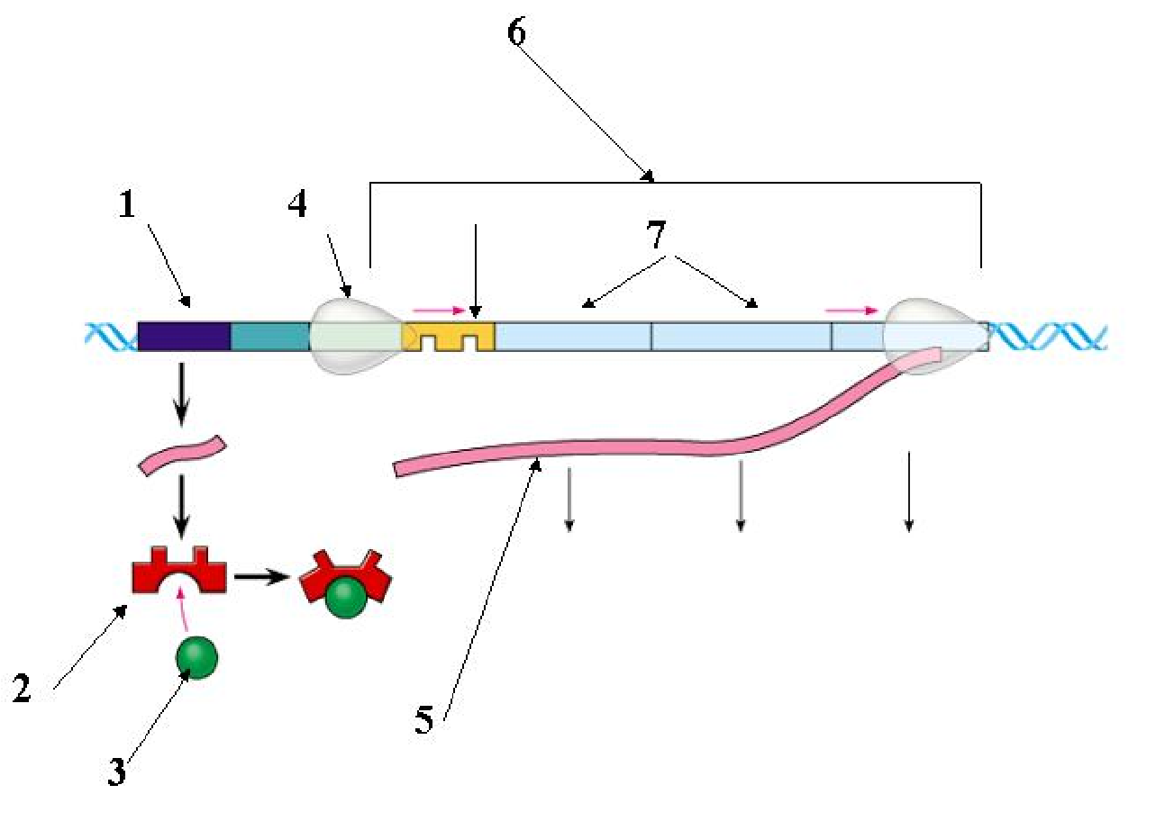
Operon genes
Operon
RNA polymerase
mRNA
Repressor protein
Operator
Repressor
Regulatory gene
Inducer

8
- Compare and contrast the lac operon and the trp operon. (Remember that compare means “to tell how they are similar,” and contrast means “to tell how they are different.”)

- What happens when a repressor is bound to the operator?

- What is CAP? How does CAP work?

- Explain why CAP binding and stimulation of gene expression is positive regulation.

- Describe the relationship between glucose supply, cAMP, and CAP.

- How can both repressible and inducible operons be negative regulators?

Concept 18.2 Eukaryotic gene expression can be regulated at any stage

- Even though all cells of an organism have the same genes, there is differential gene expression. What does this mean?

- What percentage of the genes of a typical human cell is expressed at any given time?

- What is the common control point of gene expression for all organisms?

- Gene expression can be regulated by modifications of the chromatin. Distinguish between heterochromatin and euchromatin as to their structure and activity.

- What occurs in histone acetylation? How does it affect gene expression?

- What is DNA methylation? What role may it play in gene expression?

- The inactive mammalian X chromosome is heavily methylated. What is the result of this methylation?

- What is genomic imprinting, and how is it maintained? Give an example discussed earlier in human genetics.

- Explain what is meant by epigenetic inheritance and give an example of epigenetic changes discussed in the text or in class.

- Use the sketch below to explain how enhancers and activators interact with transcription factors to affect gene expression. Label the following elements: TATA box, promoter, gene, enhancer, activators, transcription factors, transcription initiation complex, RNA polymerase II, and DNA. Then place your explanation to the right of the figure.

EXPLANATION

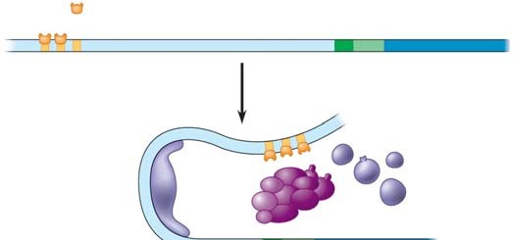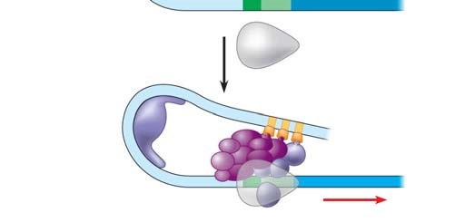
- In prokaryotes, functionally related genes are usually clustered in a single operon. What has been found to be the case in eukaryotes?

- Operons have not been found in eukaryotic cells, and the genes coding for the enzymes of a particular metabolic pathway are often scattered over different chromosomes. What is a plausible mechanism for the coordination of gene expression?

- How can alternative RNA splicing result in different proteins derived from the same initial RNA transcript?

- Posttranscriptional control includes regulation of mRNA degradation. Explain how this affects translation.

- How can proteins be activated, processed, and degraded? Give an example or describe each process.

- An article in Scientific American about proteasomes was entitled “Little Chamber of Horrors.” Explain how proteins are targeted for degradation and give a specific example of when this might occur.

- How do these “little chambers of horrors” function? Annotate the sketch below to describe their action. Then explain their role in regulation of gene expression.

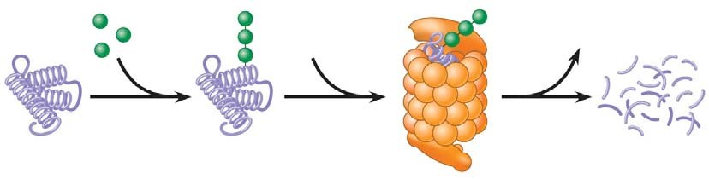

Concept 18.3 Noncoding RNAs play multiple roles in controlling gene expression

- It is now known that much of the RNA that is transcribed is not translated into protein. these RNAs are called noncoding RNAs. Read carefully to discern a crucial role played by these RNAs. What is this role?

- One of the noncoding RNAs that regulate gene expression is microRNA. On the sketch below, follow an RNA loop, called a “hairpin,” from its creation. Explain the two modes of action of microRNAs.

Be sure to label the location of hydrogen bonds and Dicer.

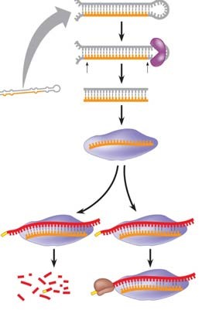

Concept 18.4 A program of differential gene expression leads to the different cell types in a multicellular organism
This concept deals with the regulation of gene expression in development. Animal development is also discussed in Chapter 47.

- What three processes lead to the transformation of a zygote into the organism?

- Explain what occurs in cell differentiation and morphogenesis.

- Differential gene expression results from different activators in different cells. How do different sets of activators come to be present in two cells? Explain how each of these occurs:
  - distribution of cytoplasmic determinants
  - different inductive signals
- What is meant by determination? Explain what this means within an embryonic cell.

- What process ensures that all the tissues and organs of an organism are in their characteristic places? Where do the molecular cues that control this process arise?

- What is controlled by homeotic genes?

Concept 18.5 Cancer results from genetic changes that affect cell cycle control

- What mechanism is involved in the beginning of tumor growth? Discuss oncogenes and proto oncogenes.

- What are three mechanisms for converting a proto-oncogene to an oncogene?

- There seem to be two categories of genes involved in cancer: oncogenes, which code for proteins to regulate cell growth, and should not be stuck “on,” much like the accelerator in a car; and tumor-suppressor genes, which work like the brakes on a car and must function! Let’s begin with a look at the ras gene, which codes for a G protein and is an oncogene. Label the sketch below to explain how a ras mutation leads to cancer.

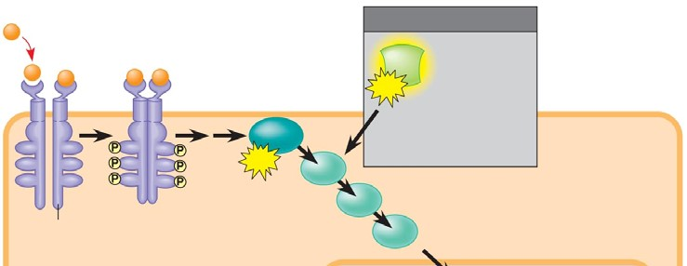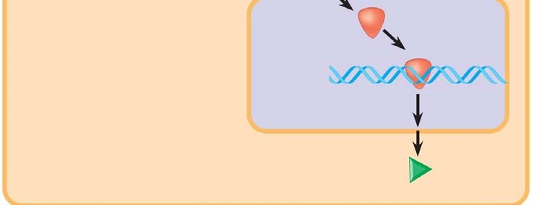

- Tumor-suppressor genes help prevent uncontrolled cell growth. One that is found mutated (and therefore nonfunctional) in more than 50% of human cancer is p53. So important is the p53 gene that it is sometimes called the “guardian angel of the genome.” Describe the double whammy that results from mutation of p53.

- Explain the multistep model of cancer development by using the specific example of colorectal cancer. The figure below may be labeled to help in your explanation.

