AP BIOLOGY 2021-22 February 8, 2022

Today’s Agenda (Day 103)

- Housekeeping Items

- Homework Check:
Ch 17 Reading Guide
- Class Activity:
QUIZ: Chapter 17 Vocabulary
*Go to www.socrative.com enter room “MSBAPBIO” enter ID #
CONT’D: Ch 17 PPT Review
- Section 17.5 – Mutations of one or a few nucleotides can affect protein structure and function
WEDNESDAY: Ch 18 PPT Review
- Section 18.1 – Bacteria often respond to environmental change by regulating transcription
- Section 18.2 – Eukaryotic gene expression is regulated at many stages
- Section 18.3 – Noncoding RNAs play multiple roles in controlling gene expression
- Section 18.4 – A program of differential gene expression leads to the different cell types in a multicellular organism
- Section 18.5 – Cancer results from genetic changes that affect cell cycle control

HOMEWORK:
- READ: Chapters 14 – 18
- STUDY: Chapter 17 Test
Chapter 17 – Gene Expression
5’ cap | A site | Alternative RNA splicing | Aminoacyl tRNA synthetase | Anticodon | Codon
Deletion | Domain | E site | Exons | Frameshift mutation | Gene expression
Insertion | introns | Messenger RNA | Missense mutation | Mutagen | Mutations
Nonsense mutation | Nucleotide-pair substitution | P site | Point mutations | Poly-A tail | Polyribosomes
Promoter | Reading frame | Ribosomal RNA | Ribosomes | Ribozymes | RNA polymerase
RNA processing | RNA splicing | Signal peptide | Signal-recognition particle (SRP) | Silent mutation | Spliceosome
Start point | TATA box | Template strand | Terminator | Transcription | Transcription factors
Transcription initiation complex | Transcription unit | Transfer RNA | Translation | wobble
Chapter 18 – Regulation of Gene Expression
Activator | Bicoid | Control elements | Corepressor | Cyclic AMP | Cytoplasmic determinants
Determination | Differential gene expression | Differentiation | DNA methylation | Egg-polarity genes | Embryonic lethals
Enhancers | Epigenetic inheritance | Histone acetylation | Homeotic genes | Inducer | Induction
Maternal effect gene | microRNAs | Morphogenesis | Oncogenes | Operator | Operon
P53 gene | Pattern formation | Positional information | Proto-oncogenes | Ras gene | Regulatory gene
Repressor | RNA interference (RNAi) | Small interfering RNAs | Tumor-suppressor genes

REMINDERS:

- TEST: Chapter 17 February 10
- Ch 18 Vocabulary – Feb. 11

AP BIOLOGY 2021-22 READING GUIDE

Chapter 17: From Gene to Protein
Overview

1. What is gene expression?

Concept 17.1 Genes specify proteins via transcription and translation

- What situation did Archibald Garrod suggest caused inborn errors of metabolism?

- Describe one example Garrod used to illustrate his hypothesis.

- State the hypothesis formulated by George Beadle while studying eye color mutations in Drosophila.

- What strategy did Beadle and Tatum adopt to test this hypothesis?

- Which organism did Beadle and Tatum use in their research? How did this organism’s nutritional requirements facilitate this research?

- How were Neurospora spores treated to increase the mutation rate?

- Study Figure 17.2 carefully. On the figure below, outline the technique used to identify and isolate mutant fungi.
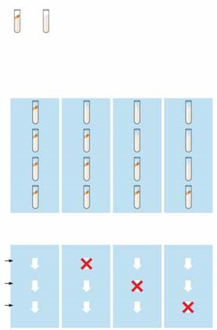

- Cite two significant findings that resulted from the research of Beadle and Tatum.
- What revision of detail (but not of basic principle) did this hypothesis undergo as more information was gained? Write this restatement and then box or highlight it. This is an important concept!

Basic Principles of Transcription and Translation
This section will introduce you to the processes and associated terminology in the form of an overview. Once you have the big picture, you will take a closer look in the next few concepts.

- From the first paragraph in this section, find three ways in which RNA differs from DNA.

- What are the monomers of DNA and RNA? Of proteins?

- Define each of these processes that are essential to the formation of a protein:
transcription

translation

- Complete the following table to summarize each process.

 | Template | Product Synthesized | Location in Eukaryotic Cell
Transcription
Translation

- In eukaryotes, what is the pre-mRNA called?

- Write the central dogma of molecular genetics, as proclaimed by Francis Crick, in the box below.

- How many nucleotide bases are there? ___________How many amino acids? __________

- How many nucleotides are required to code for these 20 amino acids? ___________________

- So, the language of DNA is a triplet code. How many unique triplets exist? ______________

- DNA is double-stranded, but for each protein, only one of these two strands is used to produce an mRNA transcript. What is the coding strand called?

- Here is a short DNA template. Below it, assemble the complementary mRNA strand.
3'A C G A C C A G T A A A 5'
- How many codons are there above? ________ Label one codon.

- Describe Nirenberg’s experiment in which he identified the first codon.

- What was the first codon–amino acid pair to be identified? __________________________

- Of the 64 possible codons, how many code for amino acids? _________________________

- What event is coded for by UAA, UAG and UGA? ________________________________

- What is the start codon? ____________________________________________________

- Why is the genetic code said to be redundant but not ambiguous?

- Explain the concept of reading frame.

- Now here is an important idea: DNA is DNA is DNA. By this we mean that the code is nearly universal, and because of this, jellyfish genes can be inserted into pigs, or firefly genes can make a tobacco plant glow. Enjoy a look at Figure 17.6 in your text . . . and no question to answer here!

Concept 17.2 Transcription is the DNA-directed synthesis of RNA: A closer look

- Name the enzyme that uses the DNA template strand to transcribe a new mRNA strand.

- You will recall from Chapter 16 that DNA polymerase III adds new nucleotides to the template DNA strand to assemble each new strand of DNA. Both enzymes can assemble a new polynucleotide only in the 5' direction. Which enzyme, DNA polymerase III or RNA polymerase, does not require a primer to begin synthesis?

- What is a transcription unit?

- Figure 17.7 in your text will require a bit of study. Use it to label the following elements on the figure below: promoter, RNA polymerase, transcription unit, DNA template, non-template DNA, and RNA transcript. Then, to the right of the figure, name the three stages of transcription and briefly describe each stage.

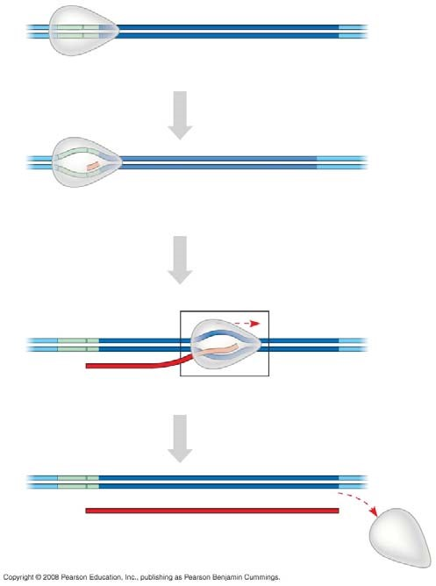

- Let’s now take a closer look at initiation. Read the paragraph titled “RNA Polymerase Binding and Initiation of Transcription” carefully. List three important facts about the promoter here.
(1)

(2)

(3)

- Use Figure 17.8 in your text to label the following elements of the figure below: TATA box, RNA polymerase II, transcription factors, template DNA strand, start point, 5' and 3', and mRNA transcript. To the right of the figure, explain the three stages of initiation that are shown.

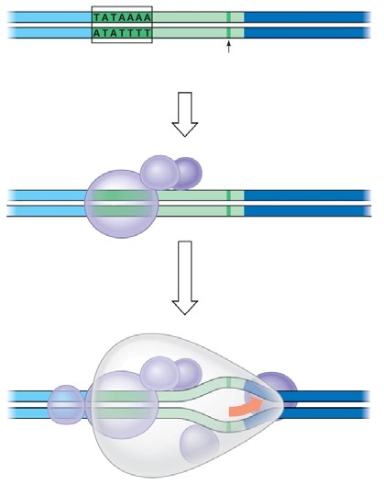
- What is the TATA box? How do you think it got this name?

- What comprises a transcription initiation complex?

- Now it is time to put all of the elements of transcription together. Write an essay below to describe the process by which mRNA is formed. Use these terms correctly in your essay, and underline each one: TATA box, gene, terminator, promoter, elongation, 5’ to 3', termination, initiation RNA, polymerase RNA nucleotides, template, start point, termination signal, and transcription factors. This essay is typical of what you might be asked to write on the AP Biology exam.

Concept 17.3 Eukaryotic cells modify RNA after transcription

- RNA processing occurs only in eukaryotic cells. The primary transcript is altered at both ends, and sections in the middle are removed.
  - What happens at the 5' end?

  - What happens at the 3' end?

- What are three important functions of the 5' cap and poly-A tail?

- Distinguish between introns and exons. Perhaps it will help to remember this: Exons are expressed.

- On the figure below, label: pre-mRNA, 5' cap, poly-A tail, introns, and exons.
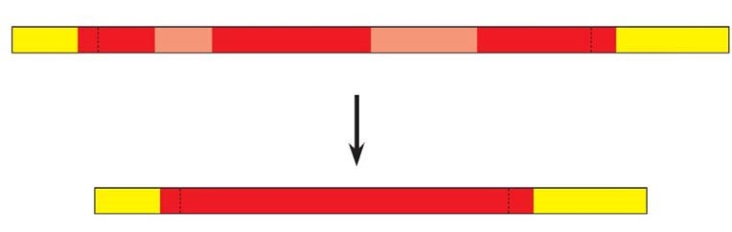

- What are snRNPs? What two types of molecules make up a snurp? (We like the word snurp! It reminds us of little cartoon characters that wore blue hoods and were called smurfs.

- You will be introduced to a number of small RNAs in this course. What type is the RNA in a snRNP?

- Snurps band together in little snurp groups to form spliceosomes. How do spliceosomes work?

- On the figure below, label the following: pre-mRNA, snRNPs, snRNA, protein, spliceosomes, intron, and other proteins.

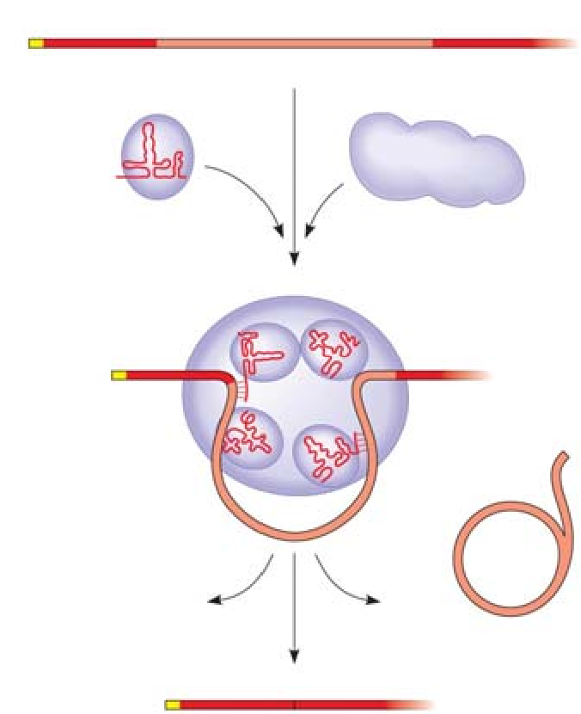

- Study the figure and text carefully to explain how the splice sites are recognized.

- What is a ribozyme?

- What commonly held idea was rendered obsolete by the discovery of ribozymes?

- What are three properties of RNA that allow it to function as an enzyme?
(1)

(2)

(3)

- What is the consequence of alternative splicing of identical mRNA transcripts?

Concept 17.4 Translation is the RNA-directed synthesis of a polypeptide: A closer look
- You may need to read on in this section in order to answer this question as well as think back to earlier information about mRNA. Come back to this question later if you wish. Three types of RNA are needed for protein synthesis. Complete the chart below.
Type of RNA | Description | Function
mRNA
tRNA

rRNA

- What is an anticodon?

- Transfer RNA has two attachment sites. What binds at each site? Sketch tRNA, indicate the 2 attachment sites, and note where complementary base pairing and hydrogen bonding occur to give tRNA its shape.

- How many different aminoacyl-tRNA synthetase are there? ____________________________

- Scientists expected to find one aminoacyl-tRNA synthetase per codon, but far fewer have been discovered. How does wobble explain this?

- Use the figure below to explain the process of a specific amino acid being joined to a tRNA. Also add these labels: aminoacyl-tRNA synthetase, ATP, amino acid, and tRNA.
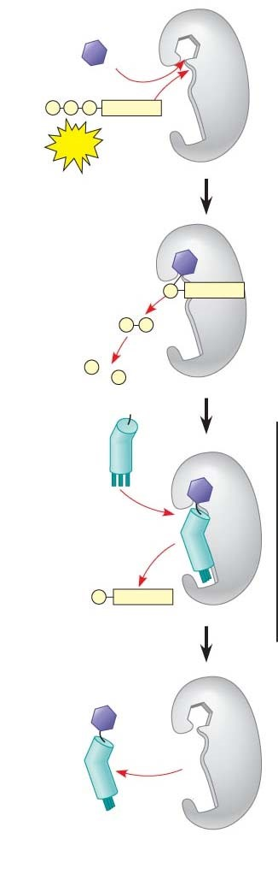
- Describe the structure of a eukaryotic ribosome.

- How does a prokaryotic ribosome differ from a eukaryotic ribosome? What is the medical significance of this difference?

- On this figure, label the large subunit, small subunit, A, P, and E sites, mRNA binding site. To the right of the figure, explain the functions of the A, P, and E sites.
- Much like transcription, we can divide translation into three stages. List them.

- Summarize the events of initiation. Include these components: small ribosomal subunit, large ribosomal subunit, mRNA, initiator codon, tRNA, Met, initiation complex, P site, and GTP. The figure below may help you.
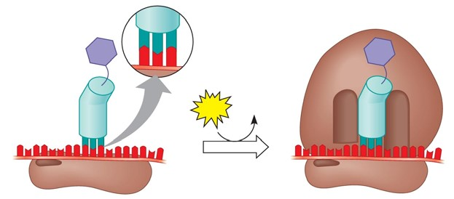
- What is always the first amino acid in the new polypeptide?

- Now, summarize the events of elongation. Include these components: mRNA, A site, tRNA, codon, anticodon, ribozyme, P site, and E site. Again, the figure may help you.

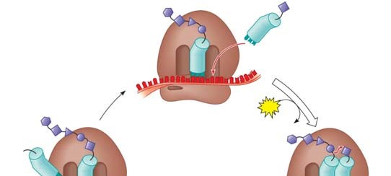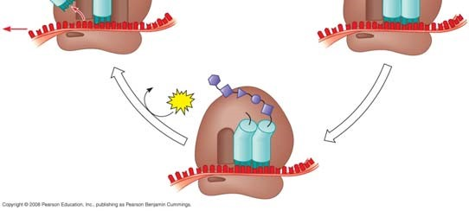
- What is a release factor? By what mechanism is termination accomplished?

- What is a polyribosome?

- What are some of the things that will result in a final-form functional protein?

- Describe at least three types of post-translational modifications.

- Use the following figure to explain how proteins are targeted for the ER.
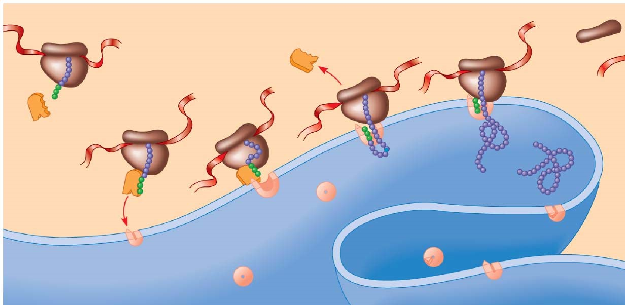

Concept 17.5 Point mutations can affect protein structure and function

- Define a mutation in terms of molecular genetics.

- Define point mutations.

- What are frameshift mutations?

- Identify two mechanisms by which frameshifts may occur.

- What is the difference between a nonsense and missense mutation?

- How can a base-pair substitution result in a silent mutation?

- What are the two categories of mutagens?

- Describe the action of difference types of chemical mutagens.

Concept 17.6 Although gene expression differs among the domains of life, the concept of a gene is universal
- Describe two important ways in which bacterial and eukaryotic gene expression differ.

- What is a gene? It used to be simply stated that one gene codes for one polypeptide. That definition has now been modified. Write below the broader molecular definition in use today.

- Finally, use this summary figure to put together all that you have learned in this chapter.
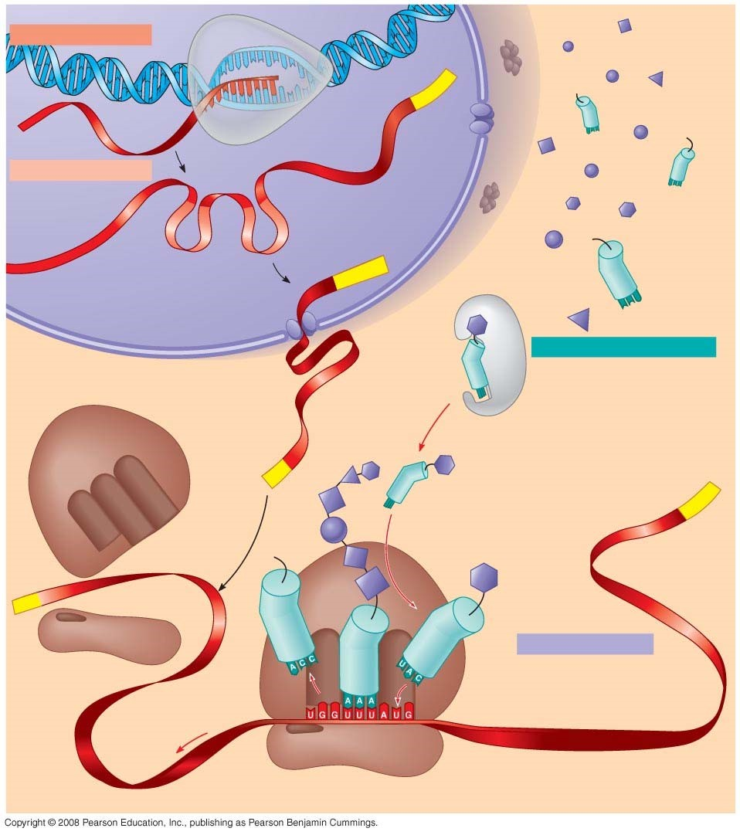

AP BIOLOGY 2021-22 READING GUIDE

Chapter 18: Regulation of Gene Expression

Overview

The overview for Chapter 18 introduces the idea that while all cells of an organism have all genes in the genome, not all genes are expressed in every cell. What regulates gene expression? Gene expression in prokaryotic cells differs from that in eukaryotic cells. How do disruptions in gene regulation lead to cancer? This chapter gives you a look at how genes are expressed and modulated.

Concept 18.1 Bacteria often respond to environmental change by regulating transcription

- All genes are not “on” all the time. Using the metabolic needs of E. coli, explain why not.

- What are the two main ways of controlling metabolism in bacterial cells?

- Feedback inhibition is a recurring mechanism throughout biological systems. In the case of E.
coli regulating tryptophan synthesis, is it positive or negative inhibition? Explain your choice.

- What is a promoter?

- What is the operator? What does it do?

- What is an operon?

- List the three components of an operon, and explain the role of each one.

- How does a repressor protein work?

- What are regulatory genes?

- Distinguish between inducible and repressible operons, and describe one example of each type.

- Label this sketch of the lac operon with the terms at right. Know the function of each structure.

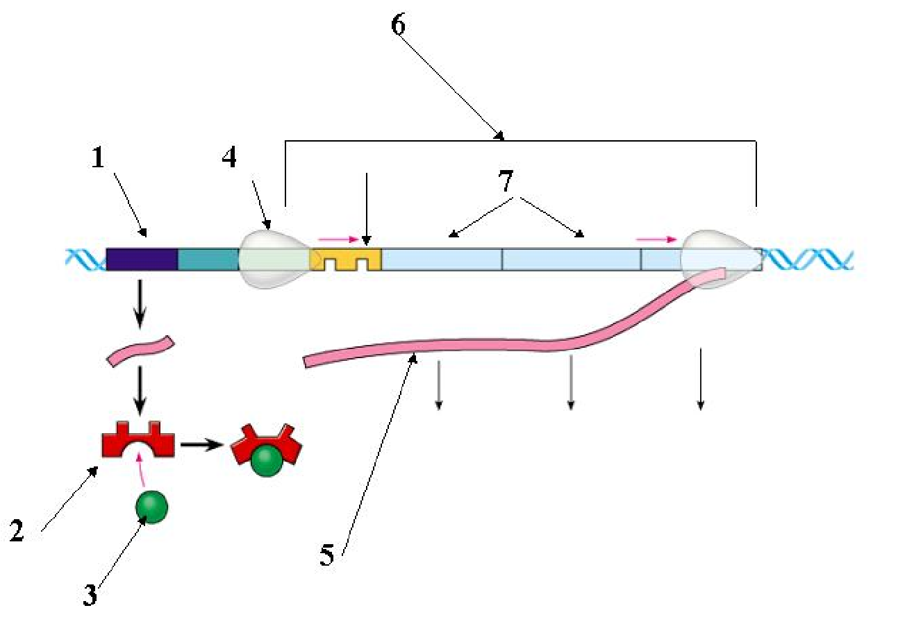
Operon genes
Operon
RNA polymerase
mRNA
Repressor protein
Operator
Repressor
Regulatory gene
Inducer

8
- Compare and contrast the lac operon and the trp operon. (Remember that compare means “to tell how they are similar,” and contrast means “to tell how they are different.”)

- What happens when a repressor is bound to the operator?

- What is CAP? How does CAP work?

- Explain why CAP binding and stimulation of gene expression is positive regulation.

- Describe the relationship between glucose supply, cAMP, and CAP.

- How can both repressible and inducible operons be negative regulators?

Concept 18.2 Eukaryotic gene expression can be regulated at any stage

- Even though all cells of an organism have the same genes, there is differential gene expression. What does this mean?

- What percentage of the genes of a typical human cell is expressed at any given time?

- What is the common control point of gene expression for all organisms?

- Gene expression can be regulated by modifications of the chromatin. Distinguish between heterochromatin and euchromatin as to their structure and activity.

- What occurs in histone acetylation? How does it affect gene expression?

- What is DNA methylation? What role may it play in gene expression?

- The inactive mammalian X chromosome is heavily methylated. What is the result of this methylation?

- What is genomic imprinting, and how is it maintained? Give an example discussed earlier in human genetics.

- Explain what is meant by epigenetic inheritance and give an example of epigenetic changes discussed in the text or in class.

- Use the sketch below to explain how enhancers and activators interact with transcription factors to affect gene expression. Label the following elements: TATA box, promoter, gene, enhancer, activators, transcription factors, transcription initiation complex, RNA polymerase II, and DNA. Then place your explanation to the right of the figure.

EXPLANATION

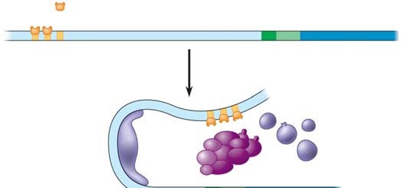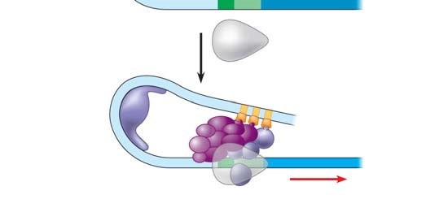
- In prokaryotes, functionally related genes are usually clustered in a single operon. What has been found to be the case in eukaryotes?

- Operons have not been found in eukaryotic cells, and the genes coding for the enzymes of a particular metabolic pathway are often scattered over different chromosomes. What is a plausible mechanism for the coordination of gene expression?

- How can alternative RNA splicing result in different proteins derived from the same initial RNA transcript?

- Posttranscriptional control includes regulation of mRNA degradation. Explain how this affects translation.

- How can proteins be activated, processed, and degraded? Give an example or describe each process.

- An article in Scientific American about proteasomes was entitled “Little Chamber of Horrors.” Explain how proteins are targeted for degradation and give a specific example of when this might occur.

- How do these “little chambers of horrors” function? Annotate the sketch below to describe their action. Then explain their role in regulation of gene expression.

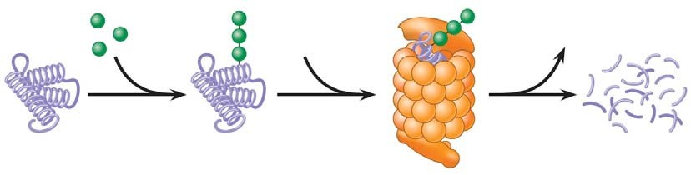

Concept 18.3 Noncoding RNAs play multiple roles in controlling gene expression

- It is now known that much of the RNA that is transcribed is not translated into protein. these RNAs are called noncoding RNAs. Read carefully to discern a crucial role played by these RNAs. What is this role?

- One of the noncoding RNAs that regulate gene expression is microRNA. On the sketch below, follow an RNA loop, called a “hairpin,” from its creation. Explain the two modes of action of microRNAs.

Be sure to label the location of hydrogen bonds and Dicer.

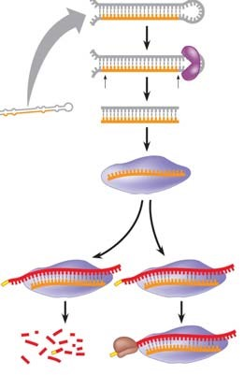

Concept 18.4 A program of differential gene expression leads to the different cell types in a multicellular organism
This concept deals with the regulation of gene expression in development. Animal development is also discussed in Chapter 47.

- What three processes lead to the transformation of a zygote into the organism?

- Explain what occurs in cell differentiation and morphogenesis.

- Differential gene expression results from different activators in different cells. How do different sets of activators come to be present in two cells? Explain how each of these occurs:
  - distribution of cytoplasmic determinants
  - different inductive signals
- What is meant by determination? Explain what this means within an embryonic cell.

- What process ensures that all the tissues and organs of an organism are in their characteristic places? Where do the molecular cues that control this process arise?

- What is controlled by homeotic genes?

Concept 18.5 Cancer results from genetic changes that affect cell cycle control

- What mechanism is involved in the beginning of tumor growth? Discuss oncogenes and proto oncogenes.

- What are three mechanisms for converting a proto-oncogene to an oncogene?

- There seem to be two categories of genes involved in cancer: oncogenes, which code for proteins to regulate cell growth, and should not be stuck “on,” much like the accelerator in a car; and tumor-suppressor genes, which work like the brakes on a car and must function! Let’s begin with a look at the ras gene, which codes for a G protein and is an oncogene. Label the sketch below to explain how a ras mutation leads to cancer.

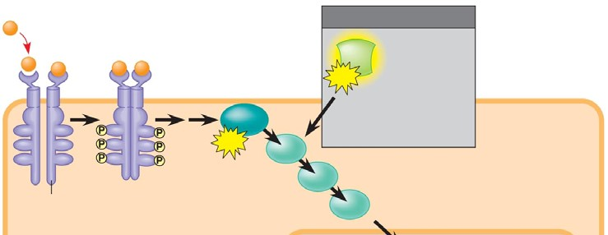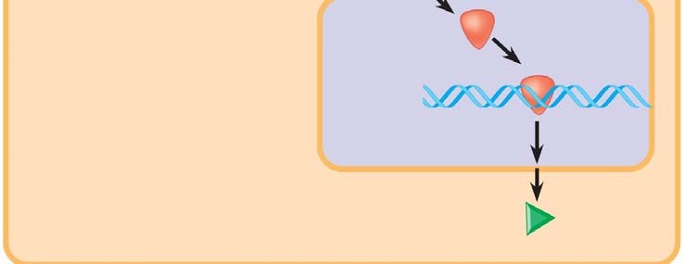

- Tumor-suppressor genes help prevent uncontrolled cell growth. One that is found mutated (and therefore nonfunctional) in more than 50% of human cancer is p53. So important is the p53 gene that it is sometimes called the “guardian angel of the genome.” Describe the double whammy that results from mutation of p53.

- Explain the multistep model of cancer development by using the specific example of colorectal cancer. The figure below may be labeled to help in your explanation.

