AP BIOLOGY 2021-22 February 7, 2022

Today’s Agenda (Day 102)

- Housekeeping Items

- Homework Check:
Ch 17 Vocabulary

- Class Activity:
CONT’D: Ch 17 PPT Review
- Section 17.4 – Translation is the RNA-directed synthesis of a polypeptide
- Section 17.5 – Mutations of one or a few nucleotides can affect protein structure and function

HOMEWORK:
- READ: Chapters 14 – 18
- STUDY: Chapter 17 Test

Chapter 17 – Gene Expression
5’ cap | A site | Alternative RNA splicing | Aminoacyl tRNA synthetase | Anticodon | Codon
Deletion | Domain | E site | Exons | Frameshift mutation | Gene expression
Insertion | introns | Messenger RNA | Missense mutation | Mutagen | Mutations
Nonsense mutation | Nucleotide-pair substitution | P site | Point mutations | Poly-A tail | Polyribosomes
Promoter | Reading frame | Ribosomal RNA | Ribosomes | Ribozymes | RNA polymerase
RNA processing | RNA splicing | Signal peptide | Signal-recognition particle (SRP) | Silent mutation | Spliceosome
Start point | TATA box | Template strand | Terminator | Transcription | Transcription factors
Transcription initiation complex | Transcription unit | Transfer RNA | Translation | wobble

REMINDERS:

- QUIZ: Ch 17 Vocabulary – Feb. 8
- Ch 17 Reading Guide – Feb. 7
- TEST: Chapter 17 February 10

AP BIOLOGY 2021-22 READING GUIDE

Chapter 17: From Gene to Protein
Overview

1. What is gene expression?

Concept 17.1 Genes specify proteins via transcription and translation

- What situation did Archibald Garrod suggest caused inborn errors of metabolism?

- Describe one example Garrod used to illustrate his hypothesis.

- State the hypothesis formulated by George Beadle while studying eye color mutations in Drosophila.

- What strategy did Beadle and Tatum adopt to test this hypothesis?

- Which organism did Beadle and Tatum use in their research? How did this organism’s nutritional requirements facilitate this research?

- How were Neurospora spores treated to increase the mutation rate?

- Study Figure 17.2 carefully. On the figure below, outline the technique used to identify and isolate mutant fungi.
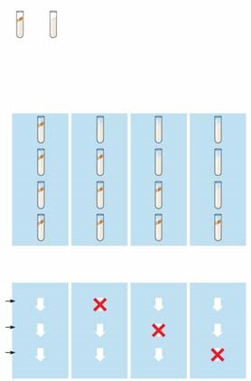

- Cite two significant findings that resulted from the research of Beadle and Tatum.
- What revision of detail (but not of basic principle) did this hypothesis undergo as more information was gained? Write this restatement and then box or highlight it. This is an important concept!

Basic Principles of Transcription and Translation
This section will introduce you to the processes and associated terminology in the form of an overview. Once you have the big picture, you will take a closer look in the next few concepts.

- From the first paragraph in this section, find three ways in which RNA differs from DNA.

- What are the monomers of DNA and RNA? Of proteins?

- Define each of these processes that are essential to the formation of a protein:
transcription

translation

- Complete the following table to summarize each process.

 | Template | Product Synthesized | Location in Eukaryotic Cell
Transcription
Translation

- In eukaryotes, what is the pre-mRNA called?

- Write the central dogma of molecular genetics, as proclaimed by Francis Crick, in the box below.

- How many nucleotide bases are there? ___________How many amino acids? __________

- How many nucleotides are required to code for these 20 amino acids? ___________________

- So, the language of DNA is a triplet code. How many unique triplets exist? ______________

- DNA is double-stranded, but for each protein, only one of these two strands is used to produce an mRNA transcript. What is the coding strand called?

- Here is a short DNA template. Below it, assemble the complementary mRNA strand.
3'A C G A C C A G T A A A 5'
- How many codons are there above? ________ Label one codon.

- Describe Nirenberg’s experiment in which he identified the first codon.

- What was the first codon–amino acid pair to be identified? __________________________

- Of the 64 possible codons, how many code for amino acids? _________________________

- What event is coded for by UAA, UAG and UGA? ________________________________

- What is the start codon? ____________________________________________________

- Why is the genetic code said to be redundant but not ambiguous?

- Explain the concept of reading frame.

- Now here is an important idea: DNA is DNA is DNA. By this we mean that the code is nearly universal, and because of this, jellyfish genes can be inserted into pigs, or firefly genes can make a tobacco plant glow. Enjoy a look at Figure 17.6 in your text . . . and no question to answer here!

Concept 17.2 Transcription is the DNA-directed synthesis of RNA: A closer look

- Name the enzyme that uses the DNA template strand to transcribe a new mRNA strand.

- You will recall from Chapter 16 that DNA polymerase III adds new nucleotides to the template DNA strand to assemble each new strand of DNA. Both enzymes can assemble a new polynucleotide only in the 5' direction. Which enzyme, DNA polymerase III or RNA polymerase, does not require a primer to begin synthesis?

- What is a transcription unit?

- Figure 17.7 in your text will require a bit of study. Use it to label the following elements on the figure below: promoter, RNA polymerase, transcription unit, DNA template, non-template DNA, and RNA transcript. Then, to the right of the figure, name the three stages of transcription and briefly describe each stage.

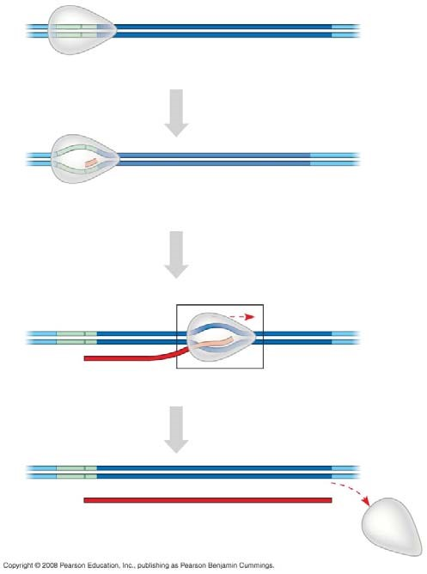

- Let’s now take a closer look at initiation. Read the paragraph titled “RNA Polymerase Binding and Initiation of Transcription” carefully. List three important facts about the promoter here.
(1)

(2)

(3)

- Use Figure 17.8 in your text to label the following elements of the figure below: TATA box, RNA polymerase II, transcription factors, template DNA strand, start point, 5' and 3', and mRNA transcript. To the right of the figure, explain the three stages of initiation that are shown.

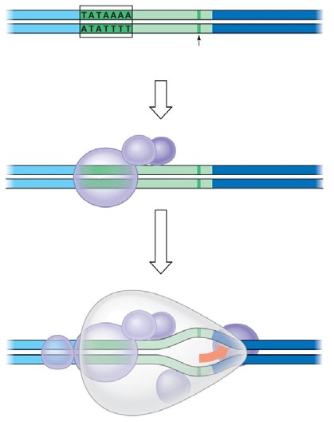
- What is the TATA box? How do you think it got this name?

- What comprises a transcription initiation complex?

- Now it is time to put all of the elements of transcription together. Write an essay below to describe the process by which mRNA is formed. Use these terms correctly in your essay, and underline each one: TATA box, gene, terminator, promoter, elongation, 5’ to 3', termination, initiation RNA, polymerase RNA nucleotides, template, start point, termination signal, and transcription factors. This essay is typical of what you might be asked to write on the AP Biology exam.

Concept 17.3 Eukaryotic cells modify RNA after transcription

- RNA processing occurs only in eukaryotic cells. The primary transcript is altered at both ends, and sections in the middle are removed.
  - What happens at the 5' end?

  - What happens at the 3' end?

- What are three important functions of the 5' cap and poly-A tail?

- Distinguish between introns and exons. Perhaps it will help to remember this: Exons are expressed.

- On the figure below, label: pre-mRNA, 5' cap, poly-A tail, introns, and exons.
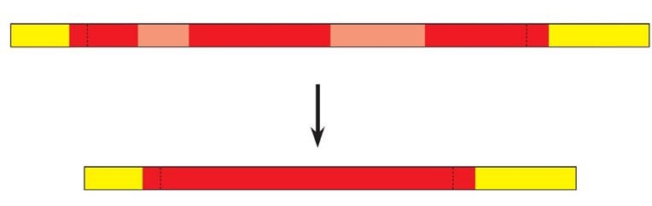

- What are snRNPs? What two types of molecules make up a snurp? (We like the word snurp! It reminds us of little cartoon characters that wore blue hoods and were called smurfs.

- You will be introduced to a number of small RNAs in this course. What type is the RNA in a snRNP?

- Snurps band together in little snurp groups to form spliceosomes. How do spliceosomes work?

- On the figure below, label the following: pre-mRNA, snRNPs, snRNA, protein, spliceosomes, intron, and other proteins.

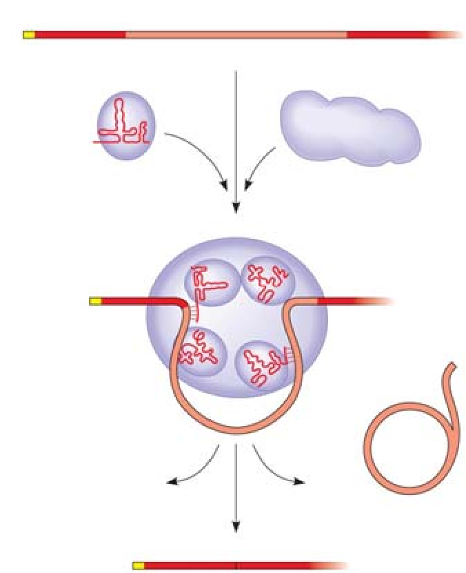

- Study the figure and text carefully to explain how the splice sites are recognized.

- What is a ribozyme?

- What commonly held idea was rendered obsolete by the discovery of ribozymes?

- What are three properties of RNA that allow it to function as an enzyme?
(1)

(2)

(3)

- What is the consequence of alternative splicing of identical mRNA transcripts?

Concept 17.4 Translation is the RNA-directed synthesis of a polypeptide: A closer look
- You may need to read on in this section in order to answer this question as well as think back to earlier information about mRNA. Come back to this question later if you wish. Three types of RNA are needed for protein synthesis. Complete the chart below.
Type of RNA | Description | Function
mRNA
tRNA

rRNA

- What is an anticodon?

- Transfer RNA has two attachment sites. What binds at each site? Sketch tRNA, indicate the 2 attachment sites, and note where complementary base pairing and hydrogen bonding occur to give tRNA its shape.

- How many different aminoacyl-tRNA synthetase are there? ____________________________

- Scientists expected to find one aminoacyl-tRNA synthetase per codon, but far fewer have been discovered. How does wobble explain this?

- Use the figure below to explain the process of a specific amino acid being joined to a tRNA. Also add these labels: aminoacyl-tRNA synthetase, ATP, amino acid, and tRNA.
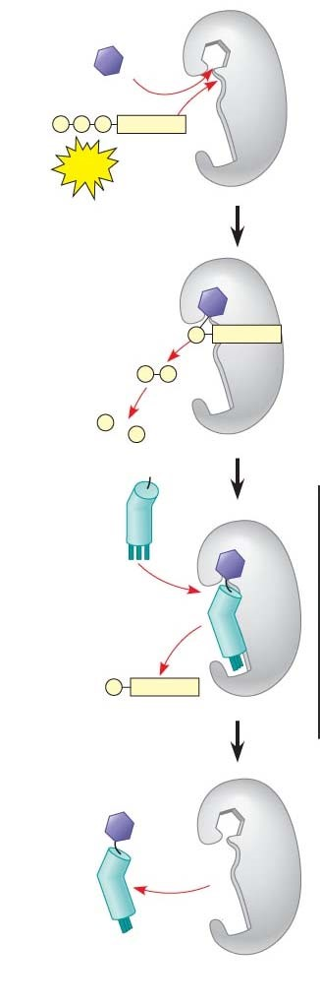
- Describe the structure of a eukaryotic ribosome.

- How does a prokaryotic ribosome differ from a eukaryotic ribosome? What is the medical significance of this difference?

- On this figure, label the large subunit, small subunit, A, P, and E sites, mRNA binding site. To the right of the figure, explain the functions of the A, P, and E sites.
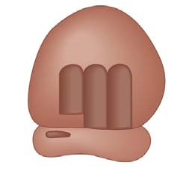
- Much like transcription, we can divide translation into three stages. List them.

- Summarize the events of initiation. Include these components: small ribosomal subunit, large ribosomal subunit, mRNA, initiator codon, tRNA, Met, initiation complex, P site, and GTP. The figure below may help you.
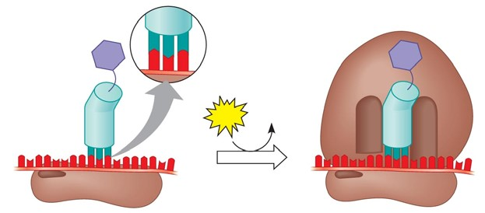
- What is always the first amino acid in the new polypeptide?

- Now, summarize the events of elongation. Include these components: mRNA, A site, tRNA, codon, anticodon, ribozyme, P site, and E site. Again, the figure may help you.

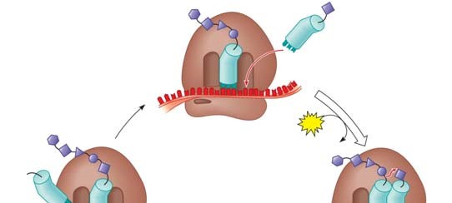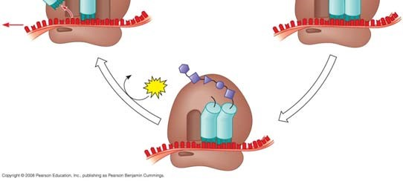
- What is a release factor? By what mechanism is termination accomplished?

- What is a polyribosome?

- What are some of the things that will result in a final-form functional protein?

- Describe at least three types of post-translational modifications.

- Use the following figure to explain how proteins are targeted for the ER.
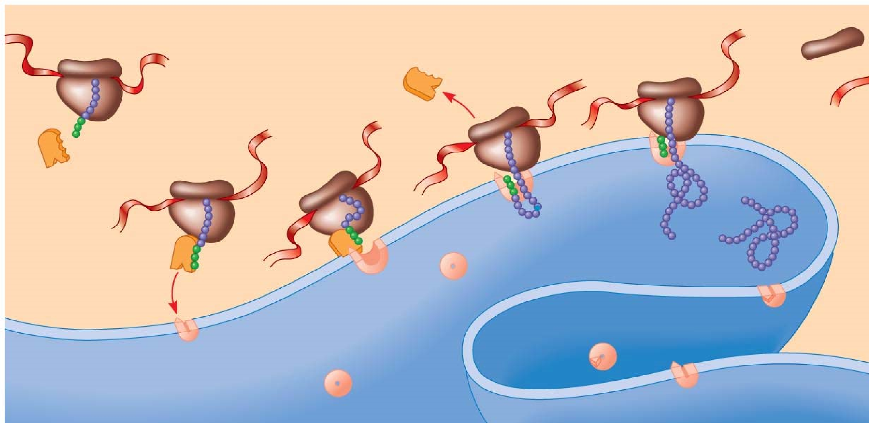

Concept 17.5 Point mutations can affect protein structure and function

- Define a mutation in terms of molecular genetics.

- Define point mutations.

- What are frameshift mutations?

- Identify two mechanisms by which frameshifts may occur.

- What is the difference between a nonsense and missense mutation?

- How can a base-pair substitution result in a silent mutation?

- What are the two categories of mutagens?

- Describe the action of difference types of chemical mutagens.

Concept 17.6 Although gene expression differs among the domains of life, the concept of a gene is universal
- Describe two important ways in which bacterial and eukaryotic gene expression differ.

- What is a gene? It used to be simply stated that one gene codes for one polypeptide. That definition has now been modified. Write below the broader molecular definition in use today.

- Finally, use this summary figure to put together all that you have learned in this chapter.
