(AP) ENVIRONMENTAL SCIENCE 2022-23 May 8, 2023

Today’s Agenda (Day 153)

- Housekeeping Items
BRING:
- Homework Check:
Chapter 20 Reading Guide
- Class Activity:
FINAL PROJECT: Earth Day Quilt
*See details below.
APES REVIEW:
Unit 1: The Living World: Ecosystems - May 3 | 6%–8%
Unit 2: The Living World: Biodiversity - May 4 | 6%–8%
Unit 3: Populations - May 5 | 10%–15%
Unit 4: Earth Systems and Resources - May 8 | 10%–15%
Unit 5: Land and Water Use - May 9 | 10%–15%
Unit 6: Energy Resources and Consumption - May 10 | 10%–15%
Unit 7: Atmospheric Pollution - May 11 | 7%–10%
Unit 8: Aquatic and Terrestrial Pollution - May 12 | 7%–10%
Unit 9: Global Change- May 15 | 15%–20%

Non-APES Students: ACTIVITY: The Story of Stuff – see p. 2 of doc below DAY 2

HOMEWORK:
- READ: Chapter 20 – Environmental Policy and Decision Making
- COMPLETE:
- STUDY: APES FINAL EXAM – May 17

REMINDER:

(AP) ENVIRONMENTAL SCIENCE 2022-23 FINAL PROJECT

EARTH DAY QUILT
Repurposing Sustainability
PART 1
*Review some quilting sites to determine the best design to encapsulate the theme of “Earth Day” 2023. Please see some below for suggestions:
file:///C:/Users/msbel/Downloads/QuiltSquareSymmetryProject-2.pdf
file:///C:/Users/msbel/Downloads/SymmetryPatchworkQuiltBlocks-1.pdf
file:///C:/Users/msbel/Downloads/KaleidoscopeofStarsPDFQuiltPattern-1.pdf
file:///C:/Users/msbel/Downloads/QuiltQuandariesBasicquiltsquarepuzzlesforfoamfeltpaperorfabric-1.pdf
https://www.husqvarnaviking.com/SiteMedia/Blogs/Sewing%20projects/2023-sewing-projects/Scrappy-Heart-Lap-Quilt_C_1.pdf
https://www.pinterest.com/pin/195273333834425791/
https://quiltytherapy.com/love-of-scrap-quilts-earth-day-2021/
https://www.missouriquiltco.com/blogs/missouri-star-blog/upcycled-fabric-projects-going-green-for-earth-day
https://blog.accuquilt.com/celebrate-earth-day-with-eco-friendly-projects
https://www.accuquilt.com/go-strip-pizzazz.html
https://sew4home.com/honor-earth-day-by-reusing-old-clothing/
https://pbswisconsin.org/watch/best-sewing-nancy/quilt-with-carefree-curves-part-two-0ota6s/
https://sarahmaker.com/quilt-patterns-for-beginners/
https://www.fatquartershop.com/free-quilt-patterns/free-quilt-patterns-for-beginners
https://www.thesprucecrafts.com/quilt-patterns-for-beginning-quilters-2821877
*Choose to be in a group of 2 or three from the same “class” as you. Decide on your overall design. Think about the color scheme and “imagery” that will convey the theme of “Earth Day 2023”/
*Using the 4” x 4” squares template, draw and color your quilt’s pattern design. Indicate the proportional dimensions you will be using. This 4 x 4 template will act as your pattern guide for the actual quilt.
*On the back of the 4 x 4 template, document the materials that you will need, including but not limited to:
sewing materials [thread (color and gauge);
needle (and size];
types of scraps of fabric [think: color scheme, texture, recycling of materials]
the number, types, dimensions, and color of shapes needed [ex. 100 x 3” green triangles; 50 x 6” yellow squares, etc.]
*Take into account the measurement for the stitch/seam distance
(AP) ENVIRONMENTAL SCIENCE 2022-23 ACTIVITY 1

THE STORY OF STUFF
Mapping the Impact
PART 1
- Recall the concept of “ecological footprint” the area of the earth’s productive surface, both land and sea, that it takes to support a person’s or a population’s lifestyle. Ecological footprint includes natural resources needed from the environment, plus space for infrastructure, recreation, and waste disposal. A more resource-intensive lifestyle results in a larger ecological footprint. What sorts of impact from consumption are left out of this type of measurement?
- Your groups is tasked to create a web diagram to illustrate the ecological footprint and human impacts associated with an everyday item. Use the following scenario, “Hamburger, Fries, and a Cola”, [see the next page for article] as a sample trial. Read the article. As you read, highlight the following: resources required to produce the meal and impacts to the environment and people.
- “Draw” a hamburger in the middle a page. Diagram the impacts associated with producing the hamburger.
- What are the basic ingredients to create a hamburger? Write these responses around the picture of the hamburger.
- What are the steps required to create each of the ingredients? Write these responses around each ingredient identified.
- Between the burger filling and the bun, what else happens? Write these thoughts around the appropriate process/ingredient.
- What impacts result from each of the processes and technologies required to produce the hamburger? Include these impacts on your diagram wherever appropriate.
- What are some impacts of hamburger consumption on people and societies, including people involved in producing it and people consuming it? Write these impacts on your diagram where they seem most appropriate.
PART 2
- Brainstorm and diagram all of the resources, processes, and impacts (positive and negative) associated with one everyday object.
- Follow the steps as above, beginning with “drawing” an image of the everyday item your group has chosen.
- You may use the table below to organize your thoughts, in needed.
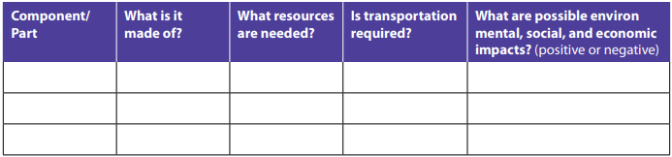
- After completing the diagram, brainstorm and list ways to reduce the ecological footprint and other impacts associated with creating or using the object.
- Be prepared to present your web diagram and your ideas to the class.

PART 3 - Reflection
1. How is the ecological footprint of a person’s lifestyle connected to social and economic impacts?
2. Would the production, use, and disposal of these everyday items be sustainable if only a small number of people purchased the items?
3. How would the impacts associated with an item change if everyone in the world purchased or used it?
4. Does lessening our impacts necessarily mean reducing our quality of life? Why, or why not?
5. How might businesses be encouraged to produce these items in ways that have more positive impacts on the environment and on people?
6. Often negative impacts associated with an item are not paid directly by the people who purchase and use the items. Who might end up paying for those impacts? Why do you think these impacts are not included in an item’s purchase price?

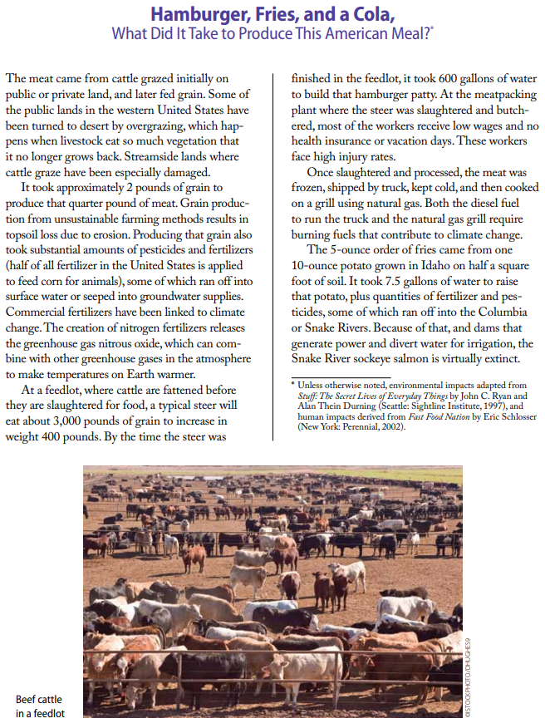
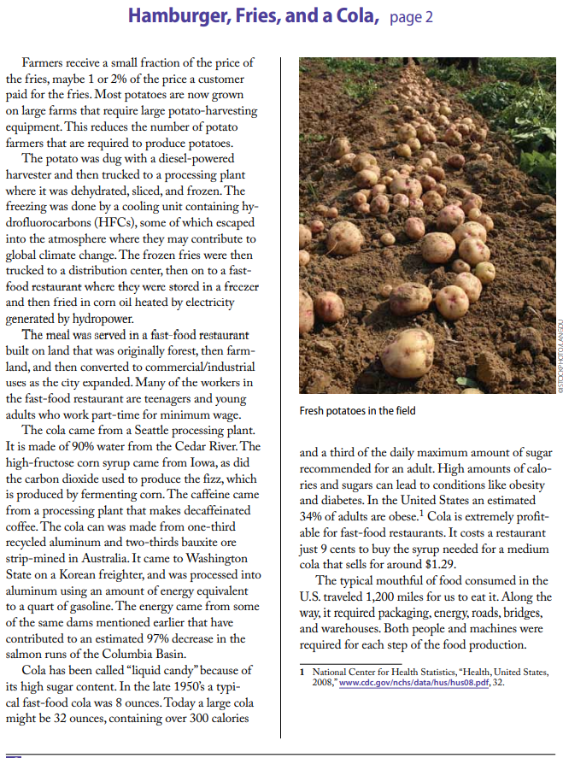

(AP) ENVIRONMENTAL SCIENCE 2022-23 ACTIVITY 2

THE STORY OF STUFF
Garbology

- In your groups, first individually make a list of each student’s trash items that have been discarded in the past 1-2 days.
- As a group, consider all the discarded items that you share in common.
- Consider which, if any, of the materials are luxury items and which are essential items. Be prepared to explain why each item has been categorized as a luxury or essential item.
- Read “Buried Treasure” and complete the instructions that follow the reading.
- For the rest of the day, until Thursday’s class, make a list of all the garbage that you accumulate.
- Complete the instructions as per the article, “Buried Treasure”.

