(AP) ENVIRONMENTAL SCIENCE 2022-23 May 4, 2023

Today’s Agenda (Day 151)

- Housekeeping Items
BRING:
- Homework Check:

- Class Activity:
APES REVIEW:
Unit 1: The Living World: Ecosystems - May 3 | 6%–8%
Unit 2: The Living World: Biodiversity - May 4 | 6%–8%
Unit 3: Populations - May 5 | 10%–15%
Unit 4: Earth Systems and Resources - May 8 | 10%–15%
Unit 5: Land and Water Use - May 9 | 10%–15%
Unit 6: Energy Resources and Consumption - May 10 | 10%–15%
Unit 7: Atmospheric Pollution - May 11 | 7%–10%
Unit 8: Aquatic and Terrestrial Pollution - May 12 | 7%–10%
Unit 9: Global Change- May 15 | 15%–20%

Non-APES Students: ACTIVITY: The Story of Stuff – see p. 2 of doc below DAY 2

HOMEWORK:
- READ: Chapter 20 – Environmental Policy and Decision Making
- COMPLETE:
- STUDY: APES FINAL EXAM – May 17

REMINDER:

- Chapter 20 Reading Guide – May 5

(AP) ENVIRONMENTAL SCIENCE 2022-23 ACTIVITY 1

THE STORY OF STUFF
Mapping the Impact
PART 1
- Recall the concept of “ecological footprint” the area of the earth’s productive surface, both land and sea, that it takes to support a person’s or a population’s lifestyle. Ecological footprint includes natural resources needed from the environment, plus space for infrastructure, recreation, and waste disposal. A more resource-intensive lifestyle results in a larger ecological footprint. What sorts of impact from consumption are left out of this type of measurement?
- Your groups is tasked to create a web diagram to illustrate the ecological footprint and human impacts associated with an everyday item. Use the following scenario, “Hamburger, Fries, and a Cola”, [see the next page for article] as a sample trial. Read the article. As you read, highlight the following: resources required to produce the meal and impacts to the environment and people.
- “Draw” a hamburger in the middle a page. Diagram the impacts associated with producing the hamburger.
- What are the basic ingredients to create a hamburger? Write these responses around the picture of the hamburger.
- What are the steps required to create each of the ingredients? Write these responses around each ingredient identified.
- Between the burger filling and the bun, what else happens? Write these thoughts around the appropriate process/ingredient.
- What impacts result from each of the processes and technologies required to produce the hamburger? Include these impacts on your diagram wherever appropriate.
- What are some impacts of hamburger consumption on people and societies, including people involved in producing it and people consuming it? Write these impacts on your diagram where they seem most appropriate.
PART 2
- Brainstorm and diagram all of the resources, processes, and impacts (positive and negative) associated with one everyday object.
- Follow the steps as above, beginning with “drawing” an image of the everyday item your group has chosen.
- You may use the table below to organize your thoughts, in needed.
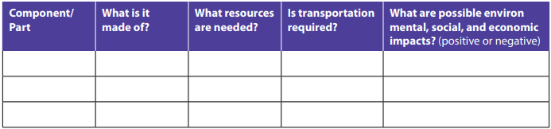
- After completing the diagram, brainstorm and list ways to reduce the ecological footprint and other impacts associated with creating or using the object.
- Be prepared to present your web diagram and your ideas to the class.

PART 3 - Reflection
1. How is the ecological footprint of a person’s lifestyle connected to social and economic impacts?
2. Would the production, use, and disposal of these everyday items be sustainable if only a small number of people purchased the items?
3. How would the impacts associated with an item change if everyone in the world purchased or used it?
4. Does lessening our impacts necessarily mean reducing our quality of life? Why, or why not?
5. How might businesses be encouraged to produce these items in ways that have more positive impacts on the environment and on people?
6. Often negative impacts associated with an item are not paid directly by the people who purchase and use the items. Who might end up paying for those impacts? Why do you think these impacts are not included in an item’s purchase price?

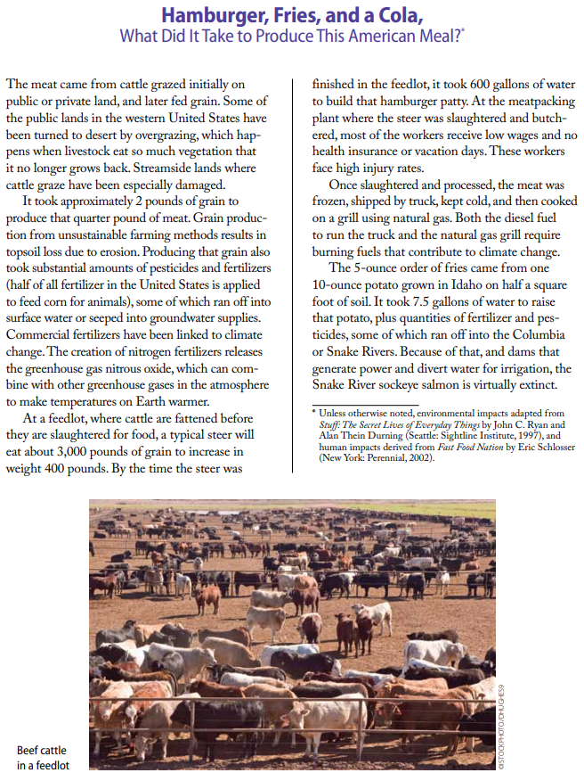
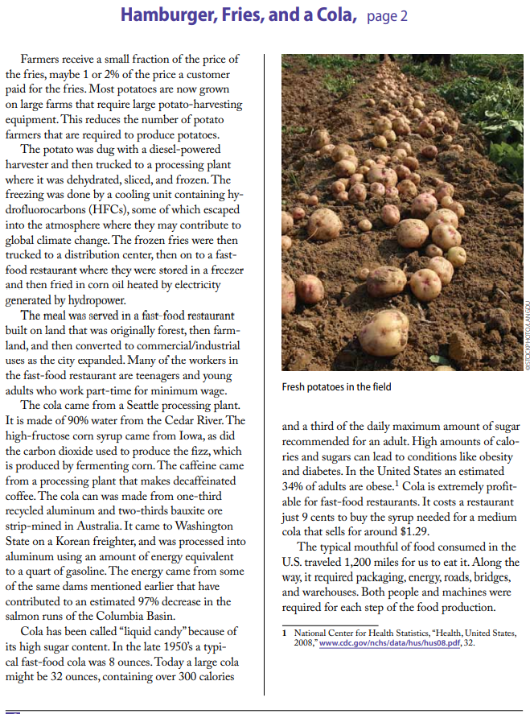

(AP) ENVIRONMENTAL SCIENCE 2022-23 ACTIVITY 1

THE STORY OF STUFF
Garbology

- In your groups, first individually make a list of each student’s trash items that have been discarded in the past 1-2 days.
- As a group, consider all the discarded items that you share in common.
- Consider which, if any, of the materials are luxury items and which are essential items. Be prepared to explain why each item has been categorized as a luxury or essential item.
- Read “Buried Treasure” and complete the instructions that follow the reading.
- For the rest of the day, until Thursday’s class, make a list of all the garbage that you accumulate.

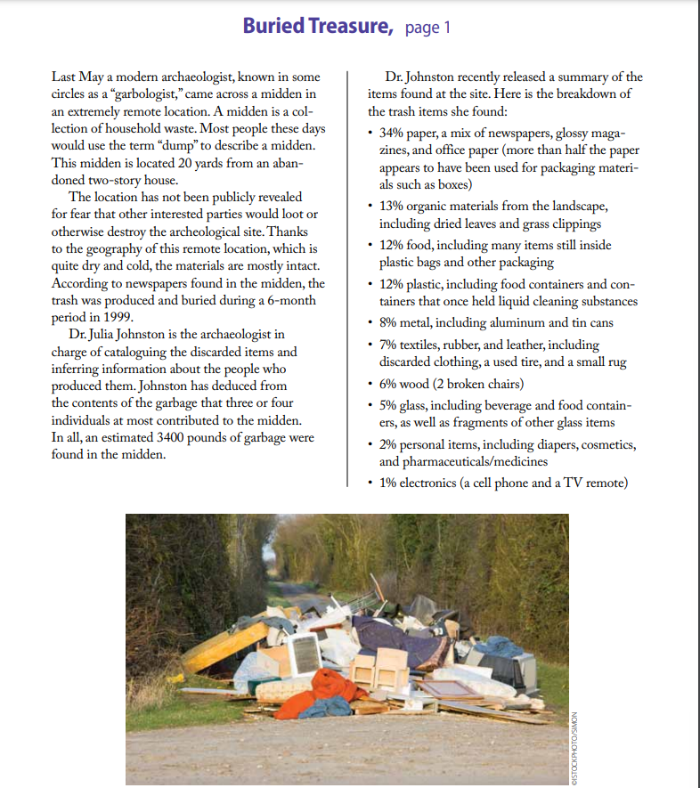
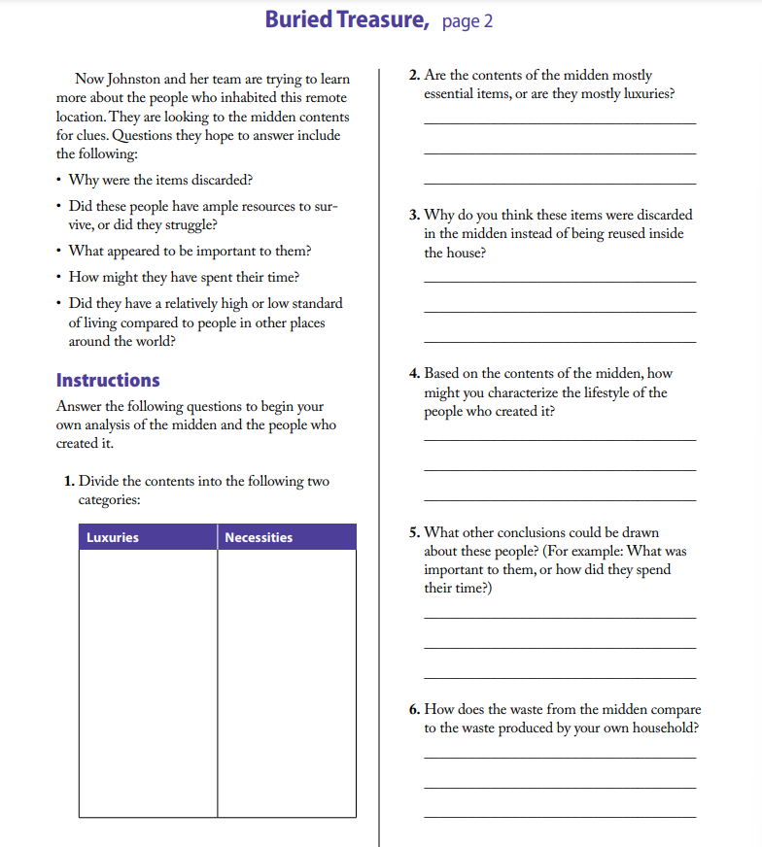

(AP) ENVIRONMENTAL SCIENCE 2022-23 READING GUIDE
CHAPTER 20

Review Questions [FOR NON-APES ONLY]
1. What are the major responsibilities of each of the three branches of the U.S. government?
2. What are some of the enforcement options in U.S. environmental policy?
3. What role does administrative law play in U.S. environmental policy?
4. What are some of the criticisms of U.S. environmental policy?
5. In the past ten years, how has public opinion in the United States changed concerning the protection of the environment?
6. Why is environmentalism a growing factor in international relations?
7. Give some examples of international environmental conventions and treaties.
8. What role does lobbying play in the development of environmental policy?
9. What is the role and function of the Environmental Protection Agency?

Critical Thinking Questions [FOR NON-APES ONLY]
1. Does chapter 20 have an overall point of view? If you were going to present the problems of environmental policy making and enforcement to others, what framework would you use?
2. The authors of this text say that “we are progressing from an environmental paradigm based on cleanup and control to one including assessment, anticipation, and avoidance.” Do you agree with this assessment? Are there environmental problems that are harder to be proactive about than others?
3. Does a command-and-control approach to environmental problems, an approach that emphasizes regulation and remediation, make sense with global environmental problems such as global climate change, habitat destruction, and ozone depletion?
4. How is it best, as a global society with many political demarcations, to preserve the resources that are held in common? What special problems does this kind of preservation entail?
5. Do you agree with William Ruckelshaus that current environmental problems require a change on the part of industrialized and developing countries that would be “a modification in society comparable in scale to the agricultural revolution . . . and Industrial Revolution”? What kinds of changes might that mean in your life? Would these be positive or negative changes?
6. New treaties regarding free trade might enable some nations to argue that other nations’ environmental legislation is too restrictive, thereby imposing a barrier to trade that is subject to sanction. What special problems and possibilities might the new global economy present for environmental preservation? What do you think about that?

