(AP) ENVIRONMENTAL SCIENCE 2022-23 September 2, 2022

Today’s Agenda (Day 13)

- Housekeeping Items

- Homework Check:
Lab: Rainbow Metrics, M & M Meltdown, Plotting Graphs
Chapter 1 Notes
Ch 2 Vocabulary
- Class Activity:
BEGIN: Chapter 2 PPT Review

- 2.1 The Call for a New Ethic
- 2.2 Environmental Ethics
- 2.3 Environmental Attitudes
- 2.4 Environmental Justice
- 2.5 Societal Environmental Ethics
- 2.6 Corporate Environmental Ethics
- 2.7 Individual Environmental Ethics
- 2.8 The Ethics of Consumption
- 2.9 Personal Choices
- 2.10 Global Environmental Ethics

For APES: LOG IN to www.collegeboard.org 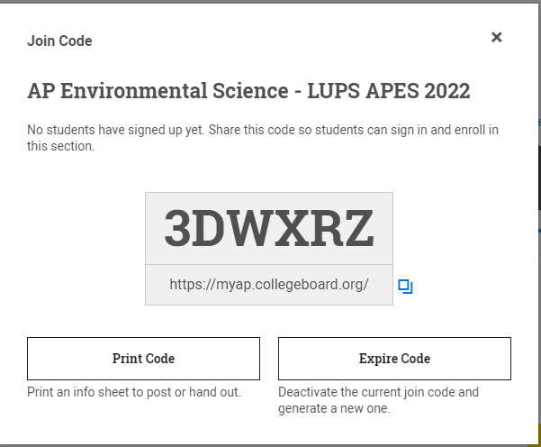
HOMEWORK:
- READ: Chapter 2 – Environmental Ethics
- COMPLETE: Chapter 2 Reading Guide Questions
- STUDY: Chapter 1 & 2 Vocabulary, Chapter 2
CHAPTER 1 VOCABULARY
Air pollution | Ecosystem | Ecosystem services | Environment | Environmental science
Food security | Globalization | Invasive species | Kyoto Protocol | Malaria
Science | Sustainability | Water pollution | World Health Organization (WHO)
CHAPTER 2 VOCABULARY
Anthropocentrism | Biocentrism | Conservationist approach | Deep ecology | Development approach | Ecocentrism
Ecofeminism | Ecological economics | Ecological footprint | Economic growth | Environmental aesthetics | Environmental economics
Environmental justice | Environmental pragmatism | Ethics | External costs | Industrial ecology | Natural capitalism
Preservationist approach | Profitability | Resource exploitation | Social ecology | Sustainable development | Triple bottom line
ABRIDGED VOCABULARY TEMPLATE
Term:
TEXTBOOK DEFINITION

SENTENCE/PICTURE/EXAMPLE/FORMULA

REMINDERS:

- Ch 2 Vocabulary – Sept. 2
- QUIZ: Ch 1 & 2 Vocabulary Sept. 6
- Chapter 2 Reading Guide – Sept. 6
- TEST: Ch 2 Sept. 8

(AP) ENVIRONMENTAL SCIENCE 2022-23 READING GUIDE
CHAPTER 2
REVIEW QUESTIONS
1. Why does the environmental crisis demand a new ethic?
2. Describe three types of environmental ethics developed by philosophers.
3. Describe three common attitudes toward the environment found in modern society.
4. Why is environmental justice part of the environmental movement?
5. What are the conflicts between corporate behavior and environmental ethics?
6. How can individuals direct business toward better environmental practices?
7. How can individuals implement environmental ethics in their own lives?
8. Where does global environmental ethics fit in the broad scheme of environmental protection?
9. Is the triple bottom line a realistic concept in the corporate world?

CRITICAL THINKING QUESTIONS [for APES students only]
1. Give three different ethical justifications for protecting a forest using an anthropocentric, a biocentric, and an ecocentric viewpoint.
2. Which approach to the environment—development, preservation, or conservation—do you think you adopt in your own life? Do you think it appropriate for everybody in the world to share the same attitude you hold?
3. What ethical obligations do you personally feel toward wolves and whales? What ethical obligations do you feel toward future generations of people? What ethical obligations do you feel toward future generations of wolves and whales?
4. Until recently, it was generally believed that growth and development were unquestionably good. Now, early in the twenty-first century, some are beginning to question that belief. Are those questions appropriate ones to address to a citizen of the developing world? Would you ever make the argument that development has gone far enough?
5. Imagine you are a business executive who wants to pursue an environmental policy for your company that limits pollution and uses fewer raw materials but would cost more. What might be the discussion at your next board of directors meeting? How would you make your case to your directors and your shareholders?
6. In 1997 Ojibwa Indians in northern Wisconsin sat on the railroad tracks to block a shipment of sulfuric acid from crossing their reservation on its way to a controversial copper mine in Michigan. Try to put yourself in their position. What values, beliefs, and perspectives might have contributed to their actions? Was it the right thing to do? How would you try and mediate a heated conversation between an Ojibwa protestor and a Michigan copper miner?
7. Wangari Maathai led a protest movement against the stripping of African forests. Are environmental issues important enough for citizens to become activists and perhaps break the law? How could an environmental activist respond to the pro-development position that it is more important to feed people and lift them out of poverty than it is to save a few trees? Are there any ethical principles that you think an environmental activist and a pro-development advocate share?

