(AP) ENVIRONMENTAL SCIENCE 2022-23 February 28, 2023

Today’s Agenda (Day 114)

- Housekeeping Items
BRING:
- Homework Check:

- Class Activity:
SCIENCE FAIR COUNTDOWN – 3 days to competition!
*PRESENTATIONS: Mock

THURSDAY: Begin Ch 13 PPT Review
- Section 13.3 – Soil and Land
- Section 13.4 – Soil Formation
- Section 13.5 – Soil Properties
- Section 13.6 – Soil Profile
- Section 13.7 – Soil Erosion
- Section 13.8 – Soil Conservation Practices
- Section 13.9 – Conventional Versus Conservation Tillage
- Section 13.10 – Protecting Soil on Non-farmland

HOMEWORK:
- READ: Chapter 13 – Soil and Its Uses
- COMPLETE: SF Report Draft; Chapter 13 Vocabulary
- STUDY: Chapter 13 Vocabulary Quiz and Test

REMINDER:
- QUIZ: Ch 13 Vocabulary Mar. 2
- TEST: Ch 13 March 7

Chapter 13 Vocabulary
Asthenosphere | Chemical weathering | Conservation tillage | Contour farming | Crust | Erosion
Friable | Horizon | Humus | Hyperaccumulators | Land | Leaching lithosphere
Litter loam | Mantle | Mechanical weathering | Parent material | Phytoremediation | Plate tectonics
Reduced tillage | Soil | Soil profile | Soil texture | Strip farming | Terraces
Waterways | Weathering | windbreaks
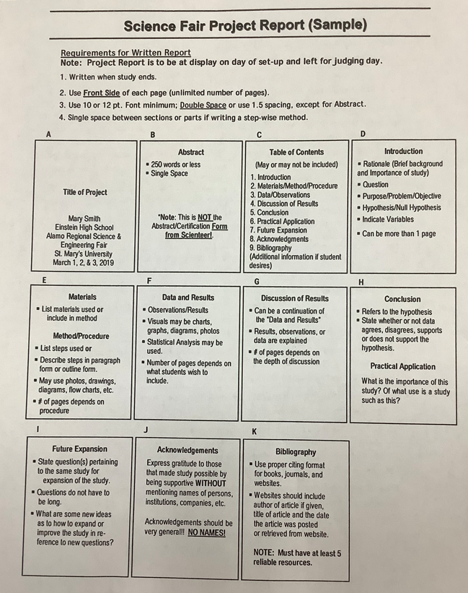

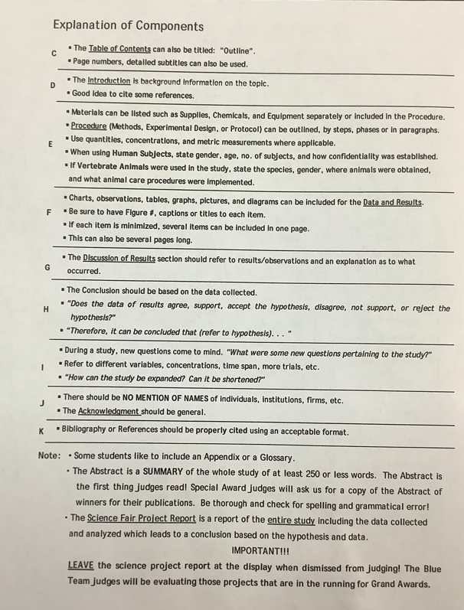

(AP) ENVIRONMENTAL SCIENCE 2022-23 READING GUIDECHAPTER 13
REVIEW QUESTIONS
1. How are soil and land different?
2. Name the five major components of soil.
3. Describe the process of soil formation.
4. Name five physical and chemical processes that break parent material into smaller pieces.
5. In addition to fertility, what other characteristics determine the usefulness of soil?
6. How does soil particle size affect texture and drainage?
7. Describe a soil profile.
8. Define erosion.
9. Describe three soil conservation practices that help to reduce soil erosion.
10. Besides cropland, what are other possible uses of soil?

CRITICAL THINKING QUESTIONS [for APES students only]
1. Minimum tillage soil conservation often uses greater amounts of herbicides to control weeds. What do you think about this practice? Why?
2. As populations grow, should we try to bring more land into food production, or should we use technology to aid in producing more food on the land we already have in production? What are the trade-offs?
3. Given what you know about soil formation, how might you explain the presence of a thick A horizon in soils in the North American Midwest?
4. Why should nonfarmers be interested in soil conservation?
5. Imagine that you are a scientist hired to consult on a project to evaluate land-use practices at the edge of a small city. The area in question has deep ravines and hills. What kinds of agricultural, commercial, and logging practices would you recommend in this area to help preserve the environment?
6. Look at your own community. Can you see examples of improper land use (urban or rural)? What are the consequences of these land-use practices? What recommendations would you make to improve land use?

(AP) ENVIRONMENTAL SCIENCE 2022-23 ACTIVITY
ACTIVITY: Making and using a quadrat

Setting up a quadrat

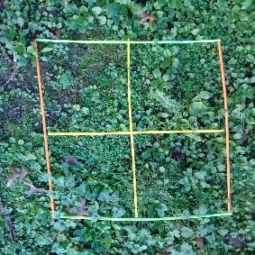
- Choose the location and the type of monitoring you wish to do. Consider any safety concerns associated with monitoring the site – especially when working within marine habitats.

- Make a 1 m² quadrat by measuring 4 m of string. Cut the string. Tie knots at 1 m intervals. The knots and string ends form the quadrat corners. Alternatively, use any objects that can form four straight 1 m sides.

- Place the quadrat(s) randomly in the area you wish to monitor.

- You can also mark out smaller sections to form four quarters within the 1 m² – this can make it easier to carry out a count in groups.

- Take a photo of the quadrat.

ACTIVITY: Create a Field Identification Guide of
Common Caribbean Weeds, Shrubs and Trees

How to Make a Field Guide

A field guide is an important tool to help a person identify a specific species. It usually has a picture and description of the species. You are going to make a field guide.

Here is what your field guide must have:

- A cover with a title
- A table of contents
- A page explaining the purpose of your field guide (how is it going to help someone identify the four species you have selected).
- One page that discusses the characteristics of the family to which your species belong.
- A brief explanation stating why carefully observation is important.
- A page dedicated to each species. This must include:
- Scientific name (binomial nomenclature) Hierarchy from Domain to species.
- A hand drawn/digital picture of your species.
- A thorough description of your species. As you write it, ask yourself, “Could someone use this description and identify the species?”
- Interesting information and facts about the species.
- To raise your level to 4, add two additional species and include the following information: where it lives, what it eats, what eats it, and what other species live in the same area.

As you do this assignment, remember what you will be using this in the gardens. So, make a DIGITAL FIELD GUIDE…perhaps in SLIDES format

Species One - TEMPLATE

Common Name: | Scientific Name:
Description of species:

Identifying characteristics/markings/etc.

Interesting facts:

