(AP) ENVIRONMENTAL SCIENCE 2022-23 February 15, 2023

Today’s Agenda (Day 110)

- Housekeeping Items
BRING:
- Homework Check:

- Class Activity:
Day 40: Science Fair
*CONT’D - Week 4 of your experiment
*Begin SF Report Draft – Due THURSDAY see p. 2 of doc

DAY 7: Chapter 12 PPT Review
- Section 12.4 – Problems associated with unplanned urban growth
- Section 12.5 – Land use planning principles
- Section 12.6 – Mechanisms for implementing land use plans
- Section 12.7 – Special urban planning issues
- Section 12.8 – Federal government land use issues

HOMEWORK:
- READ: Chapter 12 – Land Use Planning
- COMPLETE: SF Report Draft; Chapter 13 Vocabulary
- STUDY: Chapter 12 Test

REMINDER:
- TEST: Ch 12 Thursday, February 9 Feb. 16

Chapter 13 Vocabulary
Asthenosphere | Chemical weathering | Conservation tillage | Contour farming | Crust | Erosion
Friable | Horizon | Humus | Hyperaccumulators | Land | Leaching lithosphere
Litter loam | Mantle | Mechanical weathering | Parent material | Phytoremediation | Plate tectonics
Reduced tillage | Soil | Soil profile | Soil texture | Strip farming | Terraces
Waterways | Weathering | windbreaks
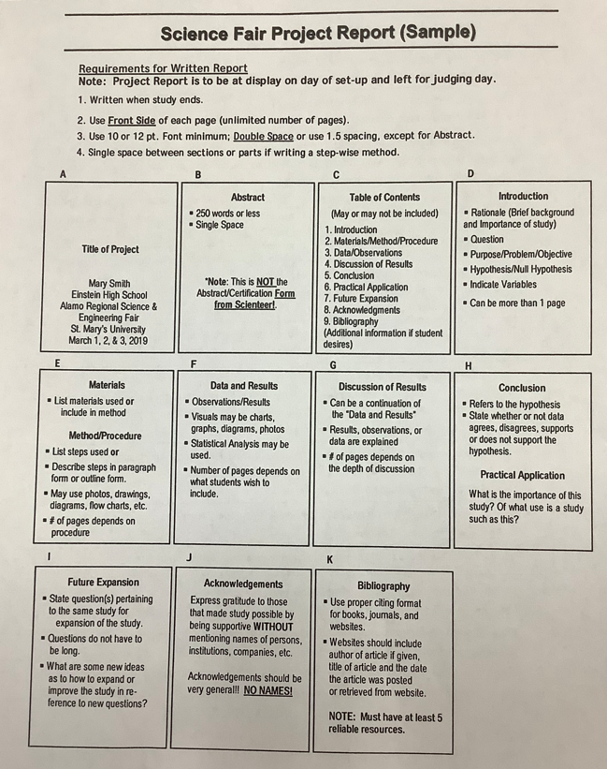

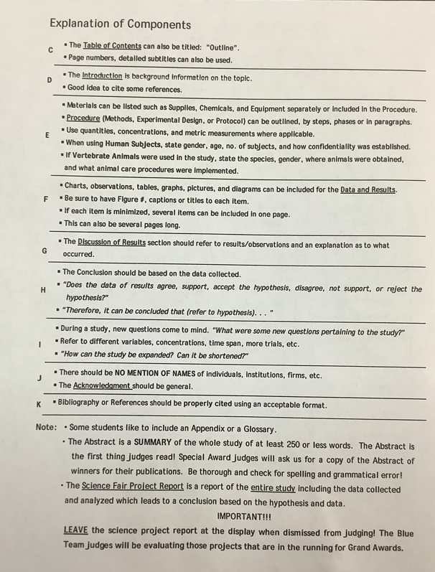

(AP) ENVIRONMENTAL SCIENCE 2022-23 READING GUIDECHAPTER 13
REVIEW QUESTIONS
1. How are soil and land different?
2. Name the five major components of soil.
3. Describe the process of soil formation.
4. Name five physical and chemical processes that break parent material into smaller pieces.
5. In addition to fertility, what other characteristics determine the usefulness of soil?
6. How does soil particle size affect texture and drainage?
7. Describe a soil profile.
8. Define erosion.
9. Describe three soil conservation practices that help to reduce soil erosion.
10. Besides cropland, what are other possible uses of soil?

CRITICAL THINKING QUESTIONS [for APES students only]
1. Minimum tillage soil conservation often uses greater amounts of herbicides to control weeds. What do you think about this practice? Why?
2. As populations grow, should we try to bring more land into food production, or should we use technology to aid in producing more food on the land we already have in production? What are the trade-offs?
3. Given what you know about soil formation, how might you explain the presence of a thick A horizon in soils in the North American Midwest?
4. Why should nonfarmers be interested in soil conservation?
5. Imagine that you are a scientist hired to consult on a project to evaluate land-use practices at the edge of a small city. The area in question has deep ravines and hills. What kinds of agricultural, commercial, and logging practices would you recommend in this area to help preserve the environment?
6. Look at your own community. Can you see examples of improper land use (urban or rural)? What are the consequences of these land-use practices? What recommendations would you make to improve land use?

