(AP) ENVIRONMENTAL SCIENCE 2022-23 February 14, 2023

Today’s Agenda (Day 109)

- Housekeeping Items
BRING:
- Homework Check:

- Class Activity:
Day 40: Science Fair
*CONT’D - Week 4 of your experiment
*Begin SF Report Draft – Due Friday see p. 2 of doc

DAY 6: Chapter 12 PPT Review
- Section 12.4 – Problems associated with unplanned urban growth
- Section 12.5 – Land use planning principles
- Section 12.6 – Mechanisms for implementing land use plans
- Section 12.7 – Special urban planning issues
- Section 12.8 – Federal government land use issues

HOMEWORK:
- READ: Chapter 12 – Land Use Planning
- COMPLETE: SF Report Draft; Chapter 13 Vocabulary
- STUDY: Chapter 12 Test

REMINDER:
- TEST: Ch 12 Thursday, February 9 Feb. 16

Chapter 13 Vocabulary
Asthenosphere | Chemical weathering | Conservation tillage | Contour farming | Crust | Erosion
Friable | Horizon | Humus | Hyperaccumulators | Land | Leaching lithosphere
Litter loam | Mantle | Mechanical weathering | Parent material | Phytoremediation | Plate tectonics
Reduced tillage | Soil | Soil profile | Soil texture | Strip farming | Terraces
Waterways | Weathering | windbreaks
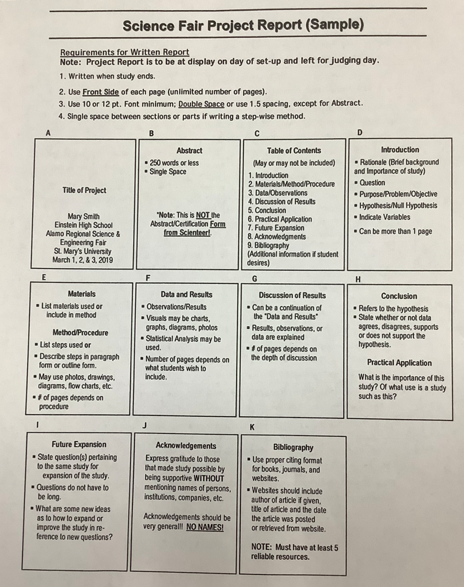

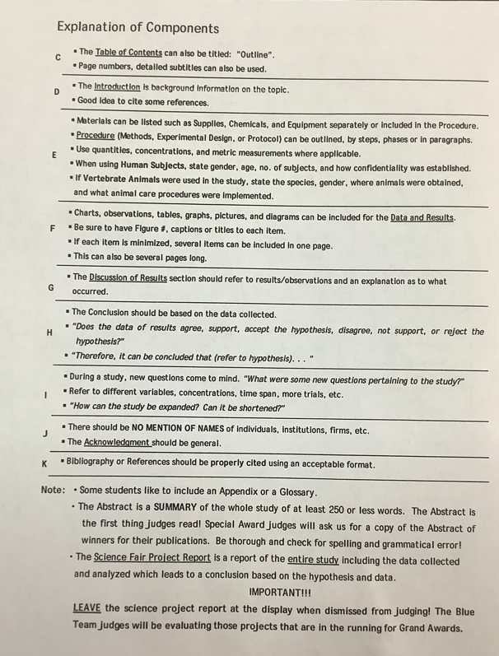

(AP)
(AP) ENVIRONMENTAL SCIENCE 2022-23 READING GUIDECHAPTER 12
REVIEW QUESTIONS
1. List three reasons why land-use planning is necessary.
2. Why did urban centers develop near waterways?
3. List three factors that encouraged people to move from rural farms to cities in the 1800s.
4. List three factors that encouraged people to leave the cities for suburbs.
5. List three physical and three social consequences of suburban sprawl.
6. Describe tract development, ribbon sprawl, and leapfrog development.
7. What is a megalopolis?
8. Describe how each of the following factors contributed to the development of suburban sprawl: automobiles, home ownership, tax laws, local zoning ordinances, federal government policies.
9. State three consequences of the dominance of the automobile as a means of transport in urban areas.
10. What characteristics of suburbs contribute to a loss of sense of community?
11. What characteristics of suburbs contribute to high infrastructure and high energy costs?
12. How does the development of suburbs around a city contribute to loss of open space, and air and water pollution problems?
13. What land uses are suitable on floodplains?
14. Describe three values provided by wetlands.
15. Why is an understanding of the geology and resource base of an area important in land-use planning?
16. List eight principles that should be involved in good land-use planning.
17. What role do state and regional planning, purchasing of land, and use restrictions play in implementing land-use plans?
18. Describe three common land-use issues cities must deal with.
19. List ten common smart growth principles.
20. List four major federal agencies that manage federal lands and their primary responsibilities.
21. Give examples of conflict over the use of federally owned property.
CRITICAL THINKING QUESTIONS [for APES students only]
1. Choose the city where you live. Interview local residents and look at old city maps. What did the city look like 75 years ago? What were the city’s boundaries? Where did people do their shopping? How did they get around? How does this compare with the current situation in the city?
2. What historical factors brought members of your family to the city? How does this compare to the factors that are currently contributing to the growth of cities in the developing world?
3. Consider the outer rim of the city closest to you. Which, if any, of the problems associated with unplanned growth are associated with your city? What factors make them a problem? What do you think can be done about them?
4. There has been tremendous development in the arid West of the United States over the past few decades, creating demands for water. How should these demands be met? Should there be limits to this type of development? What kinds of limits, if any?
5. Imagine you are a U.S. Forest Service supervisor who is creating a ten-year plan that is in the public comment stage. What interests would be contacting you? What power would each interest have? How would you manage the competing interests of timber, mining, grazing, and recreation or those between motorized and nonmotorized recreation? What values, beliefs, and perspectives help you to form your recommendations?
6. Imagine that you lived in an area of the country that has the potential to be named a wilderness area. What conflicts do you think would arise from such a declaration? Who might be some of the antagonists? Which perspective do you think is most persuasive? How would you answer the objections of the other perspective?

