(H)ENGLISH LANGUAGE ARTS (ELA) 2021-22 October 15, 2021

Today’s Agenda (Day 37)

- Housekeeping Items

- Homework Check:
Section 2.3 – Why Attend This School – Pre-Write and thesis statement draft

- Class Activity:
QUIZ: Joy Luck Club [#2 AND 3]
*Go to www.socrative.com enter room “MSBELA12” enter ID #

MONDAY: READ ALOUD: Sense and Sensibility

HOMEWORK:
- READ: Sense and Sensibility
- IDENTIFY: Vocabulary – as you read literature, identify, and define unfamiliar words (provide
- context/history as appropriate)

- CONTEMPLATE: Term 2 Essay
COMPARISON/CONTRAST & EXPOSITORY
These literary works serve as commentary of the times and location in which the stories take place. Compare and contrast the cultural and societal norms/values discussed/depicted in any of the three novels. Liken one of these cultural or societal norms to your own and your parents' cultural experiences/realities. How would you apply one of these cultural/societal norms in your life today? Are any of these cultural/societal norms/values relevant today. Explain your position.
- November 19, 2021

REMINDERS:
- QUIZ: Joy Luck Club 2 (Part 2 Rose Hsu Jordan – end of Part 3 Jing Mei Woo) October 15, 2021
- QUIZ: Joy Luck Club 3 (Whole of Part 4) October 15, 2021
- QUIZ: Sense and Sensibility 1 (Ch 1 – end of Ch 12) Oct. 22
- QUIZ: Sense and Sensibility 2 (Ch 13 – end of Ch 24) Nov. 1
- QUIZ: Sense and Sensibility 3 (Ch 25 – end of book) Nov. 10

(H)ENGLISH LANGUAGE ARTS (ELA) 2021-22 WRITER’S CHOICE

Chapter 2: Overview of the Writing Process
GRAMMAR LINK
- See below for the section regarding subject-verb agreement
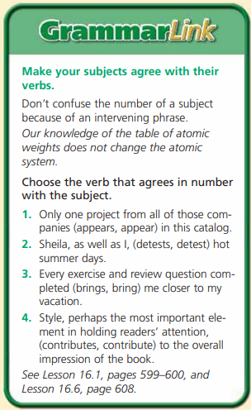
- See below for the section regarding adjectives
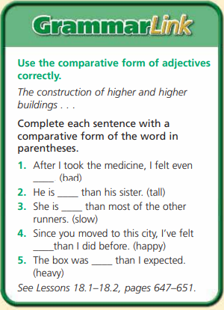
2.3 WRITING ACTIVITY – Establishing Purpose and Audience

Why do you want to attend this school?
Be honest and specific when you respond to this question. Avoid generalities like "to get a good liberal arts education” or “to develop career skills," and use details that show your interests: "I'm an aspiring doctor and your science department has a terrific reputation." Colleges are more likely to admit students who can articulate specific reasons why the school is a good fit for them beyond its reputation or ranking on any list. Use the college's website and literature to do your research about programs, professors, and other opportunities that appeal to you.

Write a Thesis Statement Develop a thesis statement for an essay about an activity that is worth the effort it takes to perform. First, refer to your cluster diagram and freewriting paragraph on the topic. Next, consider your purpose and audience—why do you want to write about this activity and who would you like to communicate with on the topic? Finally, express the main idea of the essay in a one- or two-sentence thesis statement.
PURPOSE To write a thesis statement AUDIENCE Your choice
LENGTH 1 paragraph
WRITING RUBRICS To write a good thesis statement, you should
• focus on the essay’s main idea
• reveal the purpose of the essay
• use language that is appropriate for the intended audience
2.4 WRITING ACTIVITY – Ordering your Thoughts
Draft Your Introduction Having planned the order of your college essay, write a first draft of your introduction. Look back at the opening paragraph you wrote. Think about its appeal. Would it make a reader want to go on? Does it express your main idea—either directly or implicitly?

2.5 WRITING ACTIVITY – Writing with Unity and Coherence
Draft Your Essay Reread the introduction to your college essay. What kind of order does the introduction suggest that the body of the essay will follow? Draft the body of your essay, making sure that your paragraphs flow from your introduction and have unity and coherence within themselves.
WRITING RUBRICS To write a unified and coherent draft, you should
• present ideas and details in a logical order
• include sentences that relate to the main idea of the paragraph
• use transitions to move smoothly from one sentence or idea to the next

