CHEMISTRY 2022-23 January 26, 2023

Today’s Agenda (Day 96)

- HOUSEKEEPING ITEMS
BRING
- Homework Check:
Ch 11 Mini Lab
Ch 12 Launch Lab
CHEM LAB: Compare States of Evaporation
- Class Activity:
TEST: Ch 12
*Go to www.socrative.com enter room “MSBCHEM2022 enter ID #

FRIDAY: Fossil Discovery host Ms. Yoly’s 3rd grade!

MONDAY: Chapter 13 PPT Review
- Section 13.1 – The Gas Laws
- Section 13.2 – The Ideal Gas Law
- Section 13.3 – Gas Stoichiometry

HOMEWORK:
- READ: Chapter 13 - Gases
- COMPLETE: Chapter 13 & 14 Vocabulary
- STUDY: Chapter13 & 14 Vocabulary and Ch 13 Test

Chapter 13 Vocabulary
absolute zero | Avogadro's principle | Boyle's law | Charles's law | combined gas law | Gay-Lussac's law | ideal gas constant
ideal gas law | molar volume

Chapter 14 Vocabulary
boiling point elevation | Brownian motion | colligative property | Colloid | Concentration | freezing point depression | heat of solution
Henry's law | Immiscible | Insoluble | Miscible | Molality | Molarity | mole fraction
Osmosis | osmotic pressure | saturated solution | Solvation | supersaturated solution | unsaturated solution | vapor pressure lowering

REMINDERS:
- TEST: Ch 12 Jan. 24 Jan. 26
- Chapter 13 & 14 Vocabulary – Jan. 26
- QUIZ: Chapters 13 & 14 Vocabulary Jan. 31
- TEST: Ch 13 Feb. 2

CHEMISTRY 2022-23 PRACTICE PROBLEM
CHAPTER 12 – States of Matter
Practice Problems 12.1 – Graham’s Law
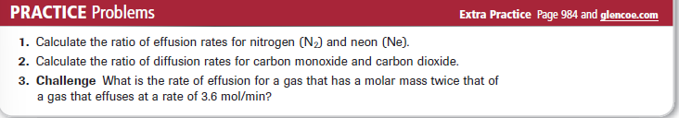
Practice Problems 12.2 – Partial Pressure of a Gas
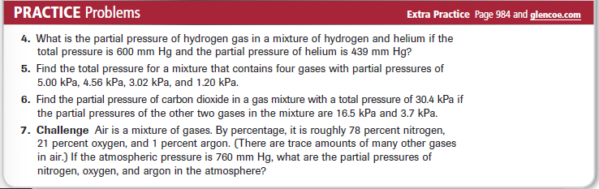

CHEMISTRY 2022-23 CHEM LAB

