CHEMISTRY 2022-23 January 24, 2023

Today’s Agenda (Day 94)

- HOUSEKEEPING ITEMS
BRING for TUESDAY: wax paper
- Homework Check:

- Class Activity:
WEDNESDAY: CHEM LAB: Compare States of Evaporation
DAY 4: Chapter 12 PPT Review
- Section 12.3 – Liquids and Solids
- Section 12.4 – Phase Changes

HOMEWORK:
- READ: Chapter 12 – States of Matter
- READ: Chapter 13 - Gases
- COMPLETE: Chapter 13 & 14 Vocabulary
- STUDY: Chapter12 Test

Chapter 13 Vocabulary
absolute zero | Avogadro's principle | Boyle's law | Charles's law | combined gas law | Gay-Lussac's law | ideal gas constant
ideal gas law | molar volume

Chapter 14 Vocabulary
boiling point elevation | Brownian motion | colligative property | Colloid | Concentration | freezing point depression | heat of solution
Henry's law | Immiscible | Insoluble | Miscible | Molality | Molarity | mole fraction
Osmosis | osmotic pressure | saturated solution | Solvation | supersaturated solution | unsaturated solution | vapor pressure lowering

REMINDERS:
- TEST: Ch 12 Jan. 24 Jan. 26
- Chapter 13 & 14 Vocabulary – Jan. 26
- QUIZ: Chapters 13 & 14 Vocabulary Jan. 31
- TEST: Ch 13 Feb. 2

CHEMISTRY 2022-23 MINI LAB

CHAPTER 11 MINI LAB – Apply Stoichiometry
How much sodium carbonate (Na₂CO₃) is produced when baking soda decomposes?

Baking soda is used in many baking recipes because it makes batter rise, which results in a light and fluffy texture. This occurs because baking soda, sodium hydrogen carbonate (Na₂CO₃), decomposes upon heating to form carbon dioxide gas according to the following equation.
2 Na₂HCO₃→ Na₂CO₃ + _{CO2} + H₂O

Procedure
1. Read and complete the lab safety form.
2. Create a data table to record your experimental data and observation.
3. Use a balance to measure the mass of a clean, dry crucible. Add about 3.0 g of sodium hydrogen carbonate (Na₂HCO₃) and measure the combined mass of the crucible and Na₂HCO₃. Record both masses in your data table and calculate the mass of the Na₂HCO₃.
4. Use this starting mass of Na₂HCO₃and the balanced chemical equation to calculate the mass of Na₂HCO₃ that will be produced.
5. Set up a ring stand with a ring and clay triangle for heating the crucible.
6. Heat the crucible with a Bunsen burner, slowly at first and then with a stronger flame, for 7–8 min. Record your observations during the heating.
7. Turn off the burner and use crucible tongs to remove the hot crucible.
WARNING: Do not touch the hot crucible with your hands.
8. Allow the crucible to cool, and then measure the mass of the crucible and Na₂HCO₃.

Analysis
1. Describe what you observed during the heating of the baking soda.
2. Compare your calculated mass of Na₂HCO₃with the actual mass you obtained from the experiment.
3. Calculate Assume that the mass of Na₂HCO₃that you calculated in Step 4 is the accepted value for the mass of product that will form. Calculate the error and percent error associated with the experimentally measured mass.
4. Identify sources of error in the procedure that led to errors calculated in Question 3.

CHEMISTRY 2022-23 LAUNCH LAB

CHAPTER 12 LAUNCH LAB – How do different liquids affect the speed of a sinking ball bearing?
You’ve probably noticed that different liquids might have vastly different properties. For example, liquids such as maple syrup, corn oil, and vegetable oil are much thicker than liquids such as water.

Procedure
1. Read and complete the lab safety form.
2. Fill a 100-mL graduated cylinder with water. Be sure to fill it exactly to the 100-mL mark.
3. Place the end of a ruler on the tabletop. Drop a ball bearing (or other small, round object) from a mark on the ruler just above the surface of the water. Use a stopwatch to time the ball bearing as it sinks to the bottom. Record this time in a data table.
4. Repeat Steps 2 and 3 two more times, dropping the object from the same height each time. Calculate the average drop time of your three trials.
5. Repeat Steps 2–4 using vegetable oil instead of water.

Analysis
1. Compare the average drop time for the two liquids.
2. Infer the relationship between the times that you recorded and how easily the liquid flows as you pour it.

Inquiry
How does temperature affect the speed with which a ball bearing sinks in a liquid? Develop a hypothesis, and design an experiment to test your hypothesis.

CHEMISTRY 2022-23 PRACTICE PROBLEM
CHAPTER 12 – States of Matter
Practice Problems 12.1 – Graham’s Law
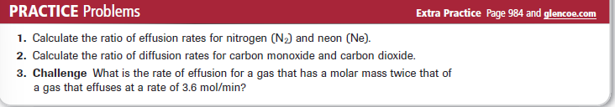
Practice Problems 12.2 – Partial Pressure of a Gas
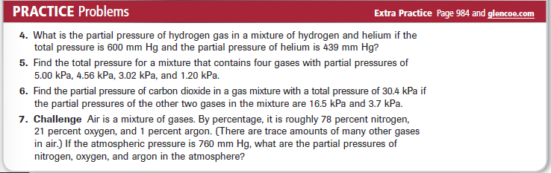

CHEMISTRY 2022-23 CHEM LAB

