CHEMISTRY 2022-23 January 10, 2023

Today’s Agenda (Day 84)

- HOUSEKEEPING ITEMS
BRING:
- Homework Check:
Practice: Balancing Equations, Naming Compounds and Writing Formulas
Practice Problems 11.1 – 11.6

- Class Activity:
QUIZ: Balancing Equations & Naming Compounds
*Go to www.socrative.com enter room “MSBCHEM2022” enter ID #
DAY 4: Chapter 11 PPT Review
- Section 11.3 – Limiting Reactants
- Section 11.4 – Percent Yield

HOMEWORK:
- READ: Chapter 11 – Stoichiometry
- COMPLETE:
- STUDY: Balancing Equations & Naming Compounds Quiz & Chapter 11 Test

REMINDERS:
- QUIZ: Balancing Equations & Naming Compounds – Jan. 10
- TEST: Ch 11 Jan. 12

CHEMISTRY 2022-23 PRACTICE
Chemistry 12
Extra Stoichiometry Problems

- Silver nitrate reacts with barium chloride to form silver chloride and barium nitrate.
a. Write and balance the chemical equation.

b. If 39.02 grams of barium chloride are reacted in an excess of silver nitrate, how many representative particles (and what type) of silver chloride are produced?

c. If 410.8 grams of barium nitrate are produced how many grams of silver nitrate were reacted?

- Nitrogen gas is reacted with hydrogen gas to form nitrogen trihydride.
  - Write and balance the chemical equation.

  - How many liters of nitrogen trihydride are produced at STP if 80.28 grams of hydrogen gas are reacted in an excess of nitrogen?

c. How many grams of hydrogen are needed to fully react 621.9 grams of nitrogen gas?

d. How many liters of nitrogen gas are needed to completely react 90.38 L of hydrogen gas at STP?

- For the following problem, use the following chemical equation:
C8H18(l) + O2(g) ! CO2(g) + H2O(g)
a. Balance the chemical equation.

b. How many moles of oxygen are needed to fully react 837.4 grams of C₈H₁₈?

c. How many liters of carbon dioxide gas are formed at STP when 3.829 x 10²⁵ representative particles of C₈H₁₈ are reacted in an excess of oxygen gas?
d. How many grams of water are produced when 382.9 liters of oxygen gas at STP are fully reacted?

CHEMISTRY 2022-23 PRACTICE
CHEMISTRY 12
Balancing Equations, Naming Compounds and Writing Formulas
PART I. Name the compounds below. Includes molecular and ionic compounds, polyatomic ions, acids, and transition metals.
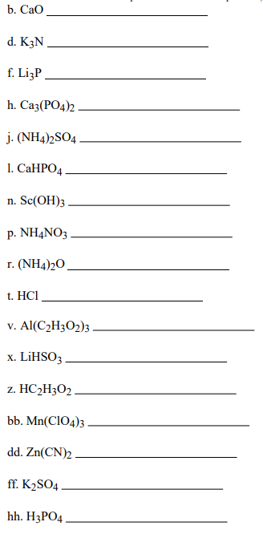

PART II. Write formulas for the compounds below. Includes molecular and ionic compounds, polyatomic ions, acids, and transition metals.
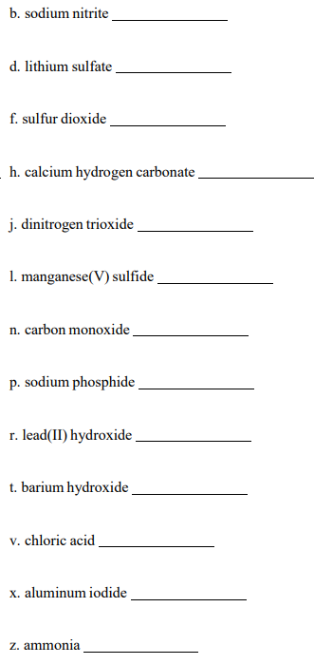

PART III. Balance each of the chemical equations shown below. Classify each reaction as being one of the following: decomposition, synthesis, single-replacement, double-replacement, or combustion.
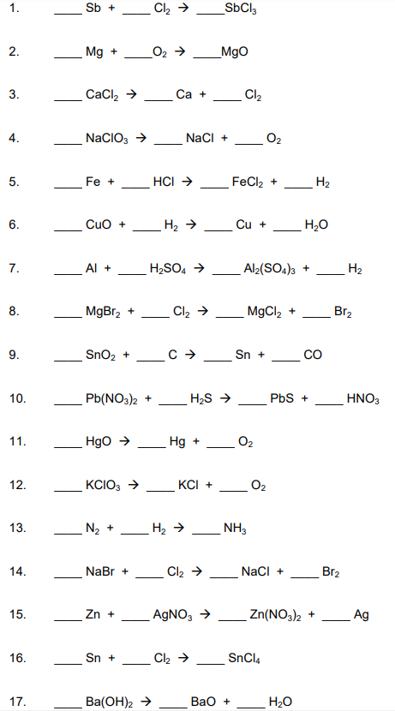

CHEMISTRY 2022-23 LAUNCH LAB

CHAPTER 11 LAUNCH LAB – What Evidence Can You Observe That a Reaction is Taking Place?

During a chemical reaction, reactants are consumed as new products are formed. Often, there are several telltale signs that a chemical reaction is taking place.

Procedure
1. Read and complete the lab safety form.
2. Use a 10-mL graduated cylinder to measure out 5.0 mL 0.01M potassium permanganate (KMnO₄). Add the solution to a 100-mL beaker.
3. Clean and dry the graduated cylinder, and then use it to measure 5.0 mL 0.01M sodium hydrogen sulfite solution (NaHSO₃). Slowly add this solution to the beaker while stirring with a stirring rod. Record your observations.
4. Repeat Step 3 until the (KMnO₄) solution in the beaker turns colorless. Stop adding the NaHSO₃ solution as soon as you obtain a colorless solution. Record your observations.

Analysis
1. Identify the evidence you observed that a chemical reaction was occurring.
2. Explain why slowly adding the NaHSO₃ solution while stirring is a better experimental technique than adding 5.0 mL of the solution all at once.

Inquiry
Would anything more have happened if you continued to add NaHSO₃ solution to the beaker? Explain.
CHEMISTRY 2022-23 PRACTICE PROBLEM
CHAPTER 11 – Stoichiometry
Practice Problems 11.1 – Interpreting Chemical Equations
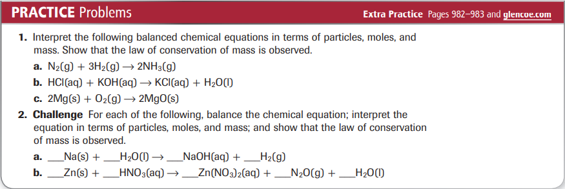
Practice Problems 11.1 – Mole Ratios
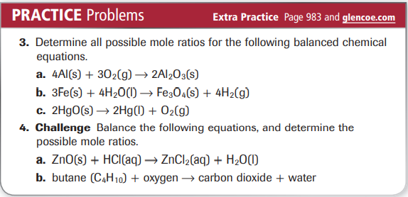
Practice Problems 11.2 – Mole-to-Mole Stoichiometry
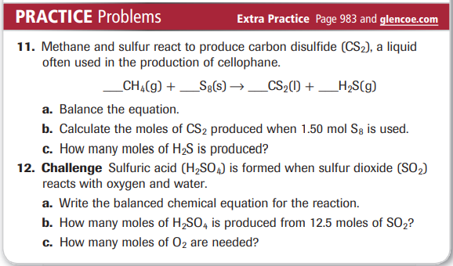
Practice Problems 11.3 – Mole-to-Mass Stoichiometry
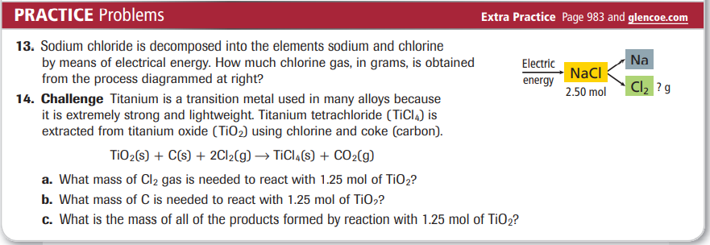
Practice Problems 11.4 – Mass-to-Mass Stoichiometry
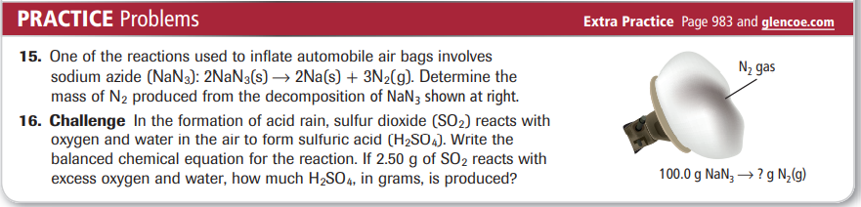
Practice Problems 11.5 – Determining the Limiting Reactant
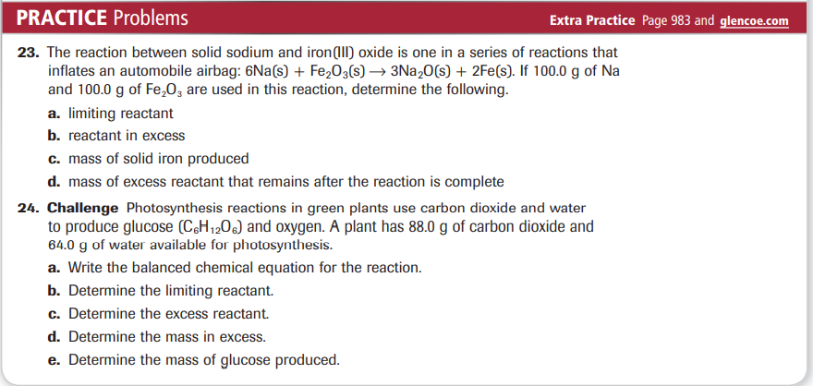
Practice Problems 11.6 – Percent Yield
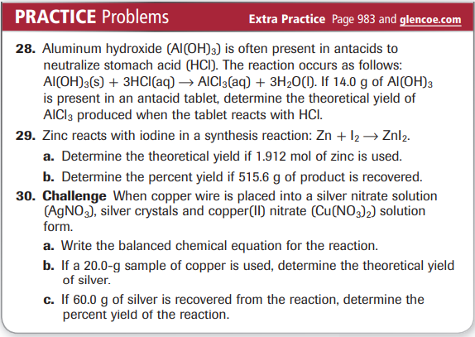
CHEMISTRY 2022-23 MINI LAB

CHAPTER 11 MINI LAB – Apply Stoichiometry
How much sodium carbonate (Na₂CO₃) is produced when baking soda decomposes?

Baking soda is used in many baking recipes because it makes batter rise, which results in a light and fluffy texture. This occurs because baking soda, sodium hydrogen carbonate (Na₂CO₃), decomposes upon heating to form carbon dioxide gas according to the following equation.
2 Na₂CO₃ → Na₂CO₃ + _{CO2} + H₂O

Procedure
1. Read and complete the lab safety form.
2. Create a data table to record your experimental data and observation.
3. Use a balance to measure the mass of a clean, dry crucible. Add about 3.0 g of sodium hydrogen carbonate (Na₂CO₃) and measure the combined mass of the crucible and Na₂CO₃. Record both masses in your data table and calculate the mass of the Na₂CO₃.
4. Use this starting mass of Na₂CO₃ and the balanced chemical equation to calculate the mass of Na₂CO₃ that will be produced.
5. Set up a ring stand with a ring and clay triangle for heating the crucible.
6. Heat the crucible with a Bunsen burner, slowly at first and then with a stronger flame, for 7–8 min. Record your observations during the heating.
7. Turn off the burner and use crucible tongs to remove the hot crucible.
WARNING: Do not touch the hot crucible with your hands.
8. Allow the crucible to cool, and then measure the mass of the crucible and Na₂CO₃.

Analysis
1. Describe what you observed during the heating of the baking soda.
2. Compare your calculated mass of Na₂CO₃ with the actual mass you obtained from the experiment.
3. Calculate Assume that the mass of Na₂CO₃ that you calculated in Step 4 is the accepted value for the mass of product that will form. Calculate the error and percent error associated with the experimentally measured mass.
4. Identify sources of error in the procedure that led to errors calculated in Question 3.

