CHEMISTRY 2022-23 August 26, 2022

Today’s Agenda (Day 8)

- HOUSEKEEPING ITEMS

- Homework Check:
Ch 1 Launch Lab
Ch 1 Mini-Lab
Chapter 1 Vocabulary

- Class Activity:
BEGIN: Chapter 2 PPT Review
- Section 2.1 – Units and Measurements
- Section 2.2 – Scientific Notation & Dimensional Analysis
- Section 2.3 – Uncertainty in Data
- Section 2.4 – Representing Data

HOMEWORK:
- READ: Chapter 1 – Introduction to Chemistry
- READ: Chapter 2 – Analyzing Data
- COMPLETE: Chapter 2 Vocabulary (abridged template)
- STUDY: APA Review, Chapter 1

CHAPTER 1
Applied research | Chemistry | Conclusion | Control | Dependent variable | experiment
Hypothesis | Independent variable | Mass | Model | Pure research | Qualitative data
Quantitative data | Scientific law | Substance | Theory | Weight

CHAPTER 2
Accuracy | base unit | conversion factor | density | derived unit | dimensional analysis
Error | Graph | Kelvin | Kilogram | Liter | Meter
percent error | Precision | scientific notation | Second | significant figure

REMINDERS:
- Ch 2 Vocabulary – Aug. 30
- TEST: Ch 1 Aug. 30
- QUIZ: Ch 1 & 2 Vocabulary Sept. 1
- TEST: Ch 2 Sept. 6

CHEMISTRY 2022-23 PRACTICE PROBLEMS

CHAPTER 2 – Analyzing Data
Practice Problems 2.1
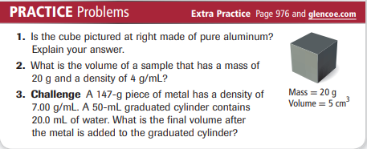
Practice Problems 2.2
