CHEMISTRY 2022-23 December 6, 2022

Today’s Agenda (Day 66)

- HOUSEKEEPING ITEMS
BRING:
- Homework Check:
MINI LAB 10: Analyzing Chewing Gum
Ch 9 LAUNCH LAB – How do you know when a chemical change has occurred
Ch 9 MINI LAB – Observe a Precipitate – Forming Reaction

- Class Activity:

DAY 3: Chapter 10 PPT Review
- Section 10.1 – Measuring Matter
- Section 10.2 – Mass and the Mole
- Section 10.3 – Moles of Compounds
- Section 10.4 – Empirical and Molecular Formulas
- Section 10.5 – Formulas of Hydrates

HOMEWORK:
- READ: Chapter 10 – The Mole
- COMPLETE: Chapter 9 Launch Lab and Mini-Lab
- STUDY: Chapter 10 Test

REMINDERS:
- TEST: Ch 10 Dec. 1 DEC. 8
- MIDTERM EXAM: Ch 1 - 10 December 15, 8:30 am

CHEMISTRY 2022-23 PRACTICE PROBLEMS
CHAPTER 10 – The Mole
Practice Problems 10.1 – Converting Particles to Moles
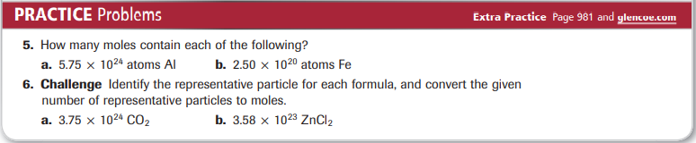
Practice Problems 10.2 – Mole-to-Mass Conversion
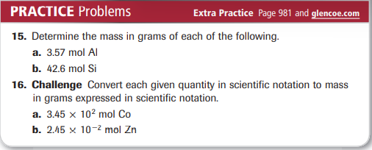
Practice Problems 10.3 – Mass-to-Mole Conversion
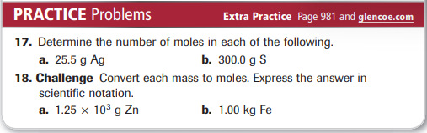
Practice Problems 10.4 – Mass-to-Atoms Conversion
Practice Problems 10.5 – Atoms-to-Mass Conversion
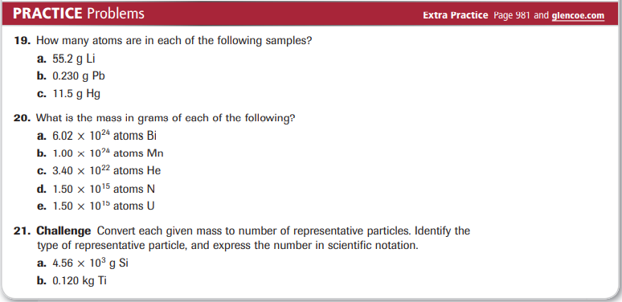
Practice Problems 10.6 – Mole Relationships from a Chemical Formula
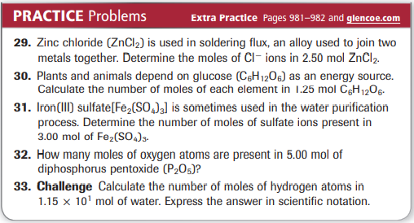
Practice Problems 10.7 – Mole-to-Mass Conversion for Compounds
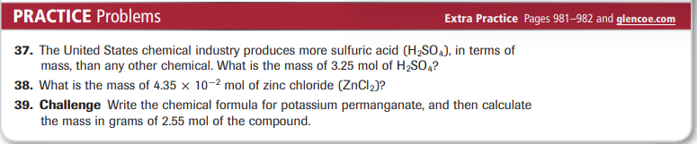
Practice Problems 10.8 – Mass-to-Mole Conversion for Compounds
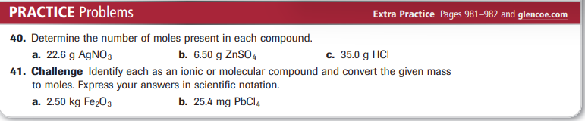
Practice Problems 10.9 – Conversion from Mass to Moles to Particles
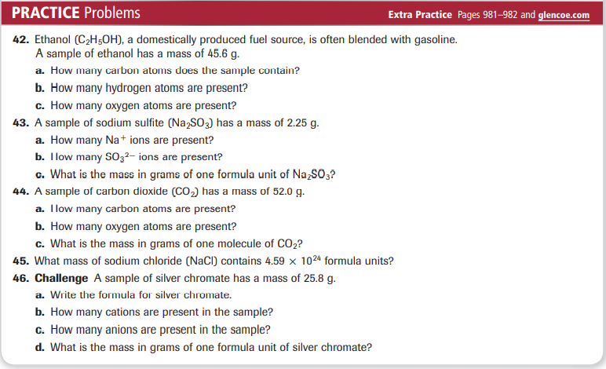
Practice Problems 10.10 – Calculating Percent Composition
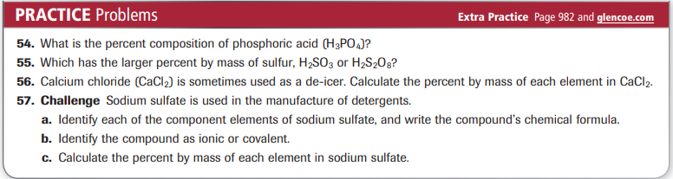
Practice Problems 10.11 – Empirical Formula from Percent Composition
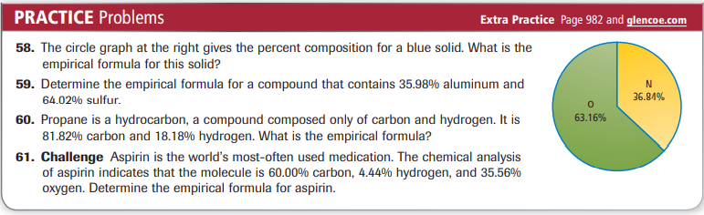
Practice Problems 10.12 – Determining a Molecular Formula
Practice Problems 10.13 – Calculating an Empirical Formula from Mass Data
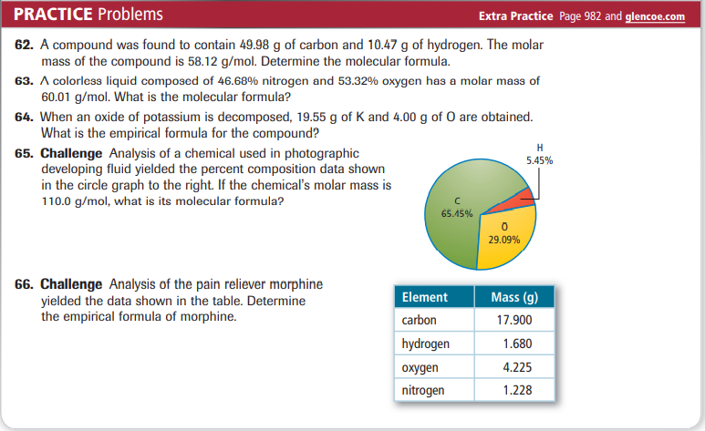
Practice Problems 10.14 – Determining the Formula of a Hydrate
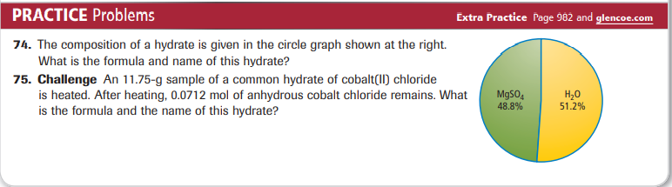
CHEMISTRY 2022-23 LAUNCH LAB

CHAPTER 9 LAUNCH LAB – How do you know when a chemical change has occurred

An indicator is a chemical that is added to the substances in a chemical reaction to show when change occurs.

Procedure
1. Read and complete the lab safety form.
2. Measure 10.0 mL of distilled water in a 25-mL graduated cylinder and pour it into a 100-mL beaker. Using a pipette, add one drop of 0.1M ammonia to the water. WARNING: Ammonia vapors are extremely irritating.
3. Stir 15 drops of universal indicator into the solution with a stirring rod. Observe the solution’s color. Measure its temperature with a thermometer.
4. Drop an effervescent tablet into the solution. Observe what happens. Record your observations, including any temperature change.

Analysis
1. Describe any changes in the color or temperature of the solution.
2. Explain Was a gas produced? If so, what did you observe to support this conclusion?
3. Analyze Did a physical change or a chemical change occur? Explain.

Inquiry
What does the universal indicator tell you about the solution? Design an experiment to support your prediction.

CHEMISTRY 2022-23 MINI LAB

CHAPTER 9 MINI LAB – Observe a Precipitate – Forming Reaction

How do two liquids form a solid?

Procedure
1. Read and complete the lab safety form.
2. Place 50 mL distilled water in a 150-mL beaker.
3. Measure about 4 g NaOH pellets on a balance. Add the NaOH pellets to the beaker one at a time. Mix with a stirring rod until each NaOH pellet dissolves before adding the next pellet.
4. Measure about 6 g Epsom salts (MgSO₄) and place it in another 150-mL beaker. Add 50 mL distilled water to the Epsom salts. Mix with another stirring rod until the Epsom salts dissolve.
5. Slowly pour the Epsom salts solution into the NaOH solution. Record your observations.
6. Stir the new solution. Record your observations.
7. Allow the precipitate to settle, then decant the liquid from the solid into a 100-mL graduated cylinder.
8. Dispose of the solid as instructed by your teacher.

Analysis
1. Write a balanced chemical equation for the reaction between the NaOH and MgSO₄. Note that most sulfate compounds exist as ions in aqueous solutions.
2. Write the complete ionic equation for this reaction.
3. Determine which ions are spectator ions, then write the net ionic equation for this reaction.

