CHEMISTRY 2022-23 December 5, 2022

Today’s Agenda (Day 65)

- HOUSEKEEPING ITEMS
BRING:
- Homework Check:
LAUNCH LAB 10: How much is a mole?
Mastering Problems 10.1 – 10.2

- Class Activity:
CHAPTER 9 LAUNCH LAB – How do you know when a chemical change has occurred
CHAPTER 9 MINI LAB – Observe a Precipitate – Forming Reaction

DAY 3: Chapter 10 PPT Review
- Section 10.1 – Measuring Matter
- Section 10.2 – Mass and the Mole
- Section 10.3 – Moles of Compounds
- Section 10.4 – Empirical and Molecular Formulas
- Section 10.5 – Formulas of Hydrates

HOMEWORK:
- READ: Chapter 10 – The Mole
- COMPLETE:
- STUDY: Chapter 10 Test
Chapter 10 – The Mole
Avogadro’s number | Empirical formula | hydrate | Molar mass | Mole | Molecular formula | Percent composition
Chapter 11 – Stoichiometry
Actual yield | Excess reactant | Limiting reactant | Mole ratio | Percent yield | Stoichiometry | Theoretical yield

REMINDERS:
- TEST: Ch 10 Dec. 1 DEC. 8
- MIDTERM EXAM: Ch 1 - 10

CHEMISTRY 2022-23 PRACTICE PROBLEMS
CHAPTER 10 – The Mole
Practice Problems 10.1 – Converting Particles to Moles
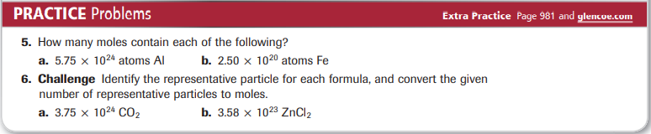
Practice Problems 10.2 – Mole-to-Mass Conversion
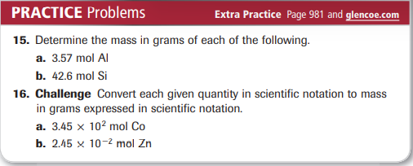
Practice Problems 10.3 – Mass-to-Mole Conversion
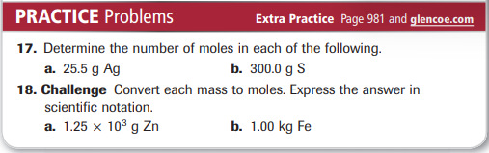
Practice Problems 10.4 – Mass-to-Atoms Conversion
Practice Problems 10.5 – Atoms-to-Mass Conversion
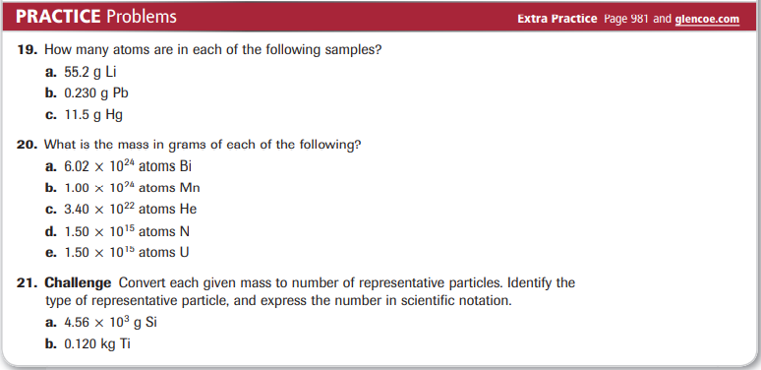
Practice Problems 10.6 – Mole Relationships from a Chemical Formula
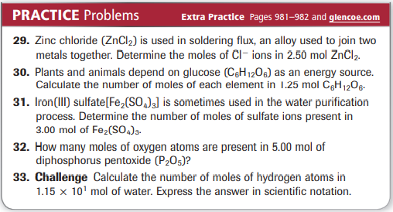
Practice Problems 10.7 – Mole-to-Mass Conversion for Compounds
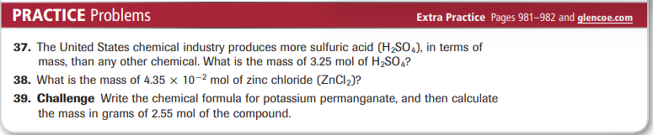
Practice Problems 10.8 – Mass-to-Mole Conversion for Compounds
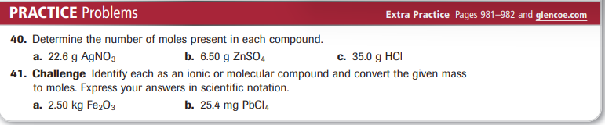
Practice Problems 10.9 – Conversion from Mass to Moles to Particles
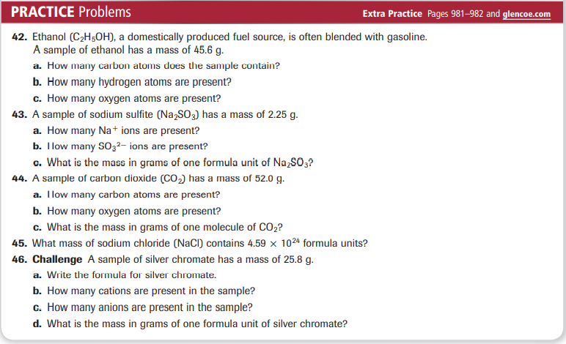
Practice Problems 10.10 – Calculating Percent Composition
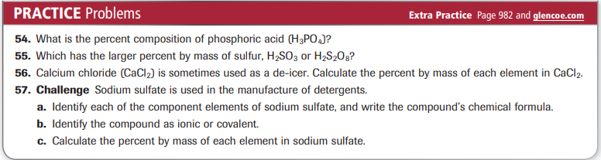
Practice Problems 10.11 – Empirical Formula from Percent Composition
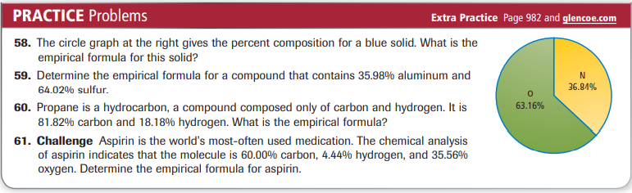
Practice Problems 10.12 – Determining a Molecular Formula
Practice Problems 10.13 – Calculating an Empirical Formula from Mass Data
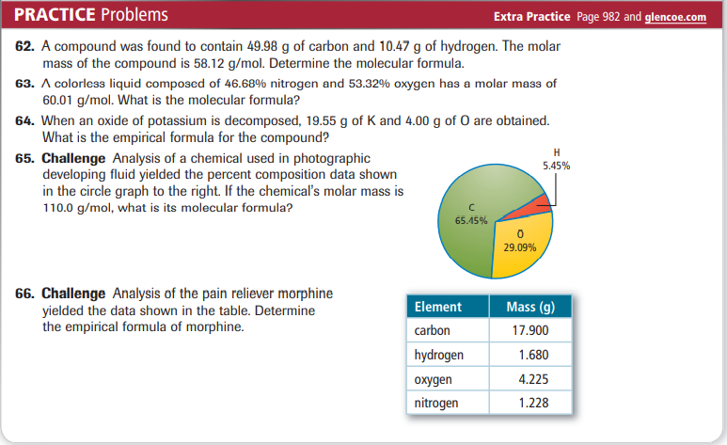
Practice Problems 10.14 – Determining the Formula of a Hydrate
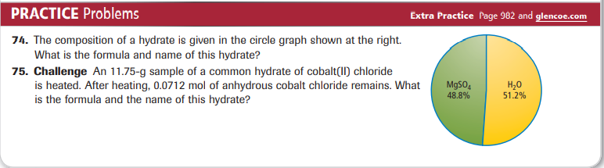
CHEMISTRY 2022-23 MINI LAB

CHAPTER 10 MINI LAB – Analyze Chewing Gum

Are sweetening and flavoring added as a coating or mixed throughout chewing gum?
Procedure
1. Read and complete the lab safety form.
2. Unwrap two pieces of chewing gum. Place each piece on a weighing paper. Measure and record each mass using a balance. WARNING: Do not eat any items used in the lab.
3. Add 150 mL of cold tap water to a 250-mL beaker. Place one piece of chewing gum in the water, and stir with a stirring rod for 2 min.
4. Pat the gum dry using paper towels. Measure and record the mass of the dried gum.
5. Use scissors to cut the second piece of gum into small pieces. Repeat Step 3 using fresh water. Keep the pieces from clumping together. WARNING: Use caution with scissors.
6. Use a 10-cm × 10-cm piece of window screen to strain the water from the gum. Pat the gum dry using paper towels. Measure and record the mass of the dried gum.

Analysis
1. Calculate For the uncut piece of gum, calculate the mass of sweeteners and flavorings that dissolved in the water. The mass of sweeteners and flavorings is the difference between the original mass of the gum and the mass of the dried gum.
2. Calculate For the gum cut into small pieces, calculate the mass of dissolved sweeteners and flavorings.
3. Apply For each piece of gum, determine the percent of the original mass from the soluble sweeteners and flavorings.
4. Infer What can you infer from the two percentages? Is the gum sugar-coated or are the sweeteners and flavorings mixed throughout?

CHEMISTRY 2022-23 LAUNCH LAB

CHAPTER 9 LAUNCH LAB – How do you know when a chemical change has occurred

An indicator is a chemical that is added to the substances in a chemical reaction to show when change occurs.

Procedure
1. Read and complete the lab safety form.
2. Measure 10.0 mL of distilled water in a 25-mL graduated cylinder and pour it into a 100-mL beaker. Using a pipette, add one drop of 0.1M ammonia to the water. WARNING: Ammonia vapors are extremely irritating.
3. Stir 15 drops of universal indicator into the solution with a stirring rod. Observe the solution’s color. Measure its temperature with a thermometer.
4. Drop an effervescent tablet into the solution. Observe what happens. Record your observations, including any temperature change.

Analysis
1. Describe any changes in the color or temperature of the solution.
2. Explain Was a gas produced? If so, what did you observe to support this conclusion?
3. Analyze Did a physical change or a chemical change occur? Explain.

Inquiry
What does the universal indicator tell you about the solution? Design an experiment to support your prediction.

CHEMISTRY 2022-23 MINI LAB

CHAPTER 9 MINI LAB – Observe a Precipitate – Forming Reaction

How do two liquids form a solid?

Procedure
1. Read and complete the lab safety form.
2. Place 50 mL distilled water in a 150-mL beaker.
3. Measure about 4 g NaOH pellets on a balance. Add the NaOH pellets to the beaker one at a time. Mix with a stirring rod until each NaOH pellet dissolves before adding the next pellet.
4. Measure about 6 g Epsom salts (MgSO₄) and place it in another 150-mL beaker. Add 50 mL distilled water to the Epsom salts. Mix with another stirring rod until the Epsom salts dissolve.
5. Slowly pour the Epsom salts solution into the NaOH solution. Record your observations.
6. Stir the new solution. Record your observations.
7. Allow the precipitate to settle, then decant the liquid from the solid into a 100-mL graduated cylinder.
8. Dispose of the solid as instructed by your teacher.

Analysis
1. Write a balanced chemical equation for the reaction between the NaOH and MgSO₄. Note that most sulfate compounds exist as ions in aqueous solutions.
2. Write the complete ionic equation for this reaction.
3. Determine which ions are spectator ions, then write the net ionic equation for this reaction.

