CHEMISTRY 2022-23 November 14, 2022

Today’s Agenda (Day 53)

- HOUSEKEEPING ITEMS
BRING: 3 x 9” aluminum pie plates; paraffin wax; sugar
- Homework Check:

- Class Activity:
DAY 6: Chapter 8 PPT Review
- Section 8.4 – Molecular Shapes
- Section 8.5 – Electronegativity and Polarity
TUESDAY: TEST: Chapter 8
*Go to www.socrative.com enter room “MSBCHEM2020” enter ID #
WEDNESDAY: Mini-Lab 8 – Compare Melting Points

HOMEWORK:
- READ: Chapter 9 – Chemical Reactions
- COMPLETE:
- STUDY: Chapter 8 Test, Chapter 9 Vocabulary Quiz & Test
Chapter 9 – Chemical Reactions
aqueous solution | chemical equation | chemical reaction | Coefficient | combustion reaction | complete ionic equation | decomposition reaction
double-replacement reaction | net ionic equation | Precipitate | Product | Reactant | single-replacement reaction | Solute
Solvent | spectator ion | synthesis reaction

REMINDERS:
- TEST: Ch 8 Nov. 15 Note change of Date!
- QUIZ: Ch 9 Vocabulary Nov. 21
- TEST: Ch 9 Nov. 22

CHEMISTRY 2022-23 MINI LAB

CHAPTER 8 MINI LAB – Compare Melting Points

How can you determine the relationship between bond type and melting point? The properties of a compound depend on whether the bonds in the compound are ionic or covalent.

Procedure
1. Read and complete the lab safety form.
2. Create a data table for the experiment.
3. Using a permanent marker, draw three lines on the inside bottom of a disposable, 9-inch aluminum pie pan to create three, equal wedges. Label the wedges, A, B, and C.
4. Set the pie pan on a hot plate. WARNING: Hot plate and metal pie pan will burn skin—handle with care.
5. Obtain samples of the following from your teacher and deposit them onto the labeled wedges as follows: sugar crystals (C ₁₂H ₂₂O ₁₁), A; salt crystals (NaCl) B; paraffin (C ₂₃H ₄₈), C.
6. Predict the order in which the compounds will melt.
7. Turn the temperature knob on the hot plate to the highest setting. You will heat the compounds for 5 min. Assign someone to time the heating of the compounds.
8. Observe the compounds during the 5-min period. Record which compounds melt and the order in which they melt.
9. After 5 min, turn off the hot plate and remove the pie pan using a hot mitt or tongs.
10. Allow the pie pan to cool and then place it in the proper waste container.
Analysis
1. State Which solid melted first? Which solid did not melt?
2. Apply Based on your observations and data, describe the melting point of each solid as low, medium, high, or very high.
3. Infer Which compounds are bonded with ionic bonds? Which are bonded with covalent bonds?
4. Summarize how the type of bonding affects the melting points of compounds.
CHEMISTRY 2022-23 PRACTICE PROBLEMS

CHAPTER 8 – Covalent Bonds
Practice Problems 8.1 – Lewis Structure of a Molecule
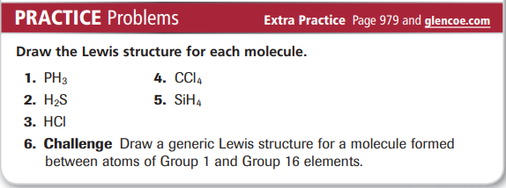
Practice Problems 8.2 – Naming Binary Molecular Compounds
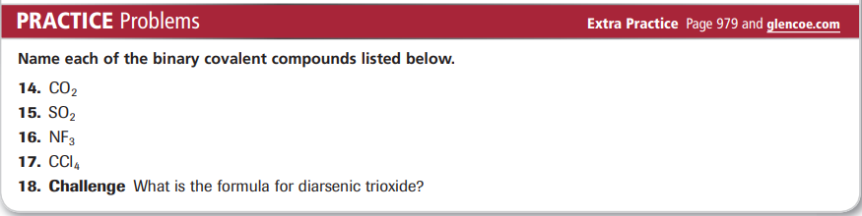
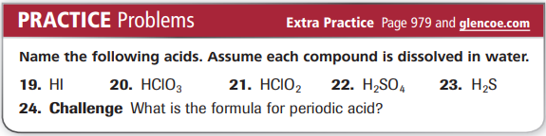
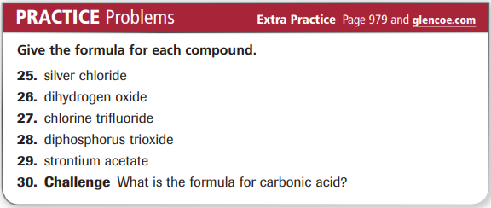
Practice Problems 8.3 – Lewis Structure for a Covalent Compound with Single Bonds
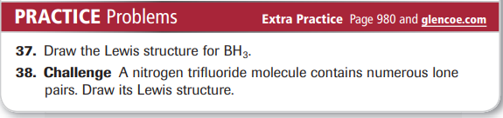
Practice Problems 8.4 - Lewis Structure for a Covalent Compound with Multiple Bonds
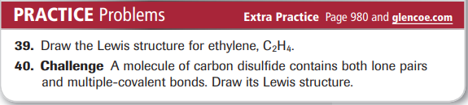
Practice Problems 8.5 – Lewis Structure for a Polyatomic Ion
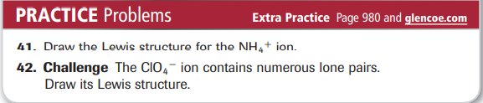
Practice Problems 8.5 – Lewis Resonance Structures
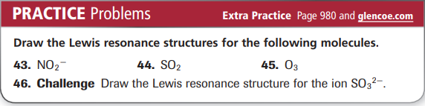
Practice Problems 8.6 – Lewis Structure: Exception to the Octet Rule
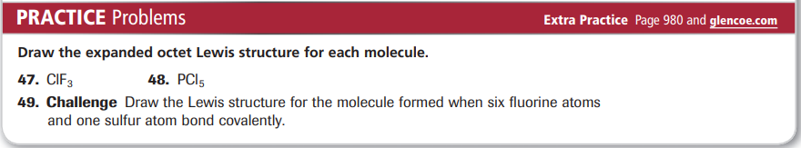
Practice Problems 8.7 – Find the Shape of a Molecule
