CHEMISTRY 2022-23 October 31, 2022

Today’s Agenda (Day 46)

- HOUSEKEEPING ITEMS

- Homework Check:
Chapter 8 Vocabulary

- Class Activity:

BEGIN: Chapter 8 PPT Review
- Section 8.1 – The Covalent Bond
- Section 8.2 – Naming Molecules
- Section 8.3 – Molecular Structures
- Section 8.4 – Molecular Shapes
- Section 8.5 – Electronegativity and Polarity

HOMEWORK:
- READ: Chapter 8 – Covalent Bonding
- COMPLETE: Chapter 8 Vocabulary
- STUDY: Chapter 8 Test, Chapter 7 & 8 Vocabulary

CHAPTER 7
Alloy | Anion | Cation | chemical bond | crystal lattice | delocalized electron
Electrolyte | electron sea model | formula unit | ionic bond | ionic compound | lattice energy
metallic bond | monatomic ion | oxidation number | Oxyanion | polyatomic ion

CHAPTER 8
coordinate covalent bond | covalent bond | endothermic reaction | exothermic reaction | Hybridization | Lewis structure
Molecule | Oxyacid | pi bond | polar covalent bond | Resonance | sigma bond
structural formula | VSEPR model

REMINDERS:
- QUIZ: Chapter 7 & 8 Vocabulary Nov. 1
- TEST: Ch 8 Nov. 8

CHEMISTRY 2022-23 CHEMLAB

CHAPTER 7 – Synthesize an Ionic Compound

Background: You will form two compounds and test them to determine some of their properties. Based on your tests, you will decide whether the products are ionic compounds.

Question: Can the physical properties of a compound indicate that they have ionic bonds?

Materials
magnesium ribbon (25 cm) crucible ring stand and ring
clay triangle Bunsen burner stirring rod
crucible tongs centigram balance 100-mL beaker
distilled water conductivity tester

Safety Precautions
WARNING: Do not look directly at the burning magnesium; the intensity of the light can damage your eyes. Avoid handling heated materials until they have cooled.

Procedure
1. Read and complete the lab safety form.
2. Record all measurements in your data table.
3. Position the ring on the ring stand about 7 cm above the top of the Bunsen burner. Place the clay triangle on the ring.
4. Measure the mass of the clean, dry crucible.
5. Roll 25 cm of magnesium ribbon into a loose ball. Place it in the crucible. Measure the mass of the magnesium and crucible together.
6. Place the crucible on the triangle and heat it with a hot flame (flame tip should be near the crucible).
7. Turn off the burner as soon as the magnesium ignites and begins to burn with a bright white light. Allow it to cool and measure the mass of the magnesium product and the crucible.
8. Place the dry, solid product in the beaker.
9. Add 10 mL of distilled water to the beaker and stir. Check the mixture with a conductivity tester.
10. Cleanup and Disposal Dispose of the product as directed by your teacher. Wash out the crucible with water. Return all lab equipment to its proper place.

Analyze and Conclude
1. Analyze Data Calculate the mass of the ribbon and the product. Record these masses in your table.
2. Classify the forms of energy released. What can you conclude about the stability of products?
3. Infer Does the magnesium react with the air?
4. Predict the ionic formulas for the two binary products formed and write their names.
5. Analyze and Conclude The product of the magnesium-oxygen reaction is white, whereas the product of the magnesium-nitrogen reaction is yellow. Which compound makes up most of the product?
6. Analyze and Conclude Did the magnesium compounds conduct a current when in solution? Do these results verify that the compounds are ionic?
7. Error Analysis If the results show that the magnesium lost mass instead of gaining mass, cite possible sources of the error.
CHEMISTRY 2022-23 MINI LAB

CHAPTER 8 MINI LAB – Compare Melting Points

How can you determine the relationship between bond type and melting point? The properties of a compound depend on whether the bonds in the compound are ionic or covalent.

Procedure
1. Read and complete the lab safety form.
2. Create a data table for the experiment.
3. Using a permanent marker, draw three lines on the inside bottom of a disposable, 9-inch aluminum pie pan to create three, equal wedges. Label the wedges, A, B, and C.
4. Set the pie pan on a hot plate. WARNING: Hot plate and metal pie pan will burn skin—handle with care.
5. Obtain samples of the following from your teacher and deposit them onto the labeled wedges as follows: sugar crystals (C ₁₂H ₂₂O ₁₁), A; salt crystals (NaCl) B; paraffin (C ₂₃H ₄₈), C.
6. Predict the order in which the compounds will melt.
7. Turn the temperature knob on the hot plate to the highest setting. You will heat the compounds for 5 min. Assign someone to time the heating of the compounds.
8. Observe the compounds during the 5-min period. Record which compounds melt and the order in which they melt.
9. After 5 min, turn off the hot plate and remove the pie pan using a hot mitt or tongs. 10. Allow the pie pan to cool and then place it in the proper waste container.
Analysis
1. State Which solid melted first? Which solid did not melt?
2. Apply Based on your observations and data, describe the melting point of each solid as low, medium, high, or very high.
3. Infer Which compounds are bonded with ionic bonds? Which are bonded with covalent bonds?
4. Summarize how the type of bonding affects the melting points of compounds.
CHEMISTRY 2022-23 PRACTICE PROBLEMS

CHAPTER 8 – Covalent Bonds
Practice Problems 8.1 – Lewis Structure of a Molecule
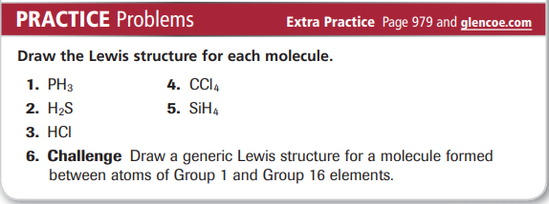
Practice Problems 8.2 – Naming Binary Molecular Compounds
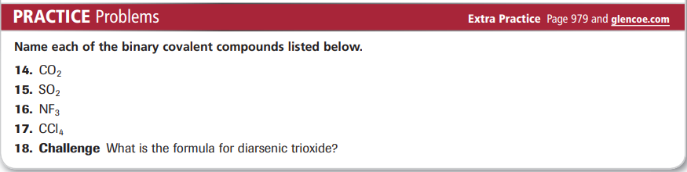
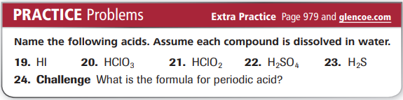
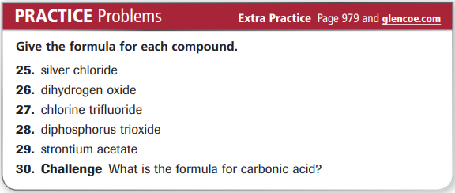
Practice Problems 8.3 – Lewis Structure for a Covalent Compound with Single Bonds
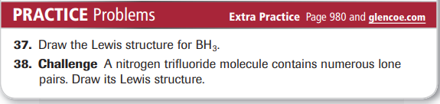
Practice Problems 8.4 - Lewis Structure for a Covalent Compound with Multiple Bonds
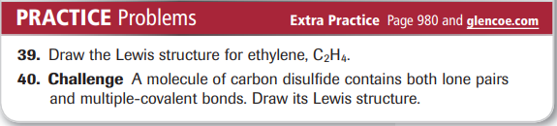
Practice Problems 8.5 – Lewis Structure for a Polyatomic Ion
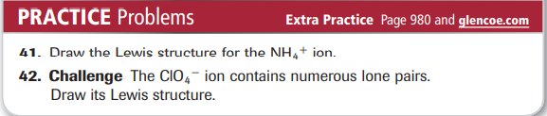
Practice Problems 8.5 – Lewis Resonance Structures
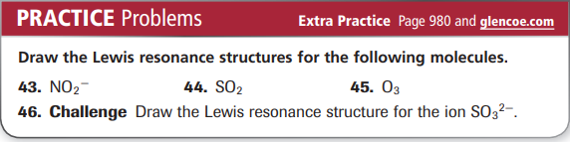
Practice Problems 8.6 – Lewis Structure: Exception to the Octet Rule
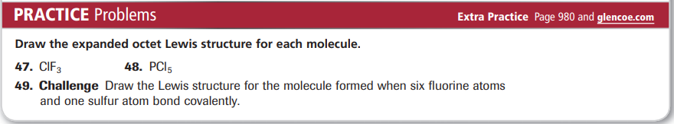
Practice Problems 8.7 – Find the Shape of a Molecule
