CHEMISTRY 2022-23 October 25, 2022

Today’s Agenda (Day 43)

- HOUSEKEEPING ITEMS

- Homework Check:

- Class Activity:

DAY 2: Chapter 7 PPT Review
- Section 7.2 – Ionic Bonds and Ionic Compounds
- Section 7.3 – Names and Formulas for Ionic Compounds
- Section 7.4 – Metallic Bonds and the Properties of Metals

HOMEWORK:
- READ: Chapter 6 – Periodic Table and Periodic Law
- READ: Chapter 7 – Ionic Compounds and Metals
- COMPLETE: Chapter 8 Vocabulary, Mini-Lab – Properties of Magnesium
- STUDY: Chapter 7 Test, Chapter 7 & 8 Vocabulary

CHAPTER 7
Alloy | Anion | Cation | chemical bond | crystal lattice | delocalized electron
Electrolyte | electron sea model | formula unit | ionic bond | ionic compound | lattice energy
metallic bond | monatomic ion | oxidation number | Oxyanion | polyatomic ion

CHAPTER 8
coordinate covalent bond | covalent bond | endothermic reaction | exothermic reaction | Hybridization | Lewis structure
Molecule | Oxyacid | pi bond | polar covalent bond | Resonance | sigma bond
structural formula | VSEPR model

REMINDERS:
- TEST: Ch 7 Oct. 27
- Mini-Lab – Properties of Magnesium - Oct. 26
- Practice Problems 7.1 – 7.3 – Oct. 26
- Chapter 8 Vocabulary – Oct. 27
- QUIZ: Chapter 7 & 8 Vocabulary Nov. 1
- TEST: Ch 8 Nov. 8

CHEMISTRY 2022-23 PRACTICE PROBLEMS

CHAPTER 7 – Ionic Compounds and Metals
Practice Problems 7.1 – Formation of Ionic Compounds
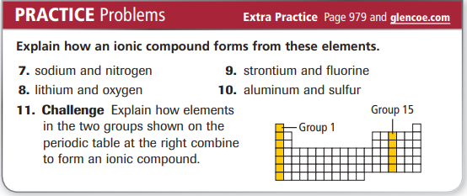
Practice Problems 7.2 – Formula for an Ionic Compound
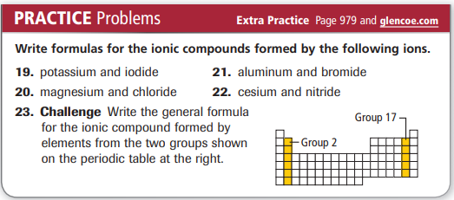
Practice Problems 7.3 – Formula for a Polyatomic Ionic Compound
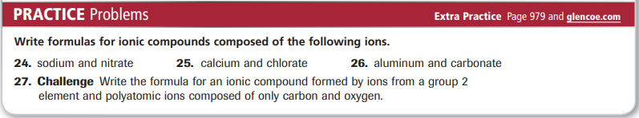
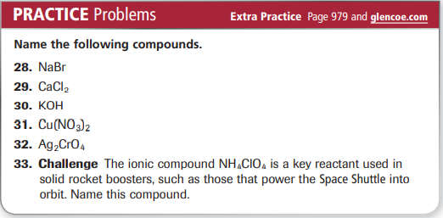
CHEMISTRY 2022-23 LAUNCH LAB

CHAPTER 7 LAUNCH LAB – What Compounds Conduct Electricity in Solution?

For a material to conduct an electric current, it must contain charged particles that can move throughout the substance. Electrical conductivity is a property of matter that tells you something about bonding.

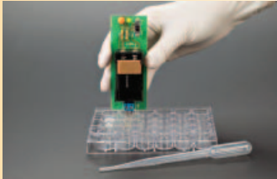

Procedure
1. Read and complete the lab safety form.
2. Make a data table to record your observations.
3. Fill an open well in a well plate with table salt (NaCl).
4. Use a disposable pipet to transfer approximately 1 mL of table salt (NaCl) solution in an open well in the well plate.
5. Place the probes of a conductivity tester in the well plate containing the solid table salt. If the light is illuminated, the table salt conducts electricity. Repeat with the solution.
6. Repeat Steps 3 to 5 using sugar (C₁₂H₂₂O₁₁) instead of table salt.
7. Repeat Steps 3 to 5 using distilled water instead of tap water.
Analysis
1. Organize Make a table listing the compounds and the results of the conductivity tests.
2. Explain your results.
Inquiry
Create a model to describe how compounds that conduct electricity in solution differ from compounds that do not conduct electricity in solution

CHEMISTRY 2022-23 MINI - LAB

CHAPTER 7 MINI LAB – Properties of Magnesium

Observing and Inferring
In this activity, you will mix magnesium with hydrochloric acid and observe the result.

Materials
test tube test-tube rack 10-mL graduated cylinder
hydrochloric acid magnesium ribbon sandpaper
cardboard wood splint safety matches

Procedure
Record all of your observations.
1. Place your test tube in a test-tube rack. For safety, the test tube should remain in the rack throughout the lab.
2. Use a 10-mL graduated cylinder to measure out about 6 mL of hydrochloric acid. Pour the acid slowly into the test tube. CAUTION: If acid gets on your skin, flush with cold running water. Use the eyewash station if acid gets in your eye.
3. Use sandpaper to clean the surface of a 3-cm length of magnesium ribbon.
4. Drop the ribbon into the acid and immediately cover the test tube with a cardboard lid.
5. As the reaction appears to slow down, light a wood splint in preparation for step 6.
6. As soon as the reaction stops, uncover the test tube and drop the burning splint into it.
7. Pour the contents of the test tube into a container specified by your teacher. Then rinse the test tube with water. Do not place your fingers inside the unwashed tube.

Analysis
1. Compare the appearance of the magnesium ribbon before and after you used the sandpaper. What did the sandpaper remove?
2. What happened when you placed the ribbon in the acid? How did you decide when the reaction was over?
3. What did you observe when you placed the burning splint in the test tube?
4. What gas can ignite explosively when exposed to oxygen in the air? (Hint: The gas is lighter than air.)

