CHEMISTRY 2022-23 August 22, 2022

Today’s Agenda (Day 4)

- HOUSEKEEPING ITEMS

- Homework Check:

- Class Activity:
REVIEW: a) Lab Equipment - https://youtu.be/chODOKSPJS4
b) Safety Signs
BEGIN: a) Chapter 1 PPT Review
b) Launch Lab
HOMEWORK:
- READ: Chapter 1 – Introduction to Chemistry
- COMPLETE: Chapter 1 Vocabulary (abridged template)
- STUDY: APA Review, Chapter 1

CHAPTER 1
Applied research | Chemistry | Conclusion | Control | Dependent variable | experiment
Hypothesis | Independent variable | Mass | Model | Pure research | Qualitative data
Quantitative data | Scientific law | Substance | Theory | Weight

ABRIDGED VOCABULARY TEMPLATE

Term:
TEXTBOOK DEFINITION

SENTENCE/PICTURE/EXAMPLE/FORMULA

REMINDERS:
- Chapter 1 Vocabulary – Aug. 25
- QUIZ: APA Review Aug. 25
- TEST: Ch 1 Aug. 30

CHEMISTRY 2022-23 ACTIVITY

IDENTIFYING LABORATORY EQUIPMENT/APPARATUS
Purpose
What are the names and functions of the pieces of laboratory equipment/apparatus found in a typical chemistry laboratory?
Procedure
1. Locate each piece of laboratory equipment on the benches in the room.
2. Match the equipment with the description of its function.
3. Record the name and draw the piece of equipment beside its function.
Observations
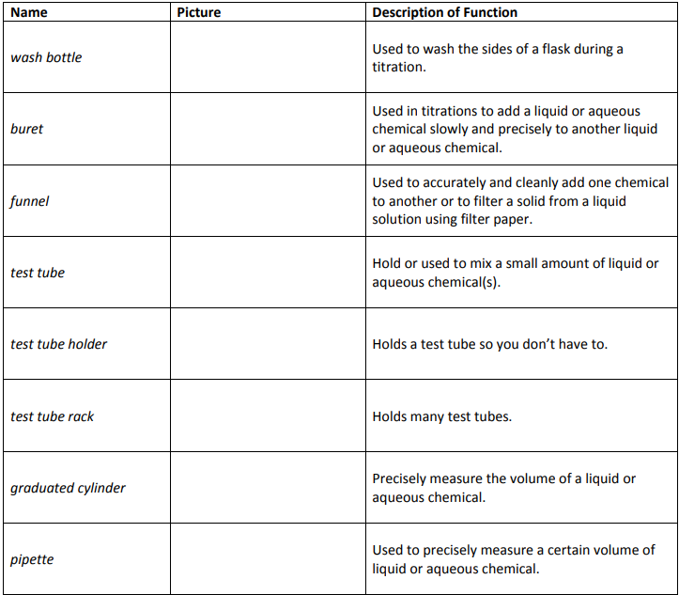
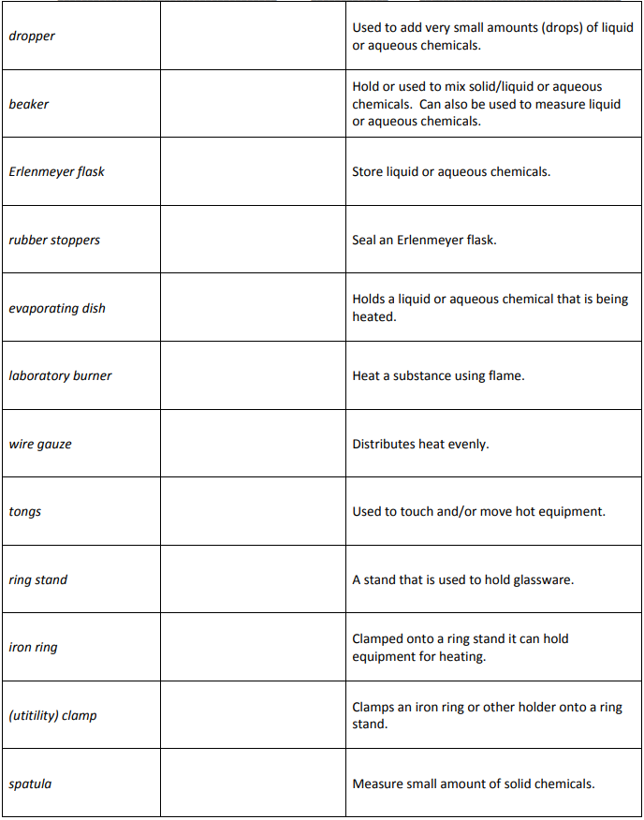

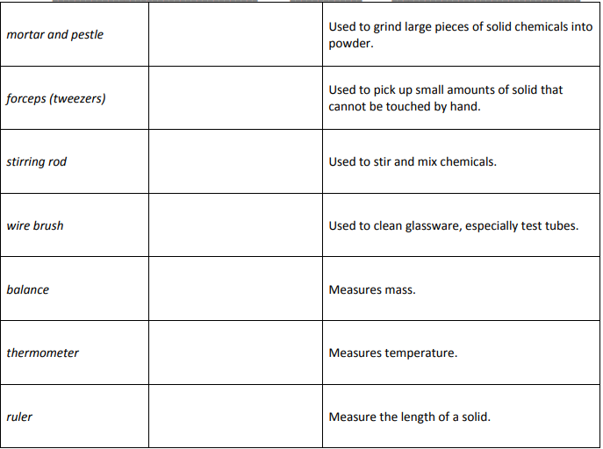

Questions
- Which laboratory equipment/apparatus can be used to measure liquid?
- Which laboratory equipment/apparatus are useful when measuring and mixing an acid and water?
- What tool or tools would you use to make each of the following measurements?
- amount of milk in a small glass
- length of a sheet of paper
- temperature of a swimming pool
- mass of a baseball

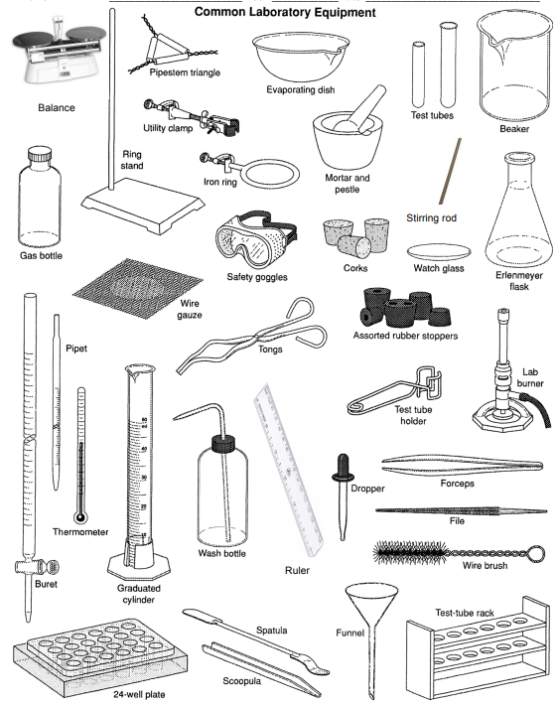

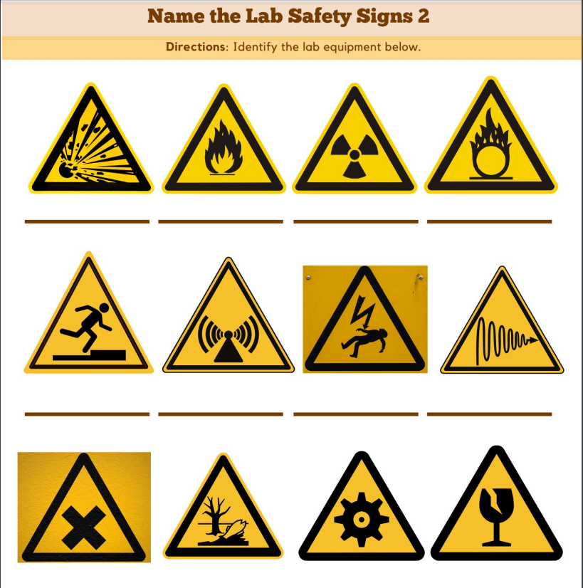

CHEMISTRY 2022-23 LAUNCH LAB

CHAPTER 1 LAUNCH LAB – Where Did the Mass Go?
When an object burns, the mass of what remains is less than the original object. What happens to the mass of the object?

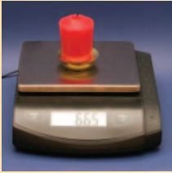
Procedure
1. Read and complete the lab safety form.
2. Use a laboratory balance to measure the mass of a candle. Record this measurement and record detailed observations about the candle.
3. Place the candle on a burn-resistant surface, such as a lab table. Carefully strike a match and light the candle. Use a stopwatch or a clock with a second hand to measure the time. Allow the candle to burn for 5 min. Then, blow out the flame. Record your observations. WARNING: Do not place matches in the sink.
4. Allow the candle to cool. Measure and record the mass of the extinguished candle.
5. Place the extinguished candle in a container designated by your instructor.
Analysis
1. Summarize your observations of the candle as it was burning and after the flame was extinguished.
2. Evaluate Where is the matter that appears to have been lost?
Inquiry
Can the amount of matter “lost” vary?
Plan an investigation to determine what factors might contribute to a different outcome.

CHEMISTRY 2022-23 MINI - LAB

CHAPTER 1 MIN LAB – Develop Observation Skills
Why are observation skills important in chemistry? Observations are often used to make inferences. An inference is an explanation or interpretation of observations.
Procedure
1. Read and complete the lab safety form.
2. Add water to a petri dish to a height of 0.5 cm. Use a graduated cylinder to measure 1 mL of vegetable oil, then add it to the petri dish.
3. Dip the end of a toothpick into liquid dishwashing detergent.
4. Touch the tip of the toothpick to the water at the center of the petri dish. Record your detailed observations.
5. Add whole milk to a second petri dish to a height of 0.5 cm.
6. Place one drop each of four different food colorings in four different locations on the surface of the milk. Do not put a drop of food coloring in the center.
7. Repeat Steps 3 and 4.
Analysis
1. Describe what you observed in Step 4.
2. Describe what you observed in Step 7.
3. Infer Oil, the fat in milk, and grease belong to a class of substances called lipids. What can you infer about the addition of detergent to dishwater?
4. Explain why observations skills were important in this chemistry lab.

