CHEMISTRY 2022-23 September 30, 2022

Today’s Agenda (Day 32)

- HOUSEKEEPING ITEMS

- Homework Check:
Chapter 5 Practice Problems
Chem Lab 4: Model Atomic Mass
- Class Activity:
MINI LAB: Periodicity of Molar Heats of Fusion & Vaporization
*work in PAIRS or INDIVIDUALLY
NEXT TUESDAY: Chapter 6 PPT Review
- Section 6.1 – Development of the Modern Periodic Table
- Section 6.2 – Classification of the Elements
- Section 6.3 – Periodic Trends
HOMEWORK:
- READ: Chapter 6 – Periodic Table and Periodic Law
- COMPLETE: Chapter 6 Vocabulary, Periodic Table Reinforcement – see p. 2 of document
- STUDY: Chapter 5 & 6 Vocabulary, Chemicals & Symbols
CHAPTER 5
Amplitude | atomic emission spectrum | atomic orbital | Aufbau principle | de Broglie equation | electromagnetic radiation
electromagnetic spectrum | electron configuration | electron-dot structure | energy sublevel | Frequency | ground state
Heisenberg uncertainty principle | Hund's rule | Pauli exclusion principle | photoelectric effect | Photon | Planck's constant
principal energy level | principal quantum number | Quantum | quantum mechanical model of the atom | quantum number | valence electron
wavelength

CHAPTER 6
actinide series | alkali metal | alkaline earth metal | Electronegativity | Group | Halogen
inner transition metal | Ion | ionization energy | lanthanide series | Metal | Metalloid
noble gas | Nonmetal | octet rule | Period | periodic law | representative element
transition element | transition metal
REMINDERS:
- Chapter 6 Vocabulary – Oct. 11
- Mini Lab 6: Heats of Fusion & Vaporization – Oct. 12
- QUIZ: Ch 5 & 6 Vocabulary Oct. 13
- Periodic Table Reinforcement – Oct. 14
- QUIZ: Chemicals and Symbols [elements, polyatomic ions, acids] Oct. 18
- TEST: Ch 6 Oct. 20

CHEMISTRY 2022-23 PERIODIC TABLE REINFORCEMENT

Chemicals and Symbols

INSTRUCTIONS: Please complete the table below with the appropriate chemical symbols (and ionic charge) for each element, common polyatomic ion, AND acid listed.

ELEMENTS, IONIC CHARGES, AND SYMBOLS
Hydrogen - | Helium - | Lithium - | Beryllium - | Boron - | Carbon - | Nitrogen - | Oxygen - | Fluorine -
Neon - | Sodium - | Magnesium - | Aluminum - | Silicon - | Phosphorus- | Sulfur - | Chlorine - | Argon -
Potassium- | Calcium - | Chromium - | Manganese - | Iron - | Cobalt - | Nickel - | Copper - | Zinc -
Arsenic - | Selenium - | Bromine - | Krypton - | Palladium - | Silver - | Cadmium - | Tin - | Iodine -
Xenon - | Cesium - | Barium - | Platinum - | Gold - | Mercury - | Lead - | Radon - | Radium -

COMMON POLYATOMIC IONS & ACIDS
Acetate | Acetate | Ammonium | Bromate | Carbonate | Chlorate | Chlorite | Chromate | Cyanate
Cyanide | Dichromate | dihydrogen phosphate | hydrogen carbonate / bicarbonate | hydrogen phosphate | hydrogen sulfate / bisulfate | Hydroxide | Hypochlorite | Iodate
Nitrate | Nitrite | Oxalate | Perchlorate | Permanganate | Peroxide | Phosphate | Phosphite | Sulfate
Sulfite | Thiocyanate | Thiosulfate
Acetic | Bromic | Chloric | Chlorous | Hydrobromic | Hydrochloric | Nitric | Phosphoric | Sulfuric

CHEMISTRY 2022-23 MINI LAB

MINI LAB 6: Periodicity of Molar Heats of Fusion & Vaporization

Making and Using Graphs The heats required to melt or to vaporize a mole (a specific amount of matter) of matter are known as the molar heat of fusion (H_{f}) and the molar heat of vaporization (H_{v}), respectively. These heats are unique properties of each element. You will investigate if the molar heats of fusion and vaporization for the period 2 and 3 elements behave in a periodic fashion.

Materials either a graphing calculator, a computer graphing program, or graph paper; Reference Table R-7 or access to comparable element data references

Procedure Use Table R-7: Properties of Elements in Reference Tables [see back of textbook] to look up and record the molar heat of fusion and the molar heat of vaporization for the period 3 elements listed in the table. Then, record the same data for the period 2 elements.

Analysis
1. Graph molar heats of fusion versus atomic number. Connect the points with straight lines and label the curve. Do the same for molar heats of vaporization.
2. Do the graphs repeat in a periodic fashion? Describe the graphs to support your answer.

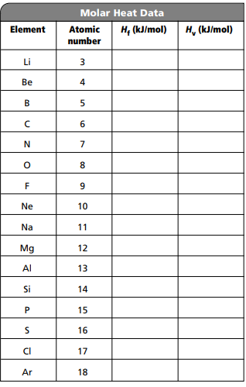

CHEMISTRY 2022-23 PRACTICE PROBLEMS

CHAPTER 5 – Structure of the Atom
Practice Problems 5.1 – Calculating Wavelength of an EM Wave
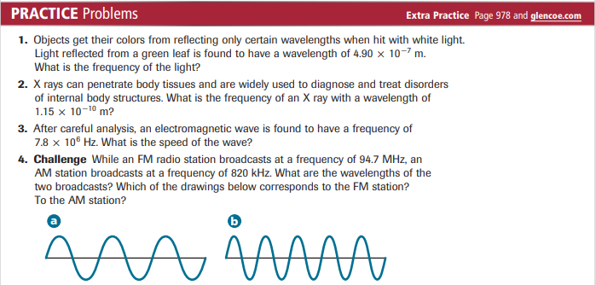
Practice Problems 5.2 – Calculate the Energy of a Photon
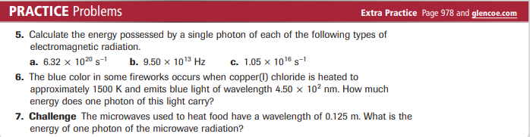
Problem-Solving Lab – Interpret Scientific Illustrations
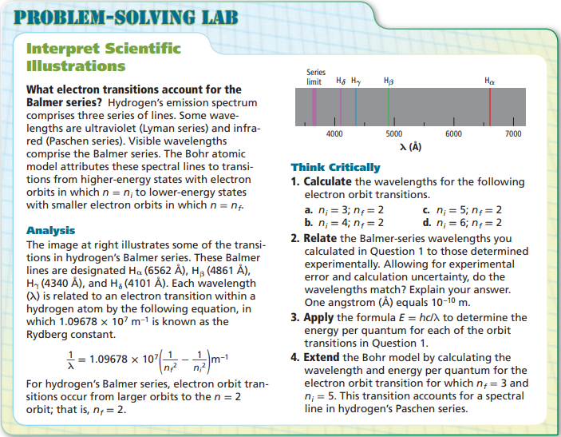
Practice Problems 5.3 – Filling Atomic Orbitals
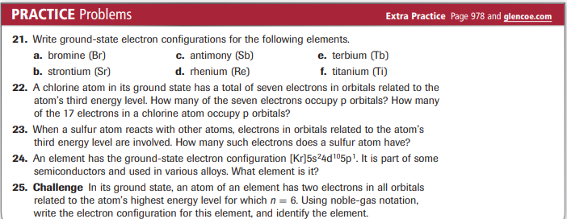
Practice Problems 5.3 – Electron-Dot Structures
