CHEMISTRY 2022-23 September 28, 2022

Today’s Agenda (Day 30)

- HOUSEKEEPING ITEMS

- Homework Check:
Chapter 5 Practice Problems

- Class Activity:
DAY 3: Chapter 5 PPT Review
- Section 5.2 – Quantum Theory and the Atom
- Section 5.3 – Electron Configuration
HOMEWORK:
- READ: Chapter 5 – Electrons in Atoms
- COMPLETE: Chapter 6 Vocabulary, Chem Lab 4 – Model Atomic Mass
- STUDY: Chapter 5 Test, Chapter 5 & 6 Vocabulary

CHAPTER 5
Amplitude | atomic emission spectrum | atomic orbital | Aufbau principle | de Broglie equation | electromagnetic radiation
electromagnetic spectrum | electron configuration | electron-dot structure | energy sublevel | Frequency | ground state
Heisenberg uncertainty principle | Hund's rule | Pauli exclusion principle | photoelectric effect | Photon | Planck's constant
principal energy level | principal quantum number | Quantum | quantum mechanical model of the atom | quantum number | valence electron
wavelength

CHAPTER 6
actinide series | alkali metal | alkaline earth metal | Electronegativity | Group | Halogen
inner transition metal | Ion | ionization energy | lanthanide series | Metal | Metalloid
noble gas | Nonmetal | octet rule | Period | periodic law | representative element
transition element | transition metal

REMINDERS:
- TEST: Ch 5 Sept. 29
- REPORT: Chem Lab 4: Model Atomic Mass – Sept. 29
- Chapter 6 Vocabulary – Oct. 11
- QUIZ: Ch 5 & 6 Vocabulary Oct. 13
- TEST: Ch 6 Oct. 18

CHEMISTRY 2022-23 CHEMLAB

CHEMLAB 4: Model Atomic Mass 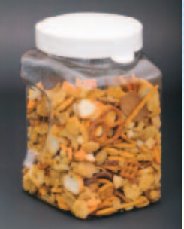
Background: Most elements in nature occur as a mixture of isotopes. The weighted average atomic mass of an element can be determined from the atomic mass and the relative abundance of each isotope. In this activity, you will model the isotopes of the imaginary element “Snackium.” The measurements you make will be used to calculate a weighted average mass that represents the average atomic mass of “Snackium.”.

Question: How are the atomic masses of the natural isotopic mixtures calculated?
Materials
balance
calculator
bag of snack mix

Safety Precautions
WARNING: Do not eat food used in lab work.

Procedure
1. Read and complete the lab safety form.
2. Create a table to record your data. The table will contain the mass and the abundance of each type of snack present in the mixture.
3. Open your snack-mix bag. Handle the pieces with care.
4. Organize the snack pieces into groups based on their types.
5. Count the number of snack pieces in each of your groups.
6. Record the number of snack pieces in each group and the total number of snack pieces in your data table.
7. Measure the mass of one piece from each group and record the mass in your data table.
8. Cleanup and Disposal Dispose of the snack pieces as directed by your teacher. Return all lab equipment to its designated location.

Analyze and Conclude
1. Calculate Find the percent abundance of the pieces by dividing the individual-piece quantity by the total number of snack pieces.
2. Calculate Use the isotopic percent abundance of the snack pieces and the mass to calculate the weighted average atomic mass for your element “Snackium.”
3. Interpret Explain why the weighted average atomic mass of the element “Snackium” is not equal to the mass of any of the pieces.
4. Peer Review Gather the average atomic mass data from other lab groups. Explain any differences between your data and the data obtained by other groups.
5. Apply Why are the atomic masses on the periodic table not expressed as whole numbers like the mass number of an element?
6. Research Look in a chemical reference book to determine whether all elements in the periodic table have isotopes. What is the range of the number of isotopes chemical elements have?
7. Error Analysis What sources of error could have led the lab groups to different final values? What modifications could you make in this investigation to reduce the incidence of error?

INQUIRY EXTENSION
Predict Based on your experience in this lab, look up the atomic masses of several elements on the periodic table and predict the most abundant isotope for each element.

CHEMISTRY 2022-23 MINI LAB

MINI LAB 6: Periodicity of Molar Heats of Fusion & Vaporization

Making and Using Graphs The heats required to melt or to vaporize a mole (a specific amount of matter) of matter are known as the molar heat of fusion (H_{f}) and the molar heat of vaporization (H_{v}), respectively. These heats are unique properties of each element. You will investigate if the molar heats of fusion and vaporization for the period 2 and 3 elements behave in a periodic fashion.

Materials either a graphing calculator, a computer graphing program, or graph paper; Reference Table R-7 or access to comparable element data references

Procedure Use Table R-7: Properties of Elements in Reference Tables [see back of textbook] to look up and record the molar heat of fusion and the molar heat of vaporization for the period 3 elements listed in the table. Then, record the same data for the period 2 elements.

Analysis
1. Graph molar heats of fusion versus atomic number. Connect the points with straight lines and label the curve. Do the same for molar heats of vaporization.
2. Do the graphs repeat in a periodic fashion? Describe the graphs to support your answer.

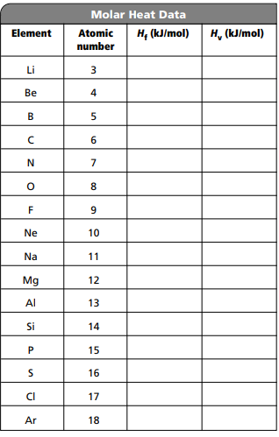

CHEMISTRY 2022-23 PRACTICE PROBLEMS

CHAPTER 5 – Structure of the Atom
Practice Problems 5.1 – Calculating Wavelength of an EM Wave
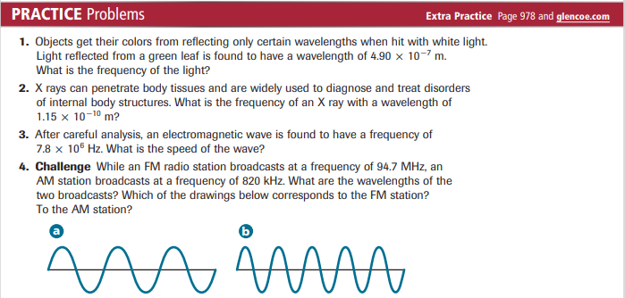
Practice Problems 5.2 – Calculate the Energy of a Photon
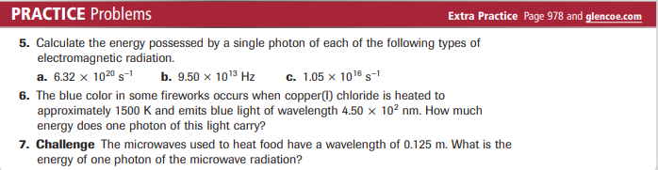
Problem-Solving Lab – Interpret Scientific Illustrations
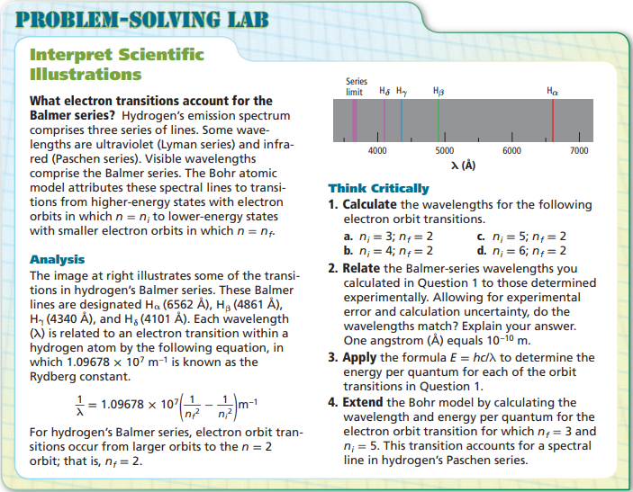
Practice Problems 5.3 – Filling Atomic Orbitals
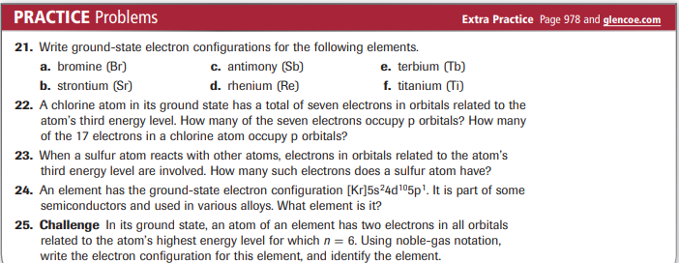
Practice Problems 5.3 – Electron-Dot Structures
