CHEMISTRY 2022-23 September 19, 2022

Today’s Agenda (Day 22)

- HOUSEKEEPING ITEMS

- Homework Check:
Lab 3.3 – Dye Separation
Lab 3.2 – Properties of Water
- Class Activity:
DAY 1: Chapter 4 PPT Review
- Section 4.1 – Early Ideas About Matter
- Section 4.2 – Defining the Atom
- Section 4.3 – How Atoms Differ
- Section 4.4 – Unstable Nuclei and Radioactive Decay

HOMEWORK:
- READ: Chapter 4 – The Structure of the Atom
- READ: Chapter 5 – Electrons in Atoms
- COMPLETE: Chapter 5 Vocabulary
- STUDY: Ch 3 & 4 Vocabulary Quiz, Chapter 4 Test

CHAPTER 3
chemical change | chemical property | Chromatography | Compound | Crystallization | Distillation
Element | extensive property | Filtration | Gas | heterogeneous mixture | homogeneous mixture
intensive property | law of conservation of mass | law of definite proportions | law of multiple proportions | Liquid | Mixture
percent by mass | periodic table | phase change | physical change | physical property | Solid
Solution | states of matter | Sublimation | Vapor

CHAPTER 4
alpha particle | Atom | atomic mass | atomic mass unit | atomic number | beta particle
beta radiation | cathode ray | Dalton's atomic theory | Electron | gamma ray | Isotope
mass number | Neutron | nuclear reaction | Nucleus | Proton | Radiation
radioactive decay | Radioactivity

CHAPTER 5
Amplitude | atomic emission spectrum | atomic orbital | Aufbau principle | de Broglie equation | electromagnetic radiation
electromagnetic spectrum | electron configuration | electron-dot structure | energy sublevel | Frequency | ground state
Heisenberg uncertainty principle | Hund's rule | Pauli exclusion principle | photoelectric effect | Photon | Planck's constant
principal energy level | principal quantum number | Quantum | quantum mechanical model of the atom | quantum number | valence electron
wavelength

REMINDERS:
- Lab 3.3 – Dye Separation – Sept. 16
- Lab 3.2 – Properties of Water – Sept. 19
- QUIZ: Ch 3 and 4 Vocabulary Sept. 20
- Chapter 4 Practice Problems – Sept. 21
- TEST: Ch 4 Sept. 22

CHEMISTRY 2022-23 PRACTICE PROBLEMS

CHAPTER 4 – Structure of the Atom
Practice Problems 4.1 – Atomic Number
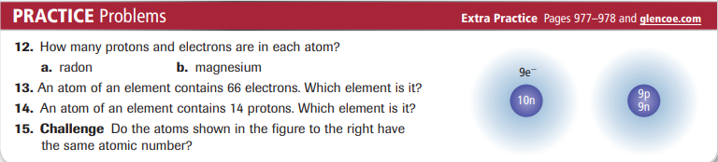

Practice Problems 4.2 – Use Atomic and Mass Number
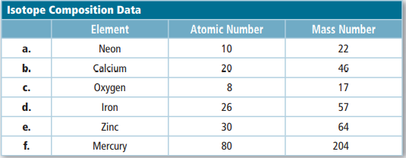
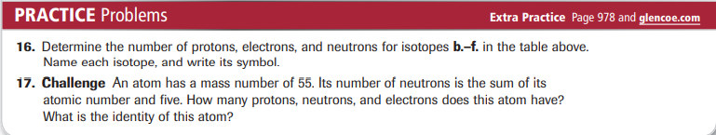

Practice Problems 4.3 – Calculate Atomic Mass
