CHEMISTRY 2022-23 May 11, 2023

Today’s Agenda (Day 156)

- HOUSEKEEPING ITEMS
BRING:
- Homework Check:
LABS:
- Class Activity:
REVIEW: Complete the next 3 sections [#4-6] from https://www.cracksat.net/sat2/chemistry/
*SUBMIT results by showing screenshot. Only results of 70%+ will be accepted

HOMEWORK:
- READ:
- COMPLETE:
- STUDY: Final Exam May 15 & 16 [in-class]

REMINDERS:
- TEST: Ch 20 April 20 May 9

CHEMISTRY 2022-23 MINI LAB

CHAPTER 19 MINI LAB – Observe a Redox Reaction
How can tarnish be removed from silver?

Procedure
1. Read and complete the lab safety form.
2. Lightly buff a piece of aluminum foil with steel wool to remove any oxide coating.
3. Wrap a small, tarnished object in the aluminum foil, making sure that the tarnished area makes firm contact with the foil.
4. Place the wrapped object in a 400-mL beaker and add a sufficient volume of tap water to cover it completely.
5. Add about 1 spoonful of baking soda and about 1 spoonful of table salt to the beaker.
6. Using beaker tongs, set the beaker and its contents on a hot plate, and heat until the water is almost boiling. Maintain the heat for approximately 15 min, until the tarnish disappears.
Analysis
1. Write the equation for the reaction of silver with hydrogen sulfide that yields silver sulfide and hydrogen.
2. Write the equation for the reaction of the tarnish (silver sulfide) with the aluminum foil that yields aluminum sulfide and silver.
3. Determine which metal, aluminum or silver, is more reactive. How do you know this from your results?
4. Explain why you should not use an aluminum pan to clean silver objects.
CHEMISTRY 2022-23 MINI LAB

CHAPTER 20 MINI LAB – Observe Corrosion
Which metal will corrode?

Procedure
1. Read and complete the lab safety form.
2. Use sandpaper to buff the surfaces of four iron nails. Wrap two nails with magnesium ribbon and two nails with copper. Wrap the metals tightly so that the nails do not slip out.
3. Place each of the nails in a separate beaker. Add distilled water to one of the beakers containing a copper-wrapped nail and one of the beakers containing a magnesium-wrapped nail. Add enough distilled water to just cover the wrapped nails. Add salt water to two additional beakers. Record your observations of the nails in each beaker.
4. Let the beakers stand overnight in the warmest place available. Examine the nails and solutions the next day and record your observations.

Analysis

1. Describe the difference between copper-wrapped nails in the distilled water and the salt water after they have been standing overnight.
2. Describe the difference between the magnesium-wrapped nails in the distilled water and in the salt water.
3. Explain the difference between a copper-wrapped nail and a magnesium-wrapped nail.

CHEMISTRY 2022-23 CHEM LAB 17
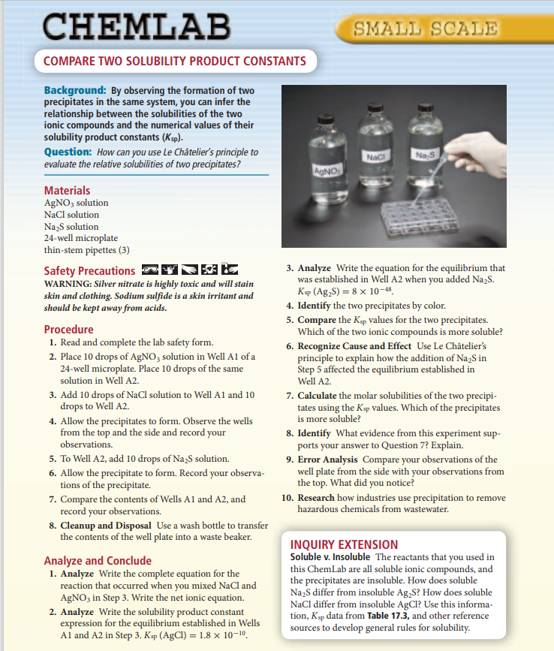

CHEMISTRY 2022-23 CHEM LAB 19
