CHEMISTRY 2022-23 April 12, 2023

Today’s Agenda (Day 142)

- HOUSEKEEPING ITEMS
BRING:
- Homework Check:

- Class Activity:

DAY 2: Chapter 19 PPT Review
- Section 19.1 – Oxidation and Reduction
- Section 19.2 – Balancing Redox

FRIDAY: Launch Lab 18 & 19, ?Mini Lab 18, Chem Lab 17
HOMEWORK:
- READ: Chapter 19 – Redox Reactions
- COMPLETE:
- STUDY: Ch 19 Vocabulary Quiz and Test

CHAPTER 19 VOCABULARY
half-reaction | oxidation | oxidation-number method | oxidation-reduction reaction | oxidizing agent | redox reaction
reducing agent | reduction | species

CHAPTER 20 VOCABULARY
anode | battery | cathode | corrosion | dry cell | electrochemical cell
electrolysis | electrolytic cell | fuel cell | galvanization | half-cell | primary battery
reduction potential | salt bridge | secondary battery | standard hydrogen electrode | voltaic cell

REMINDERS:
- TEST: Ch 19 April 13
- QUIZ: Ch 19 & 20 Vocabulary April 18
- TEST: Ch 20 April 20

CHEMISTRY 2022-23 LAUNCH LAB
CHAPTER 18 LAUNCH LAB – What is in Your Cupboards?
You can learn something about the properties of products in your household by testing them with strips of paper called litmus paper. Can you separate household products into two groups?
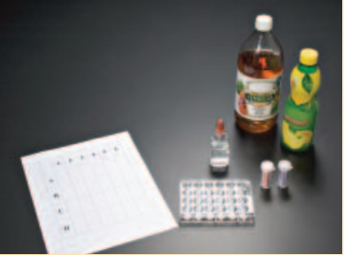
Procedure
1. Read and complete the lab safety form.
2. Place three or four drops of several household products into separate wells of a microplate. Draw a chart to show the position of each liquid.
3. Test each product with red and blue litmus paper. Place two drops of phenolphthalein in each sample. Record your observations.
WARNING: Phenolphthalein is flammable. Keep away from flames.

Analysis
1. Classify the products into two groups based on your observations.
2. Describe how the groups differ. What can you conclude?

Inquiry
Choose one sample that reacted with the phenolphthalein. Can you reverse the reaction? Design an experiment to test your hypothesis.

CHEMISTRY 2022-23 LAUNCH LAB
CHAPTER 19 LAUNCH LAB – What happens when iron and copper (II) sulfate react?
Rust is the product of a reaction between iron and oxygen. Iron can also react with substances other than oxygen.
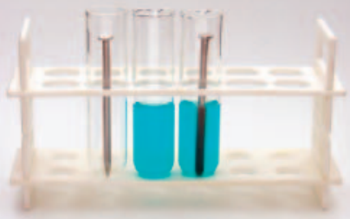

Procedure
1. Read and complete the lab safety form.
2. Use a piece of steel wool to polish the end of an iron nail.
3. Add about 3 mL of 1.0M copper (II) sulfate (CuSO₄) solution to a test tube. Place the polished end of the nail into the CuSO₄ solution. Let the test tube stand in a test-tube rack, and observe it for about 10 min. Record your observations.
Analysis
1. Explain what happened to the color of the copper (II) sulfate solution.
2. Identify the substance clinging to the nail.
3. Write the balanced chemical equation for the reaction you observed.
Inquiry
What do you think would happen if copper was placed in an iron sulfate solution? Design an investigation to test your hypothesis.

CHEMISTRY 2022-23 MINI LAB

CHAPTER 18 MINI LAB – Compare Acid Strengths
How can you determine the relative strengths of acid solutions?
Procedure
1. Read and complete the lab safety form.

2. Use a 10-mL graduated cylinder to measure 3 mL of glacial acetic acid. Use a dropping pipette to transfer the acid into Well A1 of a 24-well microplate.
WARNING: Glacial acetic acid is corrosive and toxic by inhalation. Handle with caution.

3. Lower the electrodes of a conductivity tester into Well A1. Record your results.

4. Rinse the graduated cylinder and pipette with water. Measure 3 mL of 6.0M acetic acid and transfer it to Well A2 of the microplate. Test and record the conductivity of the solution.

5. Repeat Step 4 with 1.0M acetic acid and 0.10M acetic acid using wells A3 and A4, respectively.

Analysis
1. Write the equation for the ionization of acetic acid in water and the equilibrium constant expression (K_{eq} = 1.8 × 1 0⁻⁵). What does the size of K_{eq} indicate about the degree of ionization?
2. Explain whether the following approximate percent ionizations fit your laboratory results: glacial acetic acid, 0.1%; 6.0M acetic acid, 0.2%; 1.0M acetic acid, 0.4%; 0.1M acetic acid, 1.3%.
3. State a hypothesis that explains your observations using your answer to Question 2.
4. Utilize your hypothesis to draw a conclusion about the need to use large amounts of water for rinsing when acid spills on living tissue.

CHEMISTRY 2022-23 MINI LAB

CHAPTER 19 MINI LAB – Observe a Redox Reaction
How can tarnish be removed from silver?

Procedure
1. Read and complete the lab safety form.
2. Lightly buff a piece of aluminum foil with steel wool to remove any oxide coating.
3. Wrap a small, tarnished object in the aluminum foil, making sure that the tarnished area makes firm contact with the foil.
4. Place the wrapped object in a 400-mL beaker and add a sufficient volume of tap water to cover it completely.
5. Add about 1 spoonful of baking soda and about 1 spoonful of table salt to the beaker.
6. Using beaker tongs, set the beaker and its contents on a hot plate, and heat until the water is almost boiling. Maintain the heat for approximately 15 min, until the tarnish disappears.
Analysis
1. Write the equation for the reaction of silver with hydrogen sulfide that yields silver sulfide and hydrogen.
2. Write the equation for the reaction of the tarnish (silver sulfide) with the aluminum foil that yields aluminum sulfide and silver.
3. Determine which metal, aluminum or silver, is more reactive. How do you know this from your results?
4. Explain why you should not use an aluminum pan to clean silver objects.
CHEMISTRY 2022-23 PRACTICE PROBLEM
CHAPTER 19 – Redox Reaction

Practice Problems 19.1 – Identify Oxidation-Reduction Reactions

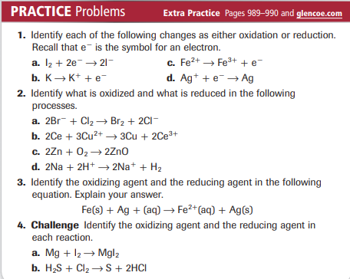

Practice Problems 19.2 – Determine Oxidation Numbers

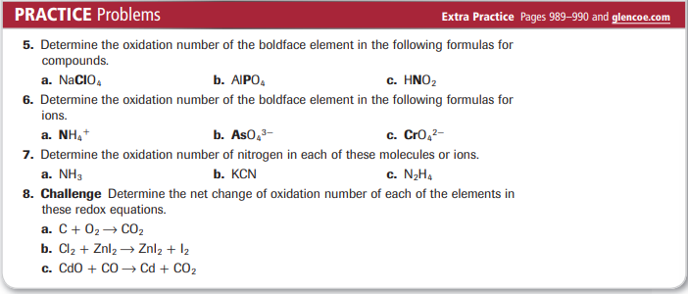

Practice Problems 19.3 – The Oxidation-Number Method
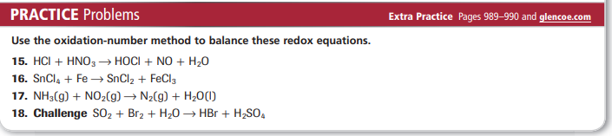

Practice Problems 19.4 – Balance a Net Ionic Redox Equation
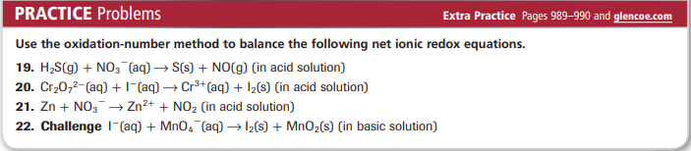
Problems 19.5 – Balance a Redox Equation by Using Half-Reactions
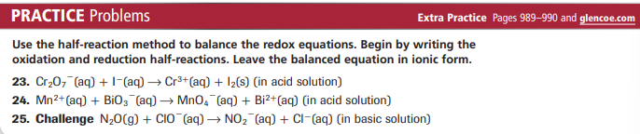

CHEMISTRY 2022-23 PROBLEM-SOLVING LAB

CHAPTER 19 Data Analysis Lab

How does redox lift a space shuttle? The space shuttle gains nearly 72% of its lift from its solid rocket boosters (SRBs) during the first two minutes of launch. The two pencil-shaped SRB tanks are attached to both sides of the liquid hydrogen and oxygen fuel tank. Each SRB contains approximately 499,000 kg of propellent mixture.

As acids and bases enter the bloodstream as a result of normal activity, the blood’s buffer systems shift to effectively maintain a healthful pH.

Data and Observations
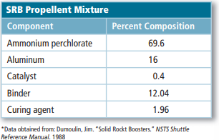

Think Critically
1. Balance an equation Use the oxidation-number method to balance the chemical equation for the SRB reaction. NH₄ClO₄(s) + Al(s) → Al₂O₃(g) + HCl(g) + N₂(g) + H₂O(g)
2. State Which elements are reduced and which are oxidized?
3. Infer What are the benefits of using SRBs for the first two minutes of launch?
4. Calculate How many moles of water vapor are produced by one SRB?
CHEMISTRY 2022-23 CHEM LAB 17
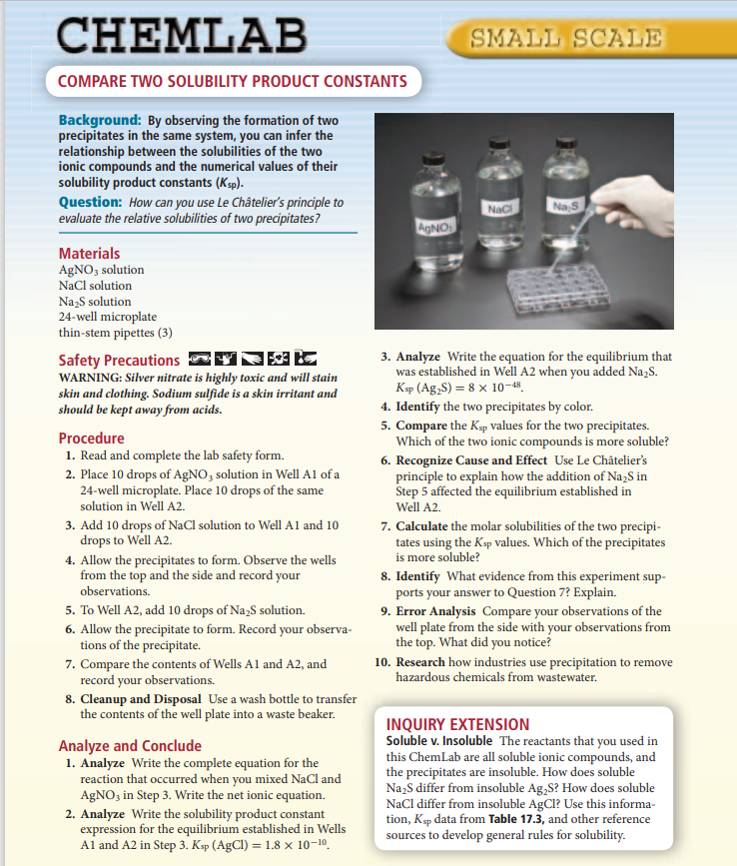

CHEMISTRY 2022-23 CHEM LAB 19
