**CHEMISTRY 2022-23 March 22, 2023**

**Today’s Agenda (Day 130)**

1. HOUSEKEEPING ITEMS

**🡪**  BRING:

1. Homework Check:

🡪

🡪

1. Class Activity:

🡪

🡪DAY 1: Chapter 17 PPT Review

1. **Section 17.1 – A State of Dynamic Balance**
2. Section 17.2 – Factors Affecting Chemical Equilibrium
3. Section 17.3 – Using Equilibrium Constants

HOMEWORK:

* READ: Chapter 17 – Chemical Equilibrium
* COMPLETE: Chapter 17 Vocabulary
* STUDY: Ch 16 Test and Ch 17 Test

CHAPTER 17 VOCABULARY

|  |  |  |  |  |  |
| --- | --- | --- | --- | --- | --- |
| chemical equilibrium | common ion | common ion effect | equilibrium constant | heterogeneous equilibrium | homogeneous equilibrium |
| law of chemical equilibrium | Le Chatelier's principle | reversible reaction | solubility product constant |  |  |

REMINDERS:

* TEST: **Ch 17 🡪 March 28**

**CHEMISTRY 2022-23 LAUNCH LAB**

**CHAPTER 17 LAUNCH LAB – What is Equal About Equilibrium?**

Equilibrium is a point of balance in which opposing changes cancel each other.



**Procedure **

1. Read and complete the lab safety form.

2. Measure 20 mL of water in a **graduated cylinder** and pour it into a **100-mL beaker**. Fill the graduated cylinder to the 20-mL mark with water. Add two drops of **food coloring** to the water in each container.

3. Obtain **two glass tubes of equal diameter**. Place one tube in the graduated cylinder and the other in the beaker.

4. Work with a partner. With the ends of the tubes at the bottoms of their containers, cover the open ends of the glass tubes with your index fingers so that water becomes trapped in the tubes. Simultaneously, move each tube to the other container and release your fingers to release the water.

5. Repeat the transfer process about 25 times. Record your observations.

**Analysis**

1. Describe your observations during the transfer process.

2. Explain Would the final result be different if you had continued the transfer process for a longer time?

**Inquiry**

Could you illustrate equilibrium using glass tubes of different diameters? Explain.

**CHEMISTRY 2022-23 MINI LAB**

**CHAPTER 17 MINI LAB – Observe Shifts in Equilibrium**

If a stress is placed on a reaction at equilibrium, how will the system shift to relieve the stress?

**Procedure **

1. Read and complete the lab safety form.

2. Place about 2 mL of **0.1M CoC l2**solution in a **test tube**. Record the color of the solution.

3. Add about 3 mL of **concentrated HCl** to the test tube. Record the color of the solution.

WARNING: HCl can burn skin and clothing.

4. Add enough **water** to the test tube to make a color change occur. Record the color.

5. Add about 2 mL of 0.1M CoC l 2 to another test tube. Add concentrated HCl a drop at a time until the solution turns purple. If the solution becomes blue, add water until it turns purple.

6. Place the test tube in an **ice bath** that has had some **table salt** sprinkled into the ice water. Record the color of the solution in the test tube.

7. Place the test tube in a hot water bath. Use a **nonmercury thermometer** to determine that the temperature is at least 70ºC. Record the solution’s color.

**Analysis**

1. Interpret Use the equation for the reaction you just observed to explain your observations of color in Steps 2–4. The equation is as follows.

Co(H2O ) 6 2+ + 4C l - ⇌ CoC l4 2- + 6 H2O pink blue

2. Describe how the equilibrium shifts when energy is added or removed.

3. Interpret From your observations of color in Steps 6 and 7, determine whether the reaction is exothermic or endothermic.

**CHEMISTRY 2022-23 PROBLEM-SOLVING LAB**

**CHAPTER 17 Problem Solving Lab – Apply Scientific Explanations**

**How does the fluoride ion prevent tooth decay?** During the last half century, tooth decay has decreased significantly because minute quantities of fluoride ion (6 × 1 0 -5 M) are being added to most public drinking-water systems, and most people are using toothpastes containing sodium fluoride or tin(II) fluoride. Use what you know about the solubility of ionic compounds and reversible reactions to explore the role of the fluoride ion in maintaining cavity free teeth.

**Analysis**

Enamel, the hard, protective outer layer of the tooth, is 98% hydroxyapatite (Ca5(PO4)3OH). Although insoluble in water (Ksp = 6.8 × 1 0-37), demineralization, which is the dissolving of hydroxyapatite, does occur, especially when the saliva contains acids. The reverse reaction, remineralization, also occurs. Remineralization is the redepositing of tooth enamel. When hydroxyapatite is in solution with fluoride ions, a double-replacement reaction can occur. A fluoride ion replaces the hydroxide ion to form fluorapatite (C a5(PO4)3F),( Ksp = 1 × 1 0-60). Fluorapatite remineralizes the tooth enamel, thus partially displacing hydroxyapatite. Because fluorapatite is less soluble than hydroxyapatite, destructive demineralization is reduced.

**Think Critically**

1. State the equation for the dissolving of hydroxyapatite and its equilibrium constant expression. How do the conditions in the mouth differ from those of a true equilibrium?

2. State the equation that describes the double-replacement reaction that occurs between hydroxyapatite and sodium fluoride.

3. Calculate the solubility of hydroxyapatite and fluorapatite in water. Compare the solubilities.

4. Calculate the ion product constant (Qsp) for the reaction if 0.00050M NaF is mixed with an equal volume of 0.000015M Ca5(PO4)3OH. Will a precipitate form (re-mineralization) **CHEMISTRY 2022-23 PRACTICE PROBLEM**

**CHAPTER 17 – Chemical Equilibrium**

**Practice Problems 17.1 –** Equilibrium Constant Expressions for Homogenous Equilibria

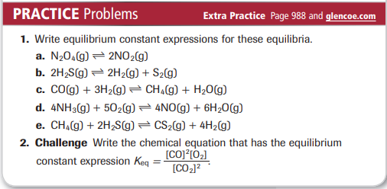

**Practice Problems 17.2 –** Equilibrium Constant Expressions for Heterogenous Equilibria

**Practice Problems 17.3 –** The Value of Equilibrium Constants

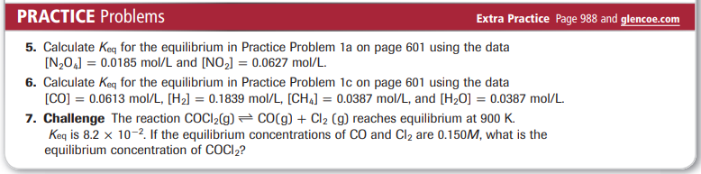

**Practice Problems 17.4 –** Calculating Equilibrium Concentrations

**Problems 17.5 –** Calculating Molar Solubility

**Problems 17.6 –** Calculating Ion Concentration

**Problems 17.7 –** Predicting a Precipitate

**CHEMISTRY 2022-23 CHEM LAB 16**

**CHEMISTRY 2022-23 CHEM LAB 17**

