CHEMISTRY 2022-23 March 10, 2023

Today’s Agenda (Day 122)

- HOUSEKEEPING ITEMS
BRING: Different types of chips [potato, rice, corn, etc] – for MONDAY!!
- Homework Check:
CHAPTER 15 Problem Solving Lab
Ch 15 Practice Problems

- Class Activity:
MONDAY: LAUNCH LAB 16 & Chem Lab 15

BEGIN: Chapter 16 Reaction Rates
- Section 16.1 - A Model for Reaction Rates
- Section 16.2 – Factors Affecting Reaction Rates
- Section 16.3 – Reaction Rate Laws
- Section 16.4 – Instantaneous Reaction Rates and Reaction Mechanisms

HOMEWORK:
- READ: Chapter 16 – Reaction Rates
- COMPLETE:
- STUDY: Ch 16 Test

CHAPTER 16 VOCABULARY
activated complex | activation energy | catalyst | collision theory | complex reaction | heterogeneous catalyst
homogeneous catalyst | inhibitor | instantaneous rate | intermediate | method of initial rates | rate law
rate-determining step | reaction mechanism | reaction order | reaction rate | specific rate constant

REMINDERS:
- QUIZ: Ch 16 March 16
- TEST: Ch 16 March 21

CHEMISTRY 2022-23 LAUNCH LAB

CHAPTER 16 LAUNCH LAB – How Can You Accelerate a Reaction?
Some chemical reactions go so slowly that nothing seems to be happening. In this lab, you can investigate one way of speeding up a slow reaction.
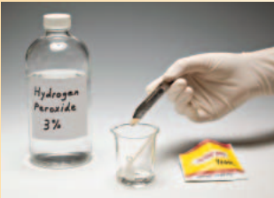

Procedure
1. Read and complete the lab safety form.
2. Create a Before and After table to record your observations.
3. Pour about 10 mL of hydrogen peroxide into a small beaker or cup. Observe the hydrogen peroxide. Complete the Before column with your initial observations. WARNING: Hydrogen peroxide is corrosive. Avoid contact with skin and eyes.
4. Add 0.1 g of baker’s yeast to the hydrogen peroxide. Stir gently with a toothpick and observe the mixture again. Complete the After column with your observations.

Analysis
1. Identify the two products formed when hydrogen peroxide decomposes. 2. Explain why bubbles are produced in Step 4 but not in Step 3.

Inquiry
What would happen if you added more or less yeast? What if you did not stir the mixture? Design an experiment to test one of these variables
CHEMISTRY 2022-23 CHEM LAB

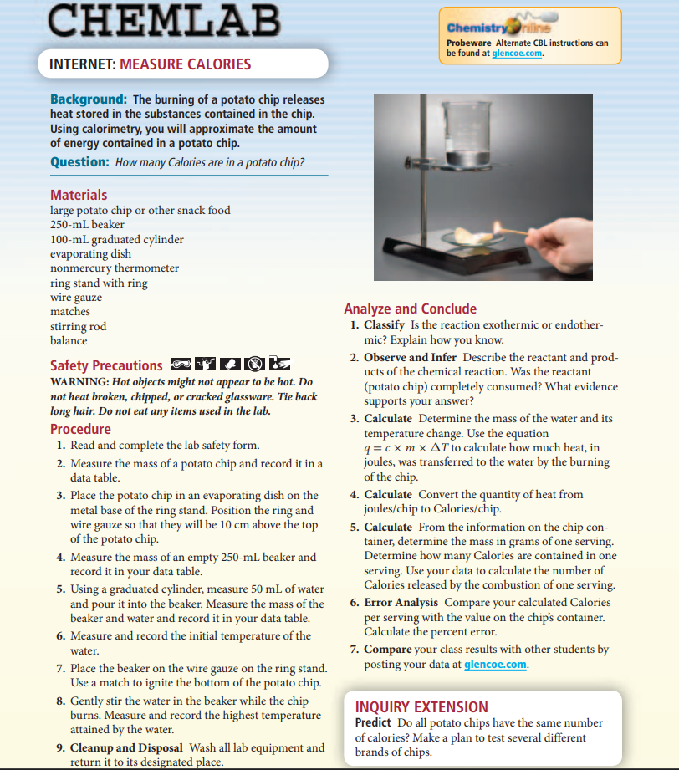
CHEMISTRY 2022-23 MINI LAB

CHAPTER 16 MINI LAB – Examine Reaction Rate and Temperature
What is the effect of temperature on a common chemical reaction?

Procedure
1. Read and complete the lab safety form.
2. Break a single effervescent tablet into four equal pieces.
3. Use a balance to measure the mass of one piece of the tablet. Measure 50 mL of room temperature water (approximately 20°C) into a 250-mL beaker. Use a nonmercury thermometer to measure the temperature of the water.
4. With a stopwatch or a clock with a second hand ready, add the piece of tablet to the water. Record the amount of time elapsed between when the tablet hits the water and when all of the solid has dissolved.
5. Repeat Steps 3 and 4, this time gradually warming the 50 mL of water to about 50°C on a hot plate. Maintain the temperature (equilibrate) throughout the run.

Analysis
1. Identify the initial mass, the final mass, and t 1 and t 2 for each trial run.
2. Calculate the reaction rate by finding the mass of reactant consumed per second for each run.
3. Describe the relationship between reaction rate and temperature for this reaction.
4. Predict what the reaction rate would be if the reaction were carried out at 40°C and explain the basis for your prediction. To test your prediction, repeat the reaction at 40°C using another piece of tablet.
5. Evaluate how well your prediction for the reaction rate at 40°C compares to the measured reaction rate.

CHEMISTRY 2022-23 PROBLEM-SOLVING LAB

CHAPTER 16 Problem Solving Lab – How Does the Rate of Decomposition Vary Over Time
The compound dinitrogen pentoxide (N₂O₅) decomposes in air according to the equation
2 N₂O₅(g) → 4NO₂(g) + O₂(g)
Knowing the rate of decomposition allows its concentration to be determined at any time.

Analysis
The table shows the results of an experiment in which the concentration of N₂O₅, was measured over time at normal atmospheric pressure and a temperature of 45°C.
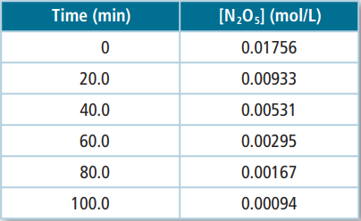
Think Critically
- Calculate the average reaction rate for each time interval: 0–20 min, 40–60 min, and 80–100 min. Express each rate as a positive number and in moles of N₂O₅ consumed per liter per minute.
- Express the average reaction rate for each time interval in moles of NO₂ produced per liter per minute. Use the reaction equation to explain the relationship between these rates and those calculated in Question 1.
- Interpret the data and your calculations in describing how the average rate of decomposition of N₂O₅ varies over time.
- Apply collision theory to infer why the reaction rate varies as it does.
CHEMISTRY 2022-23 PRACTICE PROBLEM
CHAPTER 16 – Reaction Rates
Practice Problems 16.1 – Calculate Average Reaction Rates

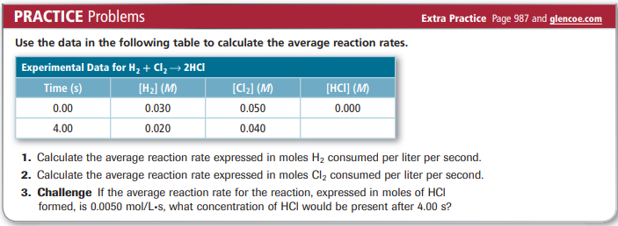

Practice Problems 16.2 – Determining Reaction Order

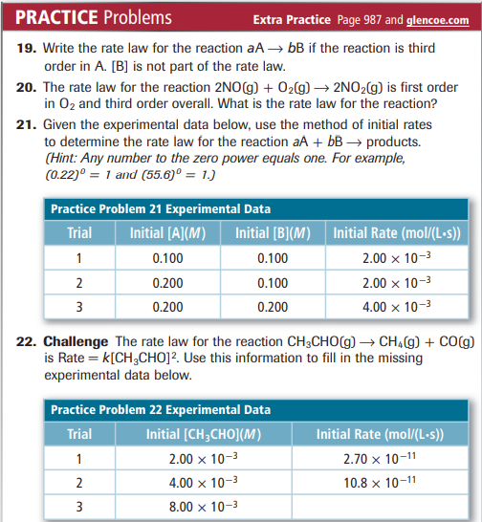

Practice Problems 16.3 – Calculate Instantaneous Reaction Rates
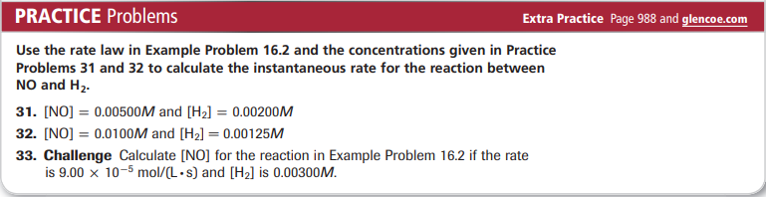

CHEMISTRY 2022-23 CHEM LAB

