CHEMISTRY 2022-23 February 27, 2023

Today’s Agenda (Day 113)

- HOUSEKEEPING ITEMS
BRING:
- Homework Check:
Ch 13 Mini Lab
Ch 14 Launch Lab
- Class Activity:

BEGIN: Ch 15 PPT Review
- Section 15.5 – Energy
- Section 15.2 – Heat
- Section 15.3 – Thermochemical Equations
- Section 15.4 – Calculating Enthalpy Change
- Section 15.5 – Reaction Spontaneity

HOMEWORK:
- READ: Chapter 15 – Energy and Chemical Change
- COMPLETE:
- STUDY: Ch 15 Test
CHAPTER 15 VOCABULARY
Calorie | Calorimeter | chemical potential energy | Energy | Enthalpy | enthalpy of combustion
enthalpy of reaction | Entropy | free energy | Heat | Hess's law | Joule
law of conservation of energy | molar enthalpy of fusion | molar enthalpy of vaporization | second law of thermodynamics | specific heat | spontaneous process
standard enthalpy of formation | Surroundings | System | thermochemical equation | Thermochemistry | Universe

REMINDERS:
- QUIZ: Ch 15 Vocabulary March 7
- TEST: Ch 15 March 9

CHEMISTRY 2022-23 LAUNCH LAB

CHAPTER 15 LAUNCH LAB – How Can You Make a Cold Pack
Chemical cold packs are used for fast relief of pain due to injury. Some chemical cold packs contain two separate compounds that are combined in a process that absorbs heat. Which compound would make the best chemical cold pack?
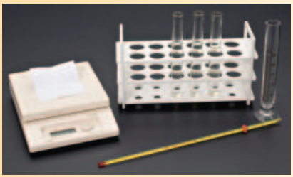

Procedure
1. Read and complete the lab safety form.
2. Use a graduated cylinder to place 15 mL of distilled water into each of three test tubes.
3. Use a nonmercury thermometer to find the temperature of the distilled water. Record the initial temperature of the water in a data table.
4. Use a balance to measure the mass of 1.0 g of potassium nitrate (KNO₃). Add the KNO₃ to Test Tube 1. WARNING: Keep all chemicals used in this lab away from heat sources.
5. Mix and record the maximum or minimum temperature reached by the solution.
6. Repeat Steps 4 and 5 with samples of calcium chloride (CaCl₂) and ammonium nitrate (NH₄NO₃).

Analysis
1. Analyze and Conclude Which is the best chemical for a chemical cold pack?
2. Describe an alternate use better suited for one of the other chemicals used in the lab.

Inquiry
Investigate a change that you could make in the procedure that would increase the temperature change.

CHEMISTRY 2022-23 PROBLEM-SOLVING LAB

CHAPTER 15 Problem Solving Lab – Make and Use Graphs

How can you derive the heating curve for water? Water molecules have a strong attraction to one another because they are polar. They form hydrogen bonds that affect water’s properties. The polarity of water accounts for its high specific heat and relatively high enthalpies of fusion and vaporization.

Analysis
Use the data in the table to plot a heating curve of temperature versus time for a 180-g sample of water as it is heated at a constant rate from -20°C to 120°C. Draw a best-fit line through the points. Note the time required for water to pass through each segment of the graph.
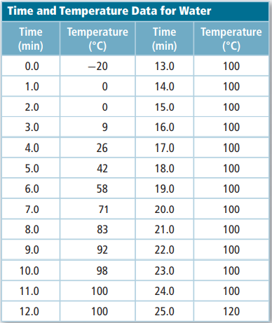

Think Critically
1. Analyze each of the five regions of the graph, which are distinguished by an abrupt change in slope. Indicate how the absorption of heat changes the energy (kinetic and potential) of the water molecules.
2. Calculate the amount of heat required to pass through each region of the graph (180 g H 2O = 10 mol H 2O, ∆ H fus = 6.01 kJ/mol, ∆ H vap = 40.7 kJ/mol, c = 4.184 J/(g · °C)). How does the length of time needed to pass through each region relate to the amount of heat absorbed?
3. Infer What would the heating curve of ethanol look like? Ethanol melts at -114°C and boils at 78ºC. Sketch ethanol’s curve from -120°C to 90°C. What factors determine the lengths of the flat regions of the graph and the slope of the curve between the flat regions?

CHEMISTRY 2022-23 PRACTICE PROBLEM
CHAPTER 15 – Energy and Chemical Change
Practice Problems 15.1 – Convert Energy Units

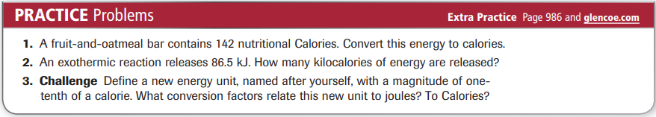

Practice Problems 15.2 – Calculate Specific Heat
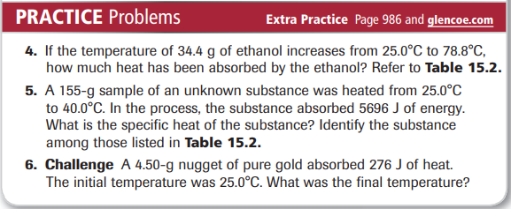

Practice Problems 15.3 – Using Specific Heat
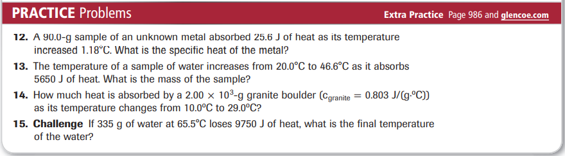

Practice Problems 15.4 – The Energy Released in a Reaction

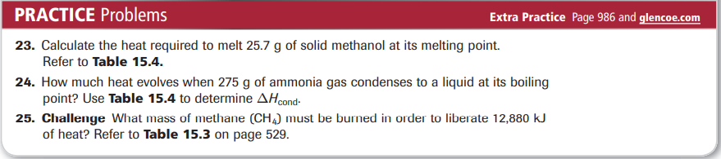

Practice Problems 15.5 – Hess’s Law

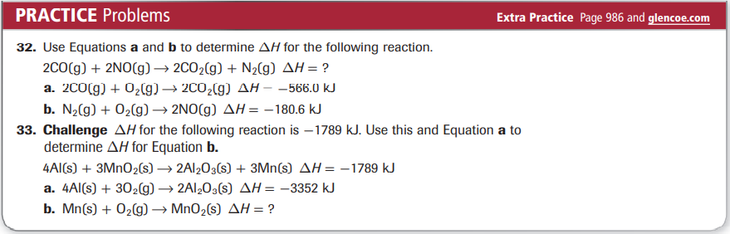
Practice Problems 15.6 – Enthalpy Change from Standard Enthalpies of Formation
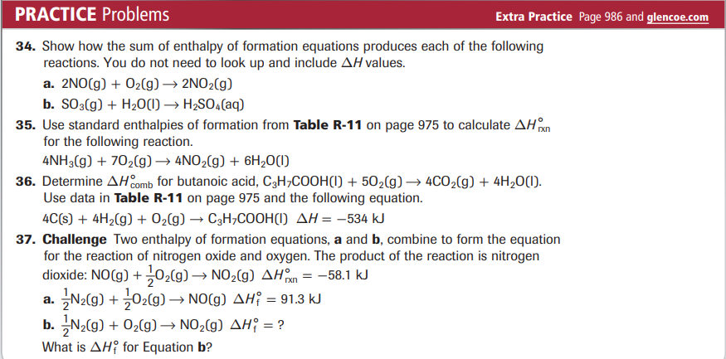
Practice Problems 15.6 – Predicting Changes in Entropy
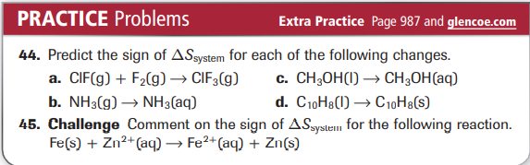
Practice Problems 15.7 – Determine Reaction Spontaneity
