BIOLOGY 2022-23 January 16, 2023

Today’s Agenda (Day 88)

- HOUSEKEEPING ITEMS

- Homework Check:
SCIENCE FAIR: Literature Review and Reverence Page
Ch 11 Reading Guide Questions
- Class Activity:
Day 8: Science Fair
*Finalize Experimental Design – identify variables (controls, independent, dependent), outline materials needed and procedures (step-by-step); OR Sketch of Prototype Design --include materials needed and timeline of how prototype will be constructed
*Prepare to have materials ready to begin experimental study/prototype construction for MONDAY!
*Discuss SF with teacher – finalize details for start of experiment

Day 1: Chapter 12 PPT Review
- Section 12.1 – DNA: The Genetic Material
- Section 12.2 – Replication of DNA
- Section 12.3 – DNA, RNA, and Protein
- Section 12.4 – Gene Regulation and Protein

HOMEWORK:
- READ: Chapter 12 – Molecular Genetics
- COMPLETE: Chapter 12 Vocabulary and Reading Guide Questions
- STUDY: Chapter 12 Vocabulary Quiz and Test
CHAPTER 12 VOCABULARY
Codon | DNA polymerase | Double helix | Gene regulation | Intron
Exon | Messenger RNA | Mutagen | Mutation | Nucleosome
Okazaki fragment | Operon | Ribosomal RNA | RNA | RNA polymerase
Semiconservative replication | Transcription | Transfer RNA | translation

REMINDERS:

- QUIZ: Ch 12 Vocabulary Jan. 19
- TEST: Ch 12 Tuesday, Jan. 24

BIOLOGY 2022-23 READING GUIDE

Chapter 12 Molecular Genetics Reading Guide

DIRECTIONS: Refer to your textbook to respond to the following questions.
- Describe Frederick Griffith’s experiment shown below.
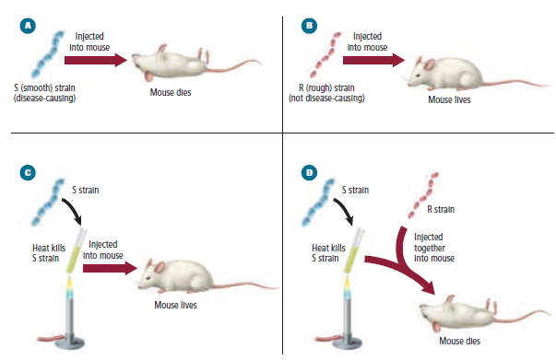
- How did Oswald Avery identify the molecule that transformed the R strain of bacteria into the S strain?
- Describe how Hershey and Chase definitively proved DNA was the transforming factor.
- List the three parts of a DNA nucleotide.
- Label the parts of the nucleotide below.
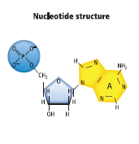
- Name and draw DNA’s two purines.
- Name and draw DNA’s two pyrimidines.
- What is the most obvious difference between your drawings in number 6 and 7 above?
- List three important features of Watson and Crick’s proposed DNA molecule.
- Draw a DNA double helix and label the sugar, phosphate, and nitrogen bases.
- Describe the orientation (direction) of the two strands in a DNA molecule.
- How do nucleosomes form?
- What is semiconservative replication? What are the three main stages of this type of replication?
- Describe the 3 main events during the unwinding stage of replication.
- What is the role of DNA polymerase in replication?
- Explain why DNA replication is more complex in eukaryotes than bacteria.
- Describe the function of each of the following in protein synthesis: rRNA, mRNA, and tRNA
- What happens during transcription?
- Why is mRNA so much shorter than the DNA it is made from?
- Differentiate between codons and anticodons.
- What happens during translation?
- Why has Beadle and Tatum’s “one gene, one enzyme” hypothesis been modified since they presented it in the 1940s.
- What are the three parts of an operon?
- Describe AND give an example of three types of DNA mutations.
- Why do you think most mutations in eukaryotes are recessive?

