BIOLOGY 2022-23 January 11, 2023

Today’s Agenda (Day 85)

- HOUSEKEEPING ITEMS
Chapter 11 Vocabulary
- Homework Check:
SCIENCE FAIR: Literature Review and Reverence Page
Ch 11 Reading Guide Questions
- Class Activity:
Day 7: Science Fair
*Finalize Experimental Design – identify variables (controls, independent, dependent), outline materials needed and procedures (step-by-step); OR Sketch of Prototype Design --include materials needed and timeline of how prototype will be constructed
*Prepare to have materials ready to begin experimental study/prototype construction for MONDAY!

DAY 4: Chapter 11 PPT Review
- Section 11.2 – Complex Patterns of Inheritance
- Section 11.3 – Chromosomes and Human Heredity

HOMEWORK:
- READ: Chapter 11 – Complex Inheritance and Human Heredity
- COMPLETE:
- STUDY: Chapter 11 Test
CHAPTER 12 VOCABULARY
Codon | DNA polymerase | Double helix | Gene regulation | Intron
Exon | Messenger RNA | Mutagen | Mutation | Nucleosome
Okazaki fragment | Operon | Ribosomal RNA | RNA | RNA polymerase
Semiconservative replication | Transcription | Transfer RNA | translation

REMINDERS:

- TEST: Ch 11 Thursday, Jan. 12

BIOLOGY 2022-23 READING GUIDE

Chapter 11 Human Heredity Reading Guide
Review pages 296 - 315 in the Glencoe Science Biology Textbook and answer the following questions.
- What is a carrier? What is the genotype of a carrier?
- Describe what each symbol represents in the pedigree below:
- How is it possible that one of the children in the following pedigree expresses Tay-Sachs?
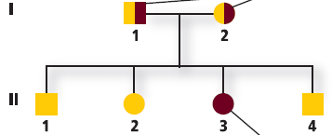
- How can pedigrees be used to infer genotypes?
- Can two parents with albinism (a recessive genetic disorder) have an unaffected child? Explain.
- What is incomplete dominance? Give an example.
- This shows the crossing of snapdragons. What is the phenotypic ratio for this incomplete dominant cross?
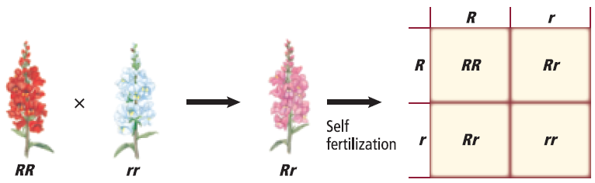
- How does codominance differ from incomplete dominance?
- Explain how coat color in rabbits is inherited.
- What are the two types of sex chromosomes? What is the genotype of a male? Female?
- What does the condition shown here cause in cats?
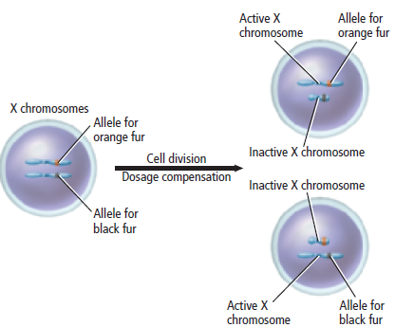
- Why are males more likely to be affected by sex-linked traits?
- Study this Punnett square. Why does the father not have color blindness?
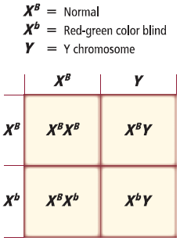
- How can the environment affect phenotype?
- How is a karyotype prepared?
- What are telomeres? What may telomeres be involved with?
- Describe what happens during nondisjunction.
- Why is down syndrome called trisomy 21?
- What can parents do if they are unsure if they are a carrier for a genetic disease?
- Describe the risks and benefits for two types of fetal testing.

