BIOLOGY 2022-23 December 7, 2022

Today’s Agenda (Day 67)

- HOUSEKEEPING ITEMS

- Homework Check:
Chapter 10 Reading Guide

- Class Activity:
THURSDAY: TEST: Ch 10
*Go to www.socrative.com enter room “MSBBIOLOGY” enter ID #

DAY 3: Chapter 10 PPT Review
- Section 10.2 – Mendelian Genetics
- Section 10.3 – Gene Linkage and Polyploidy

HOMEWORK:
- READ: Chapter 10 – Sexual Reproduction and Genetics
- COMPLETE:
- STUDY: Chapter 10 Test
CHAPTER 9 VOCABULARY
Anaphase | Apoptosis | Cancer carcinogen | Cell cycle | Centromere
Chromatin | Chromosome | Cyclin | Cyclin-dependent kinase | Cytokinesis
Interphase | Metaphase | Mitosis | Prophase | Sister chromatid
Spindle apparatus | Stem cell | Telophase

CHAPTER 10 VOCABULARY
Allele | Crossing over | Diploid | Dominant | Fertilization
Gamete | Gene | Genetic recombination | Genetics | Genotype
Haploid | Heterozygous | Homologous chromosome | Homozygous | Hybrid
Law of independent assortment | Law of segregation | Meiosis | Phenotype | Polyploidy
Recessive

REMINDERS:

- TEST: Ch 10 Dec. 8
- MIDTERM EXAM: Ch 1 – 10 December 15, 8:30 am

BIOLOGY 2022-23 READING GUIDE
Chapter 10 – Sexual Reproduction & Genetics

DIRECTIONS: Refer to your textbook to respond to the following questions.

- What are homologous chromosomes. Give an example of a trait found on homologous chromosomes.
- What are gametes? What is fertilization?
- What are the only haploid cells found in humans?
- How do gametes form? Describe this process.
- What does Meiosis I start with? What does Meiosis II end with?
- What is the unique step in prophase 1?
- What happens in metaphase I that is unique to meiosis?
- DRAW the picture below and label each phase of meiosis that you have drawn.

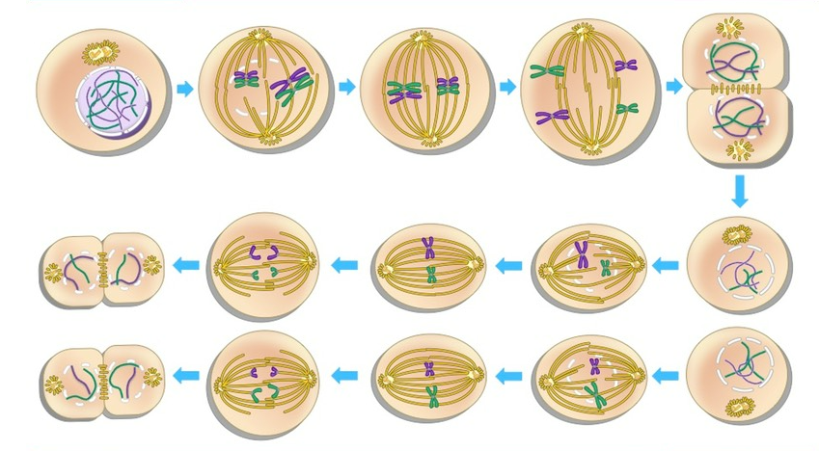
- Describe one event that is happening for each of the pictures you just drew.
- Compare and contrast mitosis and meiosis.
- How does meiosis provide variation?
- What advantage do organisms have that reproduce sexually versus asexually?
- What is heredity? Who carried out the first studies in heredity?
- How did Mendel perform cross-pollination of his pea plants? How did he prevent self-fertilization?
- Describe the results Mendel got when he crossed pure-breeding yellow seed plants with pure-breeding green seed plants crossed their offspring?
- How did Mendel determine which trait was dominant and which was recessive?
- Why did the green-seed form of the trait not appear in the F₁ generation?
- What does homozygous mean? What does heterozygous mean? Give an example of each.
- What it a phenotype? What is a genotype? Give two possible genotypes for a yellow seed phenotype.
- What is the law of segregation?
- Yy could be described as _____________ or ___________.
- Why were Mendel’s first experiments called monohybrid crosses?
- How is the law of independent assortment related to meiosis?
- What is the genotype ratio for a Tt to Tt cross?
- What is the phenotype ratio for a Tt to Tt cross?
- What is meant by “linked genes”?
- What do chromosome maps show?
- Compare and contrast polyploidy in humans and plants.

